**Install Samba Server on Ubuntu**

**Samba is a free and open-source re-implementation of the SMB/CIFS network file sharing protocol that allows end users to access files, printers, and other shared resources.**

**A Samba file server enables file sharing across different operating systems over a network.**

**Samba allows to share files and printers with other computers remotely, regardless their operating system like windows, Mac also linux.**

**for install samba run the following command**

apt install samba

**smbd will be listening on TCP port 139 and 445. nmbd will be listening on UDP port 137 and 138.**

**create a private Samba share that requires the client to enter username and password**

**The main Samba configuration file is located at: /etc/samba/smb.conf.**

In the **[global]** section, make sure the value of workgroup is the same with the **workgroup** settings of Windows computers.

**The scroll down to the bottom of the file. Add a new section like below.**

vi /etc/samba/smb.conf

*[Private]*

*comment = This is privet directory, needs username and password to access*

*path = /home/privetshare*

*browseable = yes*

*guest ok = no*

*writable = yes*

*valid users = sambauser*

**Now we need to create a Samba user.**

useradd sambauser

**you also need to set a separate Samba password for the new user with the following command:**

smbpasswd -a sambauser

**Create the private share folder.**

mkdir -p /home/privetshare

**Next run the following command to check if there’s syntactic errors.**

testparm

**then restart the samba**

systemctl restart smbd

systemctl restart nmbd

**create a public share without requiring username and password,**

vi /etc/samba/smb.conf

*[public]*

*comment = public share, no need to enter username and password*

*path = /home/publicshare*

*browseable = yes*

*writable = yes*

*guest ok = yes*

**create share directory.**

mkdir -p /home/publicshare

**give permission**

chmode -Rf 666 /home/publicshare

**restart samba service**

systemctl restart nmbd

systemctl restart nmbd

**Private** is the folder name that will be displayed on the Windows network.

**comment** is a description for the shared folder.

**path** parameter specifies the path to the shared folder. I use /srv/private/ as an example. You can also use a folder in your home directory.

**browseable = yes**: Allow other computers in the network to see the Samba server and Samba share. If set to no, users have to know the name of the Samba server and then manually enter a path in the file manager to access the shared folder.

**guest ok** = no: Disable guest access. In other words, you need to enter username and password on the client computer to access the shared folder.

**writable = yes:** Grants both read and write permission to clients.

**valid users =** **publicshare:** Only users in the samba group are allowed to access this Samba share.

**Install Samba server on CentOS**

**Samba is available from the standard CentOS repositories.**

yum install samba -y

**Creating Samba Users and Directory Structure**

sudo mkdir /home/samba

useradd abhi

smbpasswd -a abhi

**open the Samba configuration file and append the sections:**

vi /etc/samba/smb.conf

*[share]*

*comment = share directory.*

*path = /home/samba*

*writable = yes*

*broweable = yes*

*read only = no*

*guest ok = yes*

*valid user = abhi*

**Once done, restart the Samba services with:**

sudo systemctl restart smb.service

sudo systemctl restart nmb.service

**Accessing Samba Shared Folder From Windows**

**just go to start and search the Run and type ipaddress of samba server and share name like below:**

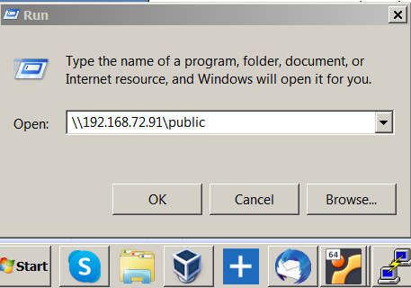

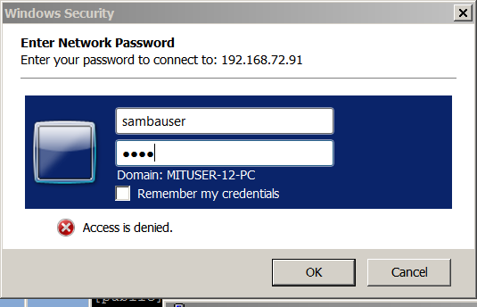

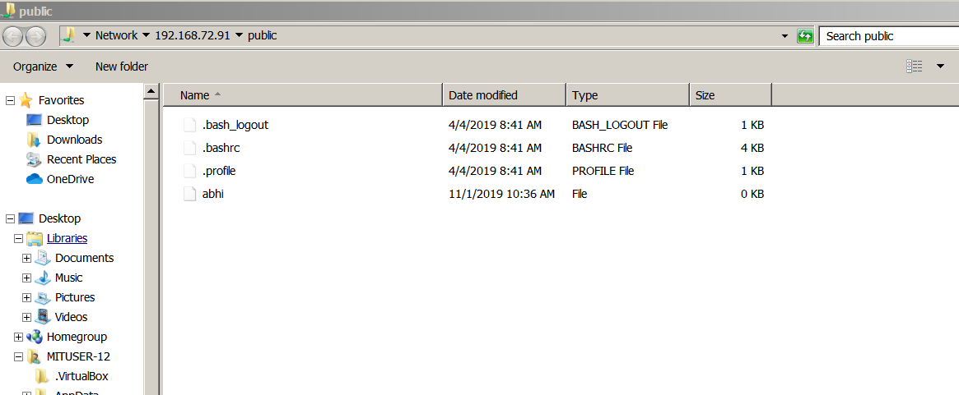

links:

<https://www.linuxbabe.com/ubuntu/install-samba-server-ubuntu-16-04>

<https://linuxize.com/post/how-to-install-and-configure-samba-on-ubuntu-18-04/>

<https://linuxize.com/post/how-to-install-and-configure-samba-on-centos-7/#creating-samba-users-and-directory-structure>