**Create a Web Server and save form data into MySQL database using PHP**

**first you have to install LAMP stack.**

**Once everything is setup please create a new file inside of the html folder**

**Then go ahead and edit the file and populate it with some basic html code.**

vi /var/www/html/form.html

|  |
| --- |
| <head>  <title>  Test Page  </title>  </head>  <body>  <form action="form_submit.php" class="alt" method="POST">  <div class="row uniform">  <div class="name">  <input name="name" id="" placeholder="Name" type="text">  </div>  <div class="email">  <input name="email" placeholder="Email" type="email">  </div>  <div class="message">  <textarea name="message" placeholder="Message" rows="4"></textarea>  </div>  </div>  <br/>  <input class="alt" value="Submit" name="submit" type="submit">  </form>  </body> |

**Database**

**Now let's setup the database to so that we can store the information. I will only cover creating database and table in Linux. First login**

mysql -u root -p

mysql> create database dev_to;

use dev_to;

create table test(

id int NOT NULL AUTO_INCREMENT,

name varchar(255),

email varchar(255),

message text,

PRIMARY KEY (id)

);

**and also you need to add user for database**

mysql> grant all privileges on dev_to.* to 'abhi'@'localhost' identified by 'temp123';

mysql> flush privileges;

**Let's make sure this works.**

**describe test;**

**output should look like:**

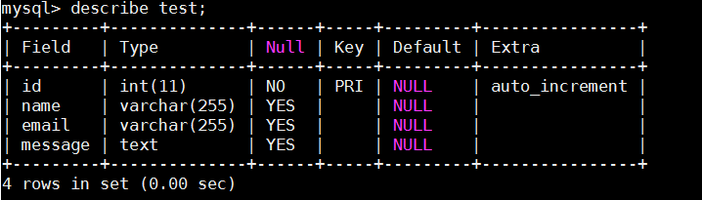

**Now we are finally ready for the PHP code that will actually handle the data and save it into the database.**

**Start by creating a new file named form_submit.php.**

**Now let's populate it with some code.**

vi /var/www/html/form_submit.php

|  |
| --- |
| <?php  $host = "localhost";  $db_name = "dev_to";  $username = "abhi";  $password = "temp123";  $connection = null;  try{  $connection = new PDO("mysql:host=" . $host . ";dbname=" . $db_name, $username, $password);  $connection->exec("set names utf8");  }catch(PDOException $exception){  echo "Connection error: " . $exception->getMessage();  }  function saveData($name, $email, $message){  global $connection;  $query = "INSERT INTO test(name, email, message) VALUES( :name, :email, :message)";  $callToDb = $connection->prepare( $query );  $name=htmlspecialchars(strip_tags($name));  $email=htmlspecialchars(strip_tags($email));  $message=htmlspecialchars(strip_tags($message));  $callToDb->bindParam(":name",$name);  $callToDb->bindParam(":email",$email);  $callToDb->bindParam(":message",$message);  if($callToDb->execute()){  return '<h3 style="text-align:center;">We will get back to you very shortly!</h3>';  }  }  if( isset($_POST['submit'])){  $name = htmlentities($_POST['name']);  $email = htmlentities($_POST['email']);  $message = htmlentities($_POST['message']);  //then you can use them in a PHP function.  $result = saveData($name, $email, $message);  echo $result;  }  else{  echo '<h3 style="text-align:center;">A very detailed error message ( ͡° ͜ʖ ͡°)</h3>';  }  ?> |

systemctl restart apache2

**Now your website should be able to handle forms and save it onto the local database.**

Here's a sample output from my test run:

