**screen command**

**Screen or GNU Screen is a terminal multiplexer. In other words, it means that you can start a screen session and then open any number of windows (virtual terminals) inside that session. Processes running in Screen will continue to run when their window is not visible even if you get disconnected.**

**To start a screen session, simply type screen in your console:**

screen

**When you enter the screen, you can do all your work as you are in the normal CLI environment.**

**Detach the screen**

**you can press “Ctrl-A” and “d“. You will not see anything when you press those buttons. The output will be like this:**

[detached from 13734.pts-0.server1]

**Re-attach the screen**

screen -r

**OR**

screen -x

**When you have more than 1 screen session, you need to type the screen session ID. Use screen -ls to see how many screen are available.**

screen -ls

*There are screens on:*

*13734.pts-0.server1 (12/06/19 06:22:29) (Detached)*

*13703.pts-0.server1 (12/06/19 06:10:16) (Detached)*

*13687.pts-0.server1 (12/06/19 06:09:32) (Detached)*

*3 Sockets in /run/screen/S-root.*

**If you want to restore screen 13734.pts-0.redis, then type this command.**

screen -r 13734

**Terminating screen**

**if you are in screen then you have to press “Ctrl-d”**

**after that it will show:**

*[screen is terminating]*

**onther way is.**

screen -ls

screen -XS [session # you want to quit] quit

screen -XS 13687 quit

**tar command**

**The Linux ‘tar’ stands for tape archive, is used to create Archive and extract the Archive files. tar command in Linux is one of the important command which provides archiving functionality in Linux. We can use Linux tar command to create compressed or uncompressed Archive files and also maintain and modify them.**

**for creates a tar file called file.tar.gz**

tar cvf file.tar.gz file

ex:

tar cvf testdir.tar.gz testdir

**for extracts files from tar archived file.tar.gz files.**

tar xvf file.tar.gz

**for list the contents of tar archive file**

tar tvf file.tar.gz

**Tar Usage and Options**

***c – create a archive file.***

***x – extract a archive file.***

***v – show the progress of archive file.***

***f – filename of archive file.***

***t – viewing content of archive file.***

***j – filter archive through bzip2.***

***z – filter archive through gzip.***

***r – append or update files or directories to existing archive file.***

***W – Verify a archive file.***

***wildcards – Specify patterns in unix tar command.***

**gzip command**

**compress file**

gzip mydoc.txt

**decompress a file**

gzip -d mydoc.txt.gz

**or**

gunzip mydoc.tex.gz

gunzip mydoc.tex.gz

**differece between tar and gzip**

**tar puts multiple files into a single (tar) file.**

**gzip compresses one file (only).**

**So to get a compressed archive, you combine the two, first use tar to get all files into a single file (archive.tar), then gzip it (archive.tar.gz). If you only have one file you need to compress (notes.txt), there's no need for tar, so you just do gzip notes.txt which will result in notes.txt.gz.**

**Ex:**

tar cvf files.tar file1 file2 file3

**Top Command**

**top command is used to show the Linux processes. It provides a dynamic real-time view of the running system. Usually, this command shows the summary information of the system and the list of processes or threads which are currently managed by the Linux Kernel.**

**Display of Top Command**

**it will show information like tasks, memory, cpu and swap. Press ‘q‘ to quit window.**

top

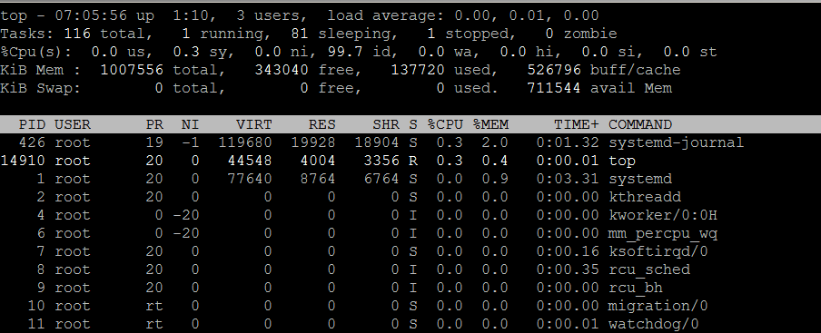

**PID:** It is the task’s unique process id.

**USER:** It is the effective user name of the task’s owner.

**PR:** It is the priority of the task.

**NI:** The nice value of the task. A negative nice value means higher priority, whereas a positive nice value means lower priority. Zero in this field simply means priority will not be adjusted in determining a task’s dispatchability.

**VIRT:** It is the total amount of virtual memory used by the task.

**RES:** It is the Resident size, the non-swapped physical memory a task has used.

**SHR:** It means the Shared Mem size (kb), the amount of shared memory used by a task.

**%CPU:** It shows the CPU usage. The task’s share of the elapsed CPU time since the last screen update, expressed as a percentage of total CPU time.

**%MEM:** It shows the Memory usage, a task’s currently used share of available physical memory.

**TIME+:** CPU Time, the same as ‘TIME’, but reflecting more granularity through hundredths of a second.

**COMMAND:** Display the command line used to start a task or the name of the associated program.

**Display Specific User Process**

top -u abhi

**Highlight Running Process in Top: Press ‘z‘ option in running top command will display running process in color**

**Kill running process: You can kill a process after finding PID of process by pressing ‘k‘ option in running top command without exiting from top window**

**Sort by CPU Utilisation: Press (Shift+P) to sort processes as per CPU utilization.**