**Download the certificate from:** [**https://esweb.marriott.com/**](https://esweb.marriott.com/)

Note: You should have submitted request to renew / to get new certificate from RequestCenter and you should have RNAC’s with you

Steps on how to open wallet can be found in the attached mail: 

1. In the Home Page select “[**Create a SSL Certificate from PKCS#10 Request (Unmanaged)**](https://esweb.marriott.com/cda-cgi/clientcgi.exe?action=serverCert)**”**

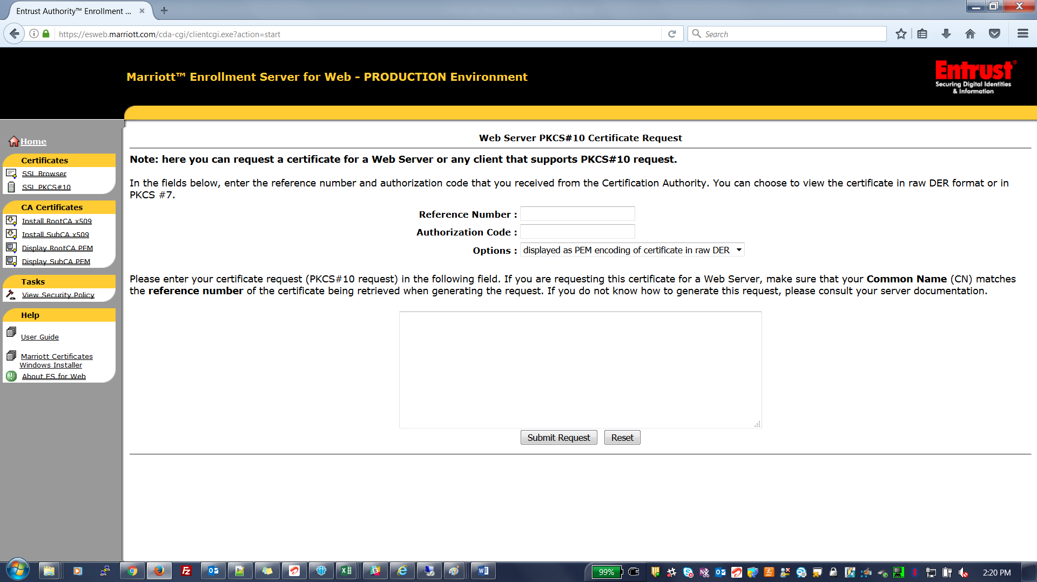

1. Enter reference number and authorization code which you received from RequestCenter and enter the CSR generated from the wallet.

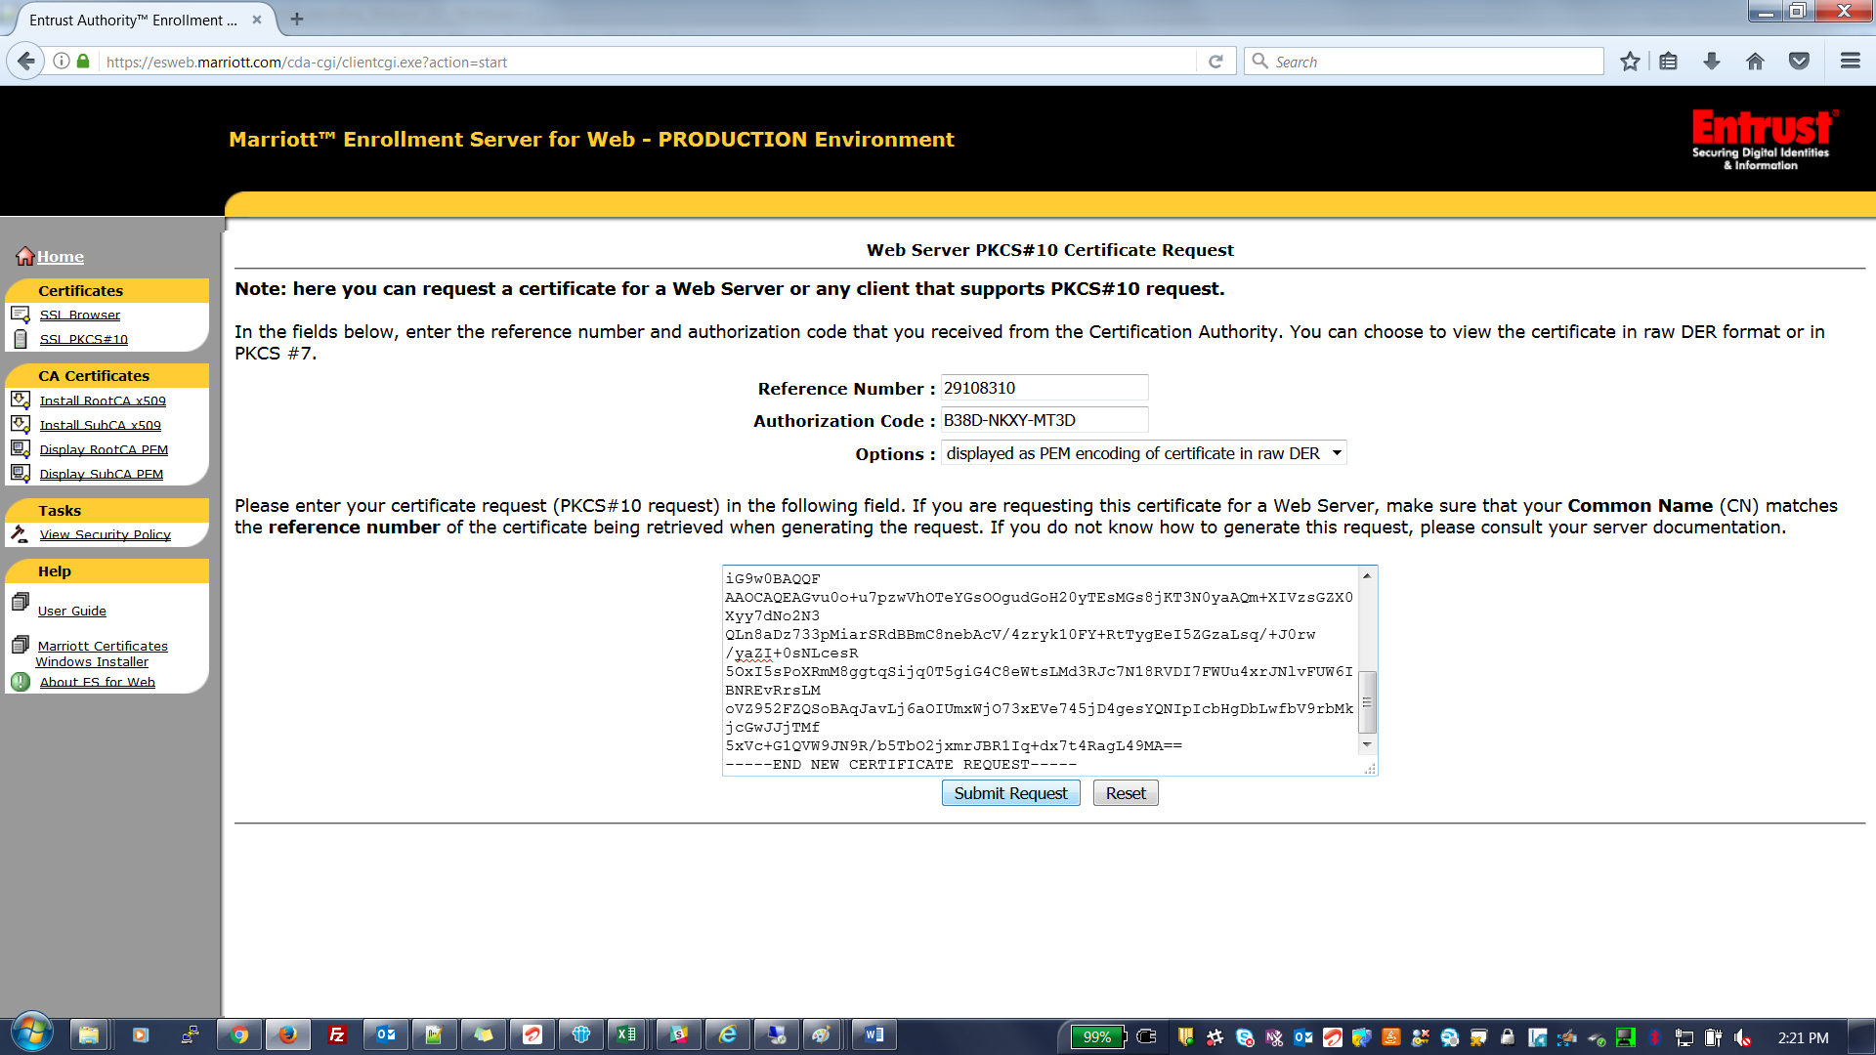

1. Upon submitting request, you will get this page. Here click on download to get the certificate

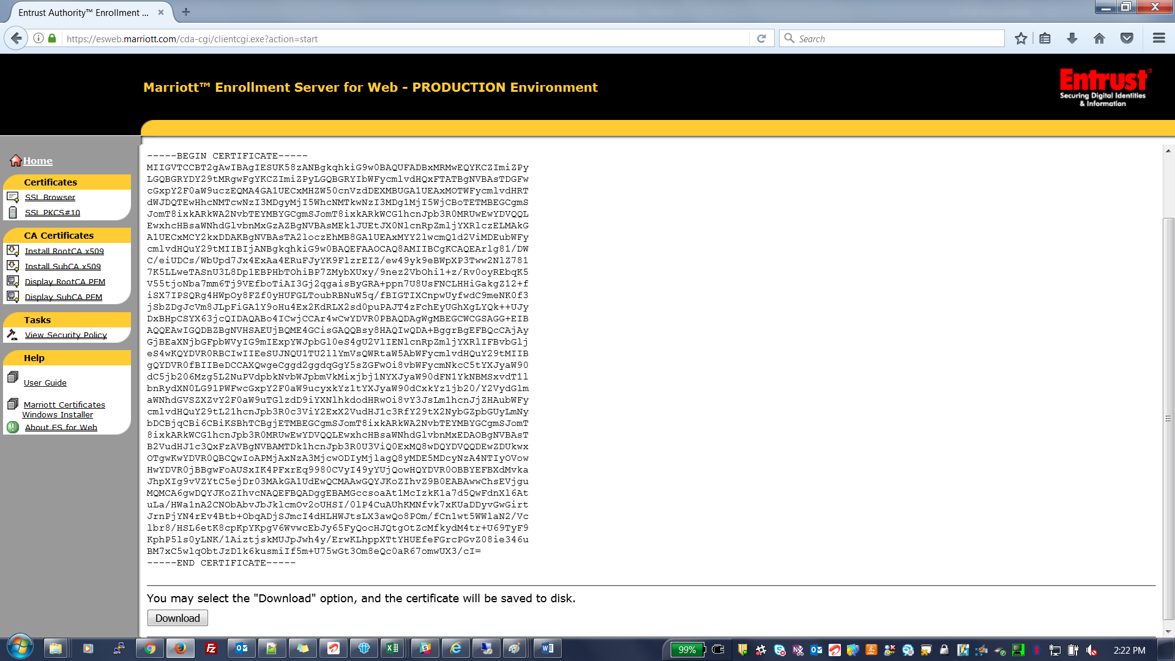

1. Repeat the above steps to download certificate with different RNAC’s and for different server

**Generate CSR from wallet**

1. Open wallet by invoking Oracle Wallet Manager utility
2. Select Add Certificate Request

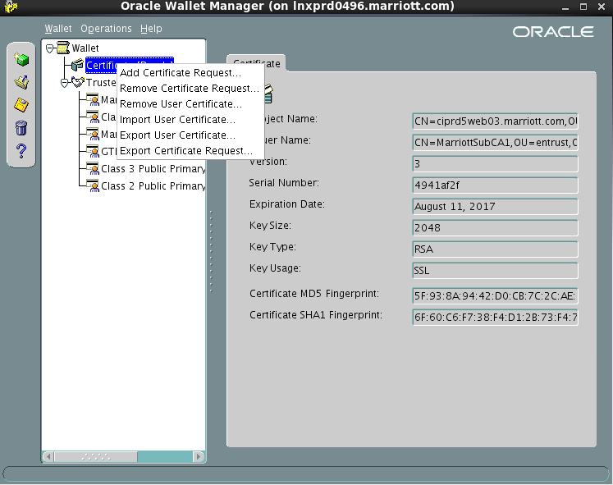

1. Click on Advance

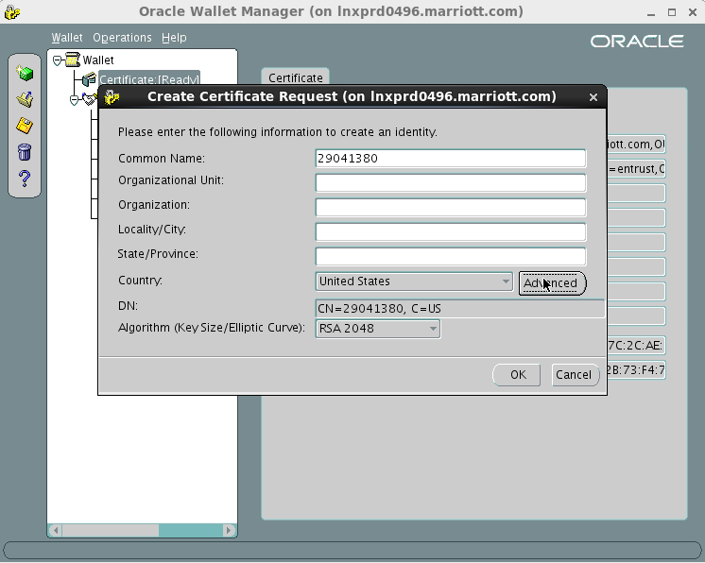

1. Enter the reference number received from RequestCenter

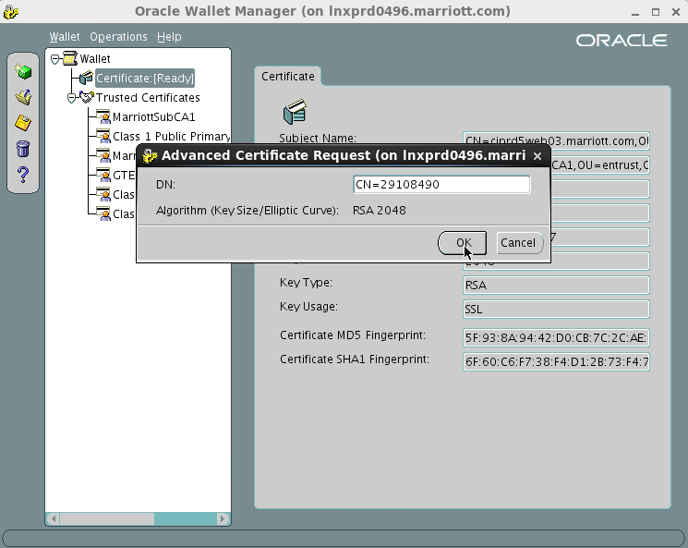

1. Click ok to create a request

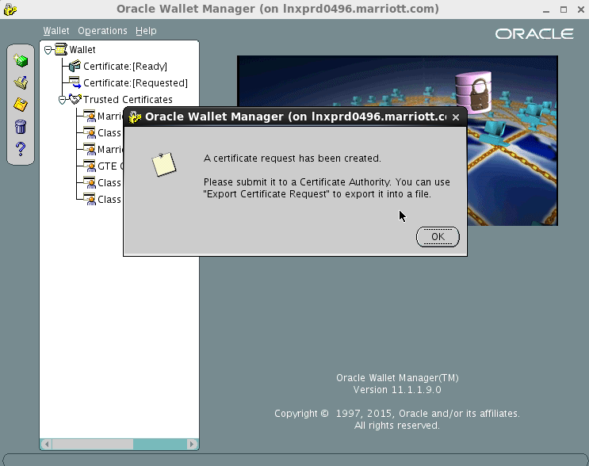

1. Once request is created, wallet looks like this and Select Export Certificate Request and save it in your local to use it to download the certificate from SSL Browser

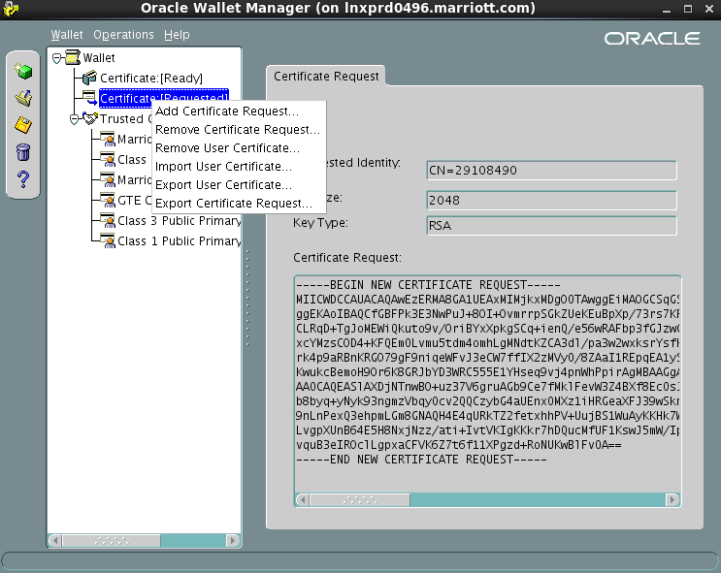

**Importing the certificate:**

1. Open the wallet using Oracle Wallet Manager
2. Select Import User Certificate



1. Provide the PATH of the certificate located in the server.
2. Check the status changed from Certificate [Requested] 🡪 Certificate [Ready]