**Certificate Renewal process (CI Training Prod Environments)**

|  |
| --- |
|  |

**PKI Certificate Request**

**Marriott and IBM Confidential**

|  |  |  |  |  |
| --- | --- | --- | --- | --- |
|  | **Document Id** | |  | |
|  | | **Version** | | **0.1** | |
|  | | **Owner** | | **IBM Siebel Admin Team**  **Pankaj Mishra** | |

**Revision History**

|  |  |  |  |  |
| --- | --- | --- | --- | --- |
| **V. No.** | **Issue Date** | **Modified By** | **Description of Changes** | **Location/Para/Page/Sec. No.** |
| 0.1 |  | PANKAJ MISHRA | Initial Draft |  |

Contents

Email notification for certificate renewal 3

Raising request for new certificates 3

Pre-Requisites 6

Invoking the Oracle Wallet Manager: 6

Opening a Wallet: 9

Add a certificate request 11

Downloading the certificate 14

Importing the certificate 14

Removal of old certificate 16

Recycling the web server 17

Verification 17

Additional Details 18

# *Email notification for certificate renewal*

Below is the notification we start receiving once the expiry due date for the existing certificates are- round the corner:



# *Raising request for new certificates*

*Access request center:*

<https://extranet.marriott.com/sdm/RequestCenter/myservices/navigate.do?query=orderform&sid=302&>

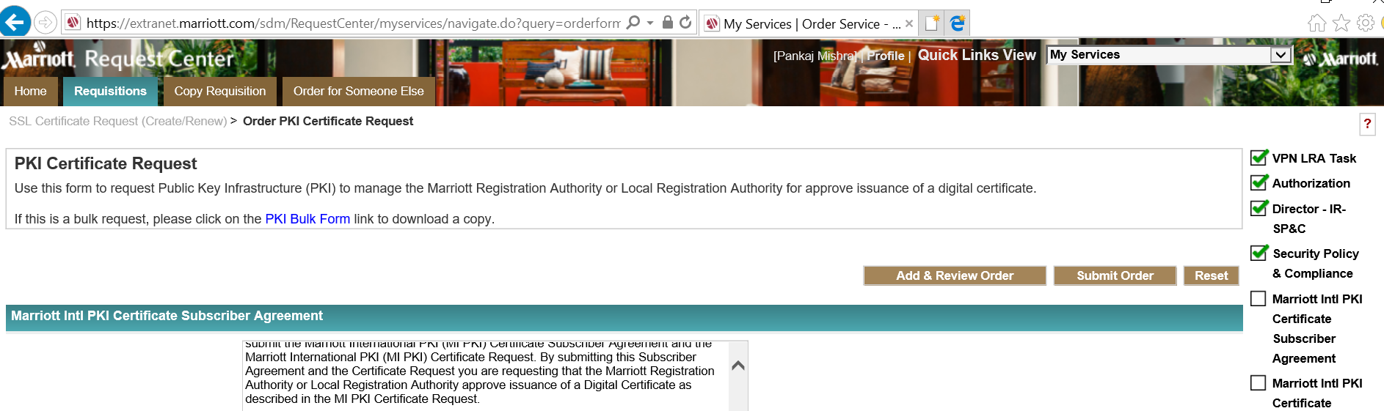

Scroll below and click accept

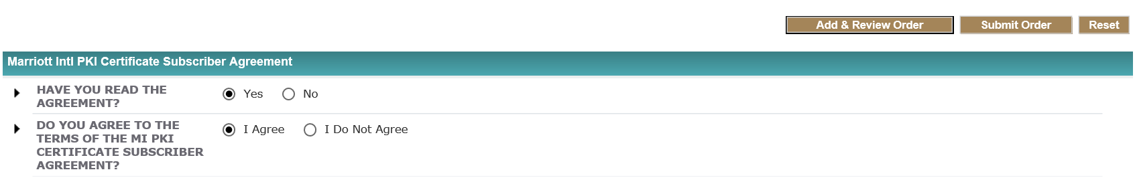

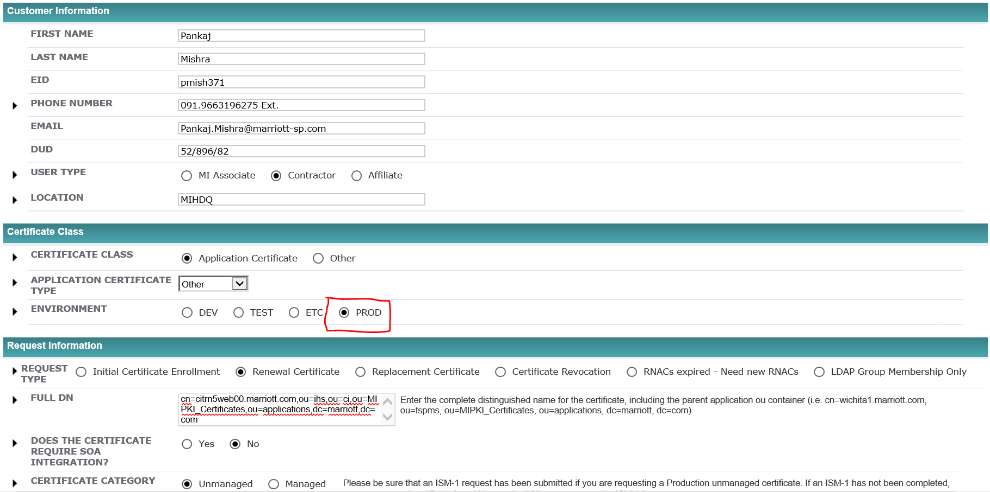

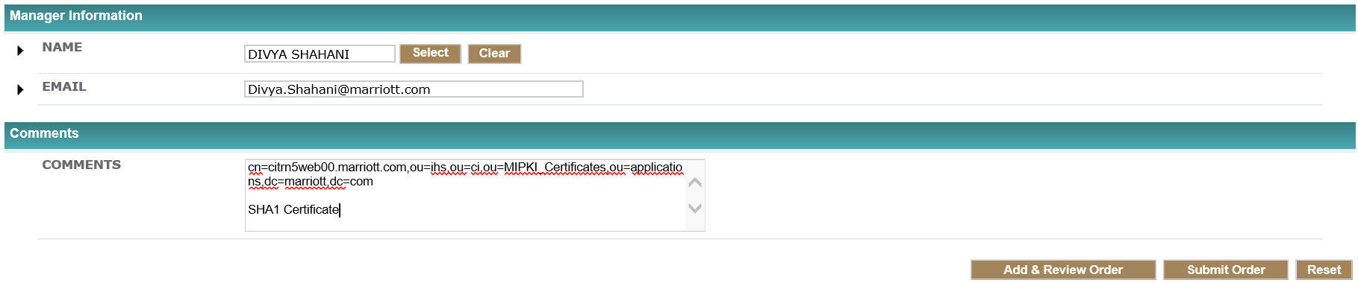

Click on ‘Submit Order’

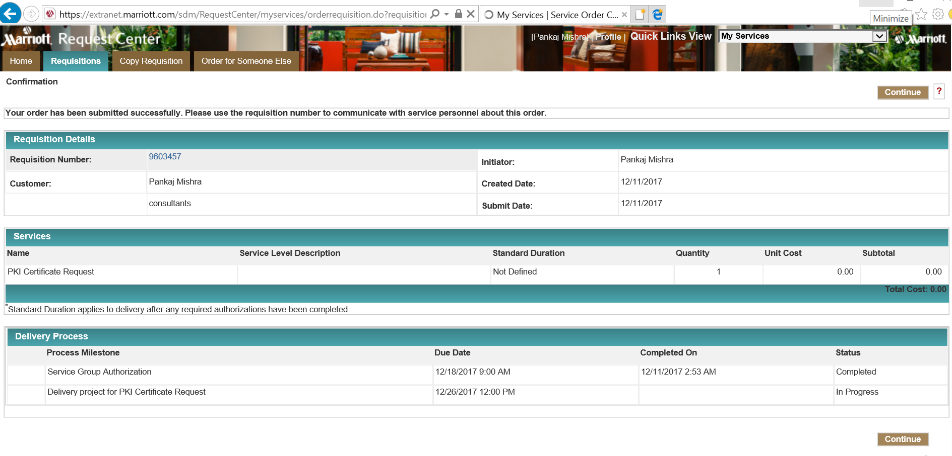

Click ‘Continue’

*Once the request is approved and completed you would get an email like below:*

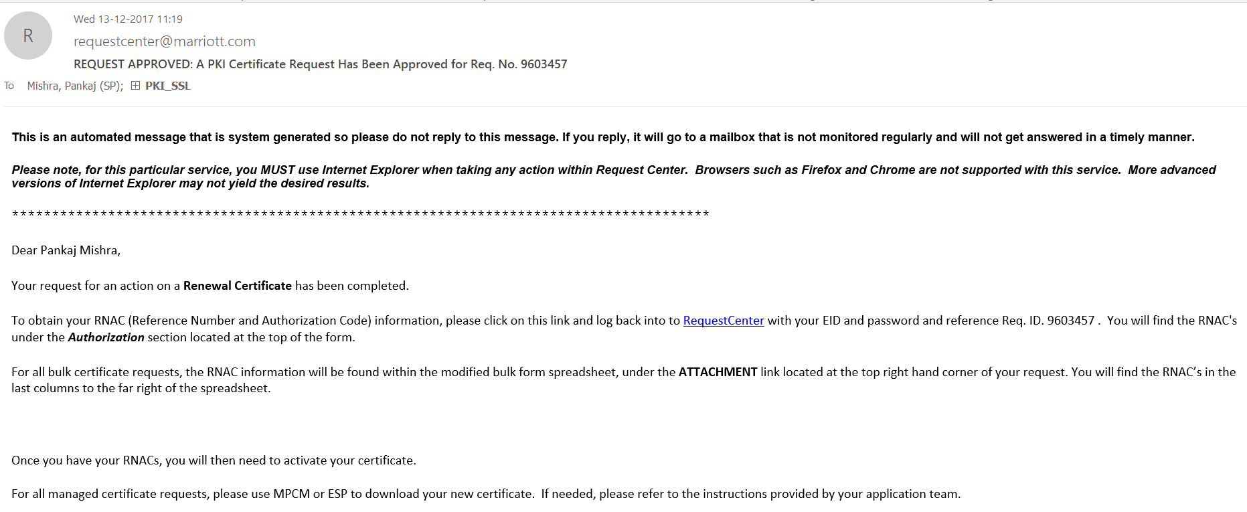

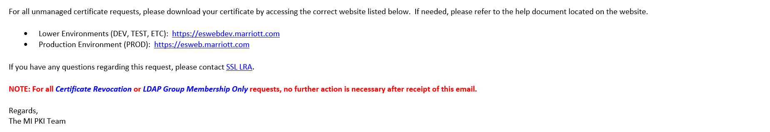

Click on the ‘RequestCenter’ link in the email which takes you to the page from where you get the Reference number and the Authorization code.

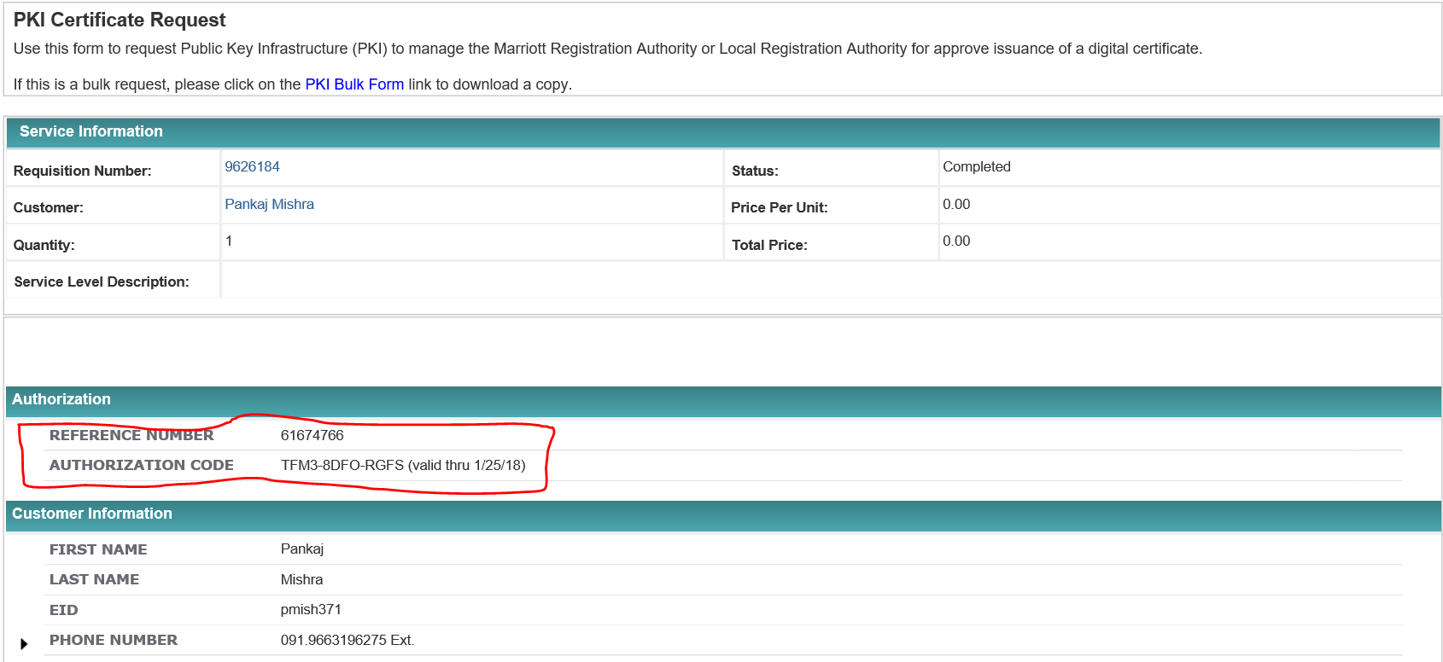

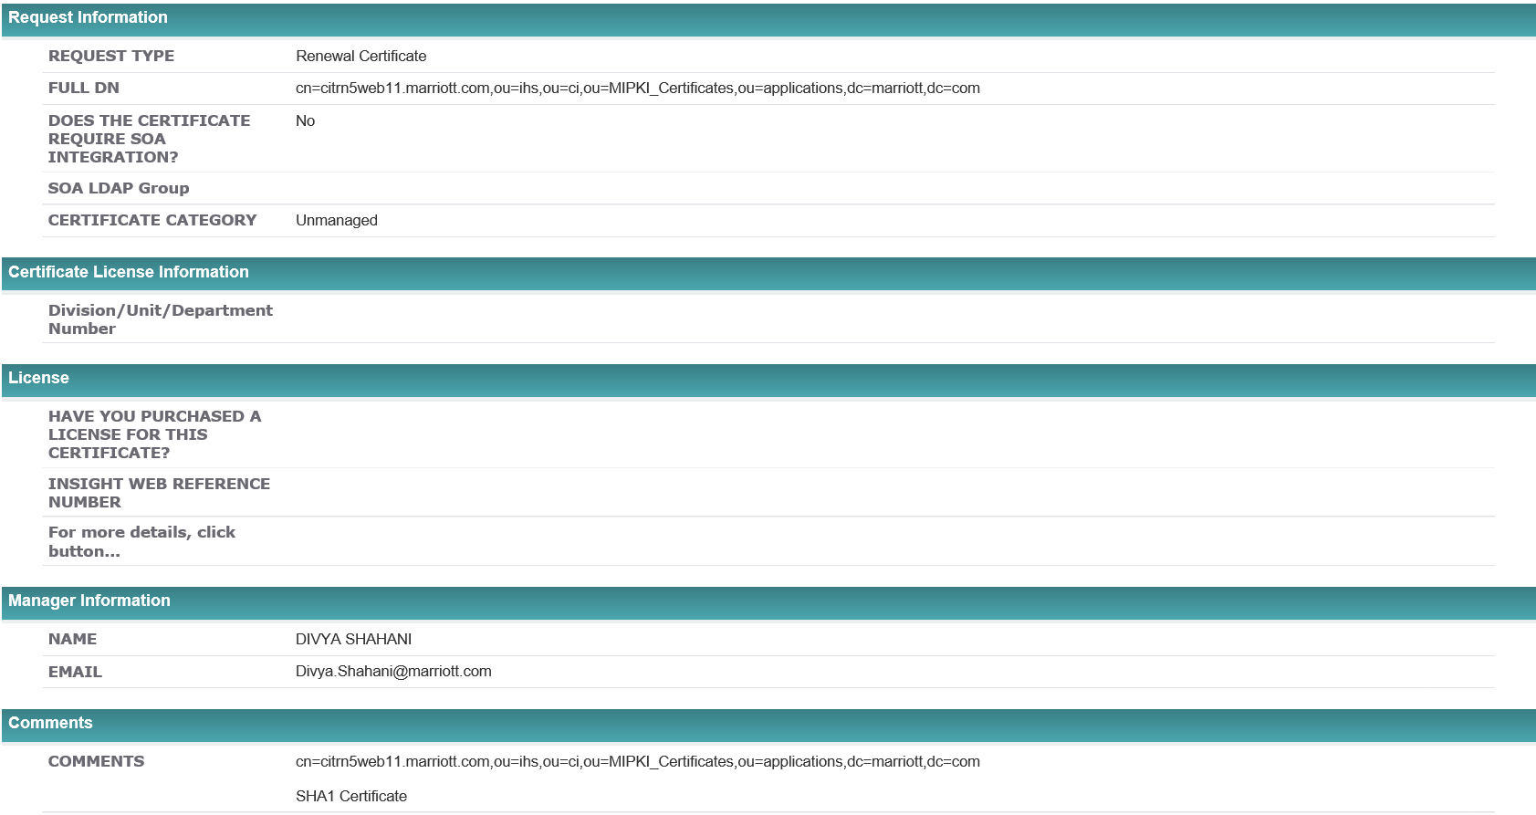

# *Pre-Requisites*

*To do this you would need the below:*

1. **RNAC** which you would receive on the request which you raised on Request Center post approval.
2. **CSR** 🡪 To generate the CSR you need to access the wallet manager the process for which is as below:

Login to [HDQNCVMCISDSD1-RDP](https://bpa2.marriott.com/Portal/Main) , then mstsc to [HDQNCVMCISDSD2-RDP](https://bpa2.marriott.com/Portal/Main)

# *Invoking the Oracle Wallet Manager:*

Open a putty session (in our case for this certificate – lnxprd0525, lnxprd0526) and load the session

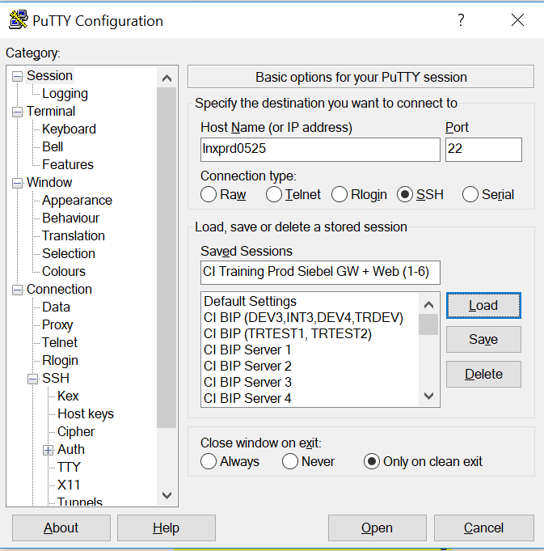

Click on ‘SSH’ and then ‘X11’ and Check the box ‘Enable X11 forwarding’

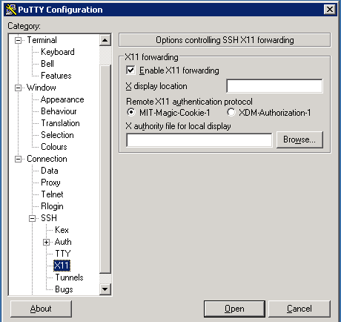

Click on session again



Click ‘Save’

Login as sadminxx user

Switch to sblwebr3 user

cd /home/sblweb

rename the exisiting .Xauthority file

mv .Xauthority .Xauthority_BKP_03Jan2018

Login as root [sudo su -]

rename the exisiting .Xauthority file

mv .Xauthority .Xauthority_BKP_03Jan2018

exit from the session

login back to session as sblweb

switch to root user

sudo su -

cd /root

sudo cp /home/sblweb/.Xauthority .

Start task manager on DSD2 box

kill the processs for Xming under processes tab

Click on the 'Xming' utility on Desktop 

cd /cir5/citrtst2o/Oracle_OHS/bin

./owm

Running this opens the ‘Wallet Manager’ as shown below:

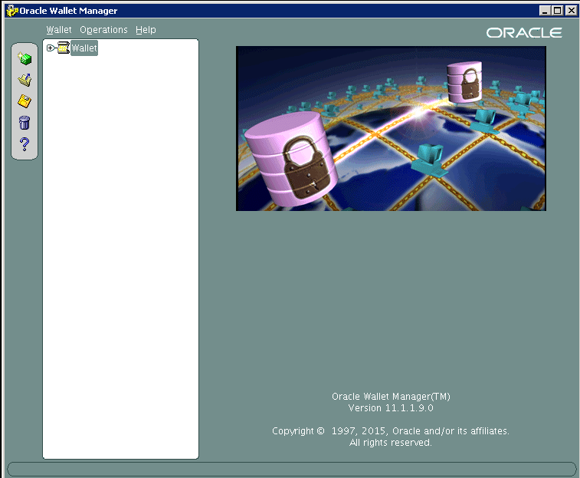

# *Opening a Wallet:*

Click on ‘Open Wallet’ -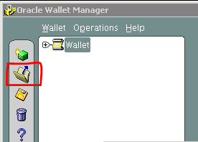

Click on Yes to continue:

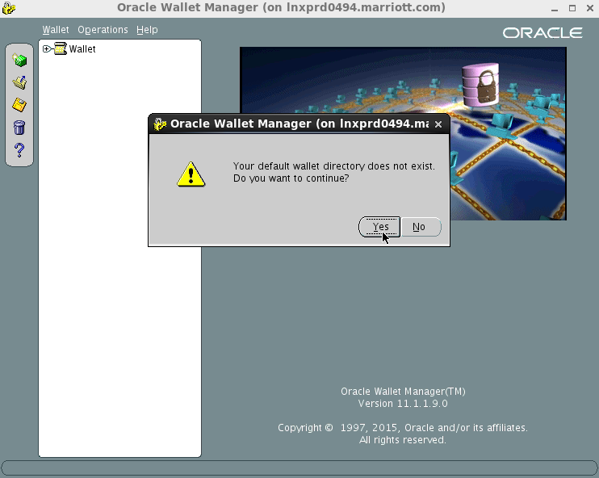

Select the key store location:

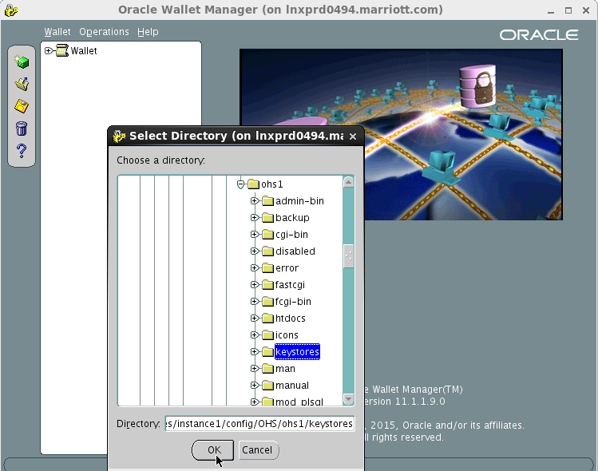

And navigate to the below mentioned location:

/ci/websrvr/citrn11/Oracle_OHS/instances/instance1/config/OHS/ohs1/keystores *(will vary with environment)*

Click Ok where it prompts you for the ‘Wallet password’

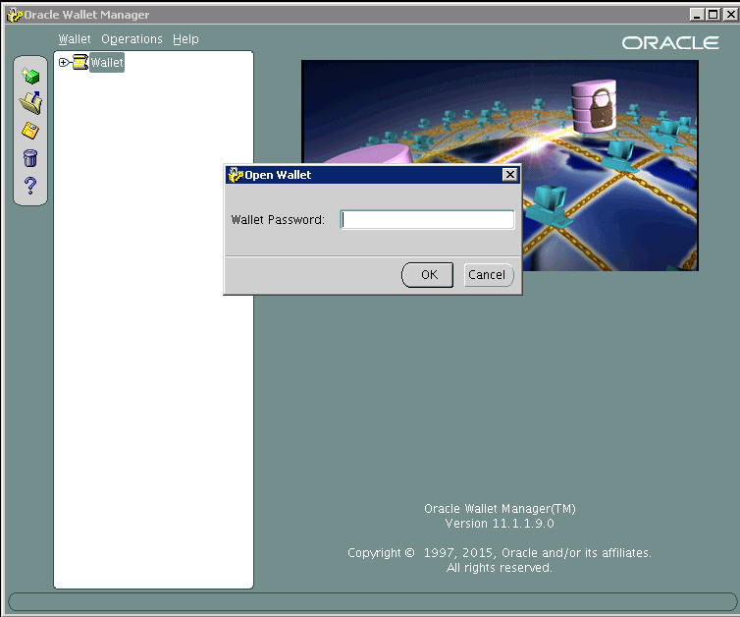

# *Add a certificate request*

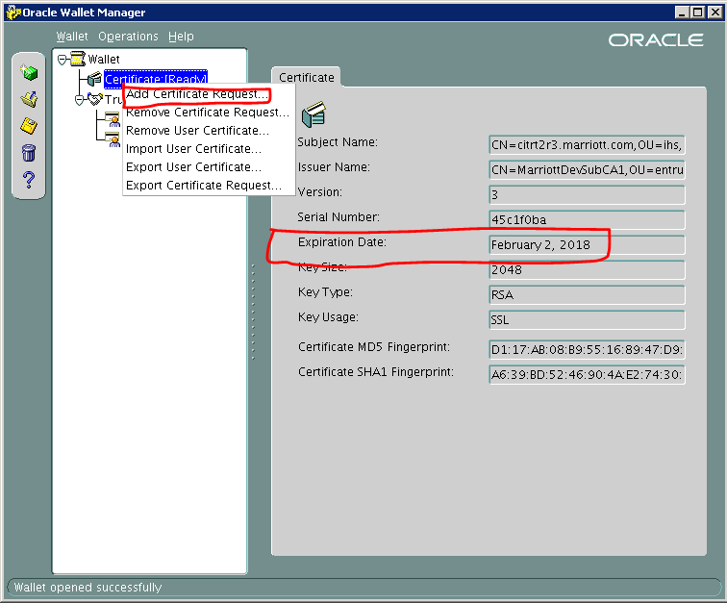

**Enter the ‘Reference number’ which you get from Request Center as shown below and also make sure you select the correct algorithm as shown below:**

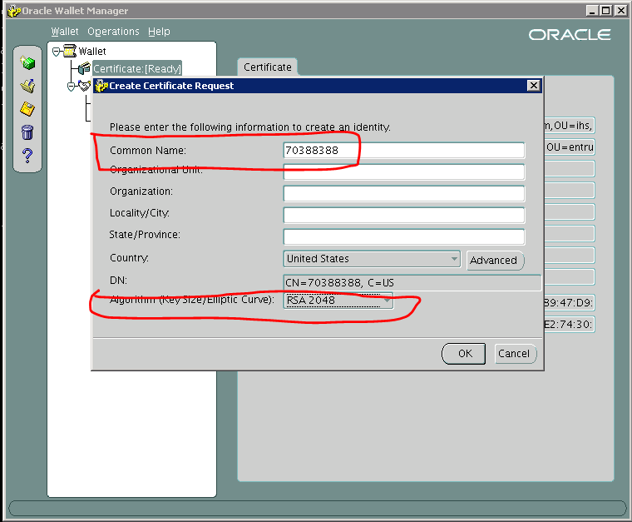

Click ‘OK’ which gets you the below screen. Click OK again

Now right click on Wallet > Certificate (Requested) and click ‘Export Certificate Request’ and enter the path on the server where you want to save the request as show below:

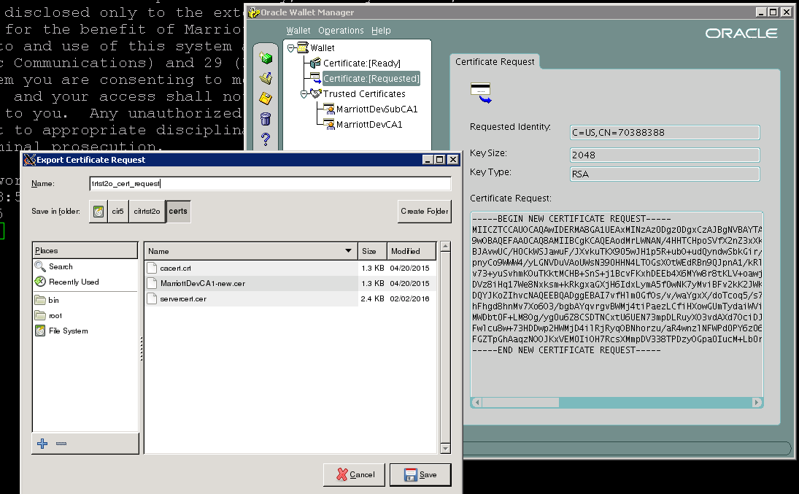

Click ‘Save’

Login to server box as root and copy the content of the files which you saved in the step above

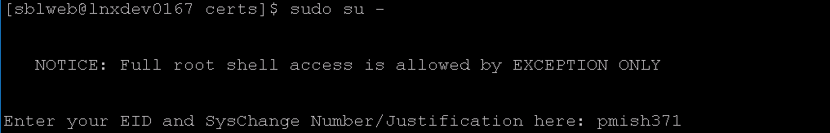

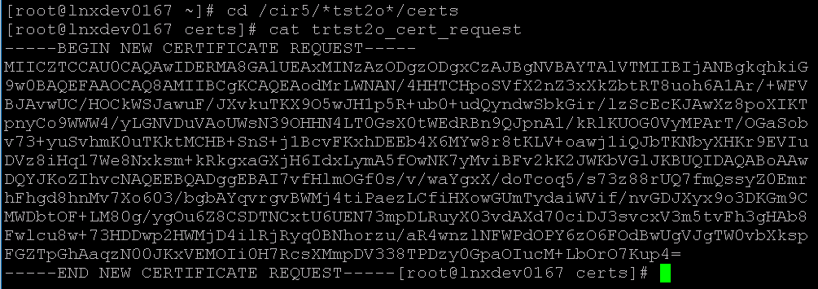

# *Downloading the certificate*

Now login to the website:  <https://esweb.marriott.com>

Enter the Reference Number, Authorization Code and the content of certificate request as copied from the step above, show below:

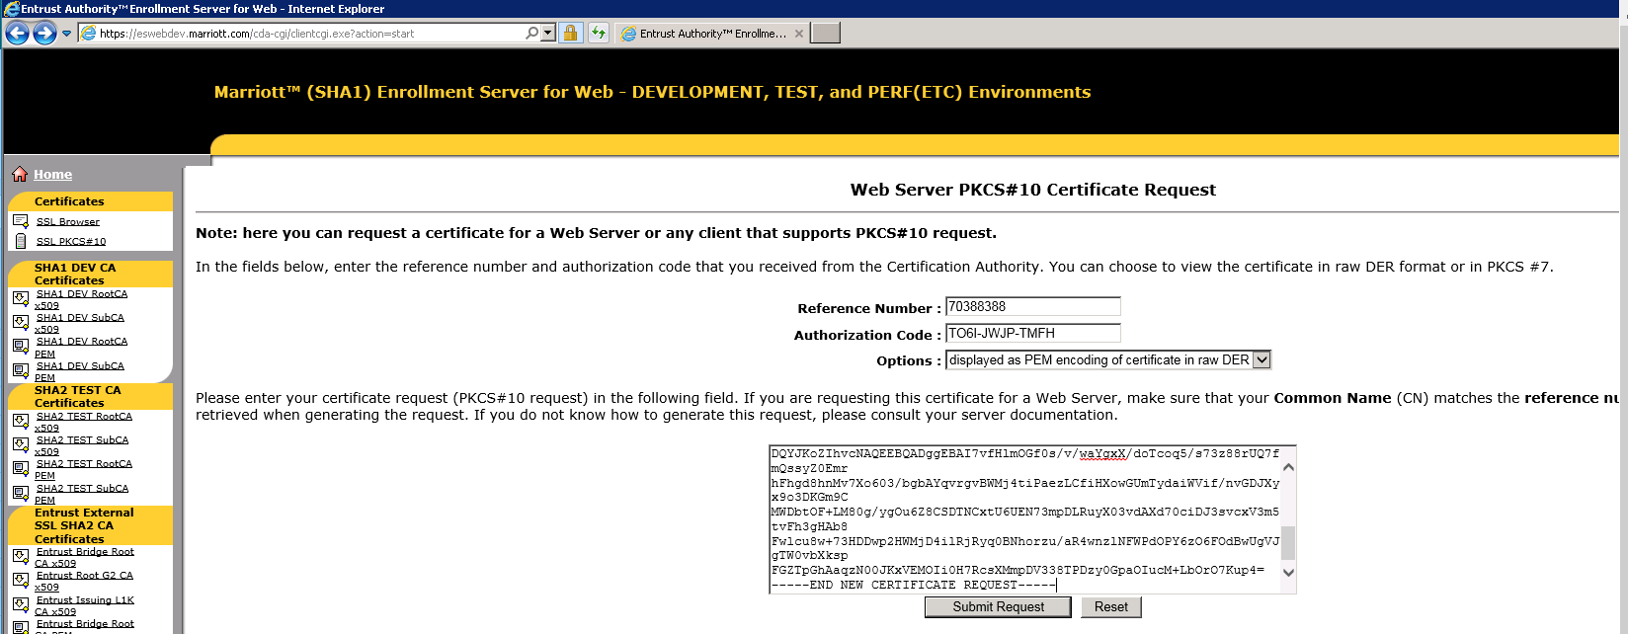

Click on ‘Submit Request’ and then click on Download

Certificate saved on DSD2 RDP machine

Folder name - C:\Users\svc-siebeladmin\Desktop\Certificates\<env_name>

File name - servercert_new.cer

# *Importing the certificate*

Go back to the Oracle Wallet Manager

***Wallet > Certificate:[Ready] > right click and click on ‘Import User Certificate’***

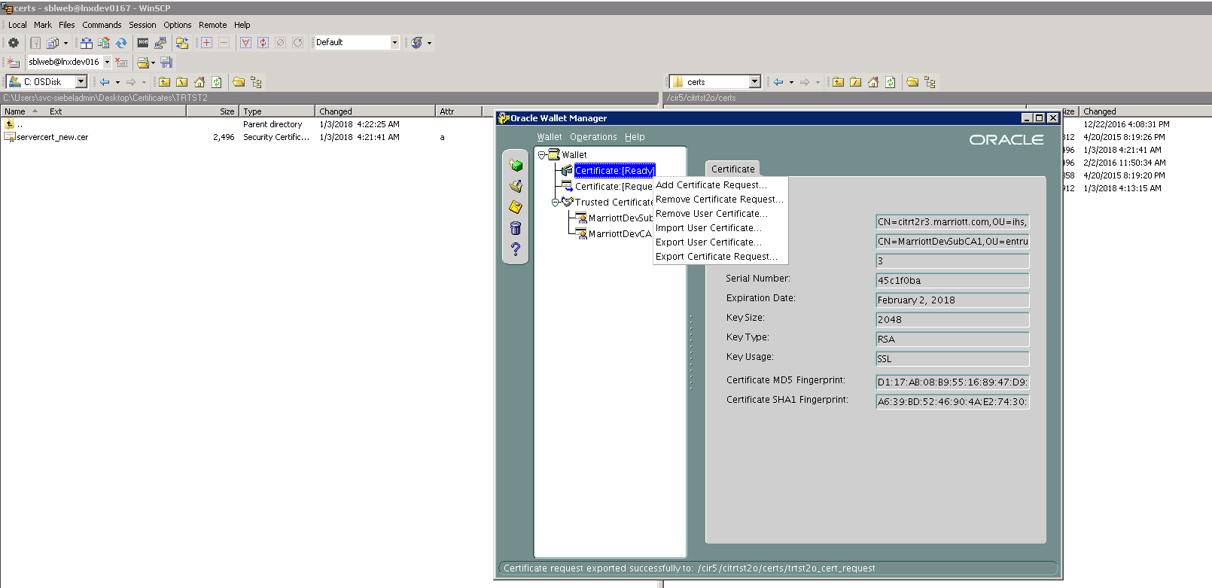

Select the default option and click OK

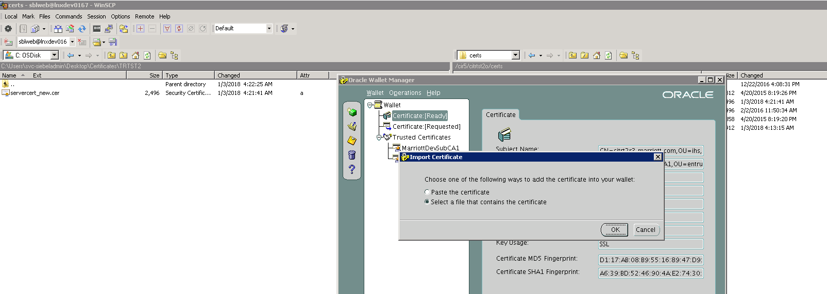

Select the certificate that was downloaded and placed on the server

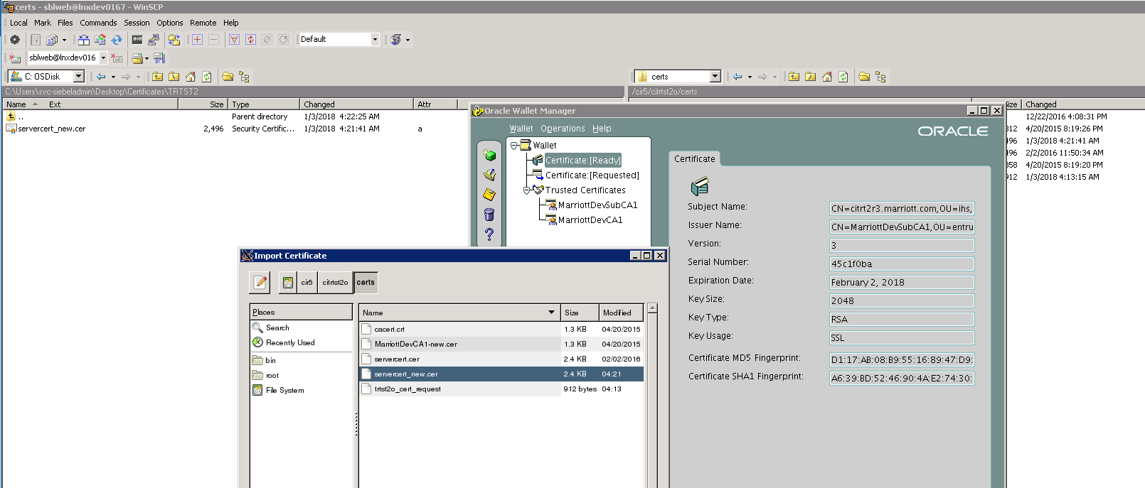

Check the newly imported certificate details as below:

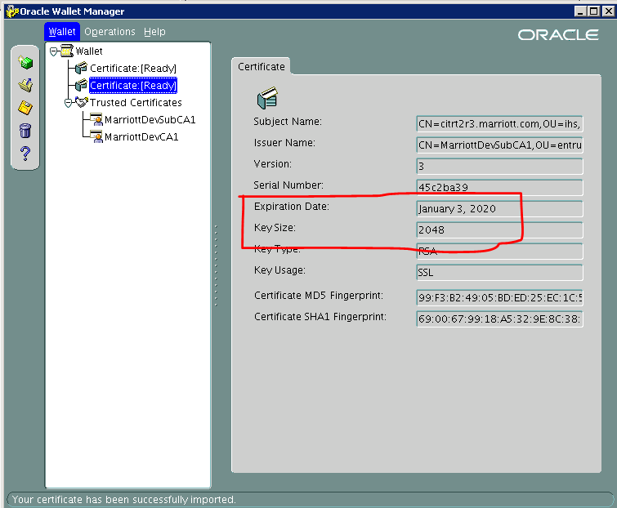

# *Removal of old certificate*

Remove the old certificate from the wallet [Certificate:[Ready] > Remove User Certificate

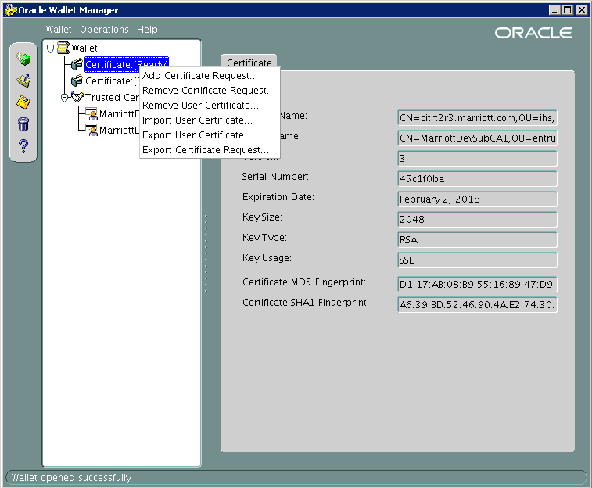

Close the wallet, while closing it will prompt you to save the wallet, click ‘Yes’

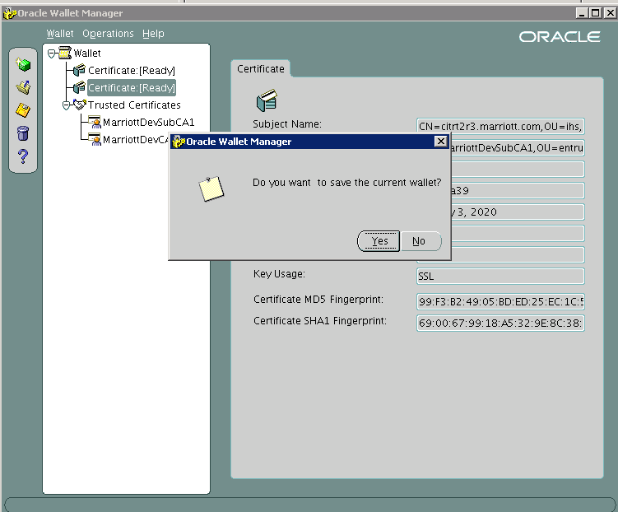

# *Recycling the web server*

Recycle the web server as shown below:

Raise a CRQ to recycle the web server instance on both servers as mentioned below:

* LNXPRD0525
* LNXPRD0526

# *Verification*

Access the respective application URL and check for certificates as show below: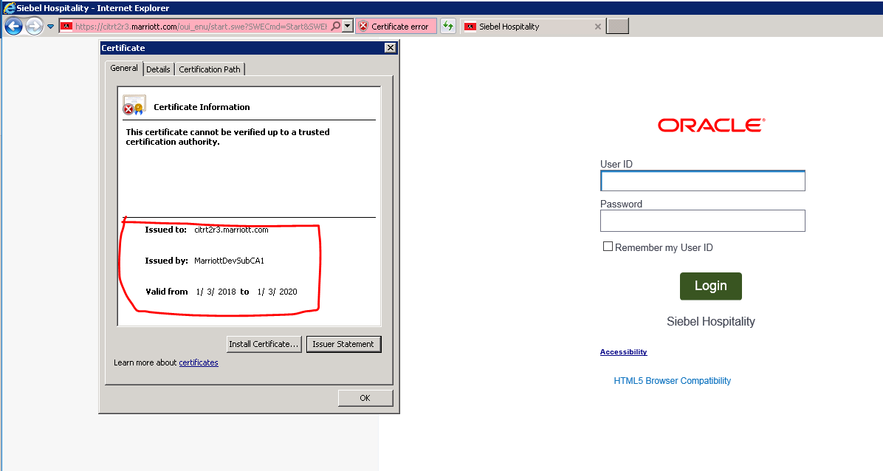

# *Additional Details*

Web server host → **LNXPRD0525**

cn=citrn5web01.marriott.com,ou=ihs,ou=ci,ou=MIPKI_Certificates,ou=applications,dc=marriott,dc=com

cn=citrn5web02.marriott.com,ou=ihs,ou=ci,ou=MIPKI_Certificates,ou=applications,dc=marriott,dc=com

cn=citrn5web03.marriott.com,ou=ihs,ou=ci,ou=MIPKI_Certificates,ou=applications,dc=marriott,dc=com

cn=citrn5web04.marriott.com,ou=ihs,ou=ci,ou=MIPKI_Certificates,ou=applications,dc=marriott,dc=com

cn=citrn5web05.marriott.com,ou=ihs,ou=ci,ou=MIPKI_Certificates,ou=applications,dc=marriott,dc=com

cn=citrn5web06.marriott.com,ou=ihs,ou=ci,ou=MIPKI_Certificates,ou=applications,dc=marriott,dc=com

Web server host → **LNXPRD0526**

cn=citrn5web00.marriott.com,ou=ihs,ou=ci,ou=MIPKI_Certificates,ou=applications,dc=marriott,dc=com

cn=citrn5web07.marriott.com,ou=ihs,ou=ci,ou=MIPKI_Certificates,ou=applications,dc=marriott,dc=com

cn=citrn5web08.marriott.com,ou=ihs,ou=ci,ou=MIPKI_Certificates,ou=applications,dc=marriott,dc=com

cn=citrn5web09.marriott.com,ou=ihs,ou=ci,ou=MIPKI_Certificates,ou=applications,dc=marriott,dc=com

cn=citrn5web10.marriott.com,ou=ihs,ou=ci,ou=MIPKI_Certificates,ou=applications,dc=marriott,dc=com

cn=citrn5web11.marriott.com,ou=ihs,ou=ci,ou=MIPKI_Certificates,ou=applications,dc=marriott,dc=com

cn=citrn5web12.marriott.com,ou=ihs,ou=ci,ou=MIPKI_Certificates,ou=applications,dc=marriott,dc=com