**The following web server certificates are deployed on each of the 3-web servers on the /cir5/websrvr instance**

*cn=ciprd5web01.marriott.com,ou=ihs,ou=ci,ou=MIPKI_Certificates,ou=applications,dc=marriott,dc=com*

*cn=ciprd5web02.marriott.com,ou=ihs,ou=ci,ou=MIPKI_Certificates,ou=applications,dc=marriott,dc=com*

*cn=ciprd5web03.marriott.com,ou=ihs,ou=ci,ou=MIPKI_Certificates,ou=applications,dc=marriott,dc=com*

Download all the certificates from the Entrust site as **Web server *.cer certificates** and import it into the wallet

**Process of doing the cert change is embedded on page 3**

**The following web server certificate is deployed on each of the 3-web server on the /cir5/websrvri instance**

*cn=ciprd5-web.marriott.com,ou=ihs,ou=ci,ou=MIPKI_Certificates,ou=applications,dc=marriott,dc=com*

Download this certificate from the Entrust site as **Web server *.cer certificates** and import it into the wallet

So /websrvr and /websrvri instance have different keystores and need to be updated every time when required

**Same process as above certificates**

**The following Web browser SSL Certificate need to be deployed on browser & on stunnel as .pem and .crt format**

*cn=lnxprd0497.marriott.com,ou=ci,ou=MIPKI_Certificates,ou=applications,dc=marriott,dc=com*

**Process of doing the cert change is embedded on page 3**

**Webserver01 [lnxprd0494]: Wallet**

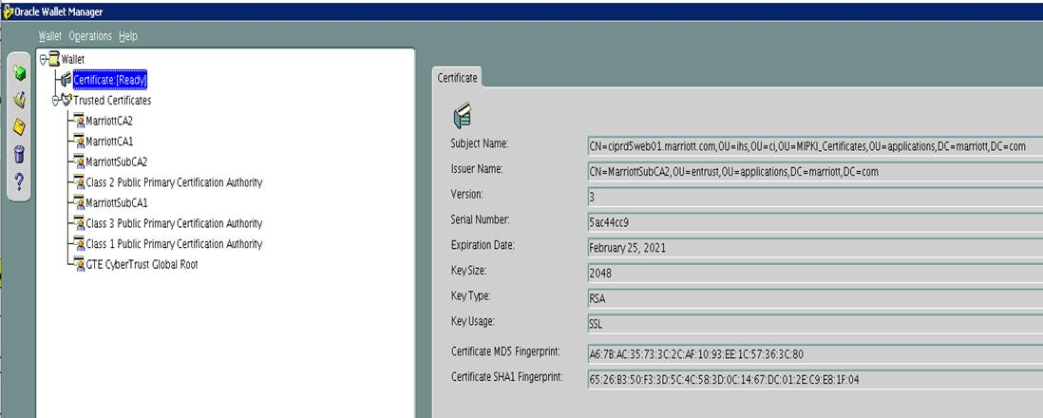

**Webserver01 running fine using SHA2 certificate** [**https://ciprd5web01.marriott.com/**](https://ciprd5web01.marriott.com/)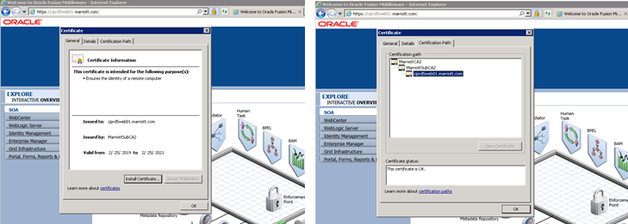



Regards,

**Pankaj Mishra**

Senior Package Solution Consultant

**Webserver02 [lnxprd0495]: Wallet**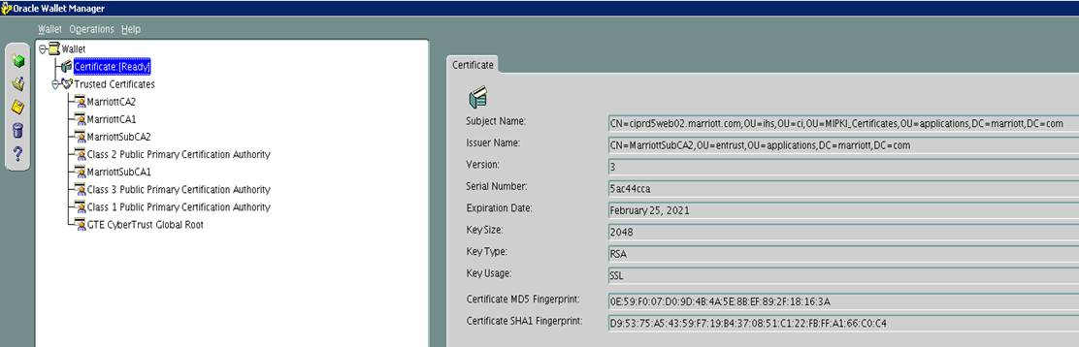

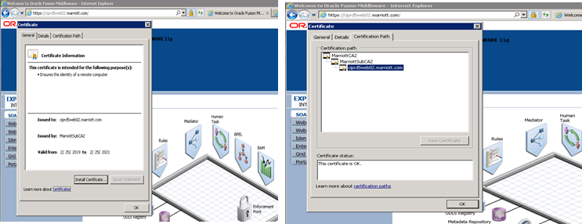**Webserver02 running fine using SHA2 certificate** [**https://ciprd5web02.marriott.com/**](https://ciprd5web02.marriott.com/)





**Webserver03 [lnxprd0496]: Wallet**

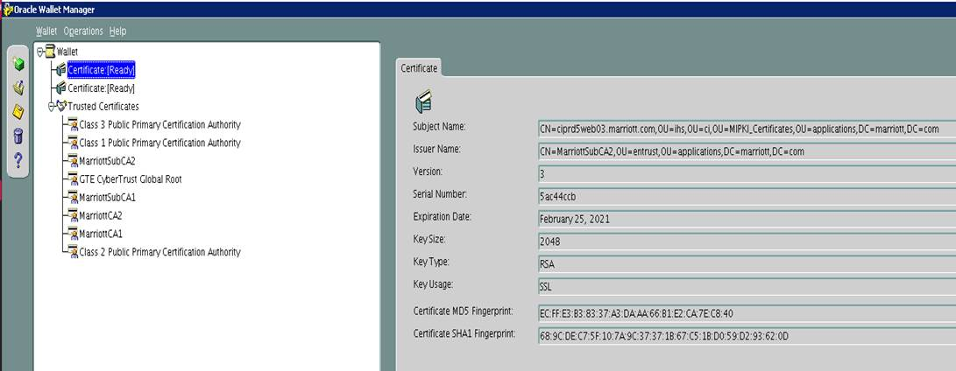

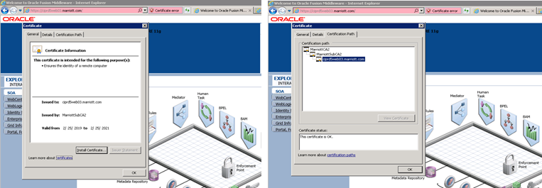**Webserver03 running fine using SHA2 certificate** [**https://ciprd5web03.marriott.com/**](https://ciprd5web03.marriott.com/)





**How to deploy web server certificate:**



**How to deploy web browser SSL certificate**

