Login to the below URL:

<https://eswebdev.marriott.com/cda-cgi/clientcgi.exe?action=start>

For SHA2 certificate click the link as shown below:

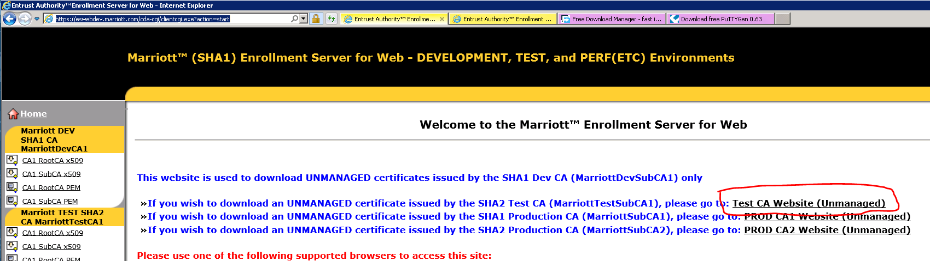

Clicking that date takes you to the below page:

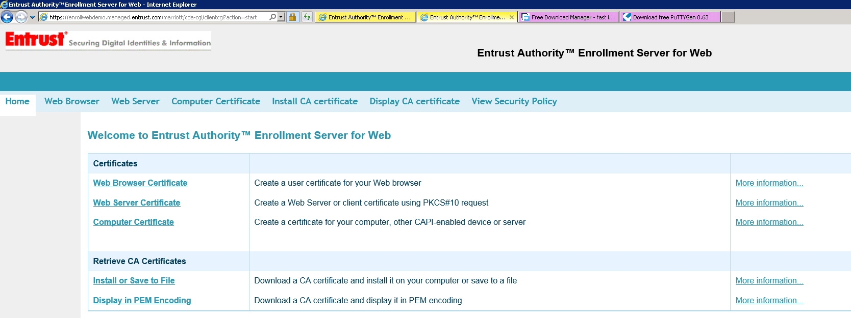

Click “Web Browser Certificate”

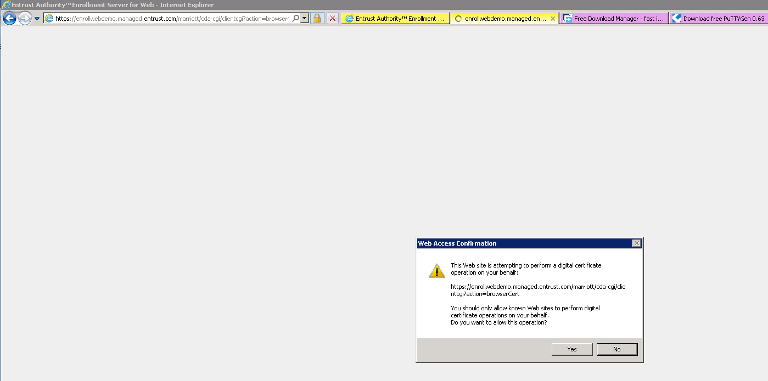

Click Yes

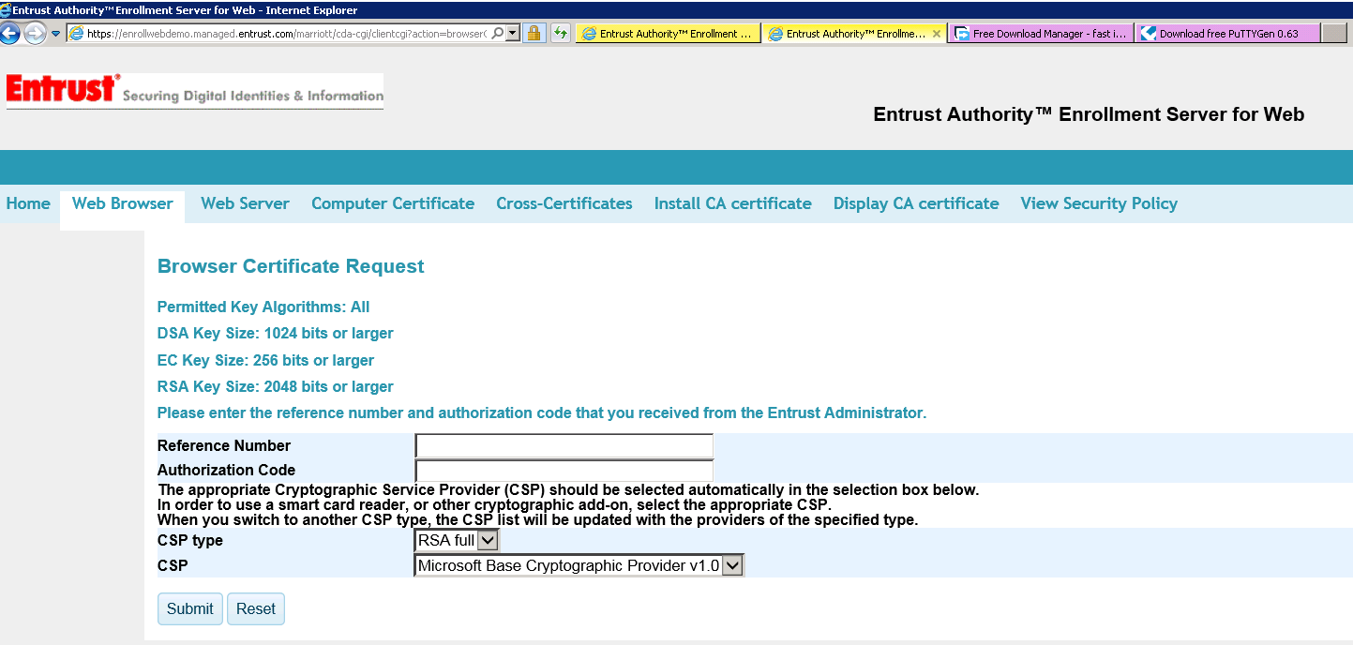

Enter “Reference Number” & “Authorization Code” from the request on request center

Chose CSP Type and CSP as defaults

Click Submit

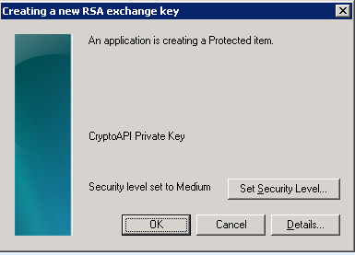

It asks you to choose a password for the file, type a password and remember it

You get a successful message on the browser that the request was successful

Open your browser in the session of your machine where you used the entrust URL

Go to Tools > Settings > Internet Options > Content Tab > Personal

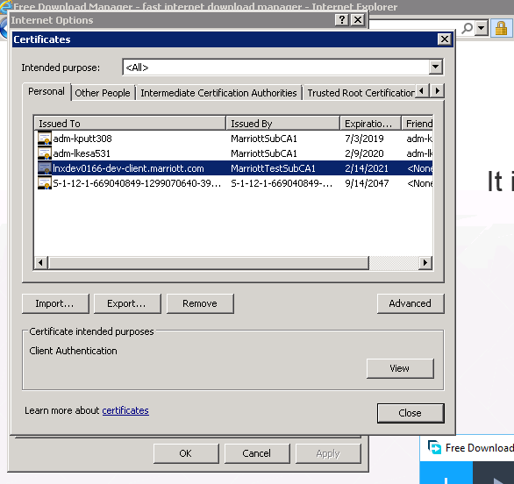

Click on “Export”

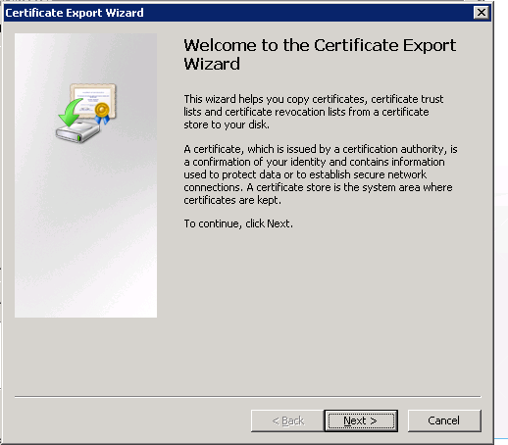

Click “Next”

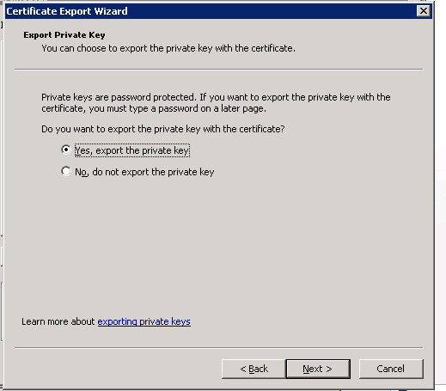

Select “Yes, export the private key” and click Next

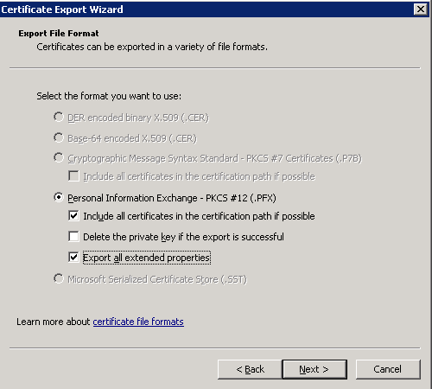

Select options as show above and click “Next”

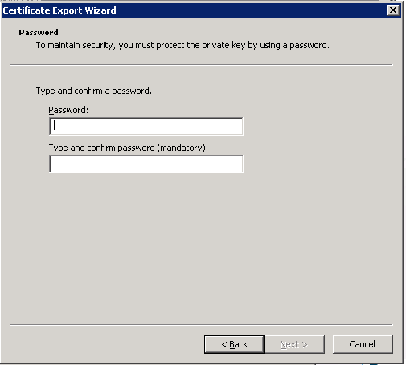

Enter the same password used while generating the certificate request and click Next

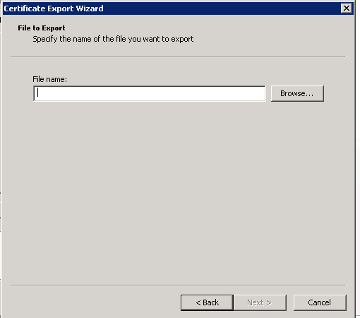

Chose a path and name the file as you what to save . The file saves as *.pfx format

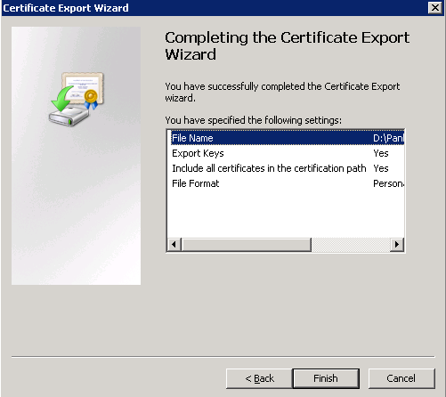

Click Finish

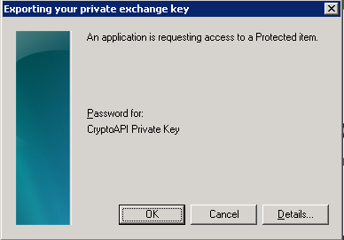

Select OK

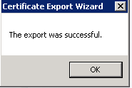

Select Ok

Now we need to convert this certificate in the .pfx format (lnxdev0166_client_cert.pfx

) to Public Cert.pem and key.pem

Run the following command to extract the private key and save it to a new file:

openssl pkcs12 -in lnxdev0166_client_cert.pfx -nocerts -out key4.pem -nodes

Now run the following command to also extract the public cert and save it to a new file:

openssl pkcs12 -in lnxdev0166_client_cert.pfx -nokeys -out DevClientMA2.pem -nodes

Now you can use the files in your Stunnel config.

NOTE:

Open the stunnel.conf file to see what all files are being referenced by stunnel

cd /cidev/stunnel

cat stunnel.conf

cert=/cidev/certs/**DevClientMA2.pem**

CAfile=/cidev/certs/**cacert1.crt**

key=/cidev/certs/**key4.pem**

[so in the commands above while converting to pem use the same naming convention so that no change needs to be done to stunnel.conf]

cacert1.crt file is the Root CA or the public cert and can be downloaded from

<https://eswebdev.marriott.com/cda-cgi/clientcgi.exe?action=start>