1. INTRODUCTION

1.1 RISC PROCESSORS

Early computers had small and simple instruction sets, forced mainly by the need to minimize the hardware used to implement them. As the processor technology began to evolve beginning with 4_bit and 8_bit processors, the trend was to have more instruction capability to the processor. As a consequence, the control unit and instruction decoder became very complex. In some processors, the control unit occupies 50 to 60% of the chip area. This results in the reduction in space available to registers. Similarly, the instructions that access memory tend to slow down the code execution. This fact gave rise to RISC design philosophy that focused on a small set of frequently used instruction, thus simplifying the hardware design and improving the processor performance.

1.2 FEATURES OF RISC PROCESSOR

1. The number of instructions is minimized(less the 100). .
2. The number of addressing modes is relatively few(less than 3).
3. The numbers of memory-reference instructions are minimized. Memory is accessed only by load and instructions.
4. The processing is registered intensive, meaning it includes may more registers and most of the computing is performed using registers rather than memory. The number of registers range from 2 registers to more than 100 registers.
5. The instruction format is simplified and each instruction is executed in one cycle.
6. Design considerations include support for high level languages through appropriate selection of instructions and optimizations for compilers.
7. A relatively large, general purpose CPU register file.

1.3 PROPERTIES OF RISC PROCESSOR

Some necessary conditions to achieve stream lined operation in RISC are:

- Fixed size of instructions equal to the processor word length and to the width of the data bus is standard.
- Execution time of all the instruction should be in a single CPU cycle.

It may occur at this that a 32 bit system could be designed with a 16 bit instruction length so that in one data transfer two instructions could be transferred and executed at one time. However, this instruction should be of standard length. At this point one will observe that a 16-bit instruction could be made standard to achieve the above. This is considerable difficult as a 16 bit instruction would not be able to match the memory addressing capability of the current processors.

Streamlined handling of all instructions is possible only if a relatively single decoding and control subsystem is used in the processor. Keeping the instruction length standard by itself will not improve streamline as a complex control circuitry would involve different execution times for different instructions. Therefore, a reduced number of instructions would improve performance. The speeding up of decoding takes place as there are fewer instructions and addressing modes, which need less decoding circuitry. Therefore, the control would be simple and less costly to design manufacture and test.

The choice of instruction to be included in the RISC processors was based on a study which established the following:
1. A relatively small percentage (10-20%) took up 80 to 90% of execution time in an extended selection of bench mark programs.
2. The most often executed instruction were data transfer and arithmetic and logical operations.

General support of HLLs as 90% of programming is done in HLL. Here a support for procedure handling, process management and parameter passing is to be implemented.
The factor which prevents the execution of instructions in signal cycle is that access to memory to fetch operands consume more time. Therefore minimizing of memory access during the execution stage should be executed.

1. Memory access is done by load store instructions only during the execution stage.
2. All operation except load and store are register to register with in the CPU.
RISC processors use hard-wired control logic, which is faster and has uniform instruction. A set of input signal is passed through a logic network to produce a control signal, this is hard-wired logic. Therefore, RISC system should have hard-wired control logic.

1.4 RISC EVALUATION

Advantages of RISC:
The Advantages of RISC will be discussed from a number of points of view
1. VLSI realization.
2. Computing speed.
3. Design cost and reliability.
4. HLL support.

RISC and VLSI realization:
Because of the simpler control unit the following advantages are achieved.
- The chip area of control unit is reduced considerably. In a CISC processor like MC68020 about 68% of the chip area is used by the control unit. Whereas in RISC processor at most 10% is the control area. Therefore , there is a higher chance of including cache, FPU, main memory management unit, input output port on the same chip as the CPU.
- A large number of register may be included by the designer to be incorporated into the CPU again due to reduction in control area.
- Regularization factor of the chip is increases as the reduction in control area is filled with numerous identical registers. The regularization factor is defined as the total number of devices on chip excluding ROM’s divided by the number of drawn devices. The increased realization factor yields lower VLSI design cost.
- GaAs VLSI chip realization technology is currently limited to a relatively low density compared to CMOS. This GaAs technology would be a favorable approach for the signal chip RISC CPU realization.

Computing speed aspect:
Speed, further to the basic principles of RISC definition, we have the case of the delayed branch technique. The instruction pipeline is flushed whenever a branch instruction is encountered. The reason is that the instruction, which would be executed after the branch, is different.

Design cost and reliability consideration:

- Shorter time to complete RISC design. Therefore, reduction of overall design cost.
- Shorter the design time, the less chances of the design being obsolete whenever it is ready.
- Higher reliability due to less number of errors. This is because of smaller and simple control unit.

HLL Support:
The RISC design also offers some features that directly support common HLL operation and simplify the design of certain HLL compilers.
- The total number of instructions in a RISC system is small, a compiler (for any HLL), while attempting to realize a certain operation in assembly language. This will make that part of the compiler shorter and simpler in a RISC.
- All in all, a RISC instruction set presents a reduced burden on the compiler write. This in turn tends to reduce the time of preparation of RISC compiler and their cost.
- The availability of a relatively large number of CPU registers in a RISC permits a more efficient code optimization stage in a compiler by maximizing the number of faster register to register operations and minimizing the number of slower memory accesses.

1.5 CHARACTERISTICS OF RISC

The concept of RISC architecture involves and attempt to reduce execution time by simplifying the instruction set of the computer. The major characteristics of a RISC processor are:
- Relatively few instructions.
- Relatively few addressing modes.
- Memory access limited to load and store instructions.
- All operations done within the registers of the CPU.
- Fixed –length, easily decoded instruction format.
- Single –cycle instruction execution.

2. BLOCK DIAGRAM OF VERI RISC CPU

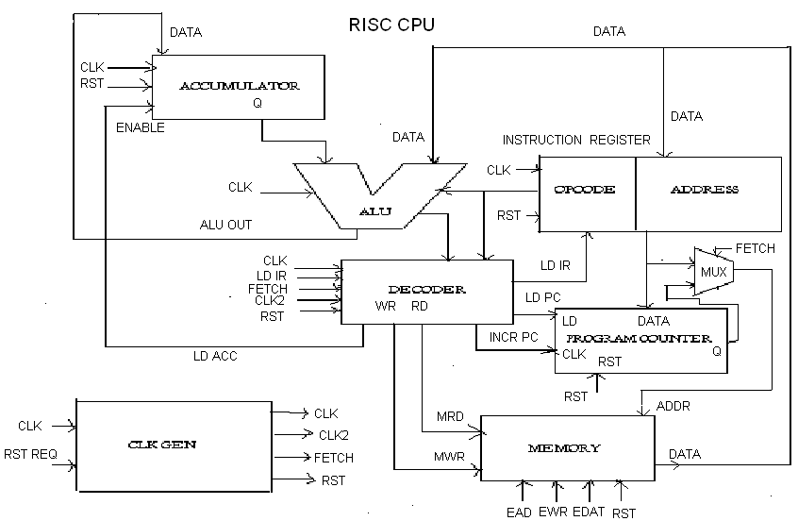
Figure 1 : RISC BLOCK DIAGRAM

2.1 DESCRIPTION OF VERI RISC CPU

To read an instruction the contents of Program counter are transferred to the address lines. This is done when the fetch signal is high and the address multiplexers chooses the contents of the program counter to be loaded on to the address bus.

As soon as the contents of the program counter are loaded onto the address bus a memory read cycle is initiated and the instruction is read from the location pointed out by the address lines and the micro instruction code is placed onto the data bus. The program counter is incremented to point to the next micro instruction in the memory location of the control memory. The data bus transfers the micro instruction to the instruction register. The instruction register has two fields, in the different formats namely.
1. Opcode, Data operand.
2. Opcode, Address of data operand.

During the first case the Opcode is given to the ALU and Decoder for decoding and a series of micro operation are generated. The data operand is loaded on to the data bus and transferred to the ALU for its respective micro operations as specified by its Opcode. In the second case the address of the data operand is loaded onto the address bus (as the fetch signal is low and the multiplexer loads the IR’s address contents onto the address lines) and a memory read cycle is initiated. Here the memory location in the main memory specified by the address lines is read and the data is transferred onto the data bus and thus given the ALU to undergo the operations specified by its Opcode.

The results of the ALU are stored in the Accumulator. Data operations may be combined with the memory contents and the Accumulator and result is transferred back to the Accumulator. The function of the Nor gate is that whenever all inputs are low the output is high and at all other times remains low. It is attached to tristate buffer. When the tristate buffer is enabled the data from ALU is fed to the memory thus allowing the data to be stored into the memory. When disabled the data is given to all and cut off from being written onto the data bus. Whenever there results a zero in the ALU a zero flag is set.

SALIENT FEATURES OF A RISC CPU ARE:
- Same instruction word length.
- Same length of timing and execution cycle.

2.2 SPECIFICATION

The RISC CPU consists of an ALU which gets its operands from an accumulator and memory. The result from the ALU is stored back in the accumulator or in the memory. Apart from the 8 bit accumulator it has two other 8 bit general purposes register, the Provides the address in memory of the next instruction. Instructions are fetched from memory and stored in the Instruction register. A Decoder provides the proper sequencing of the system. The decoder consists of the timing and control signal generator. The CPU consists of the 8 bit Bidirectional Data Bus and a 5 bit unidirectional Address bus capable of addressing 32 memory locations.

The instruction set of the CPU is also 8 bit in accordance with the data bus and consists of a 3 bit Opcode and a 5 bit address field.

Instruction Opcode

Halt 000
Skip of zero 001
Add 010
And 011
Xor 100
Load 101
Store 110
Jump 111

Table 1: Instructions with Opcode
The decoder consists of an Opcode decoder that issues the above control signals after decoding that Opcode. All the 8 instructions have the same instructions word length and the same timing cycles. The fetch cycle for all the instructions is same. The execution cycle differs from instruction to instruction but the execution timing length is the same for all 8 instructions. This property in which the instruction lengths and the instruction timing cycles are same is inherent quality of the RISC processors. Whatever instruction is taken it completes in exactly 8-T states. The fetch cycle takes 4-T states and execution cycle another 4-T state respectively.

2.3 INSTRUCTIONS AND INSTRUCTION:
FETCH CYCLE:
The program counter’s contents are loaded onto the address bus cycle with the fetch cycle high, the pc-out is selected by the address multiplexer and its contents are transferred to the address bus. The address bus points to the memory location in the memory where the and micro instruction is stored. The Decoder generates a memory read signal and the micro instruction is read and placed onto the data bus and transferred to the IR. The LDIR, loaded instructions is initiated by the decoder. The program counter is incremented by the Inc signal of the decoder.

EXECUTION:
In the IR the Opcode is sent to the Decoder to generate the required set of control signal and to the ALU to perform the micro operation onto the data operand. As soon as the Opcode is decoded in the decoder the sequence of control signal and the address of the operand is put onto the address lines with multiplexer selecting the IR address and then the decoder issues a memory read signal reading the operand from the main memory and placing it on the data bus.
The operand brings available to the ALU, the required arithmetic operations is carried out. If the operation results in a zero the zero flag is set, otherwise the result is stored in the accumulator when the decoder issues the LDACC (load accumulator) signal. The tristate buffer remains disabled and the result from ALU is prevented from being written onto the data bus.
ADD INSTRUCTION:

FETCH CYCLE:
The program counter’s contents are loaded onto the address bus cycle with the fetch cycle high, the pc-out is selected by the address multiplexer and its contents are transferred to the address bus. The address bus points to the memory location in the memory where the micro instruction is stored. The Decoder generates a memory read signal and the micro instruction is read and placed onto the data bus and transferred to the IR. The LDIR, loaded instructions is initiated by the decoder. The program counter is incremented by the Inc signal of the decoder.
EXECUTION:
In the IR the Opcode is sent to the Decoder to generate the required set of control signal and to the ALU to perform micro operation onto the data operand. As soon as the Opcode is decoded in the decoder the sequence of control signal and the address of the operand is put onto the address lines with multiplexer selecting the IR address and then the decoder issues a memory read signal reading the operand from the main memory and placing it on the data bus.
The operand brings available to the ALU, the required arithmetic operations is carried out. If the operation results in a zero the zero flag is set, otherwise the result is stored in the accumulator when the decoder issues the LDACC (load accumulator) signal. The tristate buffer remains disabled and the result from ALU is prevented from being written onto the data bus.

XOR INSTRUCTION:
FETCH CYCLE:
The program counter’s contents are loaded onto the address bus cycle with the fetch cycle high, the pc-out is selected by the address multiplexer and its contents are transferred to the address bus. The address bus points to the memory location in the memory where the micro instruction is stored. The Decoder generates a memory read signal and the micro instruction is read and placed onto the data bus and transferred to the IR. The LDIR, loaded instructions is initiated by the decoder. The program counter is incremented by the Inc signal of the decoder.
EXECUTION:
In the IR the Opcode is sent to the Decoder to generate the required set of control signal and to the ALU to perform the Xor micro operation onto the data operand. As soon as the Opcode is decoded in the decoder the sequence of control signal and the address of the operand is put onto the address lines with multiplexer selecting the IR address and then the decoder issues a memory read signal reading the operand from the main memory and placing it on the data bus.
The operand brings available to the ALU, the required arithmetic operations is carried out. If the operation results in a zero the zero flag is set, otherwise the result is stored in the accumulator when the decoder issues the LDACC (load accumulator) signal. The tristate buffer remains disabled and the result from ALU is prevented from being written onto the data bus.

LOAD INSTRUCTION:
FETCH CYCLE:
The program counter’s contents are loaded onto the address bus cycle with the fetch cycle high, the pc-out is selected by the address multiplexer and its contents are transferred to the address bus. The address bus points to the memory location in the memory where the micro instruction is stored. The Decoder generates a memory read signal and the micro instruction is read and placed onto the data bus and transferred to the IR. The LDIR, loaded instructions is initiated by the decoder. The program counter is incremented by the Inc signal of the decoder.

EXECUTION:
In the IR the Opcode is sent to the Decoder to generate the required set of control signal and to the ALU to perform the Xor micro operation onto the data operand. As soon as the Opcode is decoded in the decoder the sequence of control signal and the address of the operand is put onto the address lines with multiplexer selecting the IR address and then the decoder issues a memory read signal reading the operand from the main memory and placing it on the data bus.
The operand brings available to the ALU output simply acts as a buffer in which the Opcode is a load instruction. Then the data gets loaded into the accumulator when the decoder issues the LDACC (load accumulator) signal. Hence data from memory is eventually present in the accumulator. The tristate buffer remains disabled and the result from ALU is prevented from being written onto the data bus.

STORE INSTRUCTION:
FETCH CYCLE:
The pc on being incremented now points to the memory location containing the store micro instruction as followed in the top down approach of the micro program. A gain a fetch cycle is initiated and the pc’s contents are loaded onto the address bus with the fetch signal being high. The Decoder generates the memory read signal and the micro instruction is read and placed onto the data bus and transferred to the instruction register. The LDPC load instruction is initiated by the Decoder. The pc is incremented by the Inc signal of the Decoder.

EXECUTION:
In the IR, the Opcode is sent to the Decoder to be decoded and generate the required set of control signals. The address of the IR contains the address in the memory to where the result is to be stored. Thus the address is put onto the Address Bus. Then on ALU_clock becoming low, the accumulator contents containing the data to be stored are passed onto the ALU and out through the ALU_data. Since the fetch, mem_read and clock2 are all low. The NOR gate issues a high signal enabling the tristate buffer which then passes the contents on ALU_data and writes them onto the data bus. The memory location of the result to be stored is pointed out by the Address Bus, and the decoder issues a write signal, thus the contents of the data bus written onto that particular location, and thus the data is stored.

JUMP INSTRUCTION
FETCH CYCLE
The PC on being incremented as follows now points to the
memory location containing the Jump micro instruction as followed in the top down approach of the micro program. Again a fetch cycle is initiated and the PC’s contents are loaded onto the address bus with the fetch cycle being high. The decoder generates the memory read signal and the micro instruction is read and placed onto the data bus and transferred to the IR. The LDPC load instruction is initiated by the decoder. The PC is incremented by the INC signal of the decoder.

EXECUTION
In the IR, the Opcode Jump is sent to the decoder to be
decoded and generate the required set of the control signals. The address of the IR contains the address in the memory as to where the result is to be jumped. Thus the contents of the address field of the IR is loaded onto the address bus, so that the address bus points to the memory location from which the next instruction is to be fetched. The decoder issues a load_pc enabling the 5 bit content of the address field to be loaded into the PC replacing its previous contents in synchronization with the rising edge of the clock pulse. The PC now points to a new location in the memory. The previous contents that were replaced (which pointed to the address of the old micro instruction to be fetched) were said to be jumped i.e., the micro instruction was jumped. The jump statement is said to be an ‘Unconditional Jump’, if there is no conditional clause statement while performing that jump.

SKIP INSTRUCTION
FETCH CYCLE
The PC on being incremented now points to the memory
location containing the skip micro instruction as followed in the top down approach of the micro program. Again a fetch cycle is intimated and the PC’s contents are loaded onto the address bus with the fetch signal being high. The decoder generates the memory read signal and the micro instruction is read and replaced onto the data bus and transferred to the IR. The LDPC load instruction is intimated by the decoder. The PC is incremented by the Inc signal of the decoder.

EXECUTION
In the IR, the Opcode skip is sent to the decoder to be
decoded and generate the required set of control signals. The address of the IR is loaded onto the address bus, the PC currently points to the location in the memory from where the next instruction is to be fetched but the decoder issues another increment PC signal thus incrementing the PC again. The previous contents that were replaced (which pointed to the address bus and that micro instruction is fetched and execution cycles repeat.

HALT INSTRUCTION
FETCH CYCLE
The PC on being incremented now points to the memory
location containing skip. The Processor will wait for some time and does nothing.

EXECUTION
In the IR, the Opcode Halt is sent to the decoder to be
decoded. The decoder recognizing it as a Halt Instruction does not generate or give the control signals.
Thus no exception takes place and the processor is virtually
halted. The PC incrementation stops. So no next instruction is fetched. All control signals which are active high remain low. The Halt instruction is typically encountered at the end of the micro program indicating the terminated thus halting the system. The contents in the buses and memory remain unchanged.

3. DESIGNING OF VERIRISC CPU
Designing process of VERIRISC CPU involves, designing of following modules and integrating all of them in Top level module.

- Clock Generator
- Memory
- Multiplexer
- Program Counter
- Instruction Register
- Accumulator
- Arithmetic and Logic Unit
- Decoder
- IO Buffer

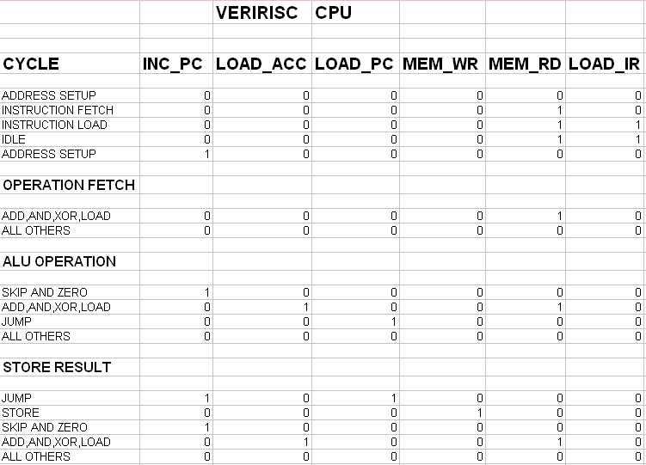
Table 2: Specifications of RISC CPU

FUNCTIONAL DESCRIPTION OF THE MODELS:
CLOCK GENERTOR:
Clock generator generates clock, clock2, fetch signal. For every negative edge of clock, clock2 is generated and for every positive edge of clock2, fetch signal is generated. Clock2 is generated form clock and fetch is generated form clock2. They are used as the input to decoder which controls the operation of CPU. It generates reset pulse. In VERIRISC CPU reset signal must be active-low. The reset should allow the reset of the signals to go high on falling edge of clock2 when fetch is low.

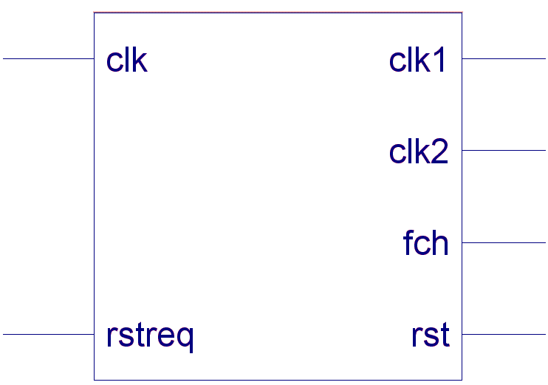

Figure 2: BLOCK DIAGRAM OF CLOCK GENERATOR

INSTRUCTION REGISTER:
In instruction register instructions are fetched form and stored in this. It performs the action always at position edge of clock. It has 3 instruction clock, reset, load-ir and data as input and output is Opcode and address. If LDIR and reset both are high, data in instruction register splits into upper 3 bits as Opcode and lower 5 bits as q-address.
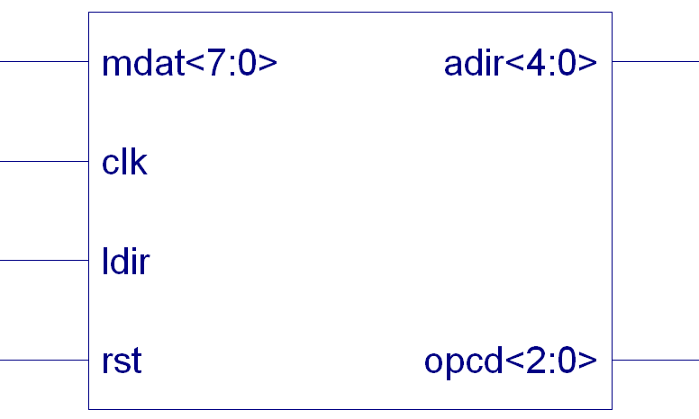

Figure 3: BLOCK DIAGRAM OF INSTRUCTION REGISTER

ACCUMULATOR:
Accumulator is a register; the result form Arithmetic Logic Unit is stored back in the accumulator. It has clock, reset, load-acc and ALU_OUT as input and accumulator as output. It is activated only at the positive edge of clock. If LDACC and reset both are high, data in the accumulator is loaded into ALU_OUT.

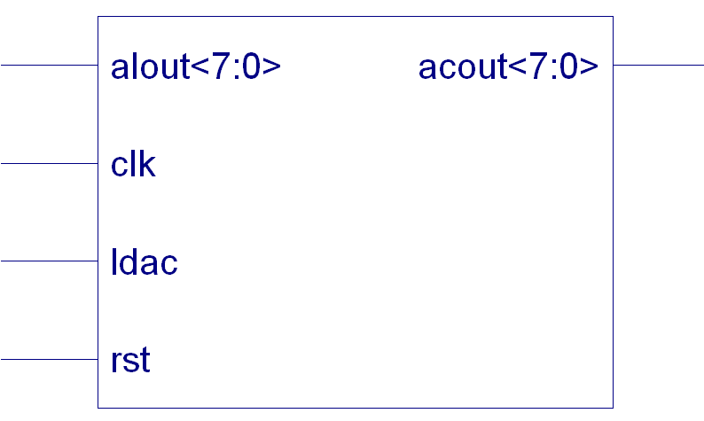

Figure 4: BLOCK DIAGRAM OF ACCUMULATOR:

MEMORY:
In VERIRISC CPU the memory should be 8-bit wide, 32-bit location deep. Each instruction retrieved form the memory will have its upper 3 bits as the Opcode and lower 5-bit as the address. Memory block has MEM_RD, MEM_WR and address as input and data as output. If MEM_RD is high, it reads the data of memory to the data register, if MEM_WR is high, data is written to the memory.

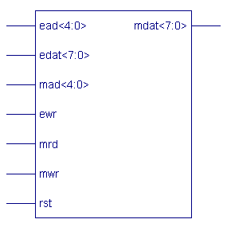
Figure 5: BLOCK DIAGRAM OF MEMORY

ARITHMETIC AND LOGIC UINT:
The ALU is a multiplexer, performs standard arithmetic and logic operations. The operation performed is listed below a total of 8 operations performed. ALU operations should be synchronized to negative edge of the clock (period is 20). At each negative edge, the ALU should perform the appropriate operation on the incoming data and accumulator, placing the result in ALU_OUT.

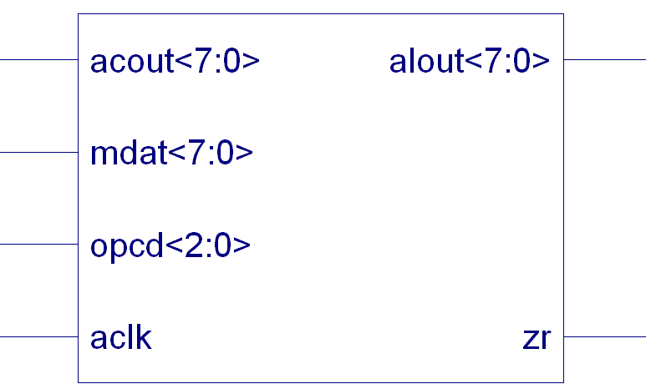

Figure 6: BLOCK DIAGRAM OF ALU

The 3 bit Opcode decodes as follows:

000: Pass Accumulator
001: Pass Accumulator
010: Add (data+ Accumulator).
011: And (data& Accumulator).
100: Xor (data ^ Accumulator).
101: Pass data.
110: Pass Accumulator.
111: Pass Accumulator.

Table 3 :Opcode Decoding.

MULTIPLEXER (2 TO 1):

The address multiplexer decides one output out of the two given inputs. When the fetch signal is high, the address of the program counter is transferred on to the address buses and hence the instruction is fetched. But if low the operand address specified in the address file of the instruction register transferred onto the address bus and consequently fetched.

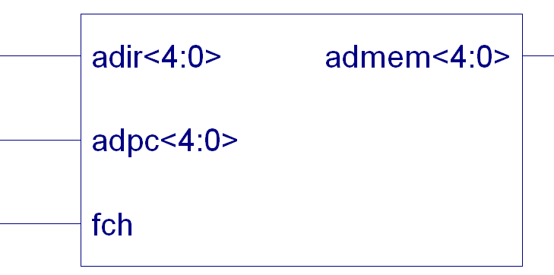
Figure 7: BLOCK DIAGRAM OF MULTIPLEXER

PROGRAM COUNTER:

It is a 5 bit general purpose register. The program counter points to the next micro instruction to be fetched from the memory. In case of an unconditional branch the said address is loaded in to the program counter for fetching of that instruction .Normally, after the fetch cycle is completed the program counter is incremented and now those points to the next instruction.

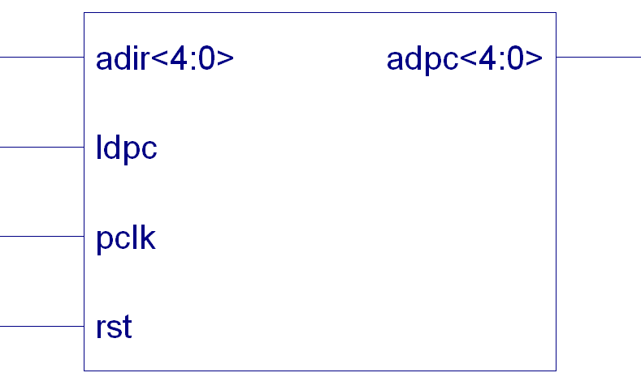

Figure 8 : BLOCK DIAGRAM OF PROGRAM COUNTER

DECODER:

A decoder provides the proper sequencing of system. It has clock, fetch, clock2, reset, zero instruction and Opcode as input and LDPC, MEM_RD, MEM_WR, LDACC as output. The zero bit should be whenever the accumulator is zero.

The decoder issues a series of control and timing signal. Depending on the Opcode it decodes after it receives from the instruction register. The decoder is a simple finite state machine which consists of states. During the first states it generates a control signal for address setup. The address bus is setup and the contents of the program counter are transferred onto the address bus. The instruction fetch is generated in the second state and the instruction is read from the memory with the memory read signal and transferred onto the data bus. When the third state starts the instruction is loaded with the LDIR being high into the instruction register. The Opcode is sent to the decoder and the appropriate control and timing signals are initiated for the execution cycle. This is done in the next state in which it remains idle during the decoding of the Opcode.
The fetch cycle ends, and the program counter is incremented with the Inc signal. The execution cycle starts and the address is again setup in the fifth state, but this time instruction register’s Address field is loaded onto the address bus. The operand is fetched in the sixth state with the MEM_RD signal being high and the data is transferred onto the data bus and given to the ALU for processing. In the seventh state the ALU is given its ALU_CLOCK and in synchronization with the falling edge of the clock the respective operation is performed. In the last stage the decoder issues an LDACC signal to store the result in to the accumulator.
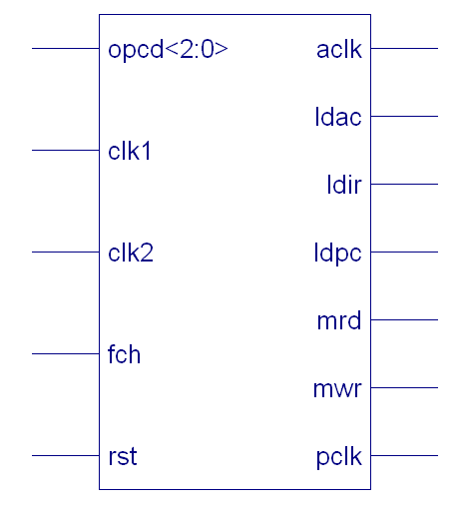

Figure 9: BLOCK DIAGRAM OF DECODER

4. EVOLUTION OF COMPUTER AIDED DESIGN

INTRODUCTION
Digital circuit design has evolved rapidly over the last 25 yrs. The earliest digital circuits were designed with vacuum tubes and transistors. Integrated circuits were then invented where logic gates were placed on a single chip. The first IC chips were SSI chips where the gate count was very small. As Technologies became sophisticated, designers were able to place ckts with 100s of gates on a chip.

These chips were called MSI. With advent of LSI, designers could put 1000s of gates on a single chip. At this point, design processes started getting very complicated and designers felt the need to automate the process. CAD Technology began to evolve. Chip designers began to use ckt and logic simulation Technology to verify the functionality of building blocks of the order of about 100 transistors.

The ckts were still tested on the breadboard, and the layout was done on the paper or by hand on a graphic computer terminal.
With the advent of VLSI Technology, designers could design the single chip with more than 1Lakh transistors. Because of the complexity of these ckts; it was not possible to verify these ckts on the breadboard. CAD Technology became critical for verification and design of the VLSI digital ckts, computer programs to do automatic placement and routing of ckt layouts also became popular. The designers are now building gate level digital ckts manually on graphic terminals.

They would build small building blocks and then derived higher level blocks from them. This process would continue until they had built the top level block. Logic simulators came into existence to verify the functionality of these ckts before they are fabricated on the chip.
As designs got larger and more complex, logic simulation assumed an important role in the design process. Designers could iron out functional bugs in the architecture before the chip was designed further.

EMERGENCE OF HDLs
For a long time, Programming Lang’s such as FORTRAN, PASCAL and C were being used to describe the computer programming that was sequential in nature. Similarly, in the field, designers felt the need for a standard language to describe the digital ckts.

Thus, HDLs came into existence. HDLs allowed the designers to model concurrency of the processes found in H/W elements. HDL such as Verilog and VHDL became popular. Verilog originated in 1983 at gate way design automation. Later, VHDL was developed under contract from DARPA, both Verilog and VHDL simulators to simulate large digital ckts quickly gained acceptance from designers.

Even though HDLs were popular for large verification, designers had to manually translate the HDL based design into a schematic circuit with interconnection between gates. The advent of logic synthesis in the late 1980s changed the design methodology radically. Digital circuits could be described at a register level (RTL) by use of a HDL. Thus, the designers had to specify how the data flows between registers and how the design processes the data.
Logic synthesis tools from the RTL description automatically extracted the details of gates and their interconnection to implement the circuit. Thus, logic synthesis pushed the HDLs into the forefront of digital design. Designers no longer had to manually place gates to build logic circuits.

They could describe complex circuits at an abstract level in
terms of functionality and data flow by designing those circuits in HDLs. Logic synthesis tools would implement the specified functionally in terms of gates and gate interconnections.
HDLs also began to be used for system level design. HDLs were used for simulation of system boards interconnect buses, FPGAs (Field Programmable Gate Arrays) and PALs (Programmable Array Logic). A common approach is to design each IC chip, using an HDL and then verify system functionality via simulation

TYPICAL DESIGN FLOW:
In any design, specifications are written first. Specifications describe abstractly the functionality, interface, and overall architecture of the digital circuit to be designed.

At this point the architects don’t need to think about how they will implement this circuit behavioral description is then created. To analyze the design in terms of functionality performance compliance to standards and other high issues. Behavioral description can be written with HDLs.

The behavioral descriptions manually converted to an RTL description in a HDL. The designer has to describe the data flow that will implement the desired digital circuit. From this point onwards the design process is done with the assistance of Computer Aided Design (CAD) tools.

Now the functionality and correctness of the behavioral description is verified. This is called Functional Simulation.

Logic synthesis tools convert the RTL description to a gate level net list. A gate level net list is a description of the circuit in terms of gates and connections between them. Now this gate level circuit is again tested for its functionality and compliance with the specifications. This is called Logic Simulation.
The gate level net list input to an Automatic Place and Route tool, which creates a layout. The layout is verified and then fabricated on chip. It is important to note, although CAD tools are available to automate the process and to cut design cycle times, the designer is still the person who controls how the tool will perform. CAD tools are susceptible to the ‘GIGO’ (Garbage in Garbage out) phenomenon. If used improperly, CAD tools will lead to inefficient designs. Thus the designer still needs to understand the nuances of design methodologies, using CAD tools to obtain an optimized design.

Importance of HDLs:
HDLs have many advantages compared to traditional schematic base design:

Design can described at a very abstract level by use of HDLs. Designers can write their RTL description without choosing a specific fabrication technology. Logic synthesis tools can automatically convert the design to any fabrication technology.

If a new technology emerges, designers don’t need to redesign their circuit. They simply input the RTL description to the logic synthesis tools and create a new gate level net list, using the new fabrication technology. The logic synthesis tool will optimize the circuit in area timing for the new technology.

Designing with HDLs is analogous to computer programming. A textual description with comments is an easier way to develop the circuits. This also provides a concise representation of the design, compared to gate level schematics. Gate level schematics are almost in comprehensible for very complex design.

HDLs are mostly certainly a trend of the future. With rapidly increasing complexities of digital circuits and increasingly sophisticated CAD tools, HDLs will probably be the only method for large digital designs. No digital circuit designer can afford to ignore HDL based design.

5. VHDL

INTRODUCTION

VHDL is an acronym for vhsic hardware description language (vhsic is an acronym for very high speed integrated circuits). It is a Hardware Description Language that can be used to model a digital system. It contains elements that can be used to describe the behavior or structure of the digital system, with the provision for specifying its timing explicitly. The language provides support for modeling the system hierarchically and also supports top-down and also bottom-up design methodologies. The system and its subsystems can be described at any level of abstraction ranging from the architecture level to the gate level, precise simulation semantics are associated with all the languages constructs, and therefore, models written in this language can be verified using a VHDL simulator

Scope of VHDL

VHDL satisfies requirements for the hierarchical description of electronic circuit from system level down to switch level. It can support all levels of timing specification and constraints and is capable of detecting and signaling timing violations. The languages model the reality of concurrency present in digital system and support the recursively of finite state machine. The concept of packages and configurations allow the creation of design libraries for the reuse of previously designed parts.

VHDL features:

A Design engineer in electronic industry uses HDL to keep pace with the productivity of the competitors. With VHDL we can quickly describe and synthesize circuits of several thousand gates. In addition VHDL provides the capabilities as follows:

- Power and flexibility
- Device –independent design
- Portability
- Benchmarking capabilities
- ASIC migration
- Quick time to market and low cost

1. Power and flexibility
VHDL has powerful language constructs with which no write / right succinct code description of complex control logic. It also has multiple levels of design description for controlling design implementation. It supports design libraries and creation of reusable components. It provides design hierarchies to create modular designs. It is one language for design and simulation.

2. Device –independent design
VHDL permits to create without having to first choose a device for implementations. With one design description we can target many device architectures. With out being familiar with it, we can optimize our design for resource utilization or performance. It permits multiple style of design description.

3. Portability
VHDL portability permits to simulate the same design description that we have synthesized. Simulating a large design description before synthesizing can save considerable time. As VHDL is a standard, design description can be taken from one simulator to another or one synthesis tool to another or one platform to another, means design description can be used in multiple projects.

4. Benchmarking capabilities
Device independent design and the probability allow benchmarking a design using different device architectures and different synthesis tools. We can take a completed design description and synthesize it, create logic foe it, evaluate the results and finally choose the device – a CPLD or an FPGA that best fits our design requirements.

5. ASIC migration
The efficiency that VHDL generates, allows out product to hit the market quickly if it has been synthesized on a CPLD or FPGA. When production volume reaches appropriate levels VHDL facilities the development of application specific integrated circuit ( ASIC ), sometimes the exact code with the PLD can be used with the ASIC and because VHDL is a well defined language, we can be assured that out ASIC vendor will deliver with expected functionality.

6. Quick time to market and low cost
VHDL and programmable logic pair will together facilitate a speedy design process. VHDL permits designs to the desired quickly. Programmable logic eliminates NRE expenses and facilities quick design iterations. Synthesis makes it all possible. VHDL and programmable logic combine as a powerful vehicle to bring the products in market in record time.

Design synthesis:
The design process can be explained in six steps:
Define the design requirements.
Describe the design in VHDL (formulate and code the design)
Simulate the source code.
Synthesis, optimize and fit the design into a suitable device.
Simulate has post layout (fit) design model.
Program the device.

6. DATA FLOW DIAGRAMS

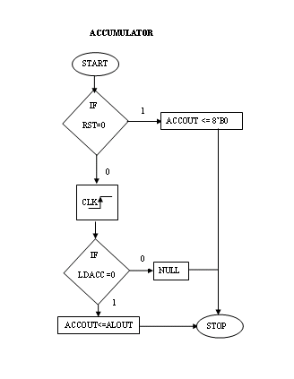
Figure 10 : FLOW CHART OF ACCUMULATOR

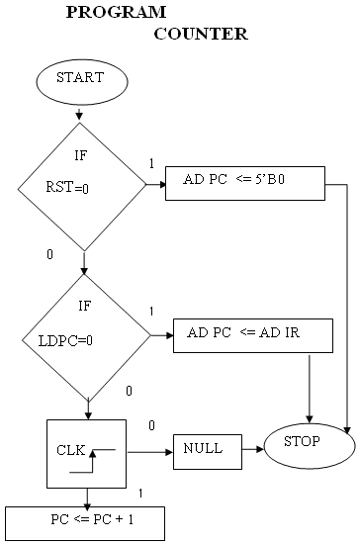

Figure 11 : FLOW CHART OF PROGRAM COUNTER

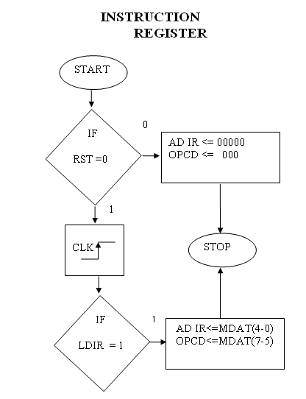

Figure 12: FLOW CHART OF INSTRUCTION REGISTER

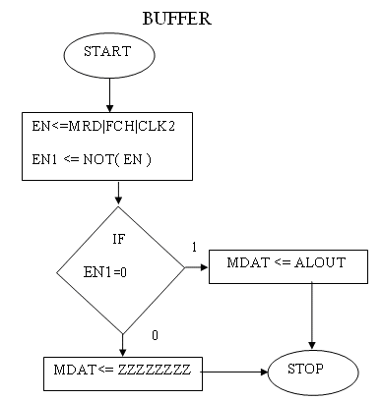

Figure 13 : FLOW CHART OF IO BUFFER

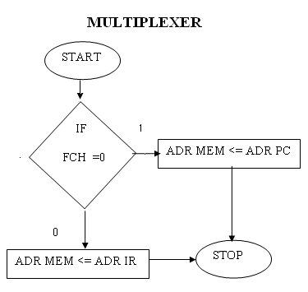

Figure 14 : FLOW CHART OF MULTIPLEXER

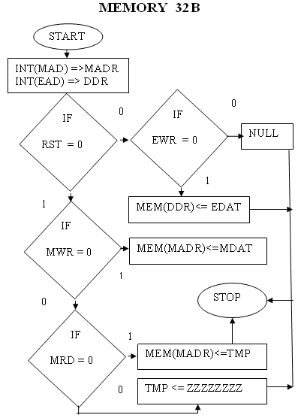

Figure 15 : FLOW CHART OF MEMORY

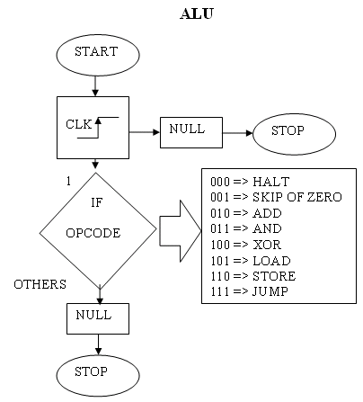

Figure 16 : FLOW CHART OF ALU

