Admin guide
For: PEA admins. Version: October 2026.
As an admin you can do everything an HR user can (see the HR guide), on every screen, whatever module access says. You also:
- look after the HR accounts and decide which screens each HR user sees;
- change settings and email templates;
- run the Excel import;
- read Sent emails, the log of every email PEA has sent;
- delete a Commando created by mistake.
Super Admins (see the Super Admin guide) also look after admins.
Contents
- Opening the Admin Portal
- Users
- Module access: who sees which screens
- Settings
- Email templates
- Upload Excel
- Sent emails
- Deleting a Commando
- Housekeeping checklist

1. Opening the Admin Portal
Click Admin Portal in the top bar. It has two tabs, User Management and Module Access, and a refresh button. Evaluation Portal (top right) takes you back to PEA, and Logout signs you out.
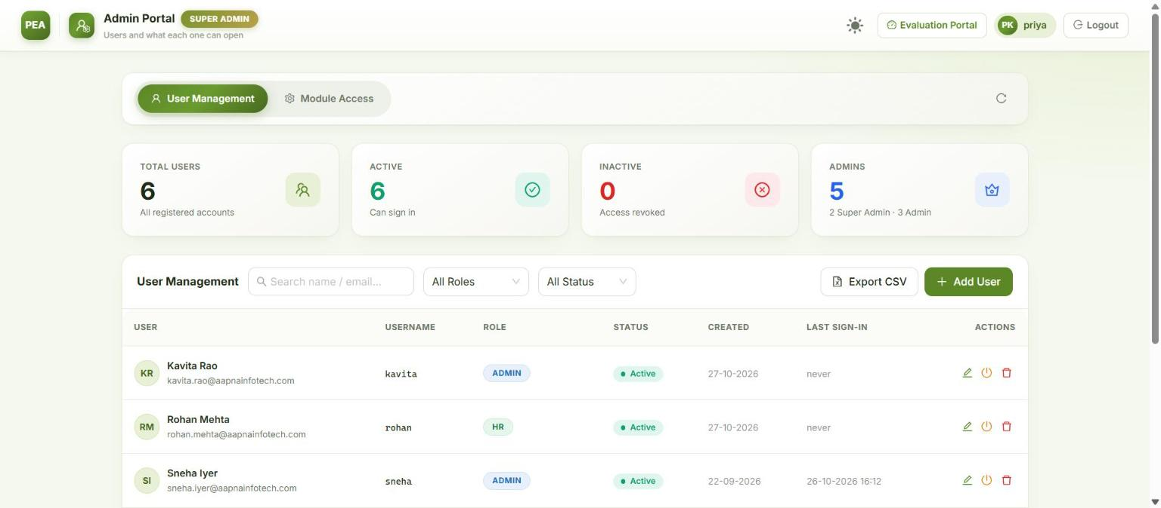
The Admin Portal

2. Users
User Management shows counts (Total Users, Active, Inactive, Admins) and the list of accounts with their username, role, status, created date and last sign-in. Search by name or email, and filter by role and status. Export CSV downloads every account.
Add a user
- Click Add User.
- Fill in First Name, Last Name and Email Address. Username is optional; left blank, they sign in with their email.
- Choose the Role. As an admin you can create Admin and HR accounts.
- Type a Password (at least 10 characters, not containing their name) and confirm it, or click Auto-Generate Password and Copy it.
- Click Create User. PEA emails the sign-in details to the person’s own inbox. If that email could not be sent, PEA says so; give them the password yourself.
Change a user: the pencil icon. Change the name, username, role or Account Status. To reset their password, type a New Password (blank keeps the current one). Changing the role or password, or deactivating, signs them out everywhere at once.
Deactivate rather than delete. The power icon deactivates: they are signed out immediately and cannot sign in until reactivated. Their history stays. Only a Super Admin can delete an account.
What you can’t do (by design):
Rule | Why
You can’t change your own role or status | Nobody can lock themselves in or out by mistake
You can’t edit, reset or deactivate another admin | Admins are peers; a Super Admin manages admins
You can’t change a Super Admin’s account | Only Super Admins can
You change your own password from the menu under your name | Not from User Management

3. Module access: who sees which screens
Module Access: pick an HR user on the left, then switch each screen on or off for them. Changes save as you click (✓ Auto-saved) and reach the person within a minute.
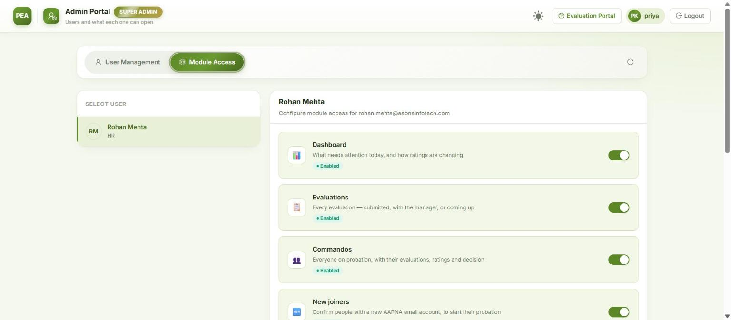
Module access
Module | Screen
Dashboard | The Dashboard (Needs action)
Evaluations | The Evaluations board and each evaluation’s page
Commandos | The Commandos list and each Commando’s page, Commando links
New joiners | New joiners: the Microsoft 365 check, confirming joiners, possible leavers
Evaluation links | Manager team links and Commando links
Settings | The settings tabs (read-only for HR)
↳ Trends | The Trends tab inside the Dashboard
↳ Upload Excel | The Upload Excel tab inside Settings
↳ Email templates | The Email templates tab inside Settings (read-only for HR)
- Settings shows in the sidebar if any one of Settings, Upload Excel or Email templates is on; the user sees only the tabs that are on.
- Admins and Super Admins always see everything. The switches apply to HR users only.
- Admin Portal access is not a switch: make the person an Admin to give it.
- An HR user with every module off sees “No modules are enabled for your account”.

4. Settings
Settings is read-only for HR; only admins can change it. Each setting saves on its own, applies straight away, and needs no restart. Changes to the important ones (marked as such) are announced to every admin through the bell.
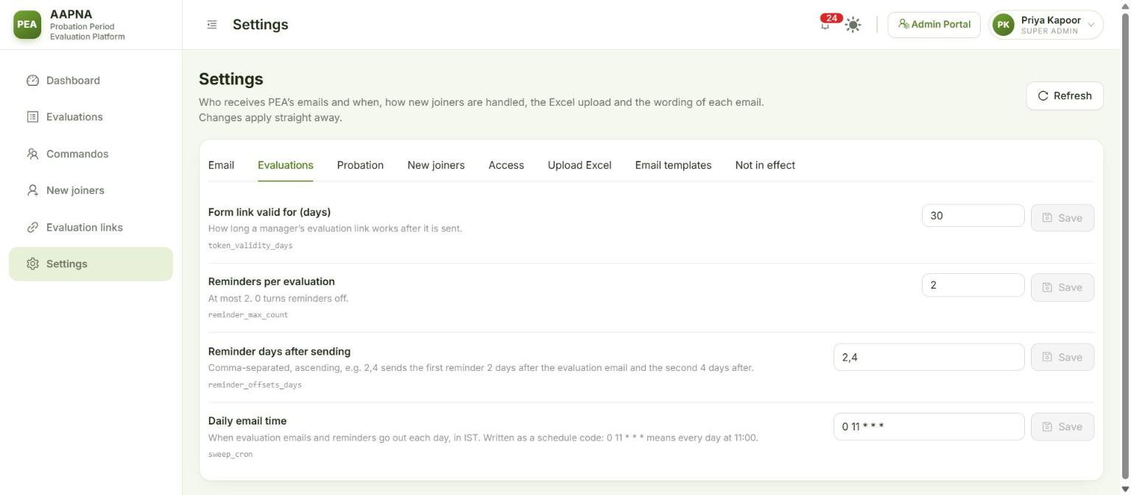
Settings

Email
Setting | What it does
Pause all email | Normally off. On (emergency only): nothing leaves PEA; emails are logged as “would have sent”. The top bar then shows No email is being sent to everyone
CC on evaluation emails | Copied on every evaluation request and reminder, alongside the project leader
HR notification recipients | Receive “evaluation submitted”, “probation extended”, and the deadline digest
“Report to IT” recipients | Where Report to IT corrections go. Needed before Report to IT works in production
Never copy these as project leader | People not to copy just because they are listed as project leader (they are still copied if they are the manager or on the CC list)
Copy HR on manager team-link emails | On: a manager’s “my team” email is copied to HR and the CC list

Evaluations
Setting | Default | What it does
Form link valid for (days) | 30 | How long a manager’s form link works after it is sent
Reminders per evaluation | 2 | At most 2; 0 turns reminders off
Reminder days after sending | 2,4 | First reminder 2 days after the evaluation email, the second 4 days after
Daily email time | 0 11 * * * (11:00 IST) | When evaluation emails and reminders go out each day. 0 11 * * * means every day at 11:00; 30 10 * * * would be 10:30

Probation
Setting | Default | What it does
Archive Commandos this many days after the probation ends | 0 | 0 = the morning after the decision or exit
Confirmation deadline (months) | 6 | A decision must be recorded this many months after joining
Deadline once extended (months) | 8 | The same after an extension
Email HR a daily deadline digest |  | On: HR is emailed daily about probations whose decision is overdue. The Dashboard and bell show them either way

New joiners
Setting | What it does
Nightly Microsoft 365 check / Daily Microsoft 365 check time | Whether the daily check runs, and when (09:00 IST by default, two hours before the evaluation emails). Scan now works either way
Look back for new accounts (days) | How far back the check looks for new accounts (45 by default)
Joiner email domains | Only accounts on these domains are joiners (aapnainfotech.com, mera.work, karyakeeper.com)
Contractor list / Leaders list | The Microsoft 365 groups used to leave contract staff out and to suggest each joiner’s project leader. Change only if IT changes the groups
Never offer these as joiners / System mailboxes | Addresses the check always leaves out
New accounts with no manager in Microsoft 365 | leave_out: they wait until IT sets a manager (the screen names them). show: they appear with the manager marked “Missing”
Designation words that suggest Fresher / Experienced | Words in the job title that pre-select the track. Only a suggestion; HR always confirms
Send the new joiner review email to | hr2@aapnainfotech.com by default. The daily “new joiners waiting” email goes only here, with Confirm / Not confirm buttons. Anyone who can read this mailbox can confirm a joiner, so keep it to the HR mailbox. Blank: it goes to every admin and HR user, without buttons
Let the scan update names and emails | Overwrites unlocked names and office emails with Microsoft 365’s. Do a Test run first
Hold evaluations when Microsoft 365 says someone has left | On (default): evaluations stop the moment an account is disabled and unlicensed, before HR confirms
Email HR when the Microsoft 365 check goes wrong | On (default): HR is told once about each problem (check failed, joiner with no manager)
Show the manual pause button | Off by default. Switch on for long leave (sabbatical, maternity), when the account stays active

Access
Setting | What it does
Manager portal link valid for (days) | How long a manager’s “my team” link works (30 by default). A new link revokes the previous one
Commando self-view | What a Commando sees through their own link: off (the link does not open), schedule (dates and status), averages (plus their averages and the decision; the default) or full (plus every rating and the manager’s comments)

5. Email templates
Settings → Email templates lists every email PEA sends. Filter by To reporting manager, To HR or To IT.
Email | Goes to
Evaluation request | Reporting manager · CC project leader and the CC list
Evaluation reminder | Reporting manager · CC project leader and the CC list
Evaluation reopened | Whoever submitted it · CC project leader and the CC list
Manager portal link | Reporting manager
Evaluation submitted | HR notification recipients
Probation extended | HR notification recipients
Confirmation deadline digest | HR notification recipients (when switched on)
Evaluation report shared | Whoever HR sends it to
Microsoft 365 check alert | HR notification recipients
New joiners waiting for review | The review mailbox (hr2@)
Report to IT | “Report to IT” recipients · CC HR
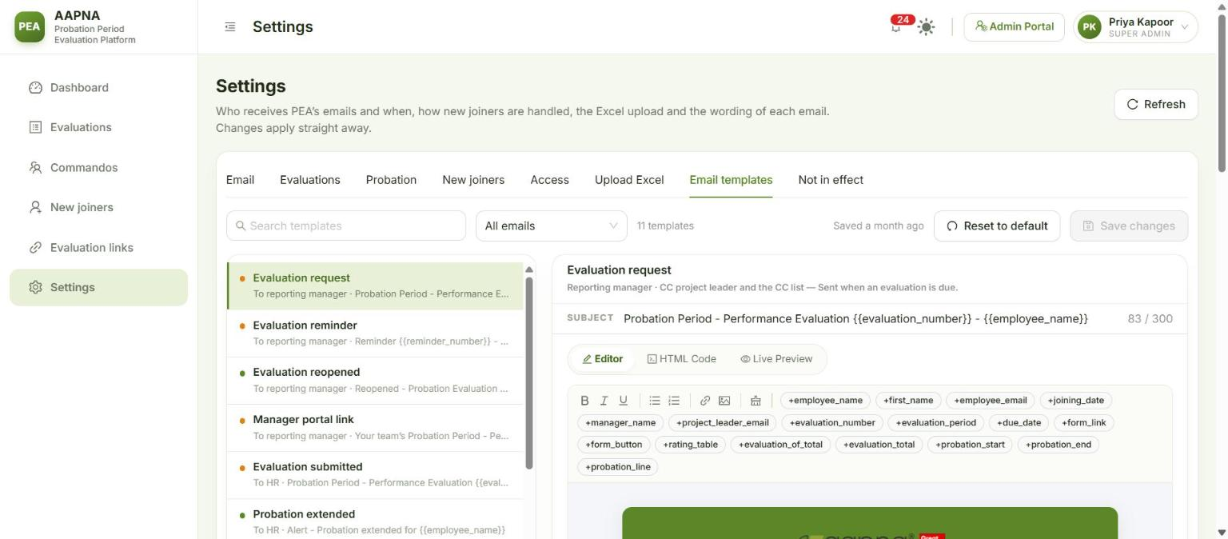
Email templates
To change one:
- Pick the email from the list (or search for it). Edit the Subject and the body in Editor (or HTML Code if you know HTML).
- Insert the details PEA fills in (the Commando’s name, the due date, the form button…) with the + buttons above the editor, such as +employee_name or +form_button. In the text they appear in double braces, {{employee_name}}; keep them exactly as written.
- Check Live Preview, which fills the email with sample data. PEA refuses to save an email that has lost a required link (for example the form button on an evaluation request), or that uses an unknown placeholder.
- Click Save changes. The AAPNA logo, green header and footer are added automatically.
Reset to default brings back the original wording. A wrong template goes to every manager who receives that email, so always check the preview first.

6. Upload Excel
Settings → Upload Excel adds Commandos and their past evaluations from Excel. It is for loading history, and for people the Microsoft 365 check cannot pick up. Nothing is saved until the last step.
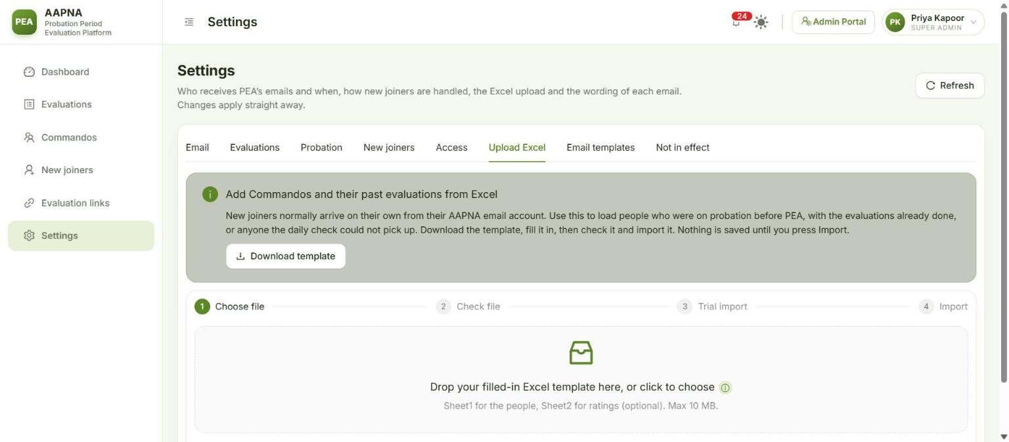
Upload Excel
- Download template, fill it in (Sheet1: one row per Commando; Sheet2, optional: the ratings). The old master workbook works too.
- Choose file (.xlsx, .xls or .xlsm, up to 10 MB).
- Check file reads every row and shows: rows read, ready, refused (with the reason for each), freshers and experienced, already decided, decision needed, and which managers will be emailed an evaluation at the next daily send. Fix refused rows in the file and check again.
- Trial import goes through the whole import without saving: how many would be added, how many are already in PEA, and anything that would fail.
- Import (admins only) asks you to confirm, then adds the Commandos with their evaluations and ratings.
Good to know:
- Anyone whose office email is already in PEA is skipped, not changed.
- An evaluation due in the last 45 days and not completed in the sheet is emailed to the manager at the next daily send. Anything due earlier is closed as history.
- Someone whose probation is already over with no decision in the sheet is imported as still on probation, with Decision due on their page. Record the decision there, or fill in Confirmation Status in the sheet first.
- HR users with Upload Excel switched on can check a file and do a trial import, but not import.

7. Sent emails
Evaluations → Sent emails (admins only) lists every email PEA has sent: When, Type, About (the Commando), To, Subject and Outcome (sent, failed, or would have sent while email was paused). Search by recipient or subject, and filter by type and outcome. Use it to check that a manager really was emailed.
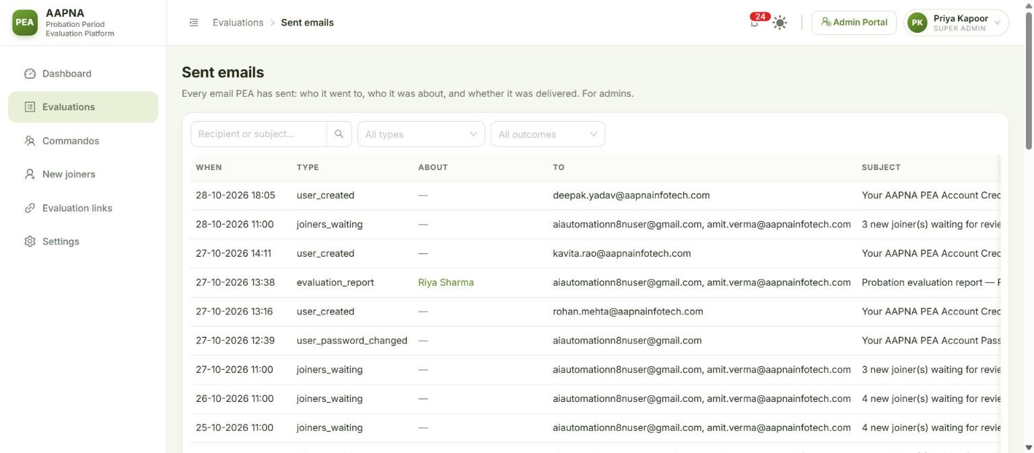
Sent emails

8. Deleting a Commando
Only for demo and test records, or someone added by mistake. More → Delete… on the Commando’s page, type their full name to confirm, and Delete permanently. Every evaluation, rating and the change history go with them, and other admins are notified.
If the person really left, use More → Mark as left… instead, which keeps their history.

9. Housekeeping checklist
Monthly, or when the HR team changes:
- ☐ People who left the HR team: deactivate their PEA account.
- ☐ New HR team members: create an HR account and set their module access.
- ☐ Dashboard → Not sent yet is 0. If not, open each one and fix it.
- ☐ Dashboard → Act on these first: nothing old left under Deadline passed.
- ☐ New joiners: nobody waiting for more than a few days, and Possible leavers dealt with.
- ☐ Settings → Email: the CC list and HR notification recipients are still the right people.
- ☐ Pause all email is off and the top bar does not say “No email is being sent”.

