**Requirement Statement**

When there is need to connect a number of sensors of the same kind to our robot. The expected output of each sensor is 10 Hz and we can talk to those sensors using TTL level RS232 connection. The sensor supports only the 9600 bps speed. To get the data from sensor (5 bytes) we need to send a command (1 byte). From the moment the command is sent, it can take up to ~70 milliseconds to get the data.

Unfortunately, we don't have 10 RS232 ports on our main computer. We have one RS232 port, one I2C and one SPI port available. We also have up to two interrupt lines available.

An additional constraint is that we cannot trigger sensors with a broadcast message. In other words, we need functionality to trigger them in a sequence.

The requirement is to find a scalable hardware/software solution to gather data from all sensors

**Analysis and Proposed Solution**

RS232 is a point to point 2 wire serial communication protocol. If we want to control 10 RS232 sensor from a single RS232 port, software only solution is not feasible. Some of the approach we can follow are mentioned below.

1. RS485-RS232 converter module and daisy chaining

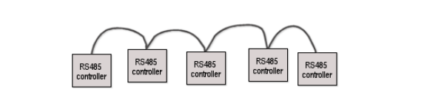

Sensor network on local bus can be created by using a RS232-RS485 convertor. Sensor can be connected in daisy chain to form a multidrop network. Each device has a Device ID to identify the controller in the same segment of the network and a Network ID to identify the network segment in the network bus. Device ID and Network ID are set by the user. Using the MS/TP communication protocol, controllers on the network configure/reconfigure themselves automatically in the network, so hot plugging/unplugging is allowed. All devices on the same network segment receive any transmitted data. The device for which the data is intended responds if necessary.

<file:///C:/Users/pankajku/Downloads/wiring%20guidelines%20for%20rs-485%20networks.pdf>

1. RS232 Serial HUB

Using the serial hub, each sensor can be enumerated in the host OS as a unique tty device.

1. RS232 MUX Demux

Multiplexer logic as shown in the below image can cascaded to emulate a 1x16 RS232 switch. Channel select will identify the sensor.

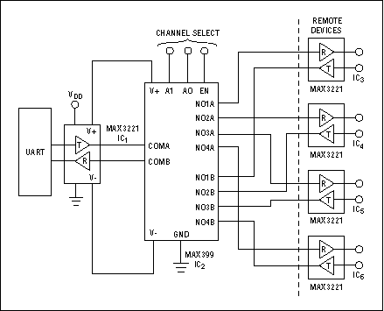

<https://www.maximintegrated.com/en/app-notes/index.mvp/id/588>

1. **Serial Communication Controller**
2. **Micro controller**

R232 Over GPIO

Sensor-01

microcontroller

(Firmware)

UART Over RS232

Sensor-10

Sensor-02

…