**PIZZA SALES MYSQL QUERIES**

**KEY KPI’s**

**1. Total Revenue:**

* Select sum(total_price) as Total_Revenue from pizza_sales;

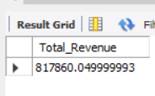

**2. Average Order Value:**

* Select sum(total_price)/count(DISTINCT order_id) as Avg_Order_value from pizza_sales;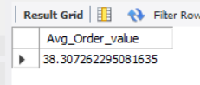

**3. Total Pizza Sold:**

* Select sum(quantity) as Total_Pizza_Sold from pizza_sales;

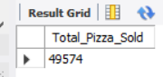

**4. Total Orders**

* Select count(distinct order_id) as Total_Orders from pizza_sales;

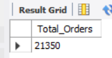

**5. Average Pizza per Order**

* Select round(sum(quantity)/count(DISTINCT order_id),2) as Avg_Pizza_per_Order from pizza_sale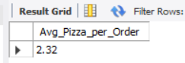

**6. Orders Based on Days**

* select dayname(order_date_d) as order_day, count(distinct order_id) as Total_orders from pizza_sales group by 1;

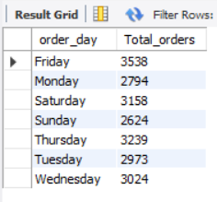

**7. Orders On Month Bases**

* select monthname(order_date_d) as Month_name, count(distinct order_id) as Total_orders from pizza_sales group by 1 order by 2 desc;

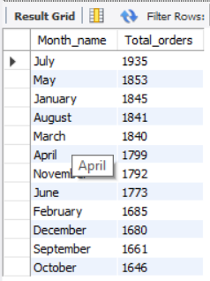

**8. Hourly Trand for Orders**

* select hour(order_time) as Month_name, count(distinct order_id) as Total_orders from pizza_sales group by 1 order by 2 desc;

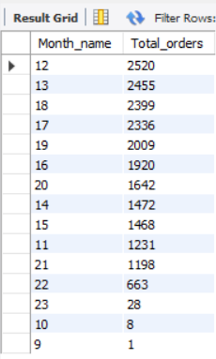

**9. % of sales by Pizza Category**

* select pizza_category, round(100*sum(total_price)/(select sum(total_price) from pizza_sales),2) as PCT from pizza_sales group by 1;

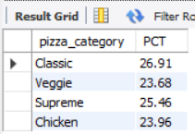

**10. % Of sales by Pizza Size**

* select pizza_size , round(100*sum(total_price)/(select sum(total_price) from pizza_sales),2) as PCT from pizza_sales group by 1;

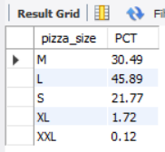

**11. Top Pizza Sold by Price**

* select pizza_name, sum(total_price) Top_Revenue from pizza_sales group by 1 order by 2 desc limit 5;

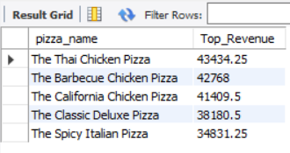

**12. Top Pizza sold by Quantity**

* select pizza_name, sum(quantity) Top_Quantity from pizza_sales group by 1 order by 2 desc limit 5;

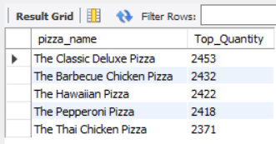

**13. Top Pizza sold By orders**

* select pizza_name, count(order_id) top_orderd from pizza_sales group by 1 order by 2 desc limit 5;

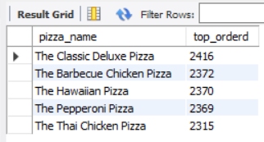

NOTE: For get Bottom of Pizza Sold by Price, Quantity and Ordered Use **ORDER BY 2 ASC** instant of **DESC**