SPHERIC benchmark test case

test case title | 2D Incompressible flow around a moving square inside a rectangular box.
SPHERIC test case number |  | to be assigned after acceptance by SC (?)
test case coordinator |  | Andrea Colagrossi and Giuseppina Colicchio
organisation and country |  | INSEAN, Italy
email |  | a.colagrossi@insean.it
Introduction
The flow across a square cylinder is an important test case for the validation of separated flows especially in the turbulent regime. In the past, it has been regularly used to validate Large Eddy Simulation (LES) models.
The test proposed is a tough benchmark for Lagrangian solvers like SPH. The main goal is to prove that the particle solver adopted is able to generate diffuse and convect correctly the unsteady vorticity. Due to the presence of sharp edges the vorticity generated is quite intense.
Even though the geometry is very simple, the flow can be very complex since increasing the Reynolds Number the vorticity decays at lower scales. Three different Reynolds Numbers are here analysed Re=50,100,150.

Flow phenomena
Generation, diffusion and convection of vorticity around a square cylinder.
Incompressible Viscous flow around sharp edge.
Measure of global loads (pressure and viscous components)

Geometry
The coordinate system adopted is represented in the sketch below, the red line is the solid boundary of the tank while the black line is the initial position of the square at time t=0.
The square is moved rightward for t>0 with a prescribed motion, starting from rest and accelerating to a final steady maximum velocity (see Boundary Conditions).

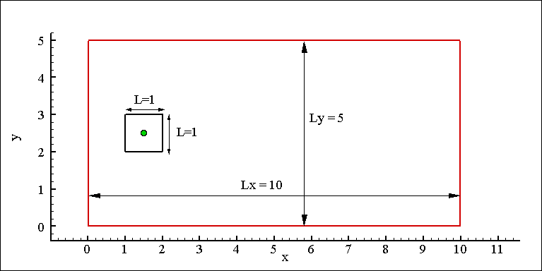

Boundary conditions
This test is characterized only by no-slip solid boundary conditions on all walls of the tank and the square.
The file Motion_Body.dat contains four columns which are respectively: time, acceleration, velocity and displacement records for the prescribed motion of the square’s center. These data are normalised to give maximum velocity U_{max} ≅ 1.0. The test is conducted for three values of Reynolds number (based on L and U_{max}), 50, 100 and 150.

Initial conditions
The geometry initial conditions are reported in the “geometry” section.
Volume forces (i.e. gravity) are not acting on the fluid.
Initially the pressure field is zero everywhere.
Fluid Properties

The fluid is incompressible and Newtonian.
Discretisation
The present test has been solved with a Navier-Stokes Finite Difference solver. A regular Cartesian grid has been adopted with 300 points on y-direction and 600 points on the x one.
Results specification
Results to be returned for this test are time histories for the drag coefficient (both pressure and viscous components) for the three Reynolds Numbers 50,100,150.
The drag coefficient C_{D} is defined as 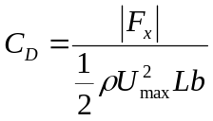 ,
where ρ is the fluid density, U_{max} is the maximum velocity of the square, L is the square side, and b the transversal length of the prismatic surface .

Results format
The time histories of pressure and viscous components of drag coefficients are available in the ASCII files: Force_Re050.dat, Force_Re100.dat, Force_Re150.dat
Results should be returned in ASCII files of the following format:
Column 1=time, 2=Cd pressure component, 3= Cd viscous component
The vorticity, pressure and intensity of velocity field contour plots are available on JPG pictures.
Benchmark results
The present test has been solved with a Navier-Stokes Finite Difference solver, with a Level-Set algorithm to capture fluid/solid interfaces.
Grid convergence has been tested for all the three Reynolds numbers using three different grid resolutions: 600×300; 400×200; 267×133 (see e.g. jpg pictures Cd_p_Convergence.jpg, Cd_v_Convergence.jpg)
The time histories of pressure and viscous components of drag coefficients are available in the ASCII files: Force_Re050.dat, Force_Re100.dat, Force_Re150.dat.
Attention: drag coefficient time records present some small amplitude and high frequency oscillations which are due to numerical reasons and have not to be taken into account for the comparison.
The following field data are available as jpg images:
- Vorticity contour plots at time instants t=5.00 and t=8.00
- Pressure contour plots P(x,y)-P(0,0) at same time instants of 1)
- Velocity magnitude contour plot at same time instants of 1)

References
G. Colicchio, M. Greco, O.M. Faltinsen, 2006,
Fluid-body interaction on a Cartesian grid: dedicated studies for a CFD validation
Proc. 21st International Workshop on Water Waves and Floating Bodies,
IWWWFB (Loughborough, UK)

