ProjectDocumentation
ProjectName:CollegeManagementSystem
- Requirement:
  - TechnicalRequirments:
    - DomainName=Collegename.com
    - WebHosting.
    - Technology:
      - Html,Css,Js,PHP
    - Database.
    - ResponsiveDesign.

  - Content:
    - HomePage
    - About
    - ContactPage
    - Courses
    - Admission
    - Gallery
    - Login

  - Team:
    - WebDesigner
    - WebDeveloper

- Analysis:

- Timerequirement:Thisprojectwilltakeabout4monthstocomplete.

- Budget:…………

- Howmanyuserworkonwebsite:

  - Guest :Website

  - Student :StudentPanel
  - Admin :AdminPanel
  - Faculty :FacultyPanel

  - College :CollegePanel

- Defineworkofeachuser:
- Guest:
  - WebsiteVisit
  - ViewCoursesCategories
  - ViewSyllabus
  - ContacttoCollege
  - CollegeCampus

- AdminPanel:
  - Login login
  - ManageCollegecategories
  - StudentManagement
  - FacultyManagement
  - Examination&ResultManagement
  - AccountsManagement
  - Managecontactus
  - Logout

- StudentPanel :

  - VisitWebsite
  - Contact
  - SignUp
  - Login
  - ProfileManagement
  - ViewInformations
  - Attendance
  - Examination
  - DownloadAdmitCard,Result,Certificates
  - Feedback
  - LogOut

- FacultyPanel:
  - VisitWebsite
  - SignUp
  - Login
  - ProfileManagement
  - ViewInformations
  - Course&SubjectManagement
  - StudentAttendance
  - ExaminationManagement
  - ReportsGeneration
  - Feedback
  - LogOut

- CollegePanel:

  - Login login
  - ManageCollegecategories
  - StudentManagement
  - FacultyManagement
  - Examination&ResultManagement
  - AccountsManagement
  - ManageAdmitCardAndStudentResults
  - Notices&Announcements
  - Managecontactus
  - Logout

- BackendPanel:
  - Login.php
  - Dashbord
  - Home Page

  - ContactPage
  - TablePage
  - FormPage/SignUpPage

- Definepanelbyuser:

  - Guest :OnlyVisit Website
  - AdminPanel:Admin
  - StudentPanel:Student
  - FacultyPanel:Faculty/Teachers
  - CollegePanel:Admin

Step 4: Define Some Diagram

- Use case Diagram :

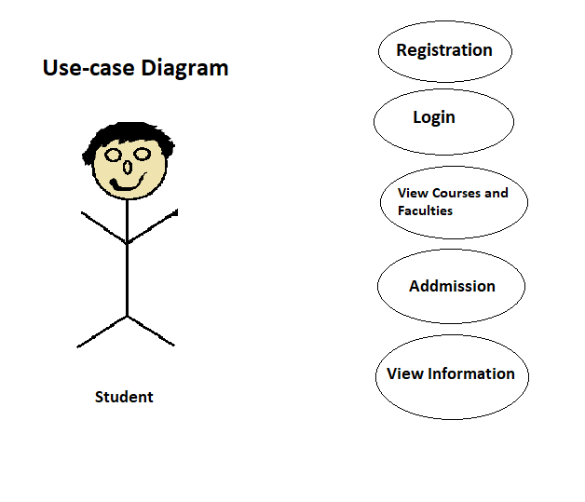

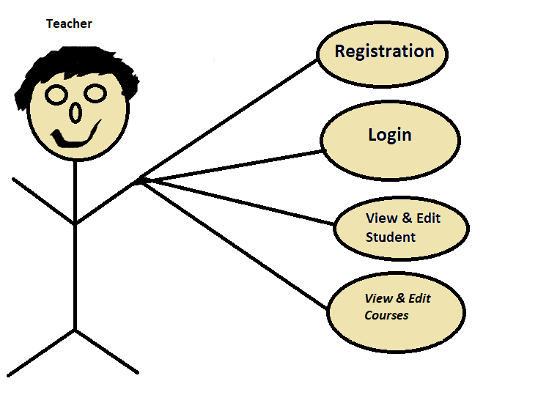

Use-case diagram

Website visit
Guest View courses categories categories.tbl
View courses courses.tbl
Contact us contacts.tbl

Website visit
View courses categories categories.tbl
View courses courses.tbl
Contact us contacts.tbl
Signup Student.tbl
Student Login Student.tbl
Manage profile Student.tbl
Make Admission Admission.tbl
Feedback feedbacks.tbl
Logout Student.tbl

Website visit
Manage courses categories categories.tbl
Manage courses courses.tbl
Manage Contact us contacts.tbl
Signup Teacher.tbl
Teacher Login Teacher.tbl
Manage profile Teacher.tbl
Add Students Admission.tbl
Manage Students Admission.tbl
Feedback feedbacks.tbl
Logout Teacher.tbl

Login admin.tbl LF
Manage courses categorie categories.tbl T - F
Manage courses courses.tbl T -F
Manage Contact us contacts.tbl T
Admin Manage Customer Student.tbl T
Manage Admission Admission.tbl
View Feedback feedbacks.tbl T
Manage Employee employees.tbl F –T
Manage Student Student.tbl F -T
Logout admin.tbl

Step 5: Define Total No. of Table List :

admin.tbl
categories.tbl
courses.tbl
contacts.tbl
Student.tbl
Teacher.tbl
Admission.tbl
feedbacks.tbl
Teacher.tbl

