Correction:

1. Why choose our platform?
2. Thank you for choosing ExChat as a way to meet people!



Correction

1. Find some of the greatest places around town



Correction:

1. Post and hear what others have to say about cool places in town.

Correction:

1. How can I get started?

Correction:

1. Download it for FREE!!A screenshot of a computer

   Description automatically generated

Correction:

1. Sign up for a profile

Correction: Enjoy!



Correction:

1. Logo+ ExChat. It shouldn’t say download.



Correction:

1. We should add Huawei store, as well. It will be on Android later.

Correction:

1. Our logo should be there.A close-up of a question

   Description automatically generated

Correction:

1. Our logo needs to be there.
2. We don’t need the “from FAQ” in the bottom.

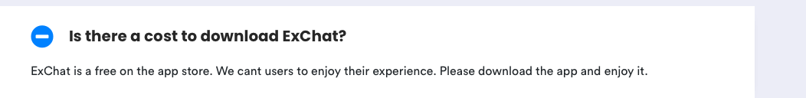

Correction:

1. “We want users to enjoy their experience.”
2. “Please download and enjoy it.”

1. What links are you referring to?

Correction:

1. “Once everything is set up correctly, you will be able to start tailoring connections with new people all around the globe.”

Correction:

1. Our logo needs to be there.



Correction:

1. Do we need this here? What is its function?

Correction:+8615315000598