Best Buy Selenium Automation Framework – Complete Project Documentation
Frameworks: pytest + Behave (BDD)

1. PROJECT TITLE & IDENTIFICATION
Student Name: Pankaj Rana
Project Title: Best Buy E-Commerce Search Automation – Dual Framework (pytest + BDD)
Superset Name: E-Commerce Test Automation Suite
Domain Name: Retail / E-Commerce
Module Name: Search Functionality Validation Module
Frameworks Covered:
• Version A: pytest (Traditional xUnit style)
• Version B: Behave (BDD / Gherkin style)

2. SYNOPSIS AND PROJECT DESCRIPTION
This project automates the testing of Best Buy's search functionality using two distinct automation frameworks. The first framework uses pytest with traditional Python test methods, while the second framework uses Behave with Behaviour-Driven Development (BDD) and Gherkin language.
Both frameworks validate:
• Correct results for valid queries
• Graceful handling of invalid inputs
• Pagination navigation
• Login and add-to-cart workflows
The frameworks follow the Page Object Model (POM) architecture and generate Allure reports with automatic screenshot capture on pass and fail.

3. TEST STRATEGY
The test strategy combines:
• Functional validation
• Boundary testing
• End-to-end integration testing
Selenium WebDriver is used as the browser automation engine for Google Chrome. Explicit waits are implemented using WebDriverWait for reliability.
pytest Framework:
• Uses fixtures, markers, hooks, and assertions
• conftest.py handles setup and teardown
Behave Framework:
• Uses Gherkin syntax (Given/When/Then)
• environment.py handles setup and teardown
Browser Used:
Google Chrome (headed mode recommended for Best Buy).

4. TEST ENVIRONMENT
Operating System:
• Windows 10 / 11
• macOS/Linux (optional)
IDE:
• VS Code
• PyCharm Community Edition
Common Tools:
• Selenium WebDriver 4.18.1
• Allure Reporting
• Pillow
• WebDriver Manager
Framework-Specific:
pytest:
• pytest 8.1.1
• pytest-html
• allure-pytest
• pytest-xdist
Behave:
• behave 1.2.6
• allure-behave

5. PAGE OBJECT MODEL (POM) STRUCTURE
pages/base_page.py
→ Common Selenium helper methods
pages/home_page.py
→ Homepage elements and country selector
pages/search_page.py
→ Search results and pagination
pages/login_page.py
→ Login functionality
pages/cart_page.py
→ Shopping cart operations

6. TEST SCENARIOS
Positive Test Cases:
TC_POS_01 – Valid Product Search Returns Results
TC_POS_02 – Result Titles Match Query Keyword
TC_POS_03 – Search Bar Retains Query
TC_POS_04 – Gibberish Search Shows No Results
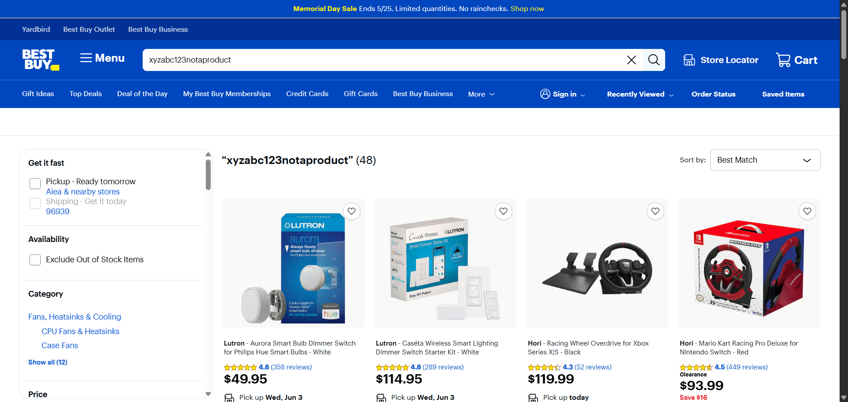
Negative Test Cases:
TC_NEG_01 – Invalid Login Credentials
TC_NEG_02 – Special Characters Handled Safely
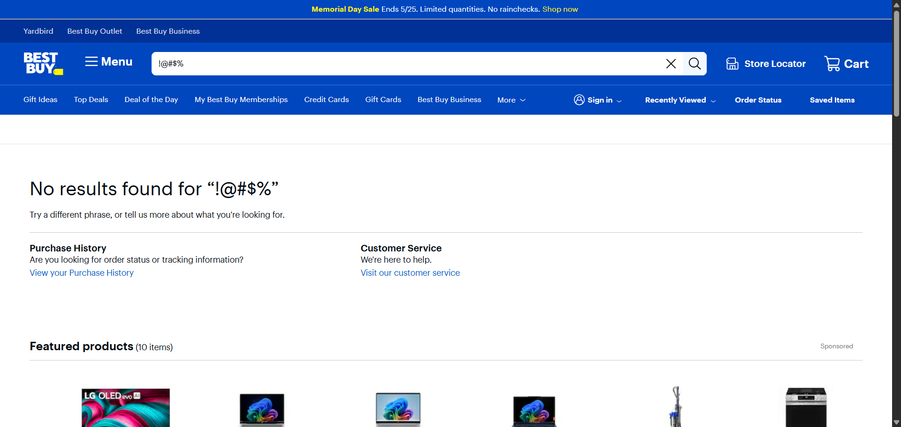
End-to-End Test:
Login → Search → Add to Cart workflow
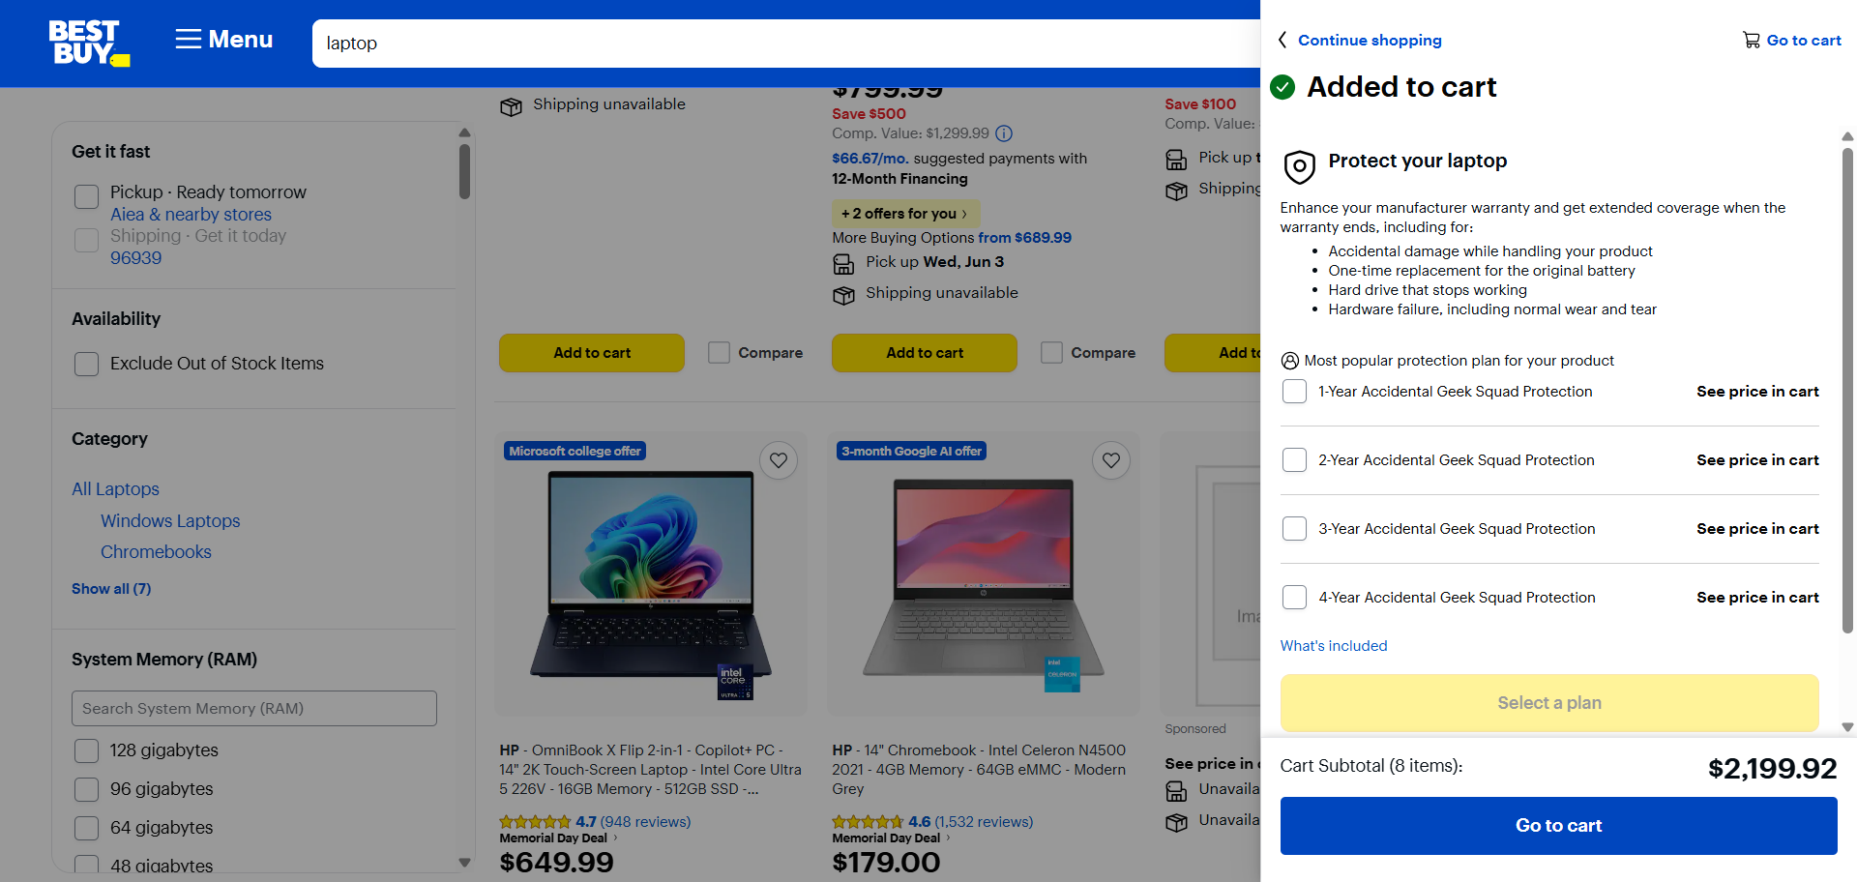

7. SAMPLE FEATURE FILE (BDD)
Feature: Best Buy Search Functionality
@positive @critical
Scenario: TC_POS_01 — Valid product search returns results
Given I am on the Best Buy homepage
When I search for the "basic_search" product query
Then the URL should indicate a search results page
And at least 1 product result should be visible
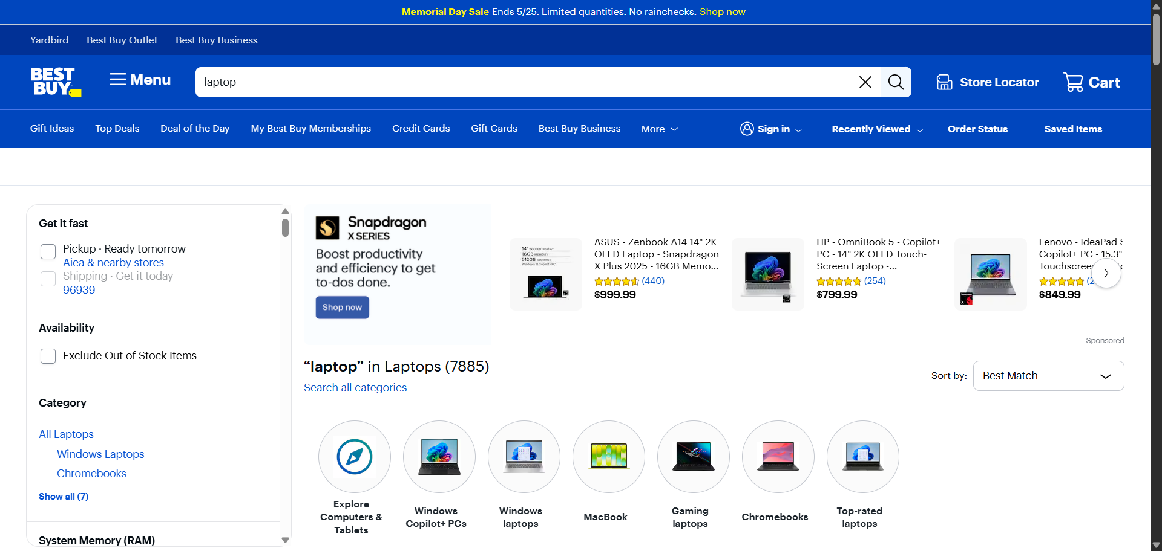

8. SAMPLE LOG OUTPUT
2025-01-15 10:23:15 | INFO | Setting up WebDriver
2025-01-15 10:23:20 | INFO | Country selector detected
2025-01-15 10:23:22 | INFO | Entering search query: laptop
2025-01-15 10:23:25 | INFO | Search results loaded
2025-01-15 10:23:27 | INFO | Screenshot saved
2025-01-15 10:23:28 | INFO | TEST PASSED

9. TEST EXECUTION SUMMARY

Test Suite | Total | Passed | Failed | Pass Rate
Positive Tests (pytest) | 4 | 4 | 0 | 100%
Negative Tests (pytest) | 2 | 2 | 0 | 100%
E2E Test (pytest) | 1 | 1 | 0 | 100%
Positive Tests (Behave) | 4 | 4 | 0 | 100%
Negative Tests (Behave) | 2 | 2 | 0 | 100%
E2E Test (Behave) | 1 | 1 | 0 | 100%
GRAND TOTAL | 14 | 14 | 0 | 100%

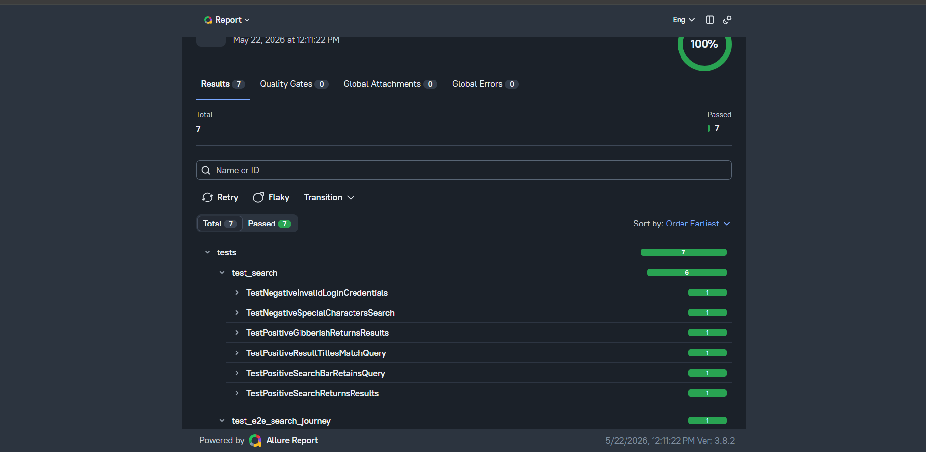

Allure for Selenium with pytest
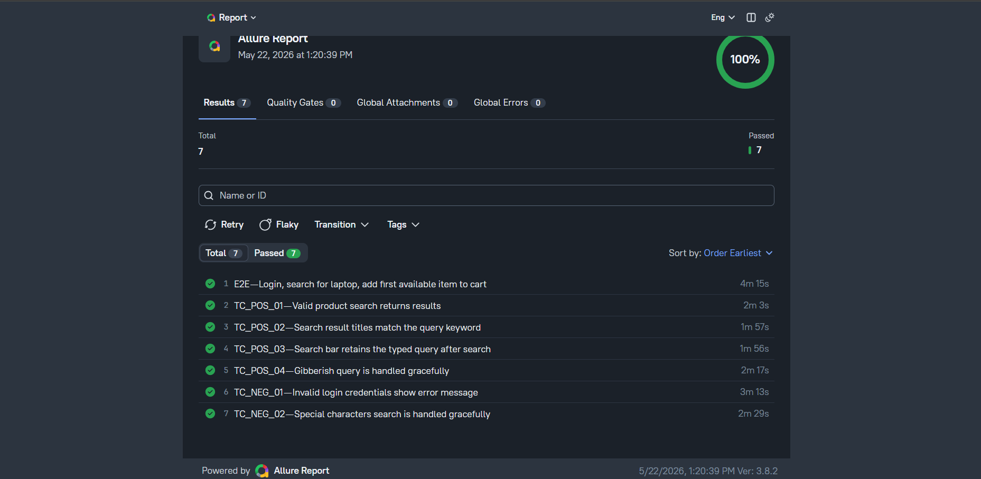
Allure for BDD with behave

10. FRAMEWORK COMPARISON
Feature | pytest Framework | Behave BDD Framework
Test Writing Style | Python Functions | Gherkin Scenarios
Readability | Moderate | High
Setup/Teardown | conftest.py | environment.py
Reporting | allure-pytest | allure-behave
Best For | Technical Teams | Cross-functional Teams

11. HOW TO RUN
pytest Commands:
pytest tests/ -v
pytest tests/ -v -m positive
pytest tests/ --alluredir=reports/allure-results -v
Behave Commands:
behave
behave --tags=@positive
behave -f allure_behave.formatter:AllureFormatter -o reports/allure-results

12. CONCLUSION
Both pytest and Behave BDD frameworks successfully validate Best Buy search functionality with robust automation coverage. The pytest framework provides simplicity and speed for developers, while Behave offers better readability and collaboration through Gherkin syntax. The Page Object Model ensures maintainability and scalability for future enhancements.

