TrackMyTrip — Figma-Ready High-Fidelity UI Specification

1. Design Direction
TrackMyTrip should feel like a calm, trustworthy travel journal—not a location tracker or accounting application. The visual hierarchy should prioritize photographs, memorable places, notes, and trip storytelling while keeping expenses, vehicle details, and odometer evidence available as supporting information. This reflects the approved product principle: meaningful checkpoints rather than continuous GPS, offline-first operation, and creator-friendly summaries.1 1
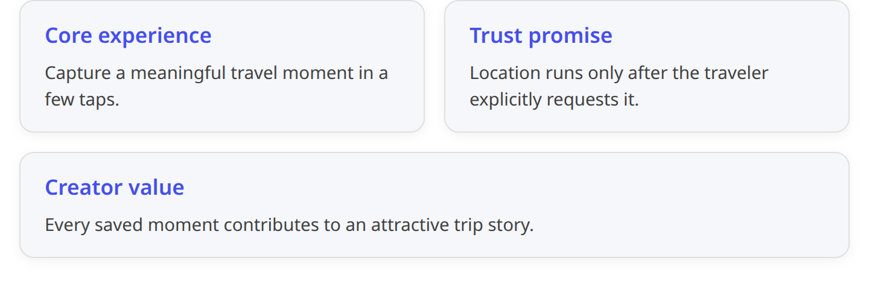

Recommended visual personality
- Editorial: large trip photography and expressive trip titles.
- Grounded: natural teal, mint, earth, and sunset colors.
- Uncluttered: one dominant action per screen.
- Transparent: clearly label location, distance, offline, and sharing behavior.
- Adaptive: restructure content into panes on tablets instead of stretching phone layouts.
Material 3 themes are structured around color, typography, and shape, and Material components inherit these theme values. Material also supports dynamic color on Android 12 and later.2 3

2. Figma Frame Set
Create these master frames:
Frame preset | Dimensions | Window class | Primary use
Android Phone | 412 × 915dp | Compact | Primary phone designs
Small Phone QA | 360 × 800dp | Compact | Text wrapping and minimum-width QA
Tablet Portrait | 800 × 1280dp | Medium | Two-column dashboards and forms
Tablet Landscape | 1280 × 800dp | Large | List-detail and supporting-pane layouts
Do not use device-name conditions in implementation. Android recommends adapting to the available window: compact is under 600dp, medium is 600–839dp, expanded is 840–1199dp, and large begins at 1200dp. Window size can change during rotation, split-screen, resizing, or folding.4

3. Material 3 Design Tokens

3.1 Brand color tokens
These are proposed TrackMyTrip tokens to enter as Figma Variables.
Token | Light | Dark | Usage
primary | #006C67 | #55DBD2 | Primary buttons, selected navigation, location action
onPrimary | #FFFFFF | #003734 | Text/icons on primary
primaryContainer | #A6F2EA | #00504C | Selected cards, active-trip emphasis
onPrimaryContainer | #00201E | #A6F2EA | Content on primary container
secondary | #4A6361 | #B1CCC8 | Filters, supporting controls
secondaryContainer | #CCE8E4 | #334B49 | Chips and subtle badges
tertiary | #835500 | #FFB951 | Highlights, journey milestones
tertiaryContainer | #FFDEA5 | #633F00 | Statistics and story highlights
error | #BA1A1A | #FFB4AB | Validation and destructive warnings
surface | #F5FBF9 | #0E1514 | Screen background
surfaceContainer | #E9F1EF | #1A2221 | Cards and sheets
surfaceContainerHigh | #E3EBE9 | #252D2C | Elevated cards
onSurface | #171D1C | #DEE4E2 | Primary text
onSurfaceVariant | #3F4947 | #BEC9C6 | Supporting text
outline | #6F7977 | #899390 | Text-field and control outlines
outlineVariant | #BEC9C6 | #3F4947 | Dividers
Create Light, Dark, and optional Dynamic variable modes. Use brand colors for exported stories even when Android dynamic color is enabled, so shared content retains a consistent TrackMyTrip identity. Material’s official Figma kit works with Material Theme Builder and contains variables, components, code snippets, and prototyping support.3 2

3.2 Typography
Use Roboto for UI and Roboto Serif only for optional editorial trip-story headings.
Figma style | Specification | Application
Display Small | 36/44 Regular | Onboarding statements
Headline Large | 32/40 Medium | Trip story title
Headline Medium | 28/36 Medium | Dashboard greeting
Headline Small | 24/32 Medium | Screen headings
Title Large | 22/28 Medium | Trip names
Title Medium | 16/24 Medium | Card headings
Body Large | 16/24 Regular | Notes and forms
Body Medium | 14/20 Regular | Supporting information
Label Large | 14/20 Medium | Buttons and tabs
Label Medium | 12/16 Medium | Chips and metadata
These align to Material 3’s display, headline, title, body, and label structure.2

3.3 Spacing and shape
- Base spacing: 4dp.
- Standard sequence: 4, 8, 12, 16, 24, 32, 40, 48.
- Phone horizontal margin: 16dp.
- Tablet outer margin: 24–32dp.
- Tablet pane gutter: 24dp.
- Text field/card vertical rhythm: 12–16dp.
- Shapes:
  - Extra small: 8dp
  - Small: 12dp
  - Medium: 16dp
  - Large: 24dp
  - Extra large: 28dp
  - Pills/FABs: full radius
Material 3 provides shape scales and tonal surface elevation; prefer tonal container differences over heavy shadows.2

3.4 Icons and imagery
- Use Material Symbols Rounded, 24dp default.
- Use filled symbols only for selected navigation states.
- Trip-cover ratio: 16:9.
- Timeline image: 4:3.
- Story/social previews: 4:5, 1:1, and 9:16.
- Use image overlays only where necessary for text legibility.
- Location pins must represent saved checkpoints, never a continuous path.

4. Onboarding and Authentication
Onboarding must communicate the value proposition but must not request Android location permission. Request permission only when the traveler presses Use current location while creating or editing a record. Android specifically recommends requesting permissions when needed and treating one-time location as foreground/session access.5 6
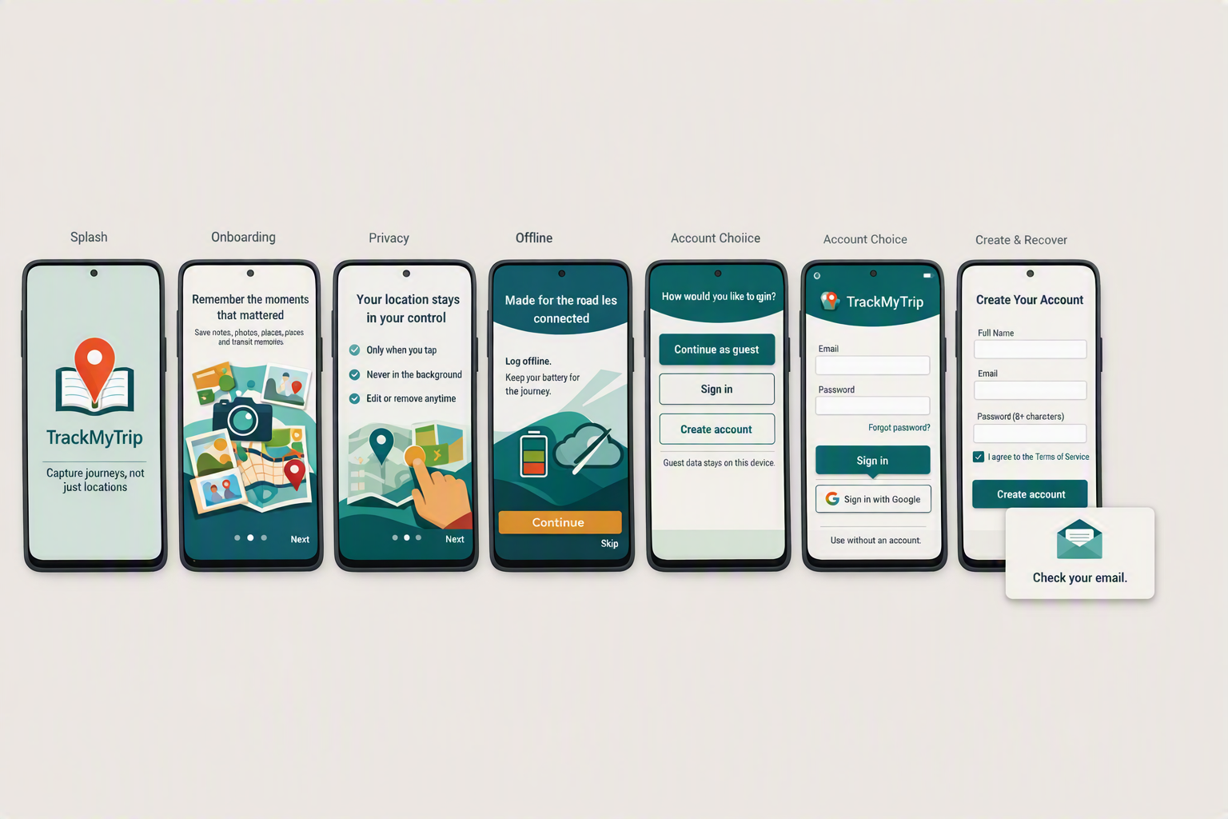
Figure 1: Onboarding and authentication concepts explain TrackMyTrip’s memory-first purpose, one-time location behavior, offline operation, and optional local-only entry before account screens.

Onboarding screens
- Welcome
  - Logo: map pin combined with an open journal.
  - “Capture journeys, not just locations.”
  - Full-width Get started button.
  - Secondary I already have an account.
- Memories
  - Editorial timeline illustration.
  - “Remember the moments that mattered.”
  - Supporting copy: notes, photos, places, and transport.
- Privacy and battery
  - Location-button illustration.
  - “Your location stays in your control.”
  - Three icon rows:
    - Only when you tap.
    - Never in the background.
    - Edit or remove anytime.
- Offline
  - “Made for the road less connected.”
  - “Log offline. Keep your battery for the journey.”
- Choose how to begin
  - Primary: Continue as guest.
  - Secondary: Create account.
  - Text action: Sign in.
  - Caption: “Guest data stays on this device.”

Authentication
- Sign in: email, password, show-password control, Forgot password, Sign in, Continue as guest.
- Sign up: name, email, password, requirements, terms checkbox, Create account.
- Recovery: email field → Send recovery link → confirmation state.
- Authentication error: retain entered email, display inline error plus summary snackbar.
- Never block local-only use because authentication is optional in the approved MVP.1 7

5. Navigation Architecture

Phone
Bottom navigation with four destinations:
- Home
- Trips
- Insights
- Settings
Use an extended FAB labeled Add update when a trip is active; otherwise use New trip. Material recommends a navigation bar for compact layouts with five or fewer destinations.2

Tablet
- Medium width: navigation rail.
- Expanded/large: navigation rail or permanent drawer.
- Use list-detail presentation for Trips, Timeline, Expenses, Settings, and Privacy.
- Preserve the user’s selected trip when the window changes size.
Material identifies navigation rails for tablets or landscape layouts and permanent drawers for larger layouts.2 4

6. Major Screen Specifications
Screen | High-fidelity layout and interactions | Tablet adaptation
Dashboard | Greeting; active-trip hero; latest memory; Add update FAB; recent trips carousel; small statistics cards | Rail + two-column grid; active trip spans two columns
My Trips | Large title; search; Active/Upcoming/Completed/Archived filter chips; photography-led trip cards | Left trip list, right selected-trip preview
Create Trip | Cover-photo slot; title; type segmented control; dates; destinations; description; default transport; Create trip | Form 65%; live trip-card preview 35%
Trip Details | Collapsing photo header; trip status; Timeline/Map/Expenses tabs; Update/Odometer/Share actions | Timeline list left; map or selected memory right
Journey Update | Moment title; note; location card; transport chips; photo carousel; expense action; sticky Save | Main form + context/privacy supporting pane
Vehicle/Odometer | Vehicle selector; km/mi; start/end readings; start/end photo cards; calculated distance | Reading/photo comparison in two columns
Expense Entry | Prominent amount; currency; category grid; date; description; receipt; linked moment | Form left; category/total summary right
Timeline | Day headers; vertical rail; memory cards with place, note, images, mode, and expense chip | Timeline left; selected memory detail right
Checkpoint Map | Full map; checkpoint pins; filter chips; selected-place bottom sheet; “Not a tracked route” label | Map 65%; checkpoint list/detail 35%
Travel Statistics | Trips, places, travel days, modes; clear links back to underlying trips | Responsive 2–4-column grid
Trip Summary | Editorial cover; dates; highlights; selected photographs; places; modes; optional expense total | Story preview left; customization right
Sharing | Format: Image/PDF; aspect ratio; privacy toggles; preview; Share | Large preview with persistent settings pane
Settings | Appearance, units, currency, vehicles, backup/account, storage, accessibility | Category list left; detail pane right
Privacy Controls | Location explanation; saved-location review; sharing defaults; local-only/account status | Privacy categories left; explanation/detail right
Export/Delete | Export trip/all data; choose format; storage summary; delete trip/account/all-data actions | Data scope list and export configuration side by side

Journey Update location card
Default state:
Location not attached
TrackMyTrip is not accessing your location.
Use current location · Enter place manually
After tapping Use current location, show an app-owned education sheet, followed by the Android permission surface if necessary. Show progress with Cancel; on timeout offer Try again, Enter manually, and Save without location. The approved requirements explicitly prohibit periodic/background collection and require acquisition to stop after success, timeout, cancellation, or leaving the screen.1 7

Vehicle and odometer
Display this section only for Car, Motorcycle, Campervan/RV, and Other Self-driven Vehicle:
- Vehicle name and optional registration alias.
- Reading unit: km/mi.
- Start reading with Take photo and Choose photo.
- End reading with the same actions.
- Calculated-distance card: End − Start.
- Source chip: Odometer.
- Inline blocking error when end < start.
- Confirmation warning for unusually large distance.
- Neither reading nor photo blocks trip saving.
The requirement includes optional start/end readings, optional evidence photographs, editable values, validation, and exclusion of evidence from sharing by default.1 7
For gallery selection, hand off to Android Photo Picker rather than designing a custom full-library screen. The picker grants access only to selected media and supports single or multiple selection.8

7. Tablet Design Concepts
The following board demonstrates the required adaptive behavior. Tablet layouts reorganize into navigation, list/detail, and supporting panes instead of enlarging phone cards.4 2
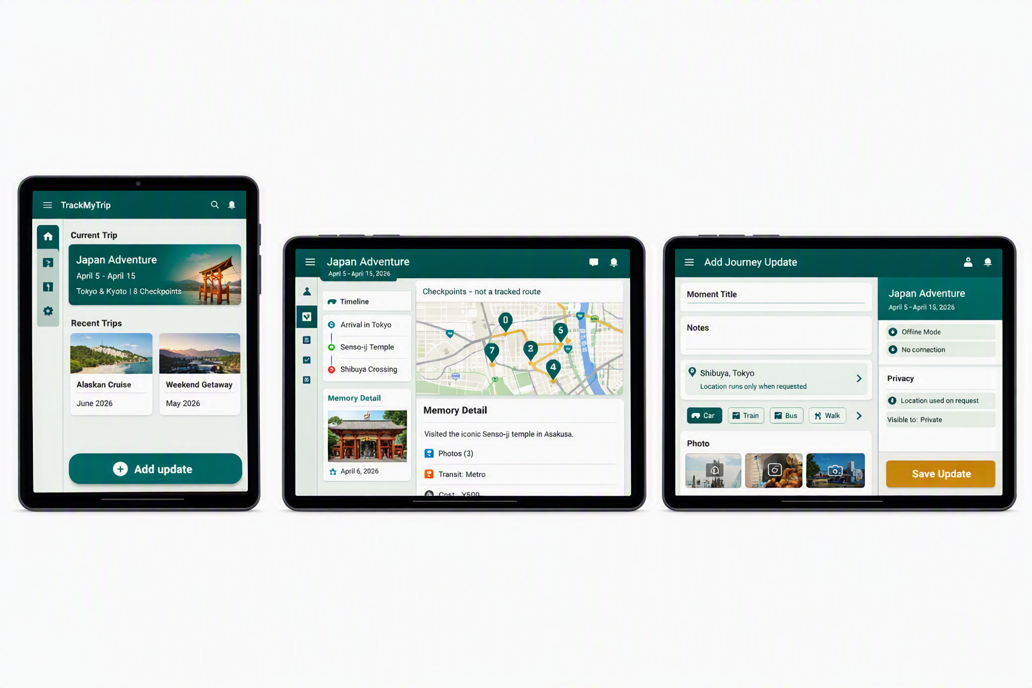
Figure 2: Adaptive tablet concepts use navigation rails and list-detail or supporting-pane layouts rather than stretching phone screens across a larger canvas.

Pane rules
- Maximum readable form width: 640dp.
- Supporting pane: 360–420dp.
- Timeline list: 360–440dp.
- Map/detail consumes remaining width.
- At compact height, collapse supporting panes into full-screen destinations or modal bottom sheets.
- Drag-and-drop is optional post-MVP; do not make it the only reordering mechanism.

8. States and Feedback
State | Required presentation
Empty dashboard | Illustration, “Your next journey starts here,” New trip button
Empty timeline | “Add your first memory,” Add update button
Offline | Persistent compact banner: “Offline — changes saved on this device”
Saved | Snackbar: “Journey update saved” with Undo where safe
Location loading | Inline progress, explanation, Cancel
Location denied | Neutral—not error—state with manual-entry primary action
Location timeout | Retry, manual entry, save without location
Map unavailable | Checkpoint list and place labels remain visible
Odometer invalid | Inline error beneath end-reading field
Optional photo missing | Helper text only; never error styling
Exporting | Determinate progress where possible; cancel action
Export success | Preview file; Share and Save another copy
Destructive action | Scope-specific confirmation; type DELETE only for delete-all/account
Interrupted local save | Recovery message with Retry and View draft

9. Accessibility Specification
- Minimum interactive target: 48 × 48dp.
- Do not communicate trip, sync, expense, or warning state by color alone.
- Provide content descriptions for meaningful images and icons.
- Decorative cover imagery should not create repetitive TalkBack output.
- Announce save, export, deletion, and location-capture completion.
- Preserve logical focus order across tablet panes.
- Support large font scaling without clipping; convert side-by-side actions to stacked actions where required.
- Every map action must have an equivalent checkpoint-list action.
Android recommends designing accessibility from the beginning, including content labels, scalable content, testing, color contrast, and sufficiently sized targets.6 9

10. Figma File Structure
1 00 — Cover & Product Principles
2 01 — Foundations
3 Colors / Typography / Spacing / Shapes / Iconography / Elevation
4 02 — Components
5 Navigation / Buttons / Cards / Inputs / Chips / Sheets / Dialogs
6 03 — Patterns
7 Trip Card / Memory Card / Location Card / Photo Grid
8 Expense Row / Odometer Card / Offline Banner / Story Preview
9 04 — Phone — Onboarding & Auth
10 05 — Phone — MVP Screens
11 06 — Tablet — Medium
12 07 — Tablet — Expanded & Large
13 08 — States & Accessibility
14 09 — Prototype Flows
15 10 — Developer Handoff
16 99 — Archive

Component naming
1 TMT/Button/Primary/{Default|Pressed|Disabled|Loading}
2 TMT/Card/Trip/{Active|Upcoming|Completed|Archived}
3 TMT/Card/Memory/{Text|Photo|Expense|Transport}
4 TMT/Location/{Idle|Loading|Captured|Denied|Timeout|Manual}
5 TMT/Odometer/{Start|End}/{Empty|Entered|PhotoAdded|Error}
6 TMT/Banner/{Offline|Warning|Success}
7 TMT/Navigation/{Bar|Rail|Drawer}
Use component properties for icon visibility, label text, status, photo presence, transport mode, and phone/tablet density. Start from the official Material 3 Figma library rather than redrawing standard Material controls.3 10

11. Prototype Flows
- Guest first use: Welcome → privacy onboarding → Continue as guest → Dashboard empty state → Create trip.
- Journey memory: Active trip → Add update → add note/photo → optionally request location → Save → timeline.
- Self-driven journey: Select Motorcycle → choose vehicle → start odometer/photo → memories → end odometer/photo → complete.
- Influencer sharing: Trip Details → Summary → select highlights/photos → privacy review → image/PDF preview → share.
- Offline: Offline dashboard → add update/expense → saved-locally state → reconnect state.
- Data control: Settings → Privacy → Export → Delete trip/all data.
The source phone-core image board encountered a rendering error, so its fully specified layouts are provided above; the onboarding/authentication and adaptive-tablet concept boards were generated successfully.

