NexaAssist

Model Access

STATUS  Proposed |  | OWNER  Unassigned |  | LAST UPDATED  24 October 2026

Authors | Codex draft
Reviewers | User review pending
Related docs | CAPABILITY_MAP.md; SPEC-model-access.md; CONSTRAINTS.md
Scope | model-access: explicit clients, judge separation and embedding integrity

1. Abstract
Proposed foundation for Session 2: connect the existing application to explicit OpenAI or Ollama model profiles while preserving cited answers, redaction and Datadog instrumentation. The user approved the capability map on 24 October 2026; this module specification awaits review.
The requested local models are qwen3.5:9b-mlx for chat and qwen3-embedding:0.6b for embeddings. Local availability, model digest, actual vector length and structured-output behavior remain unverified. Acceptance criteria are maintained in SPEC-model-access.md.

2. Goals and Non-Goals
Goals | Non-goals
Preserve the existing OpenAI path | Routing and cache policy: gateway-routing
Support the requested local model tags | Guardrails AI integration: security-guardrails
Reject incompatible embedding profiles | Comparison runs: evaluation-profiles
Keep existing data and safeguards intact | Live performance or production certification

3. Background and Problem Statement
Current factories use OpenAI configuration and force Responses for chat. Ingestion fingerprints embedding model and dimensions, but stable chunk IDs can replace vectors in the configured collection when those settings change. Judge configuration currently inherits candidate settings.
The foundation extends shared factories and validated server settings. Ingestion and retrieval must agree on one embedding identity and use its matching Atlas stores. A different embedding family uses separate collections and index; matching vector lengths alone are insufficient.

4. Proposed Architecture

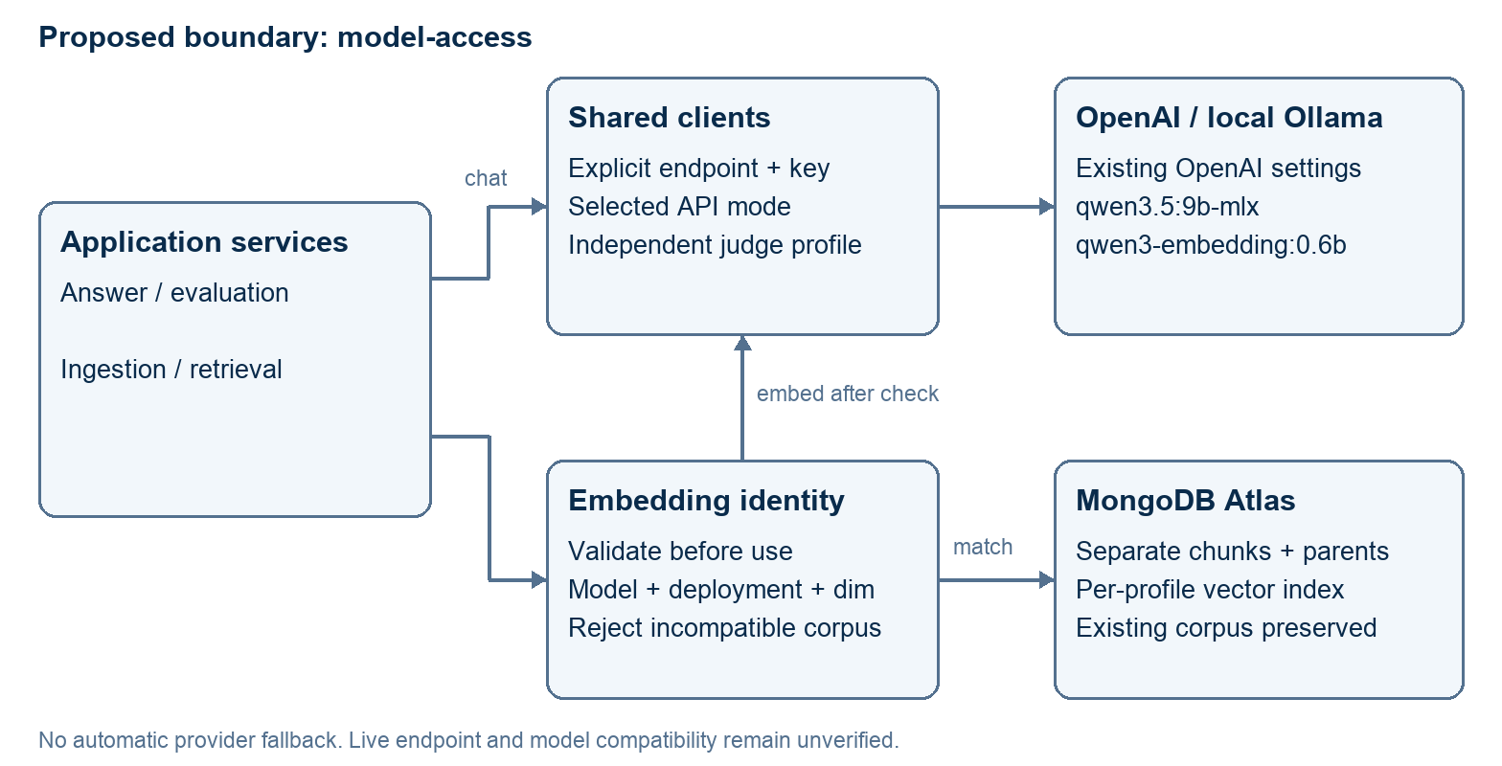
Figure 1. Proposed model-access boundary; no automatic provider fallback.

Core components

Component | Responsibility | Primary storage | Failure behavior
Settings | Resolve endpoint, mode, key and profile | Environment / SecretStr | Reject invalid configuration
Chat client | Use explicit OpenAI or local contract | Configured provider | Bounded calls; no implicit fallback
Embedding client | Share document/query profile; validate vectors | Configured provider | Reject malformed vectors
Corpus boundary | Bind model/profile to chunks, parents and index | MongoDB Atlas | Refuse incompatible reads/writes
Judge / telemetry | Separate judge identity; retain Datadog spans | Explicit judge; Datadog | No key inheritance; no invented metadata

5. Request Lifecycle
- Load validated server settings. Existing OpenAI configuration remains the default; local profiles explicitly identify endpoint, credentials and API mode.
- Apply existing request validation and PII redaction. Endpoint selection is server-controlled. Reject embedded URL credentials and invalid mode combinations.
- Before query embedding or ingestion mutation, verify the selected corpus identity against the requested embedding profile. Unknown or mixed identities fail closed.
- Invoke the shared chat or embedding client. Local embeddings carry text. Validate returned vector dimensions and finite values before Atlas writes or searches.
- Use matching, isolated chunk and parent collections. A rejected profile must leave existing chunks, parents and stale-chunk deletions unchanged.
- Keep the existing chat cap, 60-second timeout and one retry. Unsupported structured output and exhausted calls preserve sanitized errors or the existing safe rejection path.
- Validate the cited answer using existing checks and emit current workflow, prompt and token telemetry. A judge resolves its own endpoint and credential when evaluation is requested.

6. API and Data Contracts

Primary data contract

Field | Type | Required | Description
Chat profile | Server settings | Yes | Model, endpoint, credential and API mode
Embedding profile | Server settings | Yes | Model, expected dimensions and deployment identity
Corpus binding | Store identity | Yes | Matching chunk / parent collections and vector index
Judge profile | Server settings | For eval | Resolves independently from the candidate
Credential | SecretStr | Per call | Explicit endpoint secret; never logged
API mode | Validated choice | Chat | Current OpenAI Responses or local Chat Completions
Vector result | Finite floats | Embedding | Length must equal configured dimensions

Contract guarantees

- Profile validation precedes query embedding and corpus mutation; returned vectors are validated before Atlas uses them.
- Existing chunk IDs and checksums retain their meaning inside one compatible corpus. No cross-profile replay or automatic conversion.
- Record configured model, expected dimensions and declared deployment/profile identity without recording credentials. Missing provider metadata stays unknown.
- Configuration declares the intended profile; successful preflight establishes observed runtime compatibility. Neither proves production quality.
The review specification and acceptance conditions are maintained in
SPEC-model-access.md; implementation is pending specification review.

7. Consistency, Idempotency, and Replay

Matching-profile ingestion keeps current checksum reuse and failed-document retention behavior. Profile changes cannot rewrite an existing corpus. Current ingestion spans two collections without a transaction; concurrent ingestion is outside this proposal’s guarantees.
Scenario | Expected behavior | Reasoning
Same profile; unchanged document | Preserve existing checksum reuse | No needless embedding calls
Mixed or incompatible corpus | Reject before mutation or query embedding | Protect existing vectors and parents
Provider timeout / invalid result | Keep bounded errors and output validation | Do not silently switch providers
Candidate profile changes | Explicit judge and corpus profiles stay fixed | Avoid evaluator drift and key leakage

8. Security and Privacy Considerations

- Keep institution, jurisdiction, confidentiality and date filters. Local and cloud embedding profiles use separately named chunk and parent collections.
- Reuse current PII redaction and citation checks. Logs and traces omit secrets and use sanitized payloads; this proposal does not claim comprehensive injection protection.
- Use pydantic-settings and SecretStr. A custom endpoint receives its explicit credential; an OpenAI key must not be inherited by an unrelated endpoint.
- Local operations do not need a real OpenAI key. No automatic cloud call, model download, index creation or existing-corpus migration.
- Use synthetic training data for later preflight. This review changes no retention or residency policy and performs no external model or Atlas call.

9. Operational Readiness
Signal | SLO or alert | Owner | Launch gate
Offline acceptance | MA-01 to MA-08 in specification | Unassigned | Required
Latency / cost | No new target; existing gates are placeholders | Unassigned | Live evidence pending
Errors / timeouts | Existing bounded behavior retained | Unassigned | Offline contract
Profile drift | Reject incompatible or unknown binding | Unassigned | Required
Corpus integrity | No existing OpenAI data overwritten | Unassigned | Required
Review only: no application code, model download, Atlas migration or live rollout is included in this delivery.

10. Alternatives Considered

Alternative | Why it was considered | Why it was not selected
Shared LangChain clients | Installed integration and existing callers | Selected for standard API fields; runtime compatibility must be checked
New provider framework | Provider-specific extensions | No required extension established; avoid another dependency
Reuse one corpus for all embeddings | Fewer collection settings | Stable upserts can mix or overwrite incompatible vectors
Automatic embedding fallback | Apparent availability benefit | Different embedding spaces cannot share one corpus

11. Open Questions
- Specification approval: the capability map is approved; this module’s requirements and guarantees still need user review.
- Runtime evidence: exact local tags, deployment identity, vector length and structured-output compatibility have not been observed.
- Deployment evidence: isolated Atlas collection/index names and readiness are operator configuration, not assumed cluster facts.
- Operations ownership: no production owner or production SLO has been assigned by this proposal.

12. Decision and Next Steps
Review SPEC-model-access.md first. The selected spec-driven workflow then requires a reviewed implementation plan and task list before TDD implementation. The requested handoff captures that phase boundary; no application implementation or live readiness is claimed.
Milestone | Deliverable | Exit criteria
M1 | Capability boundaries | Approved by user on 24 October 2026
M2 | This model-access specification | User review pending
M3 | Plan and task list | Not started; follows spec approval
M4 | Implementation and verification | Not started; failing tests first after plan/task review

Proposed requirements; implementation and live model checks are pending.

