NexaAssist

LLMOps System Design

STATUS — Teaching draft |  | OWNER — Not assigned |  | LAST UPDATED — 23 Oct 2026

Authors | NexaAssist workshop
Reviewers | Engineering + SME (pending)
Related docs | Course map; C4 views; handouts
Scope | Policy RAG training design

1. Abstract
NexaAssist answers staff questions from registered synthetic banking-policy documents. It separates offline knowledge preparation from online retrieval and generation, preserving date scope, citations and answer provenance. This document describes the inspected training implementation and explicitly identifies course concepts that remain future work.
The implementation uses LangChain LCEL, MongoDB Atlas Vector Search, FastAPI and Streamlit. Required labs are offline. Provider quality, Atlas compatibility, Datadog export and production load have not been established by the training fakes. Organizational owners and targets remain unconfirmed.

2. Goals and Non-Goals
Goals | Non-goals
Explain all sixteen lessons with mapped practicals | Copying the course text or replacing MongoDB Atlas
Preserve typed, grounded policy answers | Credit decisions or account actions
Make quality and SLO evidence reviewable | Claiming live performance from fakes
Rehearse a compatible rollback decision | Automatic index promotion or production deployment

3. Background and Problem Statement
The Educative course develops an internal support assistant and progressively adds ingestion, retrieval, prompt management, evaluation, serving, conversation state and feedback. NexaAssist adapts the same responsibilities to synthetic policy documents. The first decks underrepresented several course lessons; the revised decks now map all sixteen lessons to specific sections and exercises.
The invariant is that the UI renders, routers validate and delegate, services coordinate workflows, chains contain pure LangChain logic, and database modules own MongoDB access. No loan approval, account action or autonomous tool execution is authorized. External service configuration does not establish measured availability or data permission.

4. Proposed Architecture

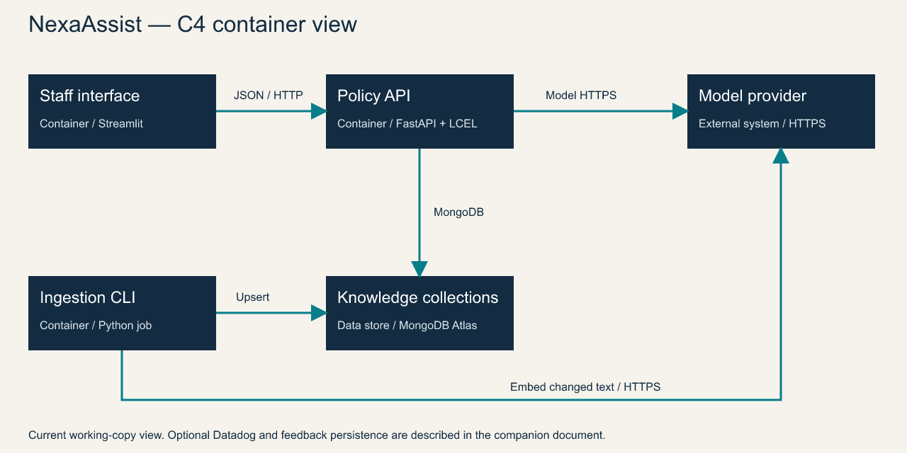
Figure 1. NexaAssist C4 container view; optional telemetry and feedback are described below.

Core components

Component | Responsibility | Primary storage | Failure behavior
Ingestion CLI | Verify, parse, redact and upsert changed documents | Registered files; Atlas chunks/parents | Isolate failed documents and report failure
Retrieval service | Apply query and corpus/date scope | Atlas Vector Search + parent store | Propagate dependency error; report empty evidence
Answer chain | Render prompt, generate and check draft | Model API and bounded context | Abstain or clarify; one citation repair
Feedback workflow | Save stable submissions and reviewer decisions | MongoDB feedback collection | Reject identity conflict; surface unavailable store
Observability/evaluation | Record operational and semantic evidence | Local reports; optional Datadog | Preserve answer when optional publication fails

5. Request Lifecycle
- Streamlit submits a question, policy date and optional product to POST /answer.
- Validate the contract and quota, then mask selected query identifiers. End-user authorization remains a deployment decision.
- Load configured retrieval/model settings; apply corpus/date filters and retrieve parents plus amendments.
- Budget evidence, render the tracked prompt and request a strict draft; abstain if required evidence is missing.
- No conversation write precedes generation. Feedback is stored separately; multi-turn history is not implemented.
- Bound provider calls, allow one citation repair and discard detected sensitive output. Readiness bounds its database ping.
- Return answer, citations, provenance and timings. Optional background judging and telemetry support diagnosis.

6. API and Data Contracts

Primary data contract

Field | Type | Required | Description
query | string | Yes | Bounded non-empty policy question
as_of | date | Yes | Policy lookup date; distinct from loan sanction date
product_id | string or null | No | Narrows the requested product scope
status | enum | Yes, response | answered, insufficient_evidence or needs_clarification
answer | string | Yes, response | Validated explanation, fixed clarification or abstention
citations | array | Yes, response | Exact quotes with matched-child identities
provenance | object or null | Response field | Prompt fingerprint, model/retrieval settings and evidence references

Contract guarantees

- Requests and drafts must satisfy their typed contracts before a supported answer is returned. Exact quotes must occur in the supplied source context.
- Ingestion uses deterministic chunk identity and checksums. Feedback IDs derive from institution, submitter and submission identifiers; conflicts are rejected.
- Capture prompt ID/version/hash, chat and embedding identities, retrieval mode and evidence references. A reproducible release also needs corpus, dataset and container identities.
- A client-submitted feedback response is investigation context, not server-authenticated proof or a golden reference. A human verifies any correction against policy evidence.
The running local API publishes its schema at
http://127.0.0.1:8000/openapi.json. Update the versioned models with each contract release.

7. Consistency, Idempotency, and Replay

Repeated unchanged ingestion skips re-embedding, while embedding or metadata changes invalidate checksums. Per-document failure isolation permits other documents to proceed and reports failure. There is no atomic blue/green corpus promotion. Parent and chunk stores must remain compatible. Feedback submission retries use stable identity and reject conflicting reuse.
Scenario | Expected behavior | Reasoning
Unchanged ingestion | No re-embedding for matching checksums | Stable identifiers and compatibility metadata
Dependency unavailable | Safe API error; private details hidden | No fabricated answer on dependency failure
Invalid citation or output PII | One citation repair, or discard sensitive draft | Preserve source and output integrity
Changed model/index configuration | Rebuild/evaluate compatible candidates | Equal dimensions alone do not prove compatibility

8. Security and Privacy Considerations

- Reviewer listing/review uses a shared bearer credential in this training app. Request metadata scopes retrieval. End-user identity, authorization, tenancy and externally exposed deployment boundaries need approval before a real rollout.
- Corpus and query patterns cover selected email, phone, PAN and Aadhaar identifiers. The output rail checks generated text and quotes. Names, addresses and arbitrary sensitive text are not comprehensively detected. Avoid recording private raw content in ordinary logs.
- Configuration uses pydantic-settings and SecretStr. Inject secrets at runtime; the application image must exclude .env. Trace payload collection needs a reviewed retention and access policy.
- Required teaching labs use fakes and temporary copies. Ingestion is an operator CLI. Live evaluation, re-indexing and deployment must use approved credentials, data permissions and budgets.
- Freshness, retention, deletion, residency and telemetry access are owner decisions. Synthetic fixtures do not authorize processing real customer data. Document those decisions in the use-case manifest before a production release.

9. Operational Readiness
Signal | SLO or alert | Owner | Launch gate
Quality | gates.json placeholders; confirm against reviewed cases | Unassigned | Required
Latency | Representative p95; no live claim | Unassigned | Required
Errors/cost | Measured request mix and approved prices | Unassigned | Required
Artifact drift | Track prompt/model/corpus/dataset identity | Unassigned | Required
Recovery | Rehearse known-good configuration and replay | Unassigned | Required
Rollout constraint: hold while required measurements or approvals are missing. Blue/green corpus promotion and multi-turn memory remain design work.

10. Alternatives Considered

Alternative | Why considered | Why not selected here
PostgreSQL / pgvector | Source-course converged database example | Project requires MongoDB Atlas Vector Search
LiteLLM / Jinja registry | Source-course provider/template abstraction | Existing LangChain integrations and prompt artifacts are sufficient for this layer
Stateful memory and rewriting | Course lesson 14 conversational workflow | Needs separate scope, authorization and multi-turn evaluation
Self-hosted inference | Potential control and steady-load economics | No measured traffic or capacity evidence justifies operating GPUs

11. Open Questions
- Who owns approval of quality/SLO thresholds and the live evaluation dataset?
- What end-user identity, data authorization, retention and provider-disclosure rules apply to a real corpus?
- Which deployment environment, traffic profile and recovery objective will be measured?
- How should reviewer identity, live prompt-release evaluation, CI and isolated index promotion be approved and verified?

12. Decision and Next Steps
Use the source-aligned workshop as an implementation and review guide. Preserve the working layer boundaries, run the required offline labs, then collect live retrieval/quality and staging traffic evidence in an approved environment. Production remains a hold until required measurements, ownership and rollback rehearsal are complete.
Milestone | Deliverable | Exit criteria
M1 | Source-aligned decks, diagrams and offline practicals | Coverage and artifact checks pass
M2 | Approved live retrieval/answer evaluation | Measured report against confirmed targets
M3 | Staging traffic and recovery rehearsal | SLOs observed; owners and rollback identified
M4 | Production release decision | Required evidence and approval complete

RAG retrieves source evidence before generation; grounding and source access remain application responsibilities.

