

User Guide

For the functionality of the tool

303 E WACKER DR, SUITE 950

CHICAGO, IL 60601

312.243.1140



Table of Contents

Table of Contents 2

1. Document Overview 3

2. Solution (Flow for Executing Cucumber Test)………………………………………………………………………4

1. Document Overview:

The given document explains how a User can test the SKU and it’s Attributes data by using this tool. So the user have to provide all the user input data which is needed for tool to run the test. After inserting all the information needed, the tool will execute the cucumber test and will display the pass and fail status after execution. This tool will also generate a Html report and a log file of the result.

1. Solution (Flow for Executing Cucumber Test)

Requirements for running the jar file:

For running the jar file user must have java installed in the system and couple of things like **Batch file**, folder containing all the required **Dependency Jar files**, and **Step automation jar** the jar which will help to execute the cucumber test.

**Note: -** The Batch file, Dependency Jars folder and Step automation jar must be in same folder.

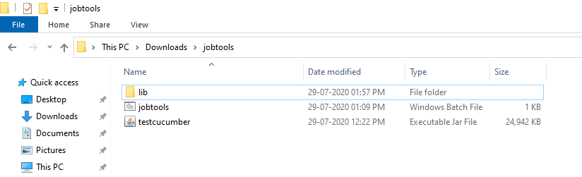

**Step 1:** User will have to click on the batch file to run it i.e. “**jobtools.bat**” and then the below screen will show up.

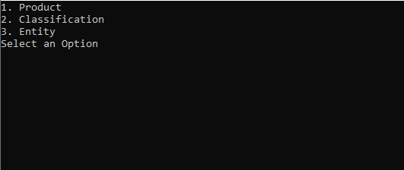

**Step 2**: In this step the User will get three options i.e. enter ‘1’ for testing **Product** data, enter ‘2’ for testing **Classification** data and enter ‘3’ for testing **Entity** data. After selecting anyone of this option the user will proceed to the next step.

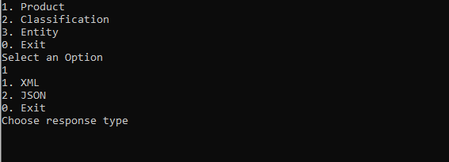

**Step 3:** In this step the user will get three options i.e. enter ‘1’ for testing the data of the input file with **XML** response file (**restapi**), enter ‘2’ for testing the data of input file with JSON response file (**restapiv2)** and enter ‘0’ for exit.

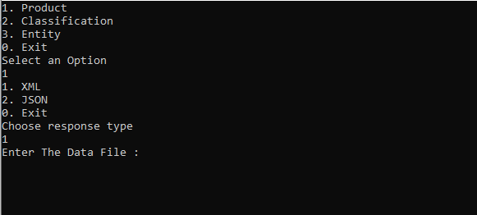

**Step 4:** Inthis step the User will have to insert the file path of the file which needs to be tested under ‘**Enter the Data File**’. User can provide file in two formats tab delimited text and Excel (xlsx, xls).

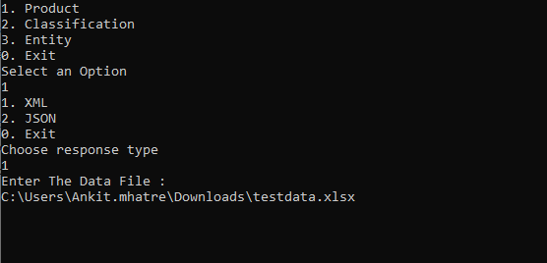

**Step 5:** In this step the User will have to provide the number of thread to be created for running the test.

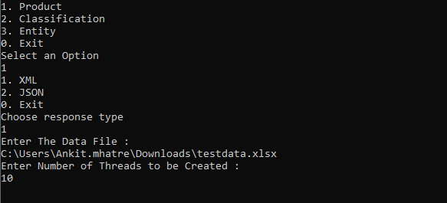

**Step 6:** In this step the User will have to insert the host URL under ‘**Enter the HostURL**’.

For Example: <http://cfd-stb1.codifyd.com/>

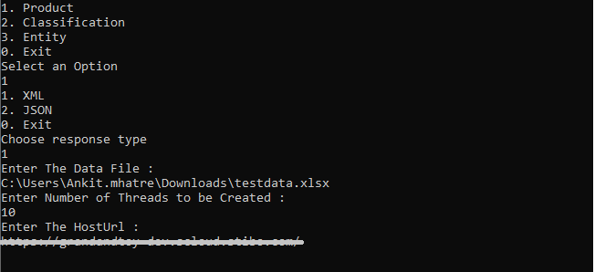

**Step 7:** In this step the User have to provide the **Context ID** of the context in which they want to test the data

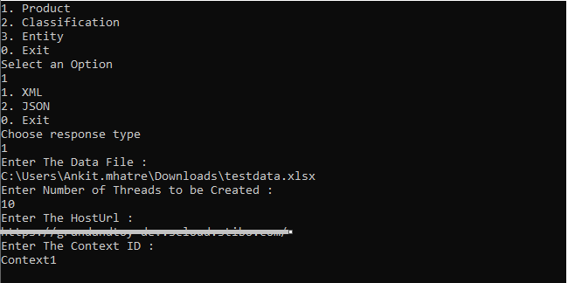

**Step 8:** In this step the User have to provide the ‘**User Id**’ and ‘**Password**’ of the instance in which they want to test data.

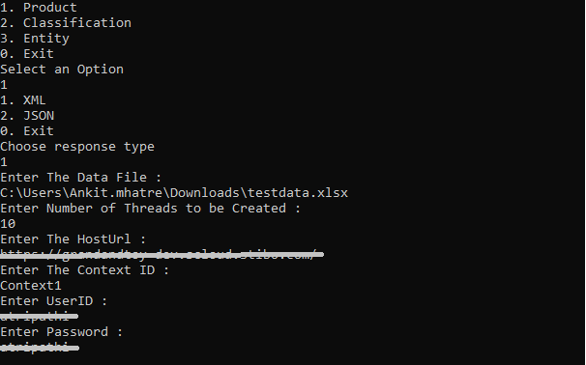

**Step 9:** In this step the User have to provide the output path for the generated report. If user does not give the output path, it will generate the report at the default path i.e. the path at which Batch file is present.

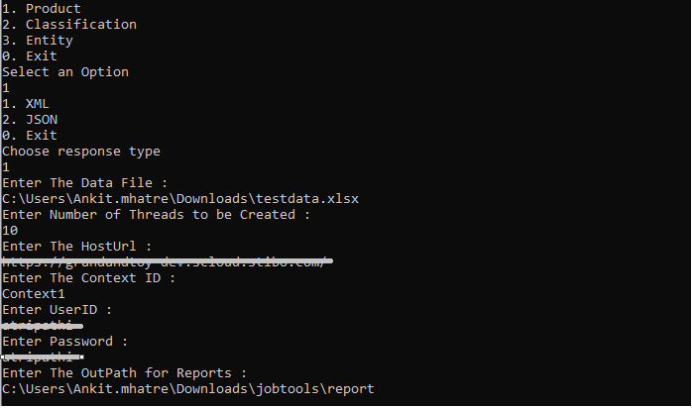

After giving the path it will run the test and the result’s will be displayed accordingly and it will also display the pass and fail status.

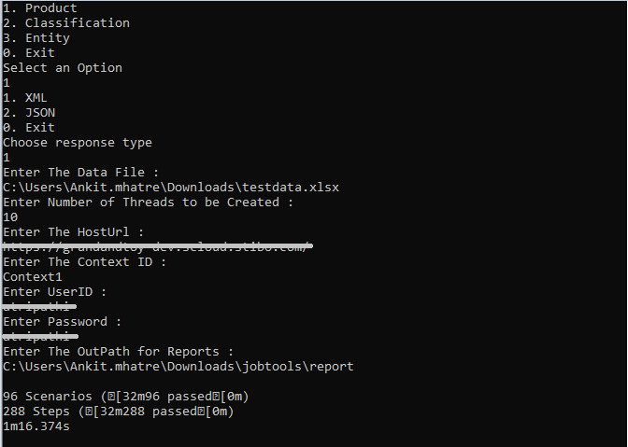

**Reports:**

1. **HTML:**

The HTML Report will get generated at the specified path or if path is not specified it will be generated at default location. Refer the screenshot below.

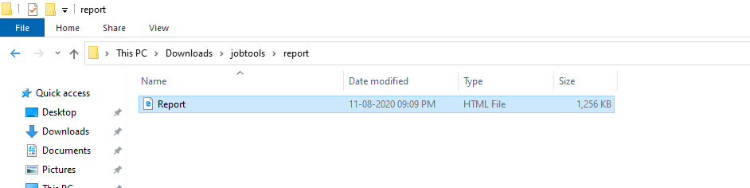



In the Html report file the scenarios represent the number to SKU to be tested and Steps represents the number of steps required to run the scenarios.

So it will display the report in following format

1. Passed: All the three key words when, then & And are verified successfully the status will be displayed as pass.

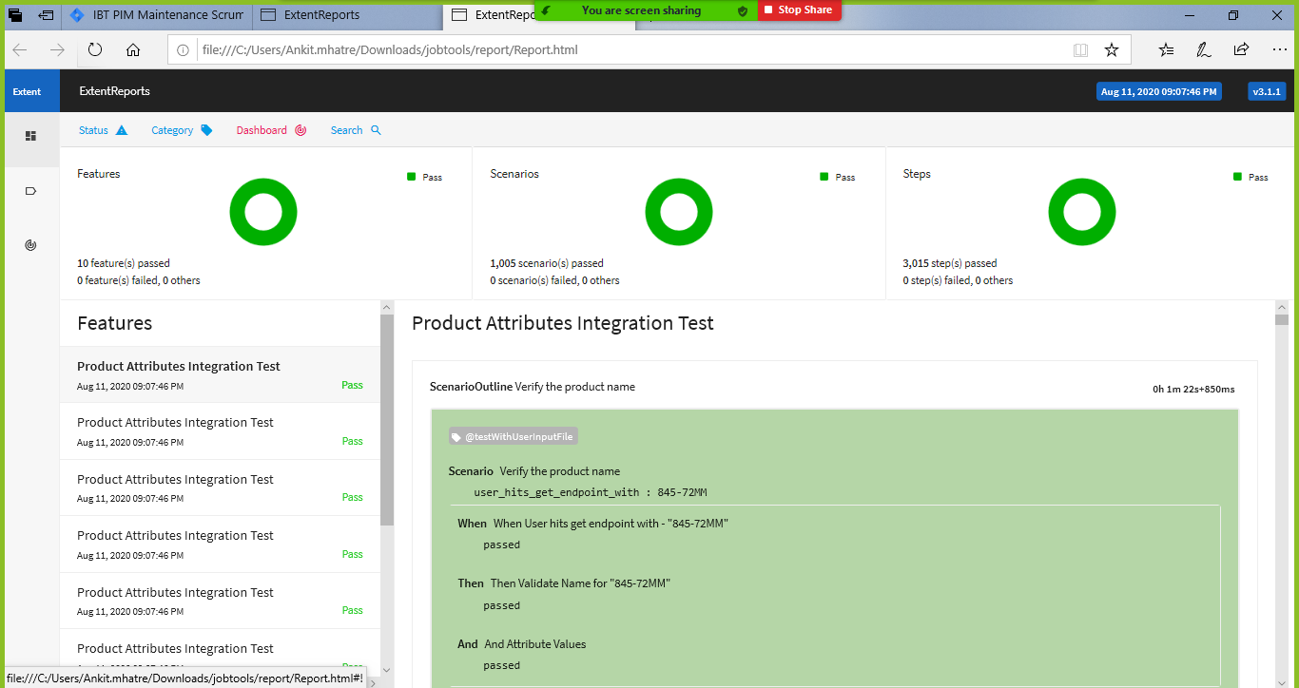

1. Fail: All the three key words when, then & And are verified and suppose one of this is failed, so the status will be displayed as fail.

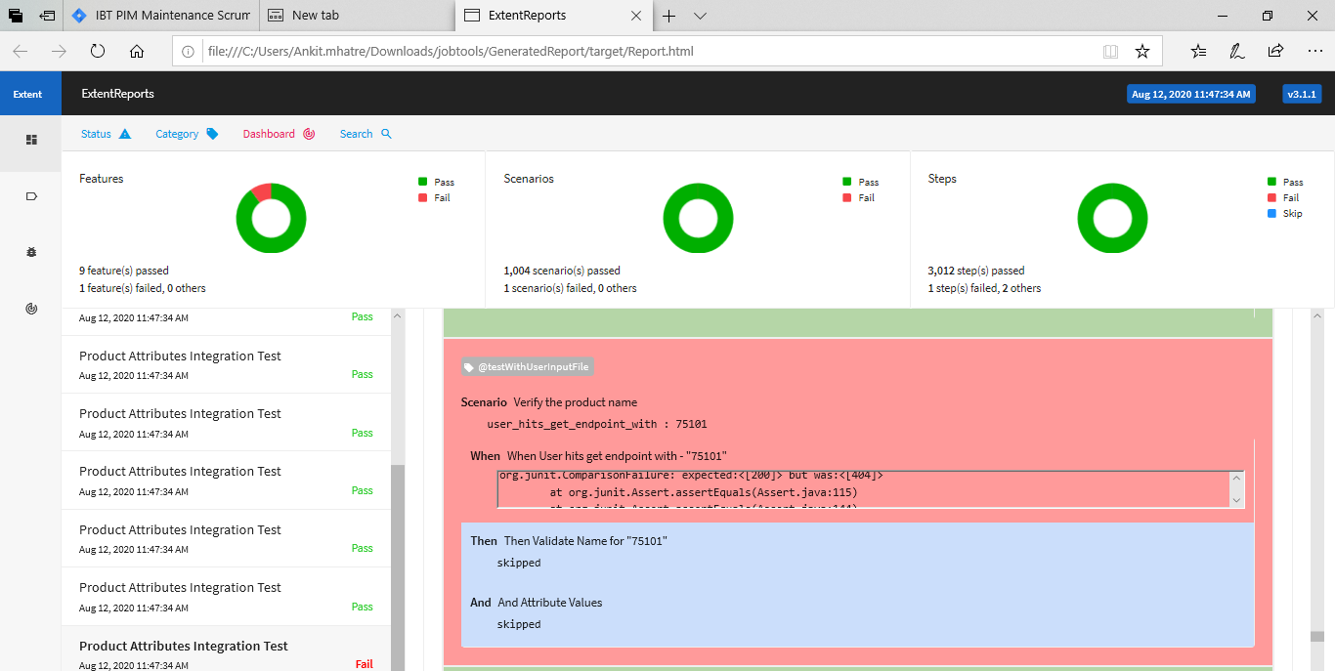

**Log file**:

The Log file folder will also get generated at the default location i.e. the location where the batch file is present.

