 Version History: DripOCP
2.9.2010 | V0.3 | Melissa Faria | Cash Department | Updated Version
11/5/13 | V0.4 | Nicole Sacco | Transaction Services | Update
7/9/14 | V0.5 | Mark Harmon | Cash Department | Update to Final Version
11/16/18 | V0.06 | Erin Cameron | Transaction Services | Update
04/08/20 | V0.07 | Erin Cameron | Transaction Services | Update
12/08/21 | V0.08 | Erin Cameron | Transaction Services | Update
Date Last Updated: 09 July 2014

DripOCP
Overview
Optional Cash Purchases (DripOCPs) are voluntary cash purchases submitted by holders via a check, for either common or employee class contributions.

Tasks Included
This procedure includes the following tasks:
- Process Rules: DripOCP
- Processing DripOCP
- Adding Notes & Rejecting
- Creating Default Enrollment Letters

Process Rules: DripOCP
Related Compliance Policies
The following Compliance Policies relate to this procedure:
http://intranetamericas.cshare.net/us/cos/Transaction%20Services/Transfers/Quality/QA%20Templates/Drip%20Enrollment%20QA%20Template.docx

Check Requirements
In order to process a DripOCP transaction, the check provided must be valid.

Things to review on the check:
Is the holder’s name pre-printed on the check?
Is the check signed by the person who’s name is on the check?
Is the date current?
Is the check payable to Computershare or the client (ATT, BAC)
Does the legal line match the numeric line?

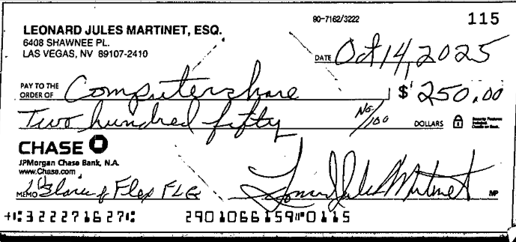

Please also see the: OCP AML-Anti Money Laundering for additional guidelines

Bulk Date
- If the bulk trade date is 35 days away the check must be returned to the submitter along with a reject letter instructing to resubmit their request.

Plan Election Requirements
- In order to process an optional cash purchase the account must be set up to reflect a plan election. A signed enrollment form is required with the exception of SEMP. All SEMP accounts are to be coded Cash if no enrollment form is received.

Investment Amount Requirements

- In order to process optional cash purchase the amount submitted must reflect at least the minimum investment amount required. Each company’s voluntary amount differs. Shown below are example pop ups which will populate when the amount submitted for the voluntary purchase is under the minimum or if the initial investment has not been met.
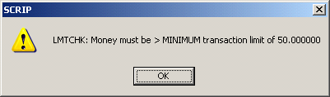 | Under the minimum investment amount of $50.
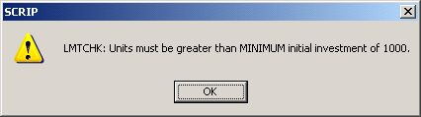 | Under the minimum initial investments of $1000.

Employee Contribution Companies

When applying funds to ESPP accounts/companies review the accounts alternative id, plan warnings, and holdings. Please refer to: ESPP Companies for the list of companies for which we process.

Processing DripOCP

Scope
The following task describes how to process DripOCP which are presented in the DripOCP Queue.

Before You Begin

You must wait for direction before you classify or process OCP for the day. The prior day’s work must be completed before we start working on the current day to avoid balancing issues.

The Team Lead will track beginning and end times for processing OCP as this is a requirement in the database and is essential for balancing.

Drip DripOCP are processed from ProStdDea0 (onshore) and ProComRML0 (offshore)– with the transaction type of DripOCP. Ensure you understand the issues outlined in Process Rules: DripOCP.

Warning:

Please go the Investor Services tab on Cosmos and refer to the Plan Type:
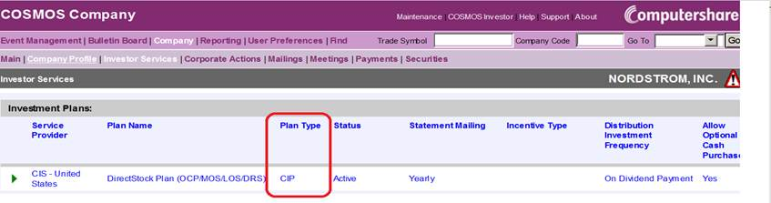

If the Plan Type is CIP, we need to reject the item. The reject letter must state: The terms of the plan require that you provide a valid email address and agree that all correspondence be sent electronically. Please go to www.computershare.com to create your account and add your valid email address. All investments must be done online. Physical checks will not be accepted and will be returned according to the terms and conditions of the plan.

Warning: Certain PEPSICO (PEP) accounts are restricted from participating in the Dividend Reinvestment Plan. The restriction will appear under the Warnings field.
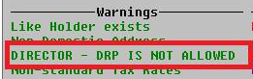
Currently there is nothing that prevents us from crediting plan shares to an account with this restriction. Before processing a purchase for PEPSICO (PEP), please check the Warnings.
Screens Used
When the workitem opens the SCRIP Bulk Processing Selection screen displays with the DripOCP Query box.
NOTE: If a note was added in Classify it will be shown in the Notes tab on Workflow when populated.

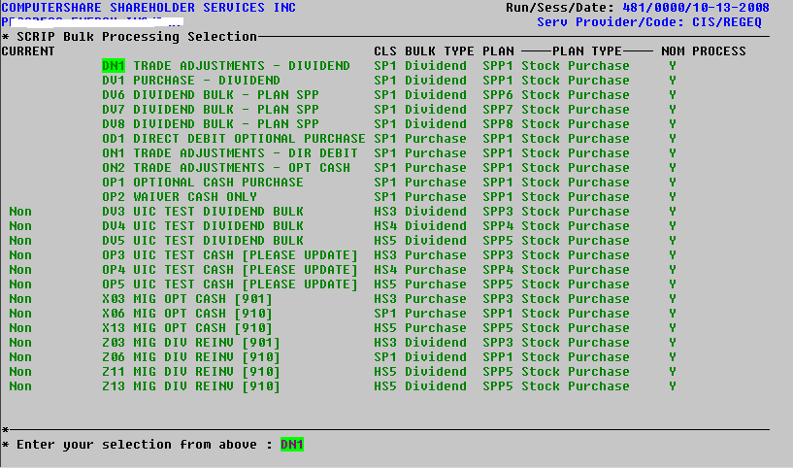
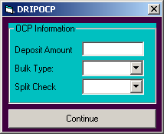

Enter the following:
- Deposit Amount: The amount of the contribution.
NOTE: The deposit amount is the amount of the contribution. To identify if the deposit amount; review the entire image; it is possible that the item might be a split check.
A Split Check is a check which is for optional cash contributions for multiple companies, not one check for multiple cash contributions for one specific company.
- Bulk Type: When selecting from the drop down menu select either of the following: OP (for optional cash contributions)
- Split Check: When selecting from the drop down menu select “N” or “Y”
- To process an NON Split Check cash contribution (which is one or multiple purchases for one company/coy) select “N” then, Click on “Continue”
- To process a Split Check cash contribution; from the drop down menu select “Y”

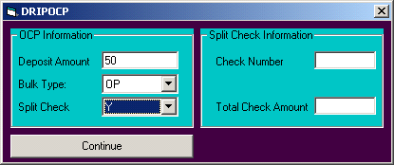
The DRIPOCP OCP Information dialog box expands and populates the Split Check Information portion of the dialog box;
Enter the following: Check Number & Total Check Amount; click on “Continue”

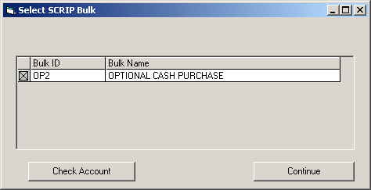

    - The Select SCRIP Bulk dialog box populates, select the appropriate bulk.
- The bulk name for common stock purchases are “Optional Cash Purchase”
- The bulk name for employee optional cash contributions are: “ESPP Optional Cash Purchase” The companies which the cash team are responsible for processing are shown above under: Process Rules: DripOCP

- Note: To identify the correct bulk name, review the image and account history. One can review the account by clicking on the “Check Account” button. When done reviewing the account, click “Continue” to proceed with the transaction. Also, note if you are in the process of possibly processing an ESPP Contribution, the dialog box appears differently. Please see the example ESPP dialog box shown below.

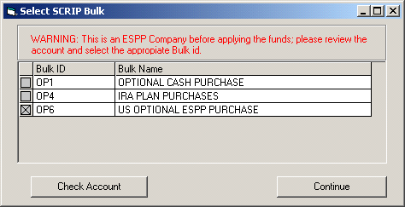

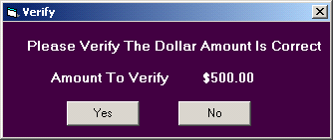

- The Verify dialog box populates;
- If the amount on the Verify dialog box is correct, click on “Yes.”
- If the amount on the Verify dialog box is incorrect, click on “No” and the cash Marco will begin again with the DRIPOCP dialog box.

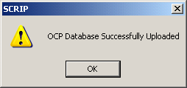

- The SCRIP OCP Database Successfully Uploaded dialog box populates, click “Ok”, the funds have been applied, from WORKFLOW select, Save&Close.

Do not save and close your workflow item if you did not receive the above Scrip message as this may mean the item did not write to the database.

Processing DripOCP
1 | When the workitem opens the SCRIP Bulk Processing Selection screen displays with the DripOCP Query box; Enter the following:  - Deposit Amount: The amount of the contribution.  Note: The deposit amount is the amount of the contribution. To identify if the deposit amount; review the entire image; it is possible that the item might be a split check. A Split Check is a check which is for optional cash contributions for multiple companies, not one check for multiple cash contributions for one specific company.  - Bulk Type: When selecting from the drop down menu select either of the following: OP (for optional cash contributions)  - Split Check: When selecting from the drop down menu select “N” or “Y”  - To process an NON Split Check cash contribution (which is one or multiple purchases for one company/coy) select “N” then, Click on “Continue”  - To process a Split Check cash contribution; from the drop down menu select “Y”  Note: If “Y” was selected for a split check contribution; The DRIPOCP OCP Information dialog box expands and populates the Split Check Information portion of the dialog box;  - Enter the following: Check Number & Total Check Amount; then click on “Continue”
2 | The Select SCRIP Bulk dialog box populates, select the appropriate bulk.  - The bulk name for common stock purchases are “Optional Cash Purchase”  - The bulk name for employee optional cash contributions are: “ESPP Optional Cash Purchase” The companies which the cash team are responsible for processing are shown above under: Process Rules: DripOCP  Note: To identify the correct bulk name, review the image and account history. One can review the account by clicking on the “Check Account” button. When done reviewing the account, click “Continue” to proceed with the transaction. Also, note if you are in the process of possibly processing an ESPP Contribution, the dialog box appears differently.
3 | The Verify dialog box populates;  - If the amount on the Verify dialog box is correct, click on “Yes.”  - If the amount on the Verify dialog box is incorrect, click on “No” and the cash Marco will begin again with the DRIPOCP dialog box.
4 | The SCRIP OCP Database Successfully Uploaded dialog box populates, click “Ok”, the funds have been applied, from WORKFLOW select, Save&Close.
Processing DripOCP is complete.
You are ready to begin Adding Notes & Rejecting.

Return To Top

Adding Notes & Rejecting
Scope
The following task describes how to add notes when rejecting a work item.

Before You Begin
Please use the following table as a guide for the action required when rejecting a workitem.
Note: When rejecting an item, the check must be separated from the checks we will be depositing. Please add all rejected OCP items to the reject report. (ALT6) Only enter one reject reason on the report even if there are multiple reasons.

 | Under the voluntary purchase minimum. | Reject
 | Under the minimum initial investment amount. | Reject

Ensure you understand the issues outlined in Process Rules: DripOCP.

Screens Used
From Workflow.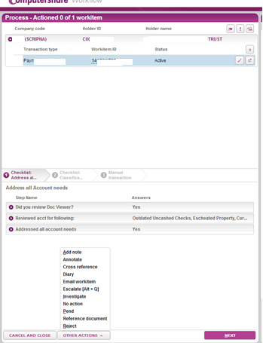
Shown above is an example of a workitem. To add a note, click on the little arrow next to OTHER ACTIONS then select “Add Note.”

The “Add Note” to launch the screen below. 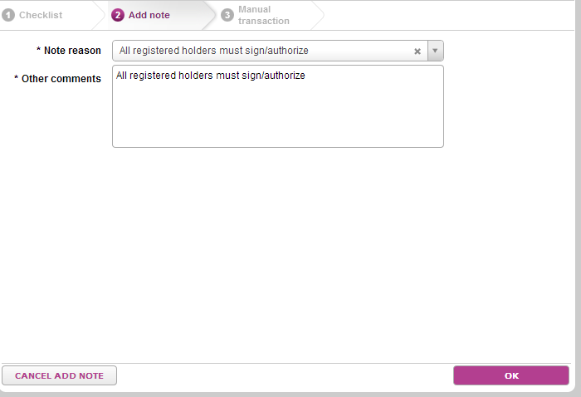

Select a reason for the note from the “Note Reason”
If no suitable reason is listed, choose “Other”.
Complete the “Other Comments” field.
Click “OK”. This will return you to the workitem’s main transaction screen.

Note: If either the Note Reason or Other Comments sections are not completed, the “Ok” button will not be enabled. Clicking the “Cancel” button will terminate the Add Note and return you to the workitems main transaction screen. Also, if you select “Ok” to add a note but, then Cancel & Close” the workitem, you also cancel the note just added. You must “Save&Close” (or Save&Next) the item for workflow to save the note you added to the workitem.

If you determine the workitem needs to be rejected, click on the the “Reject” button.
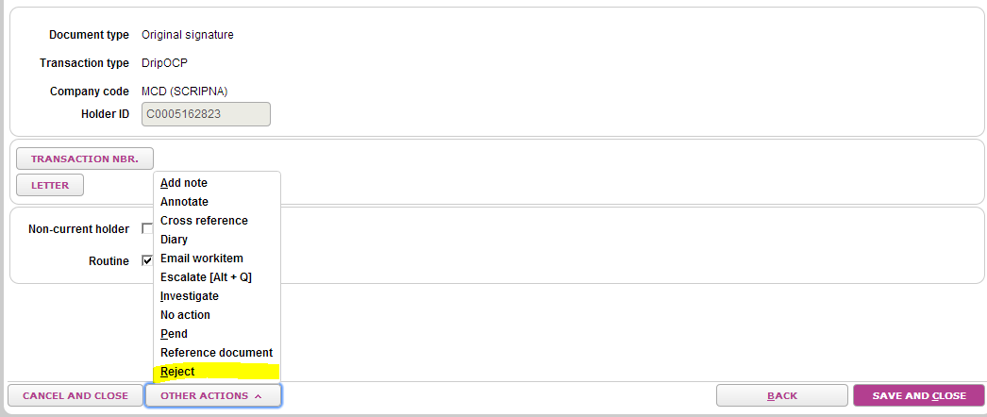

Complete the Reply Details section. Any registration details need to be removed (for example JT TEN, CUST UTMA, etc.) then select Next.
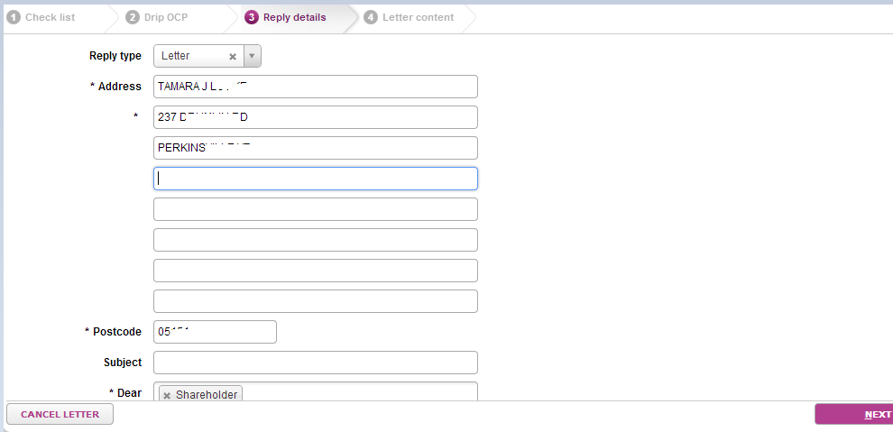

Select the appropriate Template and Paragraph(s). If the paragraph selected requires variable fields to be completed, enter the information needed. Attach any enclosures that are needed. If a check needs to be pulled and returned with the reject letter, enter the check number in the Enclosure field. If the letter needs to be edited, select the “Edit Letter” button under the Other Actions tab. Once the letter is completed, click “Save and Close” to end the item.

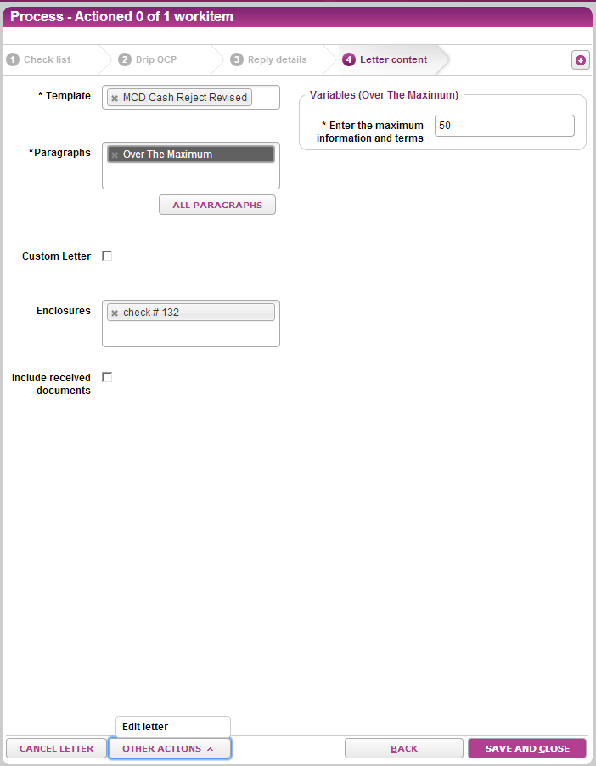

Adding Notes & Rejecting

Step | Action
1 | Add note to workitem.  - Click on the little arrow next to OTHER ACTIONS, and then select Add note.  - Click on the drop next to Note Reason select Other.  - In the Other Comments field Enter the reject reason.  - Please see: Before You Begin for Identified Issues Table.  Click “Ok”
2 | Reject workitem.  To reject:  - Click on the Reject button under the Other Actions tab.  - Complete the Reply Details section. Any registration details need to be removed (for example JT TEN, CUST UTMA, etc.) then select Next.  - Select the appropriate Template and Paragraph for the reject reason. Attach enclosure and edit letter if necessary.  Then click Save and Close.

Adding Notes & Rejecting is complete.

Return To Top

Creating Default Enrollment Letters
Scope
The following task advises in how to create Default Enrollment letters when accounts are coded to accept DripOCP.

Before You Begin
- Ensure you understand the issues outlined in Process Rules: DripOCP.

Screens Used
Letters are created from WORKFLOW.

From WORKFLOW, select “Letter”

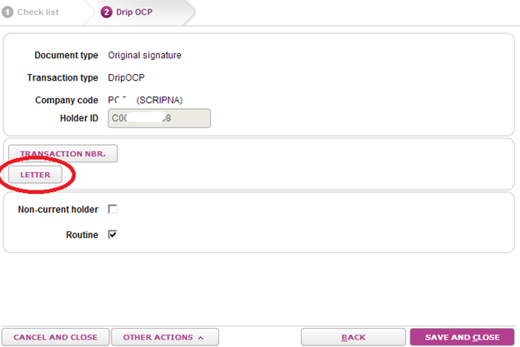

The Reply Details screen displays, change forwarding address is needed and then click Next.

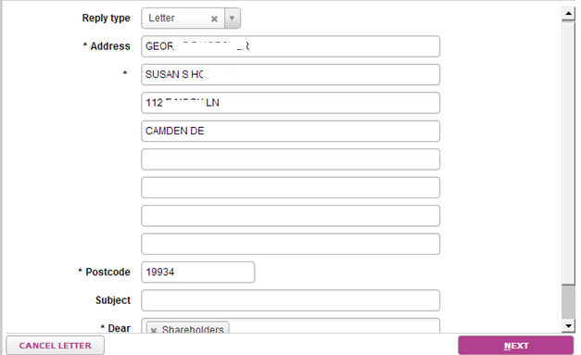

The Letter Content screen displays. The Default Enrollment Template will automatically populate.

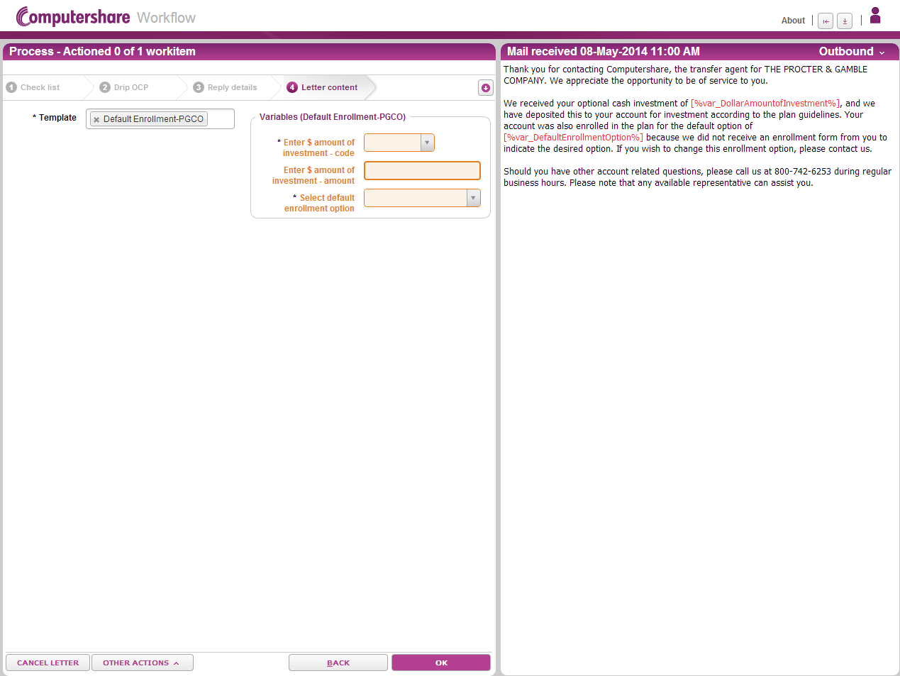

Enter the appropriate information in the Variable fields and click OK.

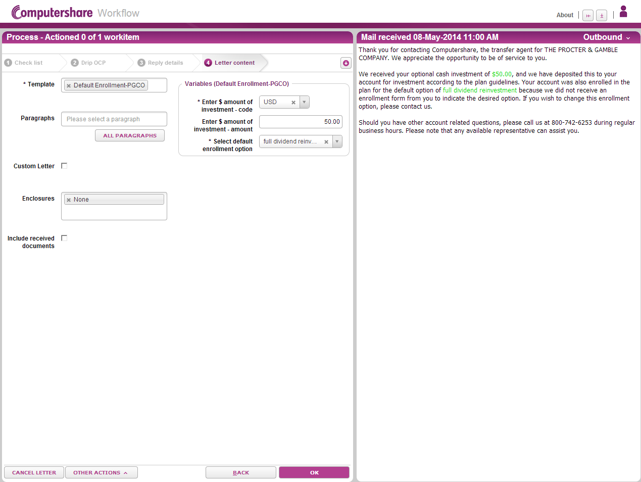

Shown below is an example of when the letter is attached to the workitem.
Note how next to Letter : A Letter has been created and can be viewed in the Outbound Documents panel.

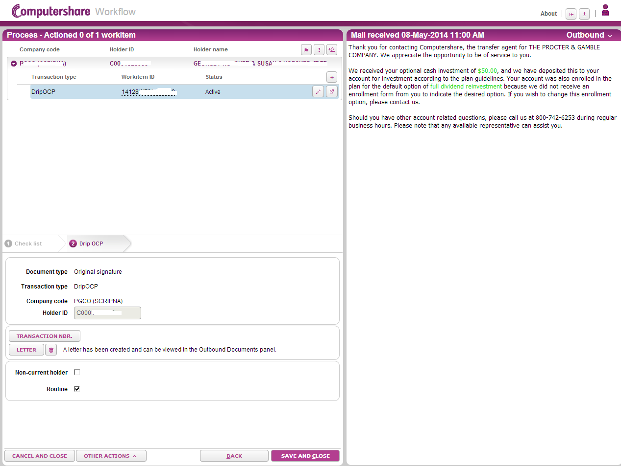

Add note on Image, “Created Defalut Enrollment quick hit letter.” Once note has been added; Save&Close on the item.
Reference: Adding Notes & Rejecting

Creating Default Enrollment Letters

1 | From WORKFLOW, select “Letter”
2 | The Reply Details screen displays, Click Next.
3 | The Letter Content screen displays. Enter the appropriate information in the Variable fields and click OK.
4 | Add note on Image, “Created Defalut Enrollment quick hit letter.” Once note has been added; Save&Close on the item.

Return To Top

