Starting CSS Series by Procodrr

Lecture 1
Inline CSS:
Using style attribute using this we can give any style to our html element
Internal CSS:
Using style Tag inside head tag
External CSS:
Using Link in style sheet, we link the external style sheet.

Lecture 2
Different Types of Selectors in CSS: It uses American English, used to select HTML code and give it the colour and design.
- Element Selector: Select only element
- Dot selector: Select only dedicated class .{}
- Hash Selector: Select the id #{}
- Attribute Selector: [class]{}
- Select a particular tag inside another tag use : Decendent selector
  - ul p {}
- Sudo Selector: Hover
- Universal Selector: *
Different Ways to give Color
- RGB
- Hexcode
- HSL format

Lecture 3
Cascade, Specificity and Inheritance
Cascade: It means the css applies from top to bottom line by line, if a property is applied overwriting the previous rule will no longer be taken in account.
- Followed it withing css sheet
- Also followed if multiple css are being called in html file
Specificity: Cascade rule will not be applied if the stylesheet selector have the higher specificity than the others. It means the importance of a selector in the stylesheet.
Importance = Specificity + Cascade
Selector Specificity(0,0,0) = (id,class,element)
Id>class>element

Inheritance
The styles will get inherited by the child tags if style is given to the parent
Body-> all tags
Ul -> li tag
! important keyword: The important keyword is most powerful it will override even the
Inline and important are used very less and difficult to override them in the website

Lecture 4: Box Model in CSS
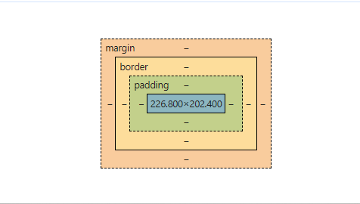
Overflow:
Div in CSS:
- It takes width in percentage from immediate parent
- The 1st div will take body as parent
- In case of height, it will only work when the height of parent will be in absolute value.
- Height and Width Affects the content area(the inner part of CSS Box model)
viewport is browser
- Avoid fixed width and fixed height, min-height and max-width will create the less overflow.
Padding: Part of box model used to give an extra space or room to make things look clear

Border:
Box-sizing: boder box ( the sizing remain same overall) if the border pixel is increases or decreases
Default box sizing: the box will keep of increasing if the border size is increased
In short the border box make the complete div like a box if padding or border is given the content space is taken.

Margin:
The gap or extra space after the element or box model outer layer.

Span or spam in span tag?
- Giving height and width doesn’t work in span tag
- Span shape is not fixed
- Padding works in span but eat out the space of other elements.
Image is the replaced inline element we can set height of that, it worked as a inline block.

- Replaced
- Non-Replaced

Inline element will only follow left and right properties of block element.
Outline grow silently.
Iframe tag, image tag, video tag

@display property:
Display: block
Display:inline
Display:none
CSS UNIT
Percent:
- Relative Unit, Follow the width percent of parent element
- Height doesn’t work in percent.
- Padding can be given percent as value but It will calculate the value from the parent width or height value that’s why most of the time we give only in px
- Doesn’t works with border attribute
- Font-size if given as percent the size will be calculated from the parent font-size.
- Width -> width related
- Height -> height related
- Padding -> width related
- Margin -> width related
- If parent font-size is not set than child font-size given in present will not go below 6px.
- Padding and Margin only be given in px or fixed unit but never in percent.
Pixels
- Height works here

em and rem UNITS
EM | REM
1 em = fontsize of the parent element | 1 rem = 16px by default
Can be used with buttons | It look the font size of html, not the parent

