JavaScript
The Founder wrote JavaScript in Just 10 days.
History
- Netscape Browser 1990’s
- Websites used to static then, browsers couldn’t do any calculation
- Marc Andreessen Founded “Mocha” -> “LiveScript” -> “JavaScript”
- Brendan Eich Creator of JavaScript
- ECMA(European Computer Management Association) Documented JS and standardization of JS
- ECMAScript, current version is ES-6
- Chrome in 2008 made V8 JavaScript Engine
- Firefox: Uses Spider Monkey
- Ryan Dahl take the V8 and created NodeJS
- AngularJs, ReactJs are the another framework of JavaScripts
- 1st Browser was WWW(World Wide Web)

Theory
- JavaScript is an Interpreted Language
- Interpreted Language is a little bit slow
- The V8 uses just in time compilation (interpreted + compilation) at the same time
- Console in dev Tools is Actually Called REPEL: Read Evaluate Print Loop
- But JavaScript file is not a repel (imp)
- Can also be written inside the script tag in html file.

How to write Output to console
Console.log(‘Hello World!!!’)
defer attribute in script tag will make the JavaScript run at the end.

Workflow
HTML file -> Browser sent req to HTML -> HTML req to JS and CSS files -> server resp to JS file and functionality will get implemented.

Data Types In JavaScript
` backtick
~ Tilda
“double quote
‘single quote
NaN: Not a Number (invalid number)
- Primitive Data Type
  - Number
  - String
  - Boolean: true or false
  - Undefined: Variables that are not defined, js uses for variables
  - Null: js don’t uses but users uses for assigning.
  - Big-int: 1239892402730238490283426139081948n
  - Symbol
- Non-Primitive Data Type
  - Object
    - Object Literals
    - Arrays
    - Functions

parseInt: To convert a sting into number and
number to string : 100 + ‘ ‘
+false -> 0, +true => 1

Typeof null is object is a bug it should be null.

Variables
Creation Types, Follow camel case naming convention.
- Let
  - Let username = ‘Anurag’
  - Let userIntro = ‘My name is Anurag singh’
  - Let isHappy = ‘true’
  - Let x, then js will put undefined in it
  - Blocked scoped

- Const
  - Declaration must be initialized.
  - Didn’t change once used

- Var
  - Earlier we used var but for now, after 2015 we use let and const in out projects
  - Var and let are same with not much difference.
  - Var is available out of block(scope) also but let is only available inside scope(block). It is also called as function scoped.
  - Var didn’t give error can be used before declaration

Object in JavaScript
Store the variable or data in key value pair
Const user = {} // Empty Object
Const user = { address:{ city: ‘banglore’}, name:’Pankaj’} // object inside an another object
Let u1 = { // some data}
u1 = {} //here the address of the object gets changed.
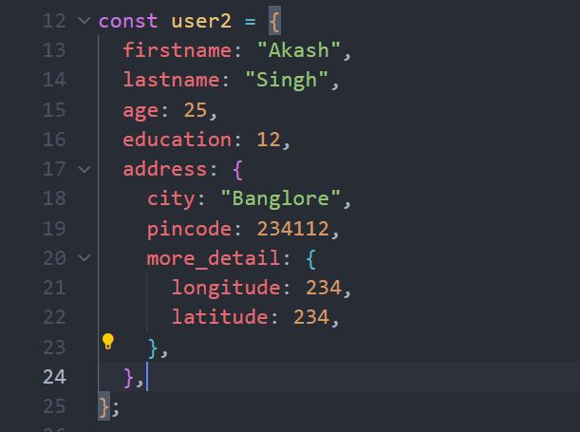
Accessing an object
User[‘string’] or user.name
User[variable_name] for variables
Assigning Values inside
User.age = 21;

Add Property
User.addr = “address”
User[‘address’] = ‘address’
Delete Property -> delete user.firstname, delete user.pata
Object.freeze() | Object.seal()
Using object.freeze the property can’t be added or deleted. | Using this any new property or deleting a new property can’t be deleted as the object is sealed.
We can’t change or modify any existing key too. | Here we can change the existing property.

In Keyword: checks only the key is present in the object.
‘mobileNumber’ in user (return true or false)

Code Execution In JavaScript
- Memory Creation Phase
  - Search for var, let, const memory is allocated and then put undefined in it.
- Code Execution Phase
  - Each variable is assigned the value and the datatype according to it.
  - Debugger key work in JS can help the programmer to debug the code present in the file.
  - Temporal Dead Zone: The duration of time for which let, const cannot be used is said as temporal dead zone
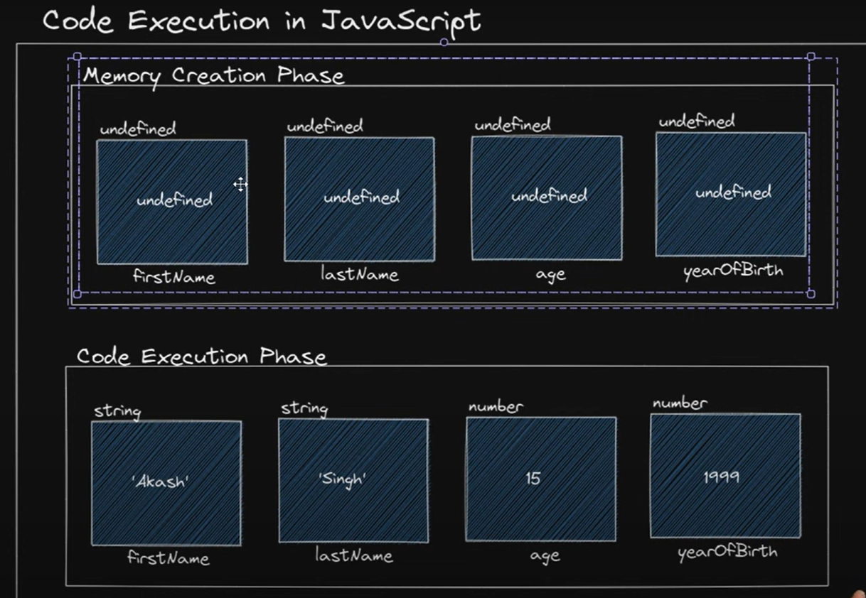

Dialog boxes in JavaScript
There are three types of Dialog Boxes
- alert(“Your Message goes here.”)
- confirm(“Your Message goes here.”)
- prompt(“Your Message goes here.”)

Strings Method and Properties / Template Literals
String are indexed, We can access any character of a string using index
Example ‘Hello’[2]
Result: ‘l’
Property(There is only single property exists)
- Length property, tell the number of character in the string
  - Example ‘Hello’.length
  - const message = ‘hello’
  - message.length
Method (Without Argument)
Didn’t modifies the original string, we can store that in new variable
- toUpperCase(): convert to upper case
- toLowerCase(): convert to lower case
- trimStart(): remove the unwanted space
- trimEnd(): remove the unwanted space from end
Method (With Argument)
- includes()-> watches for sub-string with exact case -> return boolean
- indexOf() -> returns the index of the character -> return int or -> -1
- replace(‘substring present’,’replace_value’) -> changed string
- replaceAll()-> all occurance of substring presetn
- concat() -> message.concat(‘ ’, variable)
- padStart(): message.padStart(7,’*’)
- padEnd():
- charAt(): message.charAt(3) -> return the character at that index
- charCodeAt(): return the ascii code of the character
- split(): message.split(‘ ‘) -> returns an array, at the argument given

String Template Literals
- const lastfourdigits = 3829
- const templateString = ` Last four digit of my account number is `.concat(‘ ’,lastfourdigits)
- const templateString = `Last four digits of my account number is ${lastfourdigits}`

Mathematics in JavaScript
- Addition operator (+)
- Subtraction Operator ( - )
- Multiplication Operator (*)
- Division Operator ( /)
- Remainder Operator ( % )
- Exponentiation Operator **
Maths Object in JavaScript
- Properties on Maths Object
  - Math.PI
  - Math.SQRT2
  - Math.E
Methods on Math Object
- Math.sqrt(x)
- Math.pow(x,y)
- Math.floor(x)
- Math.ceil(x)
- Math.round(x)
- Math.random()

8/0 -> Infinity

Truthy and Falsy Value
Falsy Value  - 0  - -0  - NaN  - ‘’  - Undefined  - null | Truthy Value  - rest are truthy

Comparison Operators
== | Equality [implicit conversion]
=== | Strict equality[equal value and type][explicit conversiotn]
!= | not equal
!== | Strict not equal
> | Greater than
< | Less than
>= | Greater than or equal to
<= | Less than or equal to

Logical Operators
&& | And | Returns Truthy and Falsy values
|| | Or | Type cast with Boolean to get true and false
! | Not

‘’ || ‘Hello’ => ‘Hello’
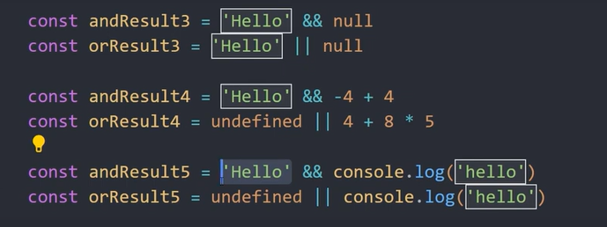
Decision Making in JavaScript
Similar to C++,
If else, if else if, if elseif else, Nested if else
Nested if else
Switch statement in JavaScript
- I think is similar to C++
- Created to remove redundant if else blocks
- Break should be used with defaults
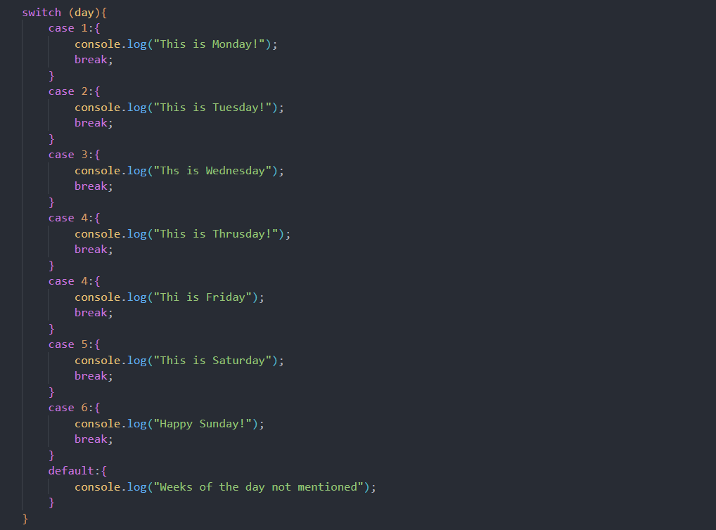

Ternary Operator:
Similar to C++ and works exactly like that.
Used in Production level code, make code simpler, less lines of code.
Nested ternary can be used
const x = true?"pankaj":100;
const y = false?"pankaj":100;

Lecture: How To See Variable Address in Dev Tools?
Dev-Tools -> Memory Tab (inline with console tab only) -> ctrl+f -> get the address of the context your variable are in search the context.

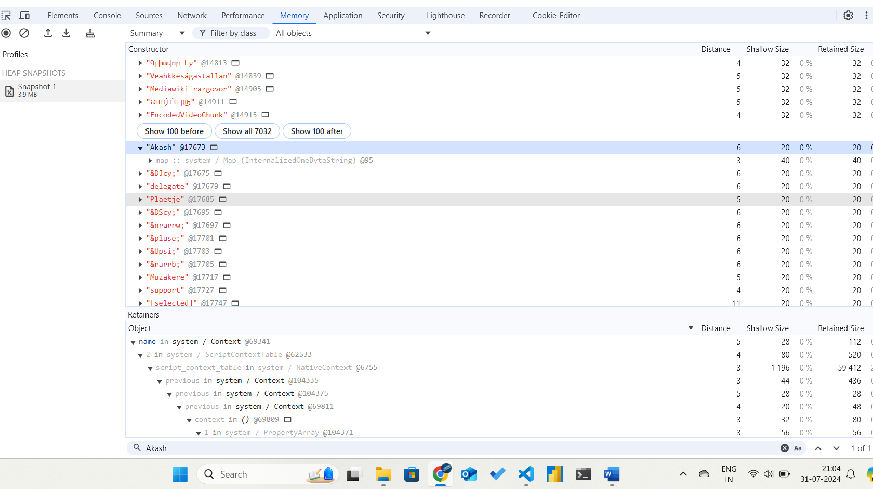

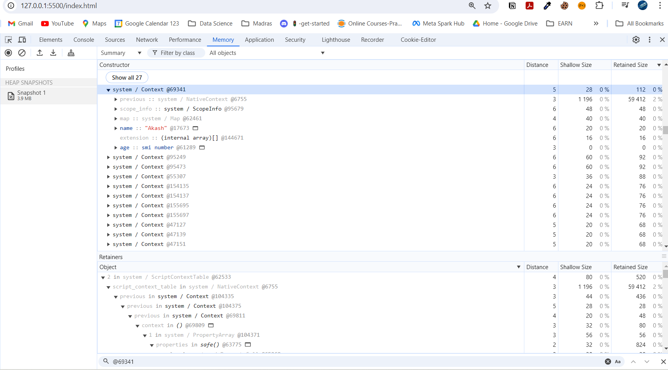

Allocation of Address inside memory
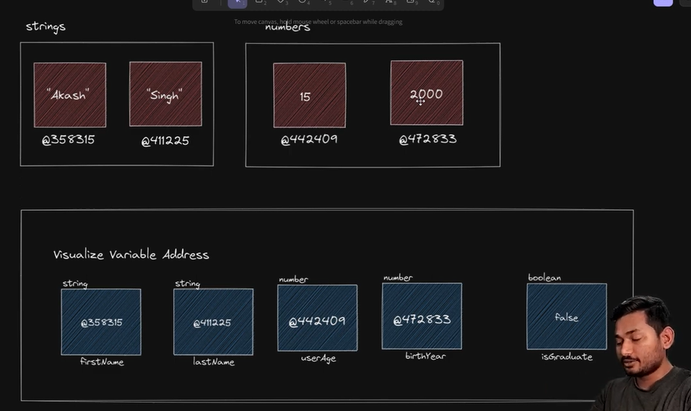
String | Group String
Number | Group Numbers
Boolean | System

- Boolean,strings with same value point to the same address in the memory
- The address always remain same, like for false Boolean it is 75 and for true Boolean it is 73 always.

ARRAYS IN JAVASCRIPT
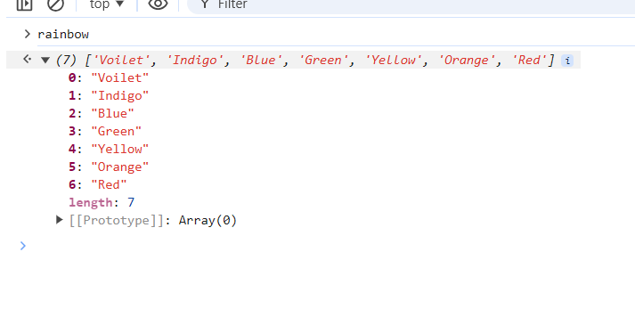
- It is an object behind the scene, syntax is different
- We can store different datatypes in the array in JavaScript, Although it is not a good practise to do, but JS allow us to do it.
- It can contain the all the datatype primitive and non-primitive
- We can data at any index the remaining index will get inserted with value empty.
- Can’t add key value pair directly, but using arr.firstname = “abc”
Addition of element in array
  - Ar[Ar.length] = element;
  - Ar.push(element) : returns the new array length.
Removing an element in array
  - Ar.pop() from the end

Basic Array Methods
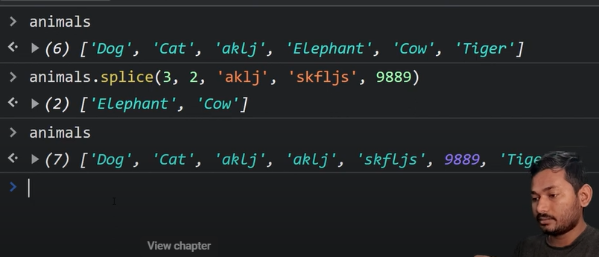
- Pop(): removes from end
- Push(): insert at end
- Shift(): removes from begning
- Unshift(): insert in begning
- Concat(): ar1.concat(ar2) return a concated array.
- Indexof(): arr1.indexof(4)
- Includes(): return the Boolean according to the presence of that particular element
- Reverese(): arr1.reverse()
- Sort(): arr.sort() sort the array, criteria is dependent on the Upper and lower case for strings
- Slice(): arr.slice(4) // didn’t change the original array
- Splice(): arr.splice(4) // changes the original array arr.splice(start,end, values)
- .length: tells us the array length in javascript.

Multi-Dimensional Arrays
Arrays inside another array is called as multi-dimensional array.
[[‘Adarsh’], [‘Akash’]]

Deep Copy vs Shallow Copy
const obj1 = { //somedata}
const obj2 = obj1

obj2.push(‘abc’) //It will also get into obj1 also.

Obj2.assign(user2,user1)

Shallow copy | Deep copy
Only copy the keys with unaffected effect | Copies nested object also efficiently
Const myfruits = […fruits] //Spread Operator | JSON.parse(JSON.stringify(obj))
Const myfruits = [].concat(fruits) | complex or special cases, libraries like Lodash offer deep cloning functions (`_.cloneDeep()`).
Const myfruits = fruits.slice()
Object.assign(myfruits, fruits)

In JavaScript, the concepts of deep copy and shallow copy are important when working with objects and arrays, as they determine how the data is duplicated and how changes affect the original data structure.

### Shallow Copy

A shallow copy creates a new object or array, but does not recursively copy the inner objects or arrays. Instead, it copies the references to those inner objects. Therefore, if the original object contains other objects as properties or arrays with nested objects, the shallow copy will still reference the same inner objects.

**Example:**

```javascript
let originalArray = [1, 2, { a: 3 }];
let shallowCopy = originalArray.slice(); // or use Array.from(originalArray)

shallowCopy[0] = 9; // Changes the first element
shallowCopy[2].a = 10; // Changes a property of the object inside the array

console.log(originalArray); // [1, 2, { a: 10 }] - original is affected
console.log(shallowCopy); // [9, 2, { a: 10 }]
```

In this example, changing the inner object's property (`a`) in the `shallowCopy` also changes it in the `originalArray`, because they both reference the same inner object.

### Deep Copy

A deep copy, on the other hand, duplicates all objects and arrays, creating a completely independent copy. This means that changes made to the copy do not affect the original object or array, and vice versa.

**Example:**

```javascript
let originalArray = [1, 2, { a: 3 }];
let deepCopy = JSON.parse(JSON.stringify(originalArray));

deepCopy[0] = 9; // Changes the first element
deepCopy[2].a = 10; // Changes a property of the object inside the array

console.log(originalArray); // [1, 2, { a: 3 }] - original is unaffected
console.log(deepCopy); // [9, 2, { a: 10 }]
```

In this example, the `deepCopy` is a completely independent copy of `originalArray`. Changing the deep copy does not affect the original array.

### How to Create Copies in JavaScript

- **Shallow Copy:**
- Arrays: `Array.prototype.slice()`, `Array.from()`, spread operator (`[...]`)
- Objects: `Object.assign()`, spread operator (`{...}`)

- **Deep Copy:**
- One common method is using `JSON.parse(JSON.stringify(obj))`. However, this method has limitations (e.g., it can't handle functions, `undefined`, or special objects like `Date`).
- For more complex or special cases, libraries like Lodash offer deep cloning functions (`_.cloneDeep()`).

Choosing between a shallow and deep copy depends on whether you want changes in the copied structure to affect the original or not.

Looping in JavaScript

While Loop
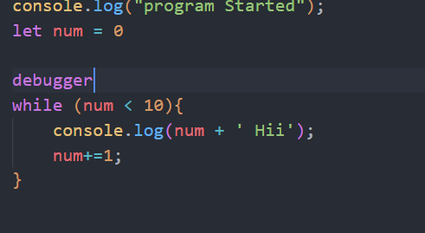

FOR LOOP IN JS
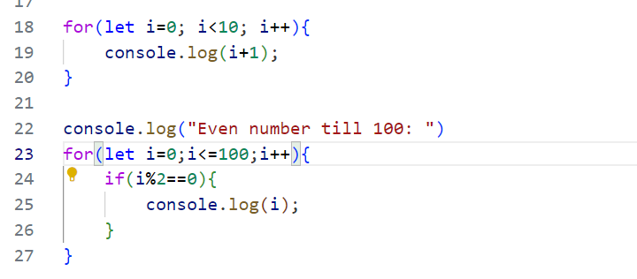

Functions in JavaScript
- As functions do reduce the line of code by solving a redundant task.
- Returns undefined by default

Functions code
- No return
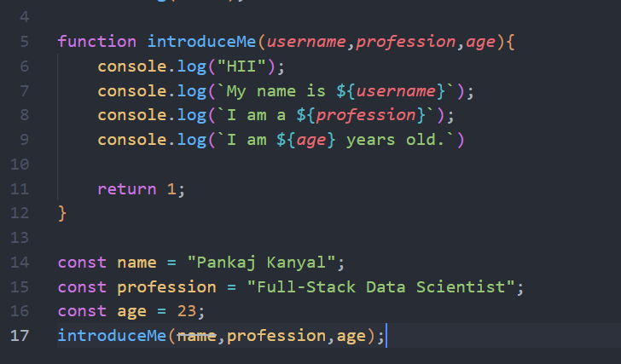

- With return

