**Hadoop HDFS Command Cheatsheet**

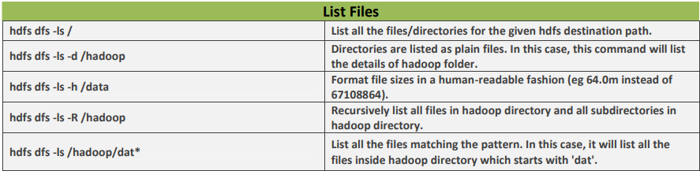

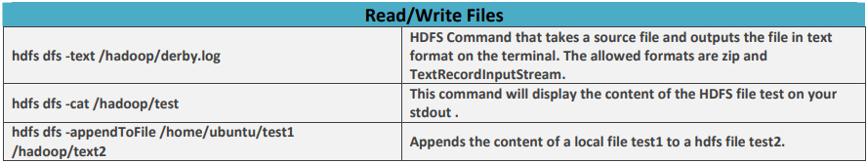

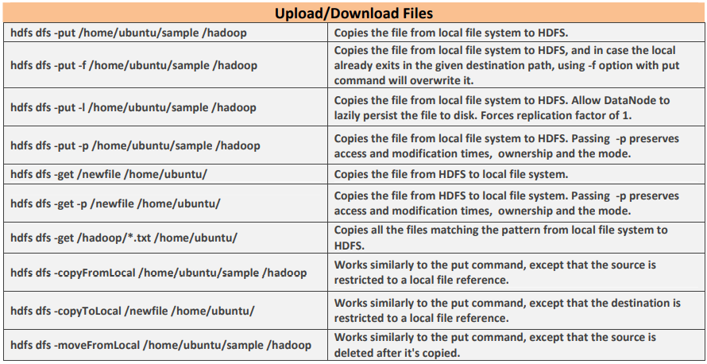

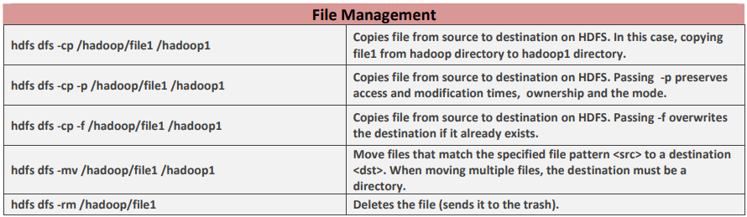

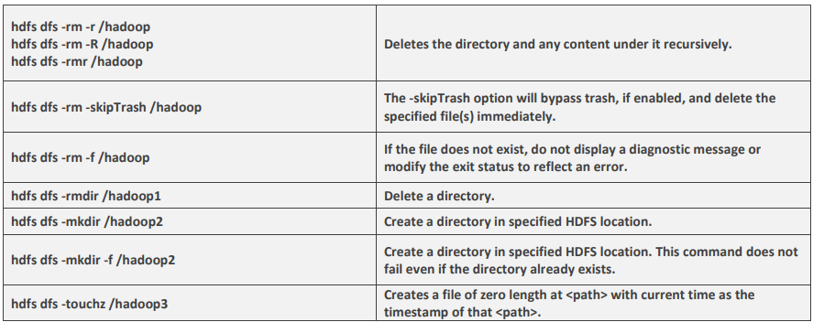

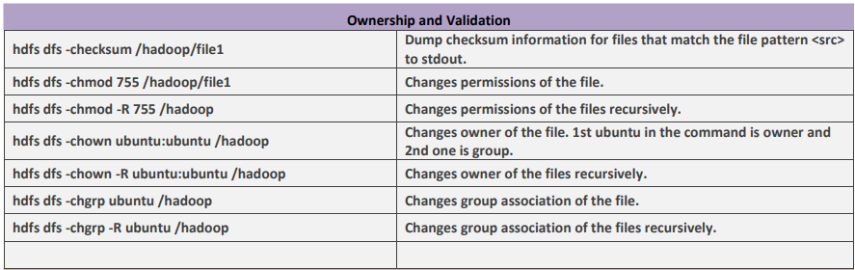

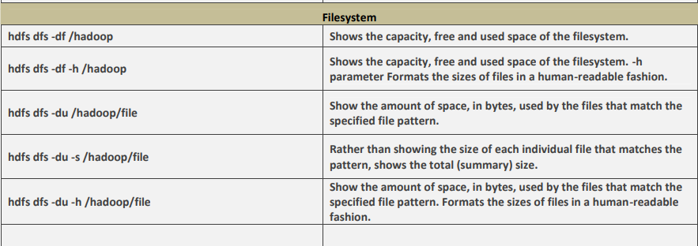

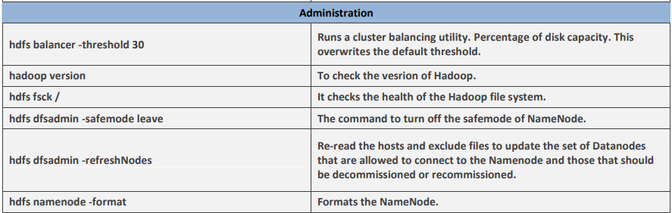

Top 10 Hadoop HDFS Commands with Examples and Usage

1. Move to the **~/hadoop-3.1.2** directory

2. Start Hadoop service by using the command



**Hadoop HDFS version Command Usage:**



### 2. mkdir

**Hadoop HDFS mkdir Command Usage:**



### 3. ls

**Hadoop HDFS ls Command Usage:**



### 4. put

**Hadoop HDFS put Command Usage:**



### 5. copyFromLocal

**Hadoop HDFS copyFromLocal Command Usage:**



### 6. get

**Hadoop HDFS get Command Usage:**



### 7. copyToLocal

**Hadoop HDFS copyToLocal Command Usage:**



### 8. cat

**Hadoop HDFS cat Command Usage:**



### 9. mv

**Hadoop HDFS mv Command Usage:**



### 10. cp

**Hadoop HDFS cp Command Usage:**

