- In Admin Panel, Go to Menus->Landing Pages and Click on “New”.

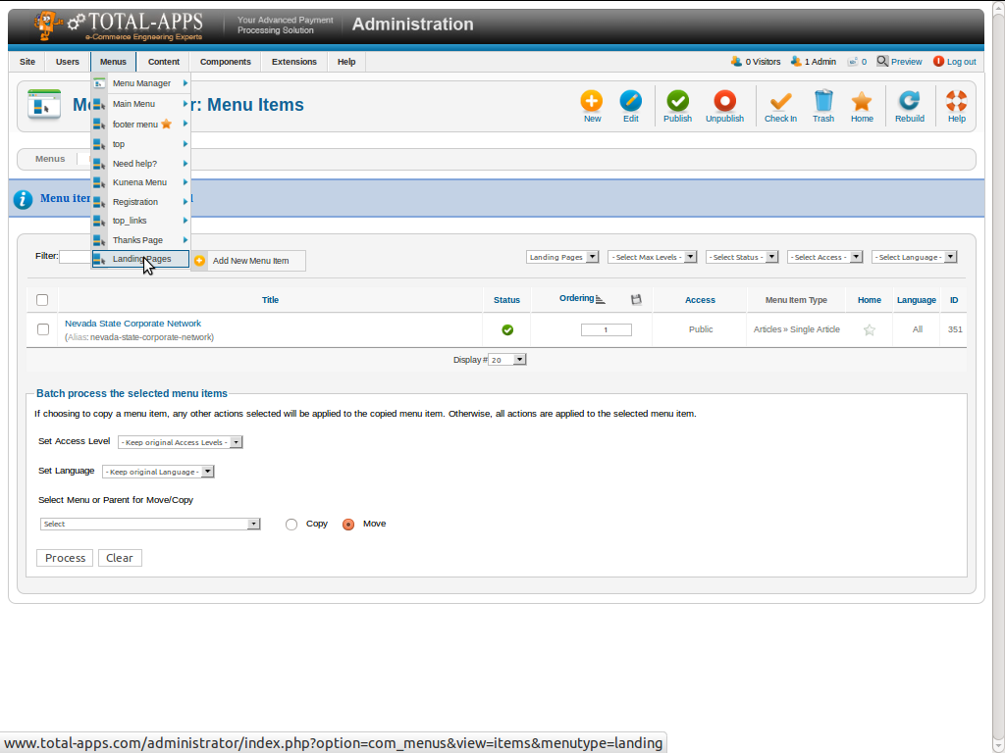

- Here you want to select “Menu Item Type”->Single Article , then enter your Menu Title.

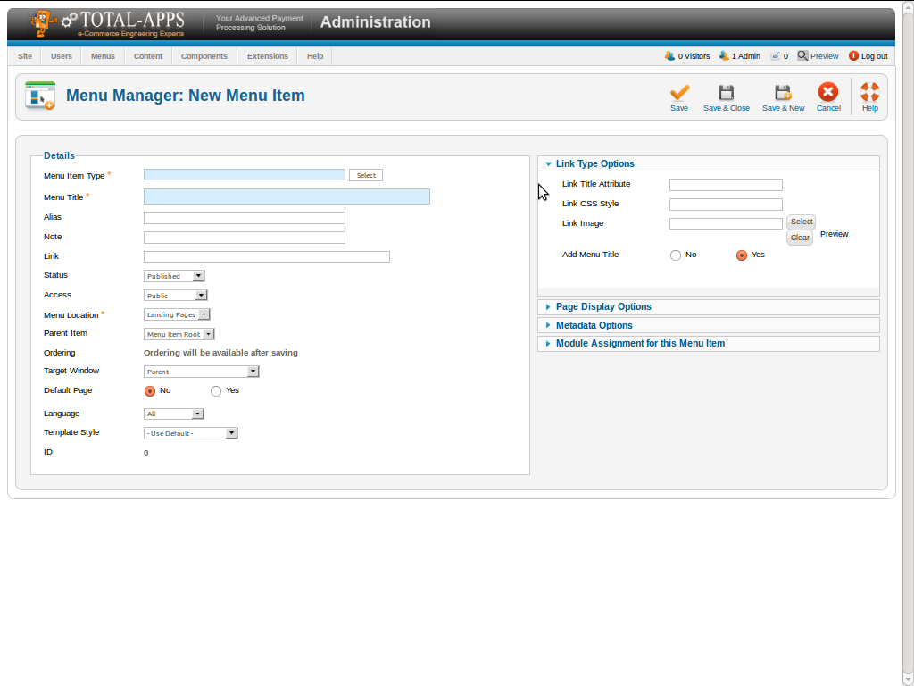

- After Select a “Menu Item Type”, in right side select Article that you have created.

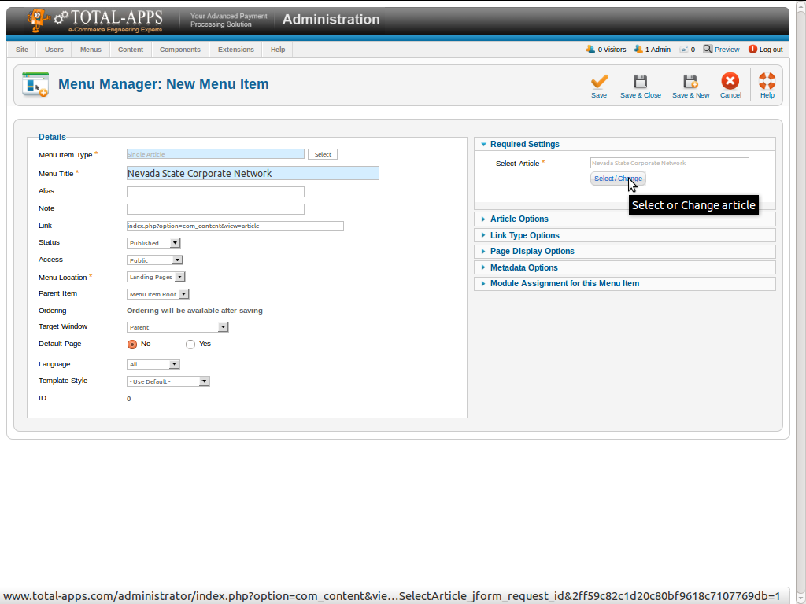

- Then go to “Article Option” and select all option as screen shot, and click on “Save”.

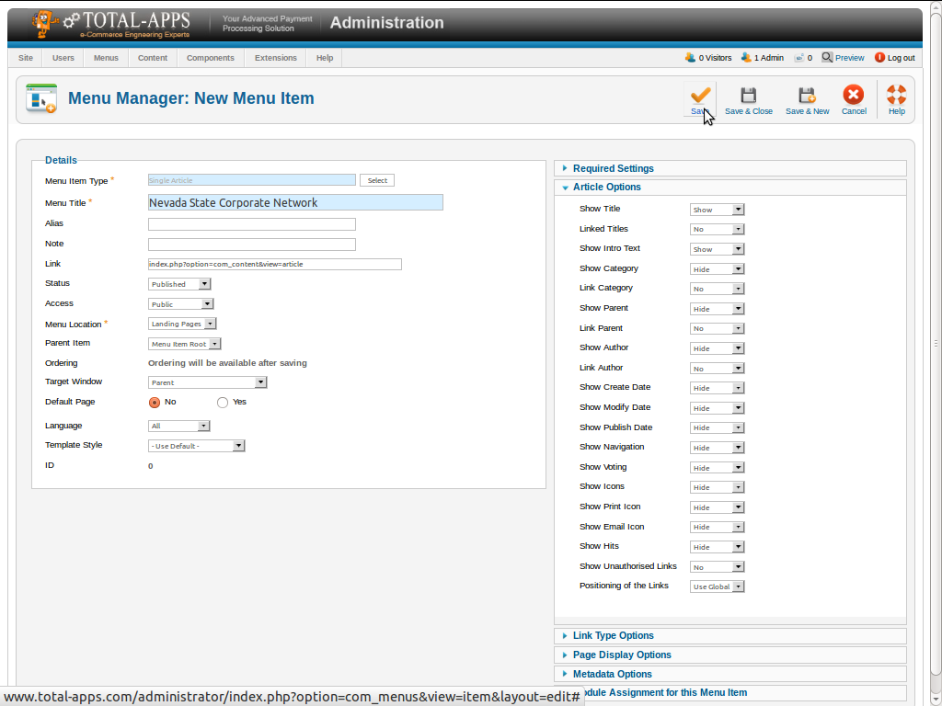

- After save a menu, Copy Alias text and just paste it after your domain name like-
http://www.total-apps.com/nevada-state-corporate-network-page

This is your landing page Url.

