Correction of the American car central website <http://www.americancarcentrale.com/> 3-24

1

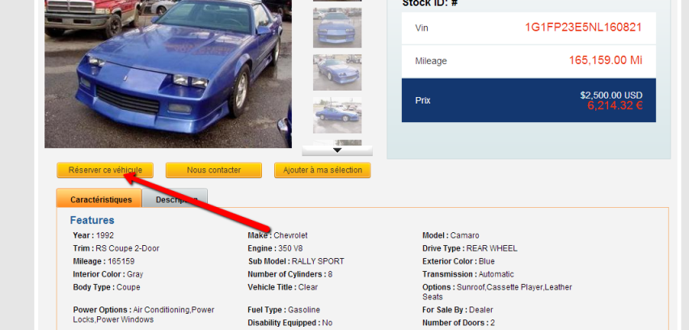

After clicking on the **Resever ce vehicule** button found on <http://www.americancarcentrale.com/ebay/171007695743>

I complete and submit the form and then I am presented with this display error(shown below) the screen is grayed out but no confirmation message is displayed

