**Management of Client login Page**

Here are some points for the management of Client login page.

1. To Add new user go to **admin panel -> Utillisateurs ->** **Ajouter**

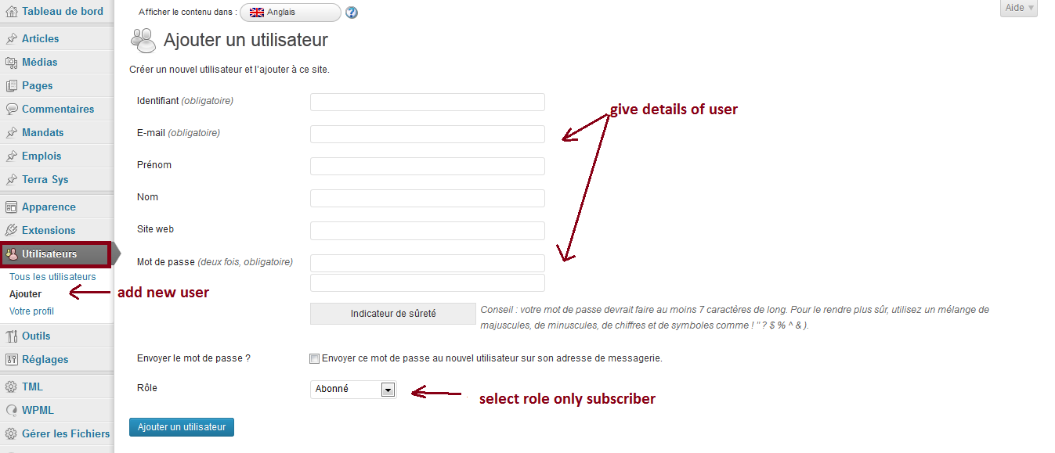

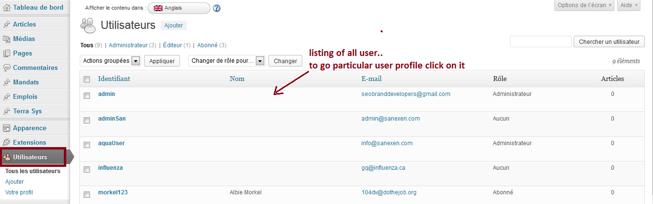

1. Manage user profile here and get user id which is shown below for upload file from ftp. To upload file from ftp go to following path “wp-content/uploads/file_uploads/user-id”

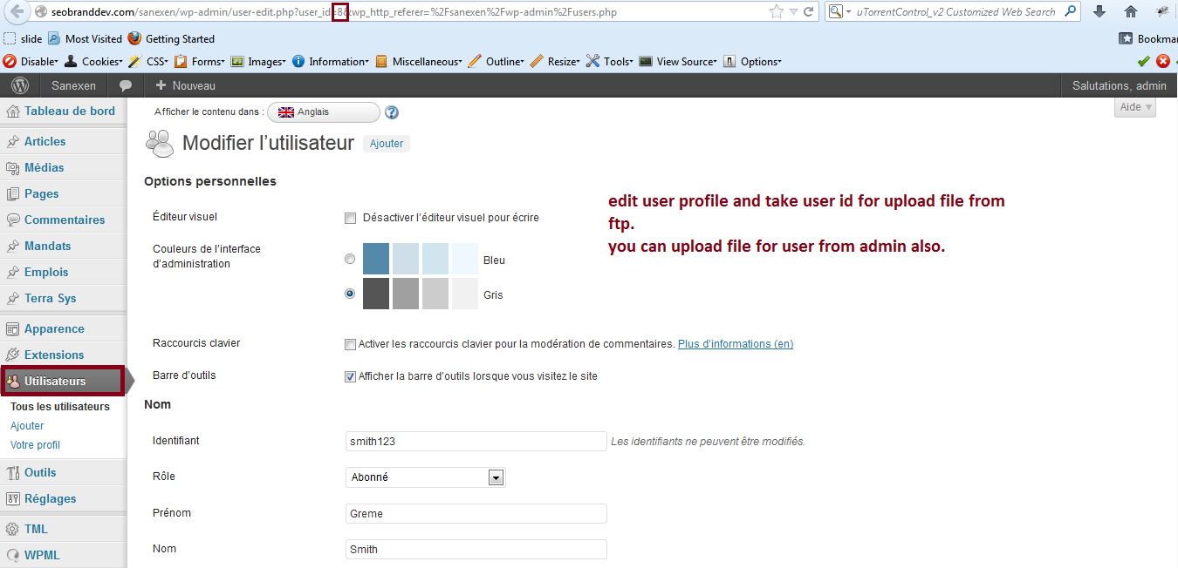

1. Manage file uploading from admin go to

**admin panel -> Gerer les Fichiers ->** **Ajouter**

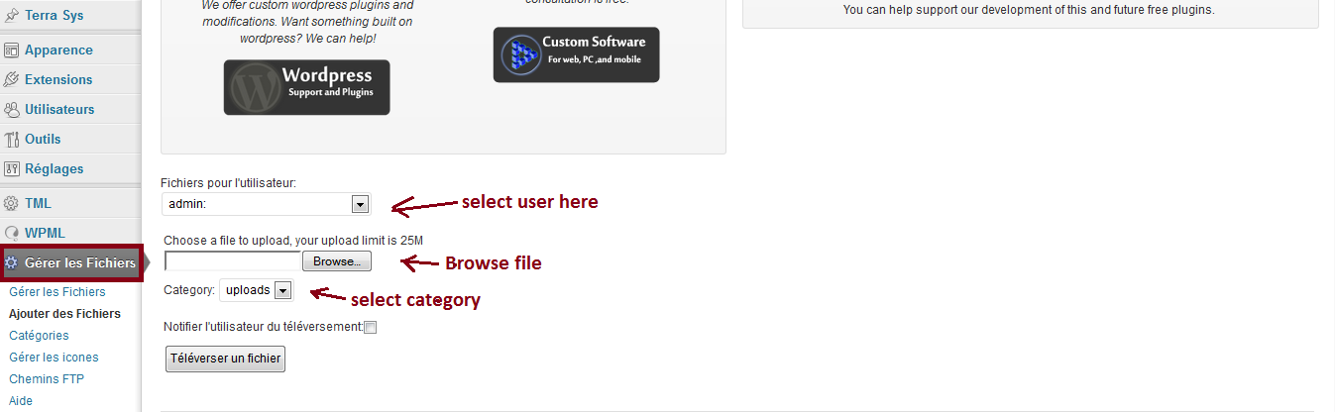

1. Add category from here.

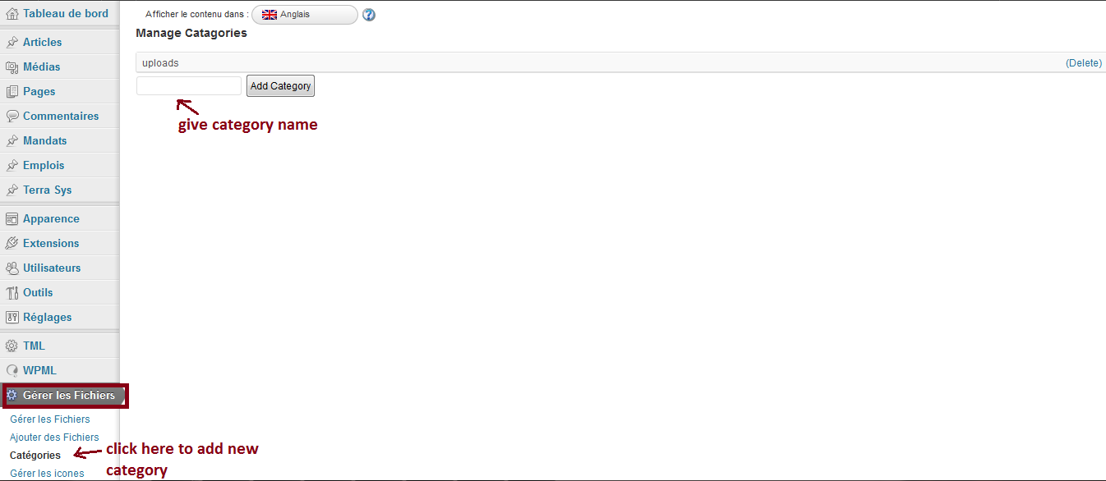

1. you can delete or edit files from here

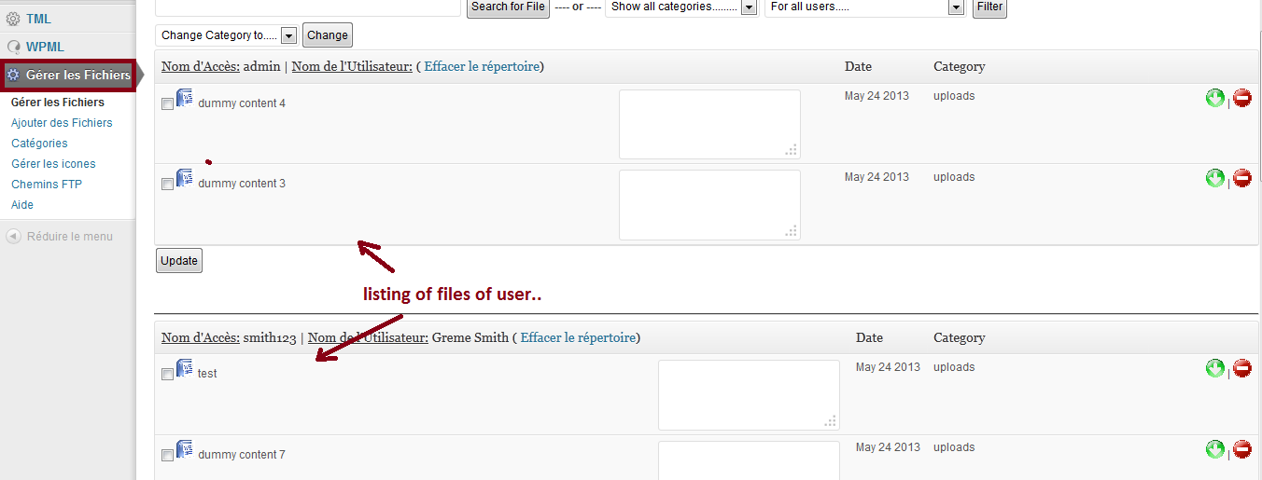

1. Uploaded files for particular user are showing below. User only can see files after login.

