# Changes to JobSeeker DashBoard

The following changes need to be made on the Job seeker Dashboard

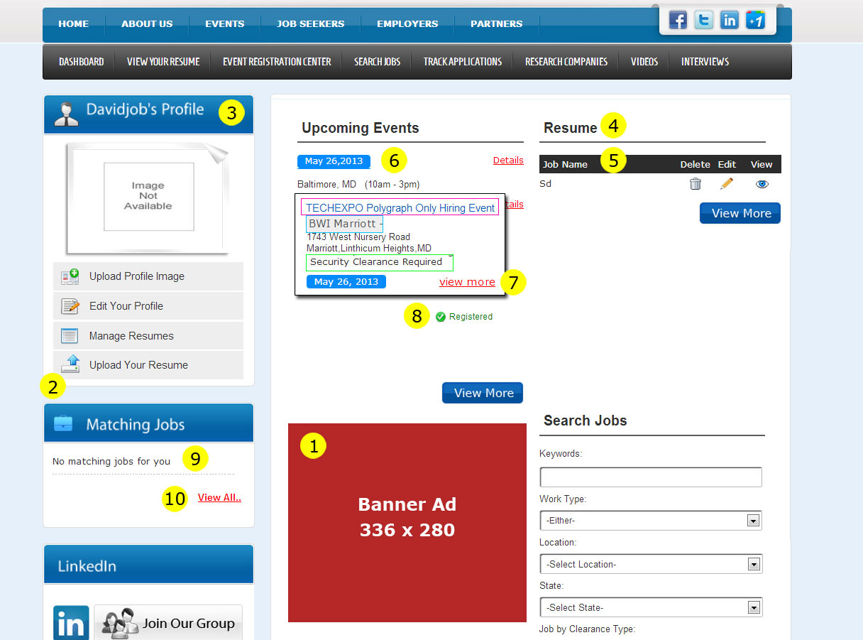

1. Remove the Video’s section and leave a space for a 336 x 280 banner ad. Banner ads will be managed through the admin and will show in this space. If is more than one active banner ad, they will rotate each time the screen is refreshed.
2. Add an item to the menu that says “Your Videos” - this will link to the same location as the “Videos” menu option in the job seeker submenu
3. Center this text vertically within the header, it is too high
4. Change “Resume” to “Your Resumes”
5. Change “Job Name” to “Resume Title”
6. Reformat the Upcoming events panel to follow the new format (see task #635 - the document for that change is also attached to this ticket)
7. If the user is not registered for the event, change this hyperlink to read “Register”
8. If the user is registered for the event, display the green checkmark icon and the copy Registered - this whole thing can be an image that is hyperlinked to the event detail screen (the same place “register” links to)
9. In the event of no matches, change this type to read “No matching jobs found”
10. In the event of no matches, do not display the “View all..” hyperlink