|  |  |
| --- | --- |
| **Document** | ENS: Project Documentation |
| **Description** | Project Documentation |
| **Document Version** | V1.0, 18 Jan, 2016 |

Overview

Requirement

Partner Activation

Partner Account Enable

Partner Account Disable

Partner User Creation

Partner User Deactivation

Job Sharing Automation

Partner Portal Navigation

Account Summaries View

Account View

Job View

Technical Implementation Information

Sharing Automation

Job Lookup relationship changes

# 

# 

# Overview

ENS International (ENS) is an existing Salesforce customer. ENS has one Enterprise Edition and 10 Force.com licences in use by ENS internal staff. ENS is looking to implement a Salesforce Partner Community environment to provide 60 partners with access to Salesforce information. The ENS partners are licenced to sell ENS Training and Consulting services.

There is an existing database of 55,000 contacts in Salesforce. A mass update of the records will assign the appropriate permissions to the existing accounts and contacts in Salesforce. There are a number of accounts and contacts that are not currently linked to a Partner. These accounts can be allocated to a Partner to take ownership of the account and create an opportunity, e.g. activate a dormant account.

# Requirement

The requirement is to deliver the following tasks for Salesforce customisation:

* Architecture and Design - Review the current Salesforce configuration and security settings
* Mass update of the existing records to assign accounts and contacts to Partner users
* Partner Community setup using default Salesforce Tab style user interface
* Setup 60 Partners users in the Community
* Setup the sharing rules and security settings for the Partner Community
* Generate reports - subject to allocated time
* Knowledge Transfer

# Partner Activation

This section describes about how to enable a partner account and partner user.

## Partner Account Enable

To enable a Partner Account:

* Create a new business account / Browse an existing account
* Click on the **Manage External Account**
* Click on **Enable as Partner**

Once this is done, this will become a partner account, and the contacts under it can be enabled as Partner user.

For more information, please refer to the official Salesforce help:

<https://help.salesforce.com/apex/HTViewHelpDoc?id=partner_portal_creating_partner_accounts.htm&language=en>

## Partner Account Disable

A Partner account is not able to be deleted, unlike a normal Business Account

However, you can disable a Partner Account:

* Browse an existing Partner Account
* Click **Manage External Account**, then **Disable Partner Account**
* Click **OK** to confirm

The Partner account will then be disabled together with up to 15 partner users parked under this account

For more information, please refer to the official Salesforce help:

<https://help.salesforce.com/apex/HTViewHelpDoc?id=partner_portal_disabling_partner_accounts.htm&language=en_US>

## Partner User Creation

Partner user can be created from a contact parks under a Partner Account using the following steps:

* Browse an existing partner account
* Create a new Contact or browse an existing contact under this partner account
* Click **Manage External User** and then **Enable Partner User**
* Edit the user record for this partner
  + Set Profile = **ENS Partner Community User**
  + Set **Active** flag
  + If the username is already being used (eg: already a CRM user), put a “.partner” as a postfix. Email remains the same
  + If you wish to sent the activation link to the Partner user upon creation, scroll to the bottom and checked the flag “**Generate new password and notify user immediately**”
* Then click **OK** to confirm

If activation link is sent to the Partner user, he will received an activation email. Follow the steps below to complete the activation:

* Login using the temporary password
* Enter a new password
* Retype the new password
* Continue to the Partner Portal

For more information, please refer to the official Salesforce help:

<https://help.salesforce.com/apex/HTViewHelpDoc?id=partner_portal_creating_partner_users.htm&language=en>

## Partner User Deactivation

To deactivate a partner user, just go to the User detail page of the Partner user, unset the **Active** flag.

# Job Sharing Automation

If a job is not assigned to a partner user, partner user will have **read-only access** to limited account and contact information read-access.

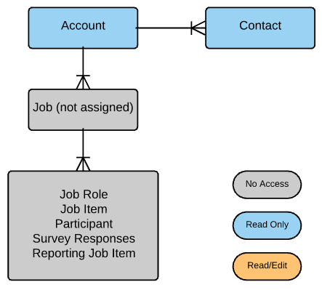

If an active Partner is one of the **“Sell” Job Roles** of the Job, he will have the following access:

* **Read/write access** to the job’s account and contact information
* **Read access** to the job and it’s related information
* No sharing will be granted if the Job Role added is not “**Sell**”

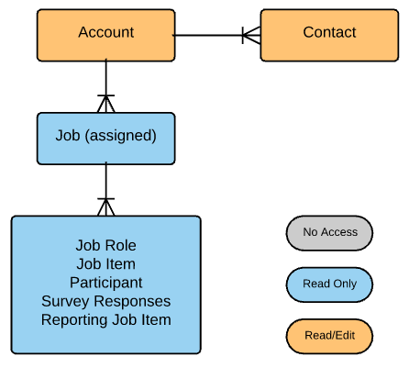   
* These access will be removed once the relevant “Sell” Job Role is removed

# Partner Portal Navigation

This is the landing page once a Partner user login to the portal. Below is the portal navigation:

* Using the **tabs** on top, user can navigate to Account, Account Summaries and assigned jobs
* User can search any of the records above using the **search** panel on the left
* Up to 10 recently viewed items are displayed as shortcut on the **Recent Items** section
* Task summary are displayed at the bottom

## 

## Account Summaries View

Partner User can access to all account information in a glance to the following information:

* Account Summary
* Client Status
* Billing Country
* Billing Locality
* Industry
* Sub Industry
* Sell 1
* Sell 2
* Spot 1
* Spot 2

For any Account that jobs are not assigned to any partner (No Sell or Spot), partner can contact ENS to request to take care of the account.

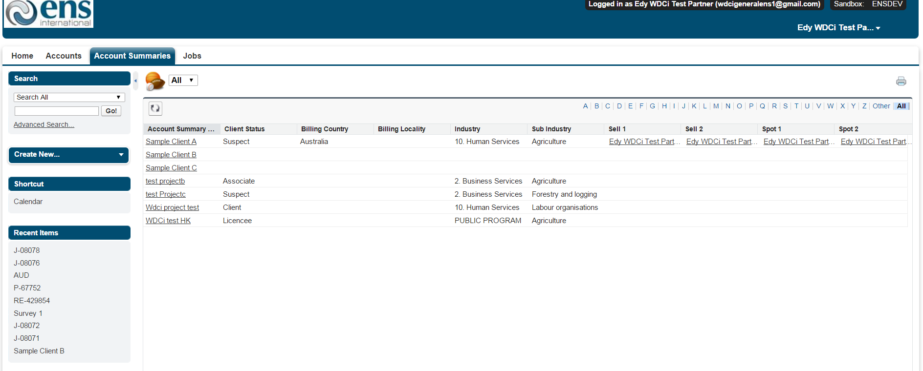

## Account View

Partner User will have full read/write access to account information, if the account contains jobs that have been assigned to the partner user.

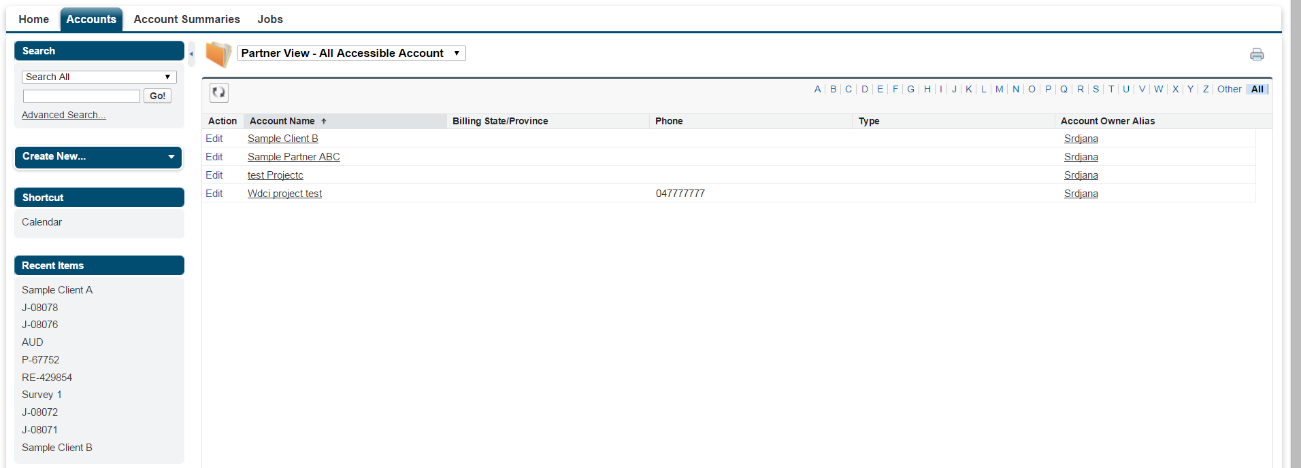

Click on the account name to display the account details

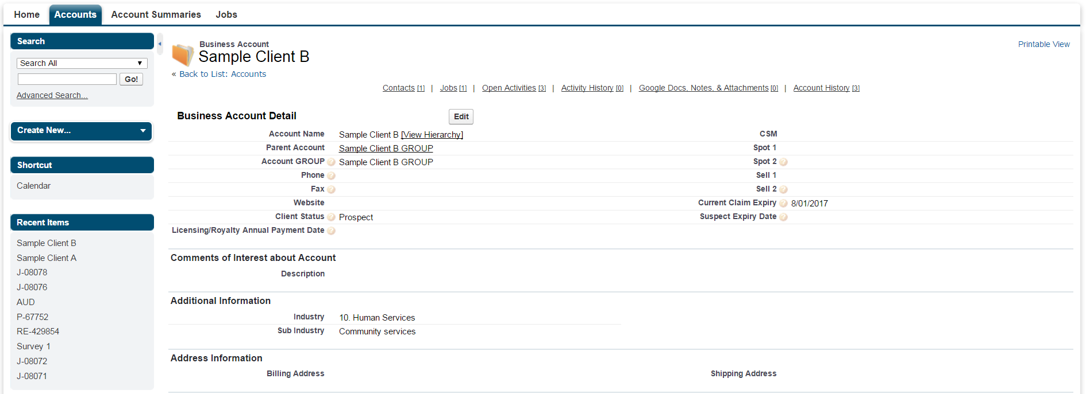

Partner can click on the Edit button to edit the account information.

Scroll further to the bottom, partner will be able to view the Contact & Job associated, also the open activities that assigned to the partner.

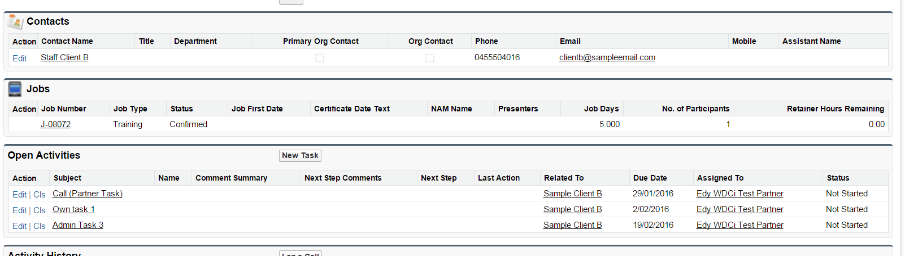

Click on the Contact to be able to view and edit limited contact information as below:

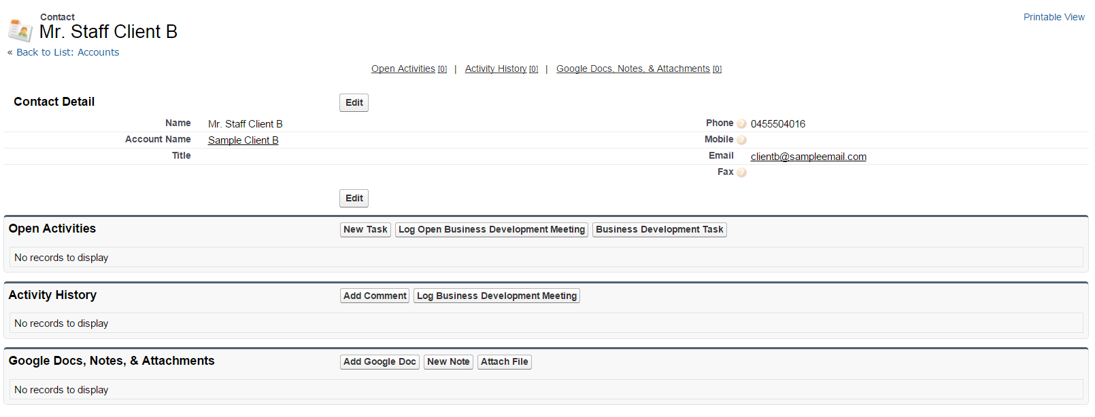

Partner can also click on the “New Task” button to create a task that assigned to himself, eg: reminder to follow ups and call activities.

## Job View

Partner User can only read-only access to the Job that assigned to them. User will not be able to edit any job and it’s related information

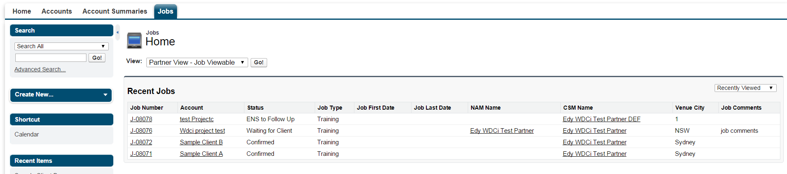

From the Job list, click on the Job Number to display the Job details. User can also click on the **Evaluation Report** to view the participant evaluation feedback.

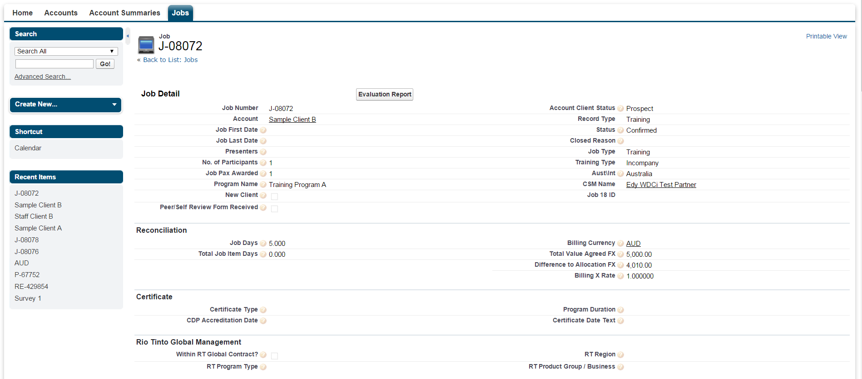

One Job record consists of the following related information:

* Job Role - Who is involved in handling the job
* Job Item - What Item/course/program this customer subscribed
* Participant - Who are the participant of the course/program
* Survey Responses - Feedback from the participant
* Reporting Job Items - For reporting purpose

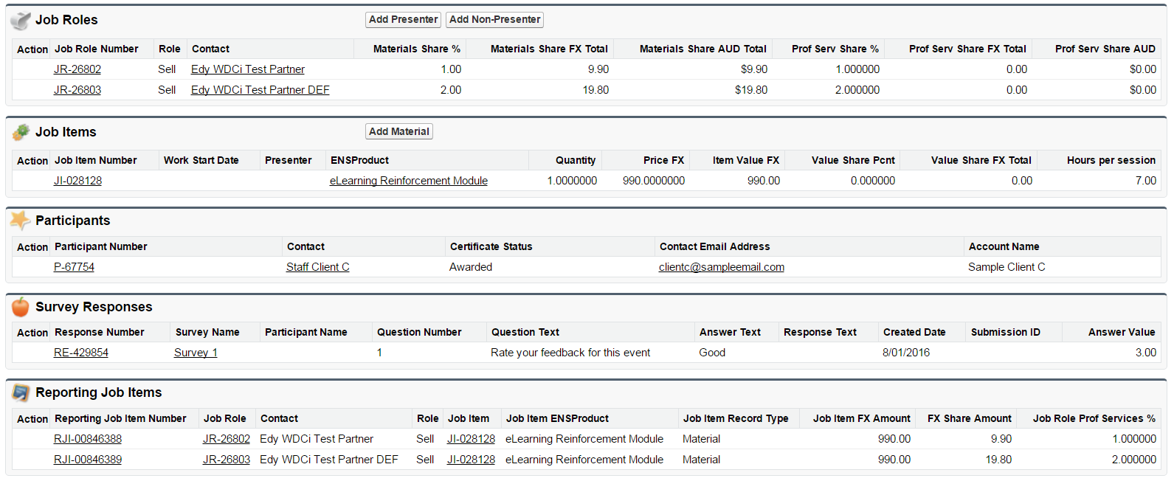

# Technical Implementation Information

This section describes about how to enable a partner account and partner user.

## Sharing Automation

A Salesforce trigger (trigger name: JobRoleAction) is used to automate the sharing of Account, Contact, Job and Job related information once a Job Role=”Sell” is added.

## Job Lookup relationship changes

To cater for this sharing model, all the job lookup in the Job related information have been changed from Lookup to Master detail

Before

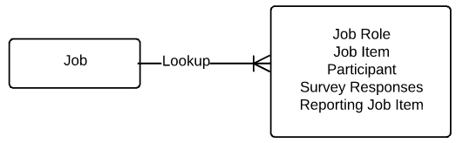

After

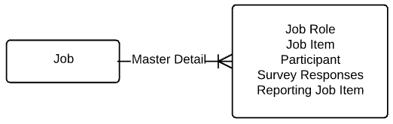

There is a few benefits in doing so:

* A much straight forward of sharing rule implementation implementation approach
* Utilising Salesforce out of the box inheritance sharing model that will minimise bugs while handling more complex scenarios
* Improve data integrity

Changing this to master detail relationship means that the Job lookup will be mandatory when creating these records. In the current production, there are a small amount of job related records which do not have any job linked to them. These are the orphan records left by the deleted Jobs and will be parked under a placeholder job in a one off migration practice.