4/12 Eniket Sarbajaya

Profilke -

Include fields for things in this form: <https://docs.google.com/forms/d/e/1FAIpQLSc083f4j_78d9gdXZvukJ1uZD_vIIa8KM5sUN8wpjEa666yEQ/viewform?usp=sf_link> SME gets verified by the administrator

profile pic - tried, produced 2 errors Browser doesn’t support File____ API, non error message when upload a PNG that was maybe too large?

Split -

* please don’t delete children when parent is deleted
* Please don’t insert comma in the parent, use space to concatnate the children
* When editing a parent, instead of

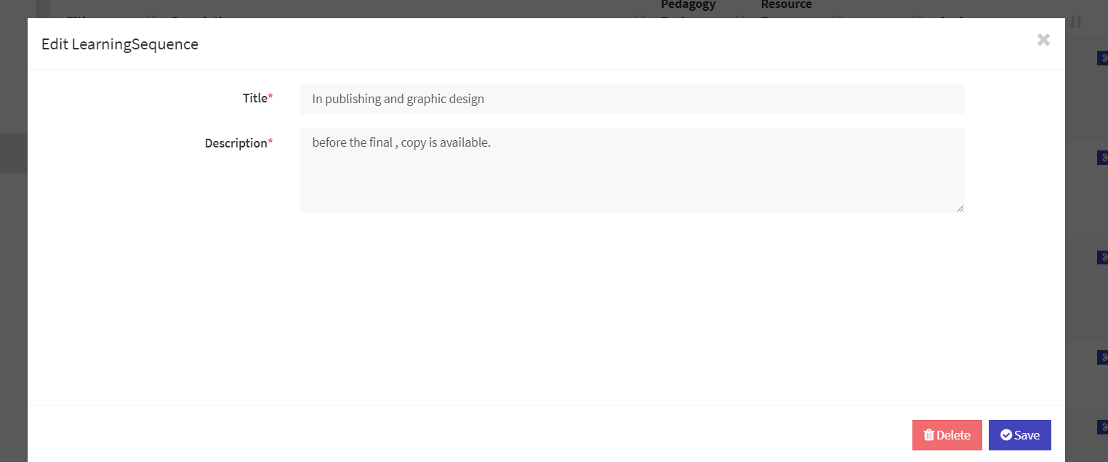

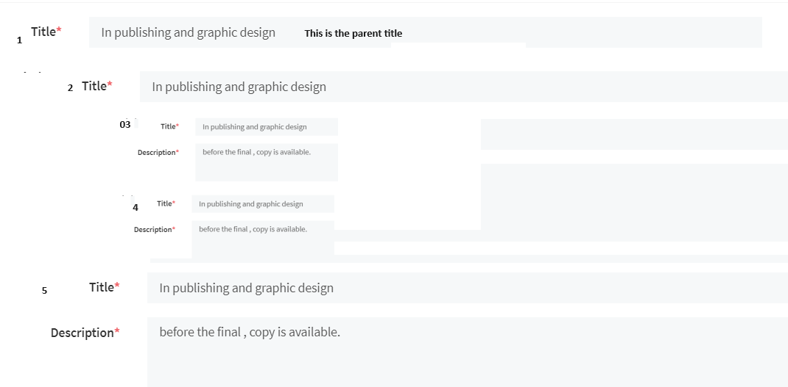

1 has no content; content is [2,5]

2 has no content; content is [3,4]

indentation helps, collapsible helps: if a learning sequence is a composite, then when editing, show title and expansion arrow if daughter is composite and show title/description if not composite for each daughter.

Compose

* Button “Aggregate” on learning sequences screen, next to “Add” button
* Aggregate will cause checkboxes to appear next to all learning sequences and they can be selected (checkbox) and sequenced (double vertical line for a handle) and “Create” button aggregates them into a new learning sequence:
  + title = create new one from user, initial placeholder title cab be “<aggregate>” or aggregate of titles in sequence
  + union of goals
  + union of pedagogy tags, union of resource type tags
  + maintain a hierarchical structure

Goals

* Thank you for the color branding in various places! Let’s use our secondary color to differentiate goals. use #44ddd4 for goalsbadges
* Remove “title” from goals screen
* favicon (Qu) and icon at top left (qusteam initiative icon) - will email and place in drive
* In learning sequence screen UI, Instead of truncating a very long goal like now

show 15 characters and truncate. the title is unrestricted but the display on learning sequence truncates the goal to display nicely. encopuntered an error trying to overflow goal title on the goal UI.

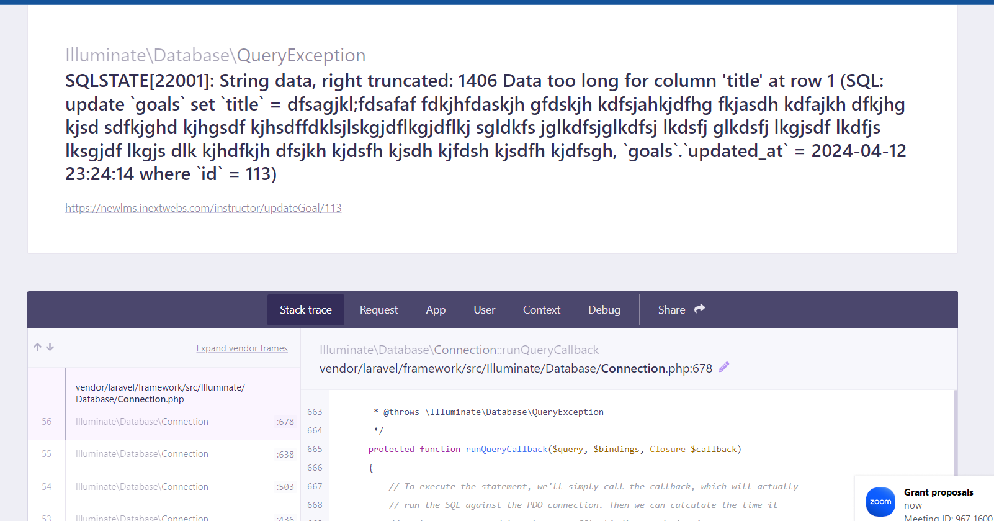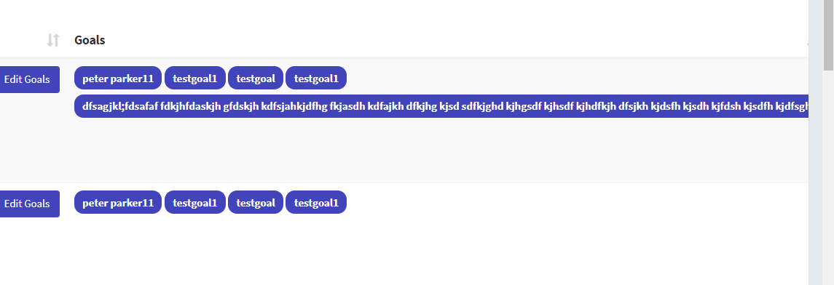

use “mouse over tool tip” on a truncated goal to display the full title.



Pedagogy tags - like goals in that learning sequence can be tagged with pedagogy tags. Except no way for most users to edit the set of available pedagogy tags. An administrator should be able to add, delete, edit tags

CSS for these badges: also cyan

* + - Backward design (clear learning outcomes with aligned assessment)
    - Open-ended questions that reveal student thinking
    - Rubric-based
    - Hands-on
    - Project-based
    - Problem-based, open-ended, student hand in defining the task
    - Exercises with worked examples using subgoal labeling
    - Flipped instruction: short video(s) or reading(s) with student prompt(s) preparing for upcoming class
    - Additional resources for background knowledge and similar support
    - Additional resources for extending learning
    - References to STEM and STEM education literature
    - References to news, the arts, and popular press
    - Culturally responsive pedagogy (social prompts to draw out student life expertise)
    - Culturally responsive teaching (subculture-specific content connections)
    - Bridge math content
    - Technical vocabulary definitions
    - Language-learners’ vocabulary definitions
    - Accessibility: prerequisite knowledge, blind/deaf/colorblind/ELL
    - Engaging activities
    - Formative assessment metrics
    - Student sample responses
    - Student-facing text
    - technical vocabulary
    - CRP
    - Video for flipped instruction
    - active learning suggestions
    - open-ended questions
    - exercises
    - widgets, annotated links and resources
    - Project (Problem statement, constraints, dimensions of student choice, rubric(s), exemplar(s))
    - Instructor-facing text (day-by-day prep, answers keys)
    - Instructor-participant-facing text, video, key terms, annotated links/references (PD for instructors)
    - Lead-teacher-facing
    - PBL, QPU use, video for flipped instruction, check for understanding, active learning, open-ended assessment, project-based, culturally responsive pedagogy, or culturally relevant content, technical and language learner’s vocabulary, exercise set, widgets, or rubric.
    - 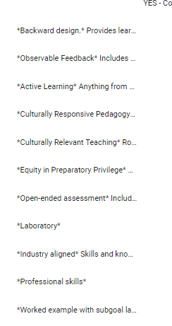

Resource type tags:

CSS with white text on black

* + - video
    - pen-ended questions
    - exercises
    - widgets, annotated links and resources
    - Project (Problem statement, constraints, dimensions of student choice, rubri

3/20 Eniket Sarbajaya

Fantastic progress! Thank you!

Steps to do:

* remove header row at bottom of tables
* put QuSTEAM logo in top left and #4144bb for top bar
* When viewing a subgoal, show enclosing goals to the top as below, and allow new subgoal of subgoal.
* In display of hierarchy, use the expansion chevron > to expand/collapse subgoals within subgoals, increasing indentation at each lower level.
* Show descension from “Learning goals” down through goal hierarchy using goal titles and breadcrumbs style hotlinks:

Hot link here: “Learning Goals” has the effect of the left-mnav “Goals” that you have now, it takes you to a list of the top-level goals. Here, we’re looking at a subgoal of Entanglement Measures

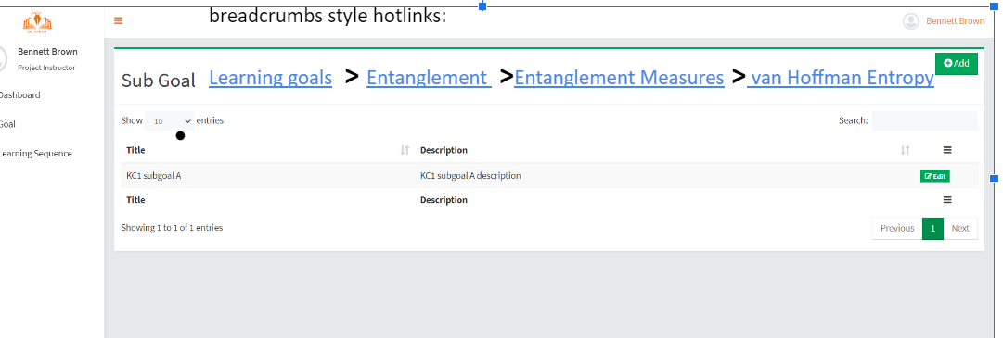

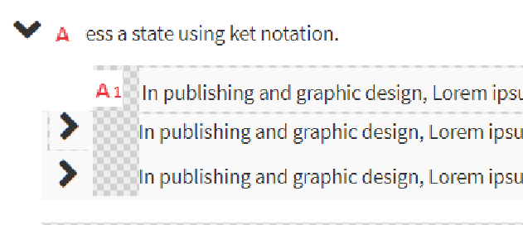

* Make ESC key exit out of dialog boxes
* Split by “ | “ is a good idea. Use a longer more unique split character sequence “
* Place directions in italics after “Split Description”: To split this learning sequence into two or more smaller pieces, insert “-^|^-”. assign all of parent’s goals to daughters. Assign parent title to both daughters.
* 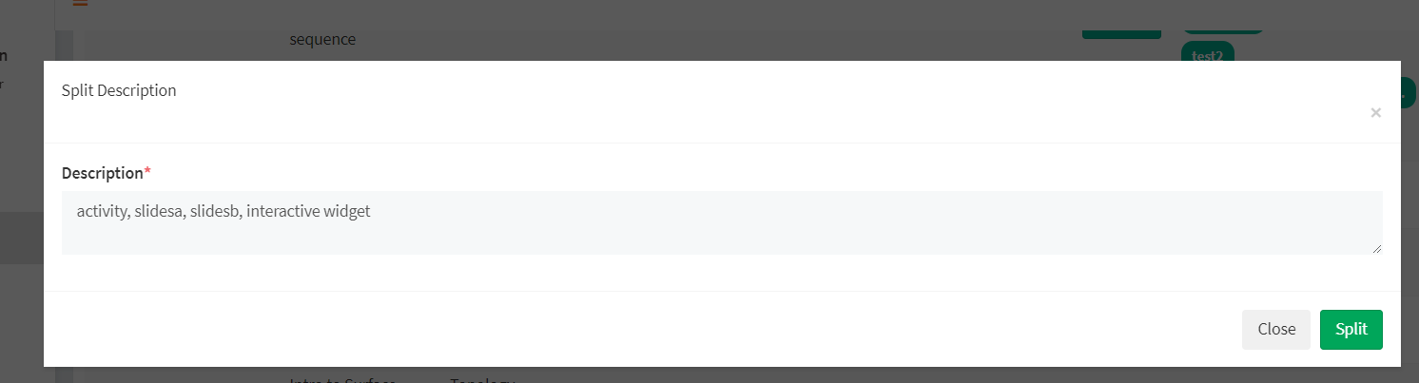

In this mock up above, A has three subgoals: A1, A2, A3. (I just didn’t show A2 anbd A3 labels, but labels are just for reference here not in UI.) A1 has no subgoals. Chevrons for A2 and A3 are aligned with the start of text of the title of A. Chevrons only appear when there are subgoals.

Learning Sequences. again, thank you!

Select goals using a menu>submenu>submenu style. Could be

1. use the chevron expand/collapse style
2. use the click on text dropdown menu style

Tops ection lists all goals checked, from any level in the heirachy, with indentation, as a way to quickly see and uncheck those that were checked. The bottom section here shows collapsioble hierarchy, including checked and unchecked goals.

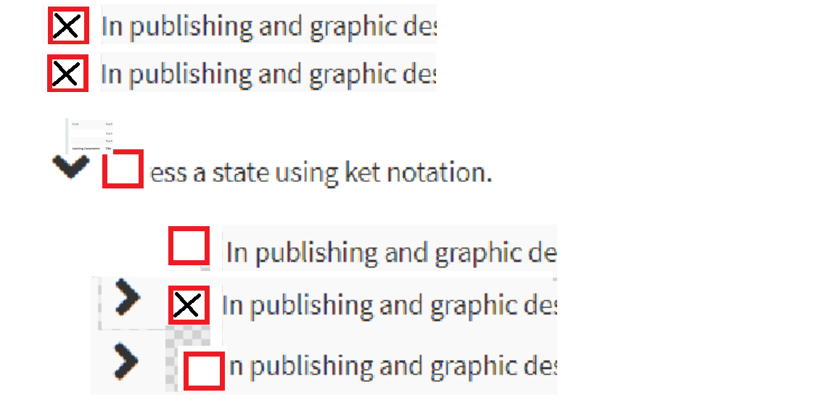

Edit button on all learning sequence, including compositions as wellk as unsubdivided learning sequences.

“Add Goal” button please “Edit goals”. Eliminate column titles Goals, Split and make column “Assign Goals” be “Goals”. Eliminate the whole column showing sublearning sequences that you’ve labelled “Learning Components”.

Learning Sequence now has Title, Description, and in a relational table has ties to goals, has a sequence of learning sequences.

Please expand this a little so that there are resource tags ,pedagogy tags, and topic tags.

Tables:

topic_tag (topic_tag_id, topic_tag_text)

pedagogy_tag (pedagogy_tag_id, pedagogy_tag_text)

Relational tables:

topic_tag_id, learning_sequence_id

pedagogy_tag_id, learning_sequence_id

Title and Description (what you’ve been using as description call title.)

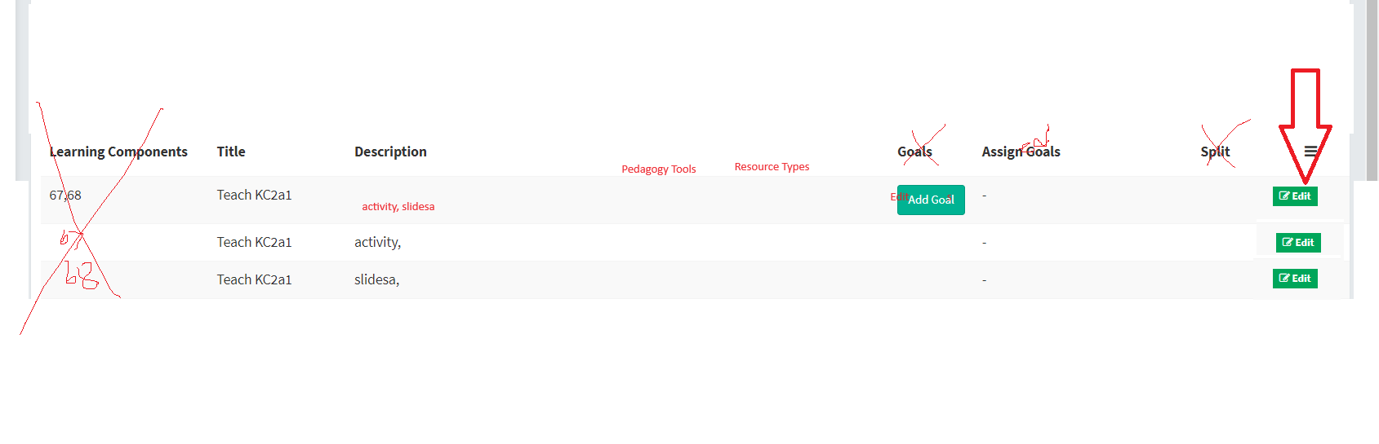

3/13 BB, Eniket, Sarbajaya Das,

As discussed in the previous meeting, here are the points we have worked on:

1. delete all pages done like for every goal and learning sequence delete added into edit panel from there u can delete

2. goal section and sub gaol is dynamic

3. edit problem issue fixed

4. learning sequence goal added for particular learning sequence u can 5. add more goals

6. dropdown of goal is added in below of learning sequence title

7. clone button added if u want u can clone or duplicate learning sequence and its added just above edit button

<https://newlms.inextwebs.com/auth/instructor>

instructor login normal email id:

bbrown@qusteam.org

password- 12345678

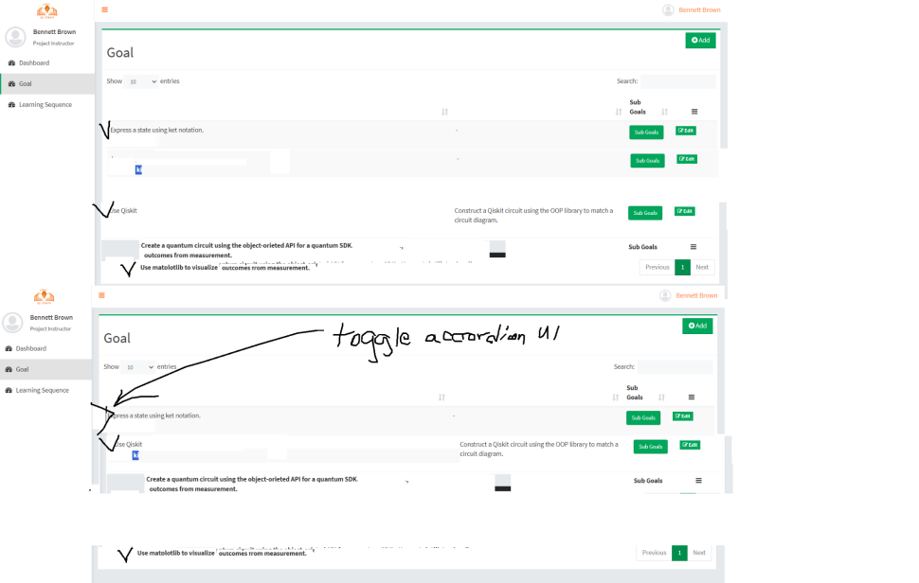

Next steps:

for goals UI

* Use expandible toggle like described <https://jsfiddle.net/smlombardi/kW33s/> and <https://stackoverflow.com/questions/23940547/setting-up-disclosure-triangles-for-bootstrap-3-accordion>
* eliminate display of the word “title”
* eliminate the goal description all together from anywhere.

For learning sequence UI

* goals should show in learning sequence using the same goals that were created in goals from main menu
* goals selectable and expandible from drop down in learn sequence view
* many-many relationship in relational database
* split like Jupyter notebooks.: <https://community.databricks.com/t5/data-engineering/split-a-code-cell-at-cursor-position-add-a-cell-above-below/td-p/29465> except the split is only applied to the content (description) but the title and goals are duplicated. (well, additional rows create duplicate relationships to the same goals in a many-many table.

Goals table

|  |  |
| --- | --- |
| Goal_ID (primary key) | Goal_text |
| 1 | Explain how diverse types of data can be represented in binary. |
| 2 | Represent an integer in binary |

Learning_Sequence Table

|  |  |  |  |
| --- | --- | --- | --- |
| Learning_Sequence_ID (primary key) | Learning_Sequence_Components | Title | Content |
| 1 | NULL | Representing Data | Explanation here. Practice with Cisco game. |

Goal_Sequence_Relations table

|  |  |  |
| --- | --- | --- |
| Goal_Sequence_Relation_ID (primary key) | Goal_ID | Learning_Sequence_ID |
| 1 | 2 | 1 |
| 2 | 1 | 1 |

**Goal_subgoal table**

|  |  |  |
| --- | --- | --- |
| Goal_Relation_ID (primary key) | Goal_ID_super | Goal_ID_sub |
| 1 | 1 | 2 |
|  |  |  |

**If user splits when cursor is here:** Explanation here. **|** Practice with Cisco game.

then result will be

Goal table

|  |  |
| --- | --- |
| Goal_ID (primary key) | Goal_text |
| 1 | Explain how diverse types of data can be represented in binary. |
| 2 | Represent an integer in binary |

Learning_Sequence Table

|  |  |  |  |
| --- | --- | --- | --- |
| Learning_Sequence_ID (primary key) | Learning_Sequence_Components | Title | Content |
| 1 | [2,3] | Representing Data | null |
| 2 | null | Representing Data | Explanation here. |
| 3 | null | Representing Data | Practice with Cisco game |

Goal_Sequence_Relations table

|  |  |  |
| --- | --- | --- |
| Goal_Sequence_Relation_ID (primary key) | Goal_ID | Learning_Sequence_ID |
| 1 | 2 | 1 |
| 2 | 1 | 1 |
| 3 | 2 | 2 |
| 4 | 1 | 2 |
| 5 | 2 | 3 |
| 6 | 1 | 3 |

**Goal_subgoal table**

|  |  |  |
| --- | --- | --- |
| Goal_Relation_ID (primary key) | Goal_ID_super | Goal_ID_sub |
| 1 | 1 | 2 |
|  |  |  |

¾ next steps:

* Learning sequence requires one or more goals from any level of the heirarchy
* Goals are hierarchical, allow adding a goal anywhere in the existing hierarchy
* Learning sequence can be split into 2 copies that are sisters
* Learning sequence should allow inclusion of existing learning sequences.

Save but important: tagging with course hierarchy, pedagogies, topics, move registration to profile

3/4/24 link: <https://newlms.inextwebs.com/auth/instructor>

previous meeting: unable to create account, too much validation, too many required answers.

today: wouldn’t validate qusteam.org, used iweb website. Login in by google threw error:

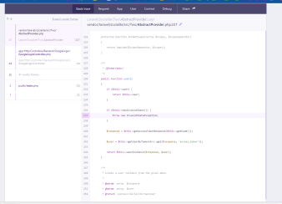

https://newlms.inextwebs.com/auth admin email id is.. admin@gmail.com and password....12345

Type of Users:

1. Instructor

2. Student

Dashboard Features:

Instructors:-

1. Collaboration - instructors only

a. Learning Goals: refer to Example goal in drive (hierarchical order, could be changed by admin after thumbs up by more than 5 instructors)

add goal

edit goal

review a goal with SME

threaded discussion about a goal

view revision history of goal

create subgoal

tag goal with another part of the hierarchy (location in hierarchy is the “primary tag” but other tags indicate elsewhere in hierarchy; “moving goal” would be the same as changing which tag is primary

b. Learning sequence ( learning modules after completion of class and students can comment under that module )

add a sequence: requires

selecting 1+ goal

providing text, file, link, discussion prompt OR selecting 2+ other learning sequences (composition)

add/remove goals to learning sequence

edit learning sequence

decomposition

tag learning sequence with pedagogy (e.g. project, culturally responsive pedagogy, etc.)

tag learning sequence with content type (e.g. video, link, slide, lab, coding, etc.)

2. Course Cloner - instructors only select learning sequence (built in the collaboration platform) → forks that learning sequence so that students can be enrolled into a static version that only that instructor can modify

3. Instruct - instructor only

invite instructor or student

edit goals and learning sequences

pull changes from upstream goals and learning sequences

publish/pull request to upstream goals and learning sequences

export course to Canvas Common Cartridge format

Students

See courses available - QuSTEAM public/for pay, invited by their instructor, instructor can only invite students registered at their member institution

⅜ Goals and learning sequence can be edited now.

* sign in - no email?
* sub goals can have subsubgoals, etc.
* place delete goal functionality within edit interface to make harder to accidentally delete
* show goals and subgoals and subsubgoals using collapsible indented style
* eliminate description attribute of a goal.

learning sequence:

* select a goal from a hierarchical (goal-subgoal-subgoal) dropdown menu, again collapsible
* show goals that have been selected for this learning sequence, allow add more goals
* move delete to within edit screen
* add a “duplicate” button alongside “edit”
* add a “split” button within edit-learning-sequence that makes two learning sequence objects to replace the original sequence. The two have the same goals as the original, and same title as the original, but they split the description.

Example:

learning sequence ID: 23

title: blahblah

goals: ABC, DEF

description: lkjfdhgkjfdhgljkdsfhgj | hdfkjghsl (note the cursor)

clicking “split”

Now there are 3 sequences:

1.

learning sequence ID: 23

title: blahblah

goals: ABC, DEF

description: reference to ID70+ID71

2.

learning sequence ID: 70

title: blahblah

goals: ABC, DEF

description: lkjfdhgkjfdhgljkdsfhgj

3.

learning sequence ID: 71

title: blahblah

goals: ABC, DEF

description: hdfkjghsl