Kobe_Analysis

Pankaj Kumar

7/14/2019

## Some observation on the data

length(kobe_data)

## [1] 29

nrow(kobe_data)

## [1] 20697

ncol(kobe_data)

## [1] 29

dim(kobe_data)

## [1] 20697 29

## check if there are any null or empty values are there

## recId action_type combined_shot_type   
## FALSE FALSE FALSE   
## game_event_id game_id lat   
## FALSE FALSE FALSE   
## loc_x loc_y lon   
## FALSE FALSE FALSE   
## minutes_remaining period playoffs   
## FALSE FALSE FALSE   
## season seconds_remaining shot_distance   
## FALSE FALSE FALSE   
## shot_made_flag shot_type shot_zone_area   
## FALSE FALSE FALSE   
## shot_zone_basic shot_zone_range team_id   
## FALSE FALSE FALSE   
## team_name game_date matchup   
## FALSE FALSE FALSE   
## opponent shot_id attendance   
## FALSE FALSE FALSE   
## arena_temp avgnoisedb   
## FALSE FALSE

### Not null or missing

## recId action_type combined_shot_type   
## FALSE FALSE FALSE   
## game_event_id game_id lat   
## FALSE FALSE FALSE   
## loc_x loc_y lon   
## FALSE FALSE FALSE   
## minutes_remaining period playoffs   
## FALSE FALSE FALSE   
## season seconds_remaining shot_distance   
## FALSE FALSE FALSE   
## shot_made_flag shot_type shot_zone_area   
## FALSE FALSE FALSE   
## shot_zone_basic shot_zone_range team_id   
## FALSE FALSE FALSE   
## team_name game_date matchup   
## FALSE FALSE FALSE   
## opponent shot_id attendance   
## FALSE FALSE FALSE   
## arena_temp avgnoisedb   
## FALSE FALSE

### Transformations :

minutes remaining and second remaining can be compined to make a new variable called time remaining

# plots

## Factors

Graphs of all the variable with alphanumeric value.

### action_type

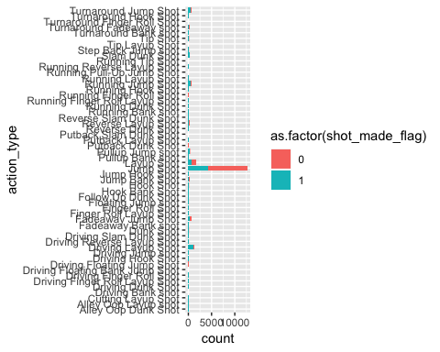

### combined_shot_type

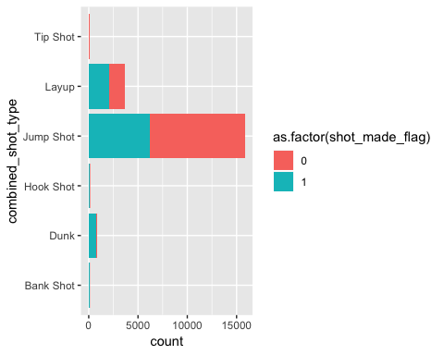

### matchup

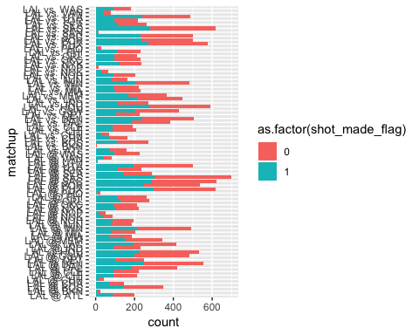

### opponent

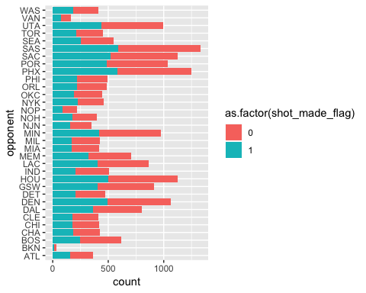

### Season

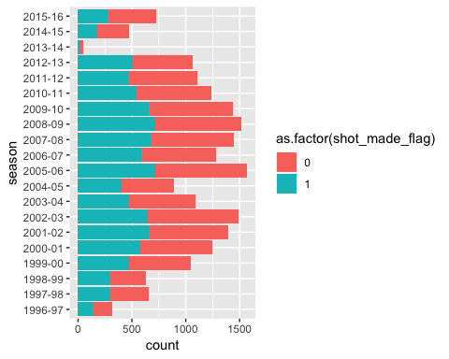

### shot_type

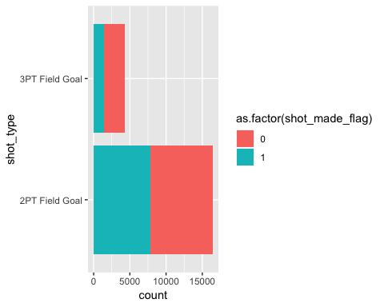

### period

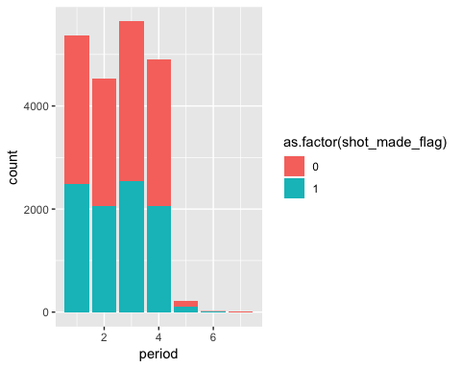

## `stat_bin()` using `bins = 30`. Pick better value with `binwidth`.

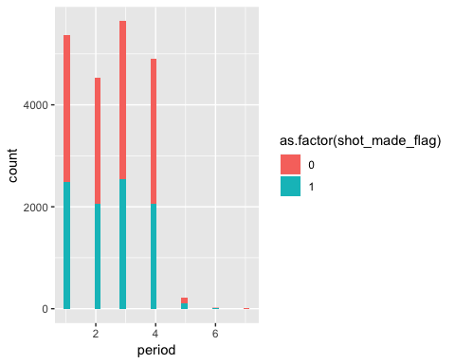

## <ggproto object: Class CoordFlip, CoordCartesian, Coord, gg>  
## aspect: function  
## backtransform_range: function  
## clip: on  
## default: FALSE  
## distance: function  
## expand: TRUE  
## is_free: function  
## is_linear: function  
## labels: function  
## limits: list  
## modify_scales: function  
## range: function  
## render_axis_h: function  
## render_axis_v: function  
## render_bg: function  
## render_fg: function  
## setup_data: function  
## setup_layout: function  
## setup_panel_params: function  
## setup_params: function  
## transform: function  
## super: <ggproto object: Class CoordFlip, CoordCartesian, Coord, gg>

### playoffs

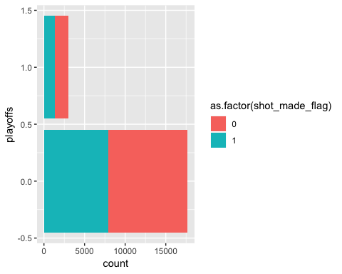

## `stat_bin()` using `bins = 30`. Pick better value with `binwidth`.

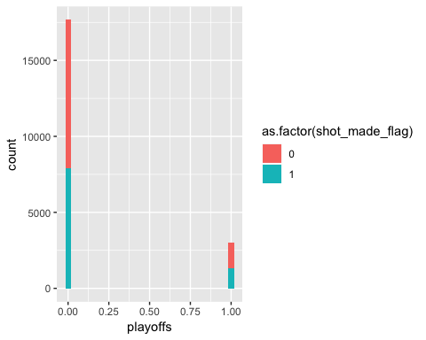

## <ggproto object: Class CoordFlip, CoordCartesian, Coord, gg>  
## aspect: function  
## backtransform_range: function  
## clip: on  
## default: FALSE  
## distance: function  
## expand: TRUE  
## is_free: function  
## is_linear: function  
## labels: function  
## limits: list  
## modify_scales: function  
## range: function  
## render_axis_h: function  
## render_axis_v: function  
## render_bg: function  
## render_fg: function  
## setup_data: function  
## setup_layout: function  
## setup_panel_params: function  
## setup_params: function  
## transform: function  
## super: <ggproto object: Class CoordFlip, CoordCartesian, Coord, gg>

### shot_zone_area

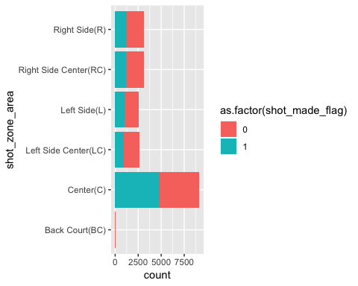

### shot_zone_basic

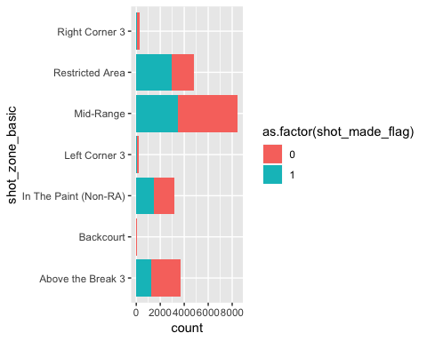

### shot_zone_range

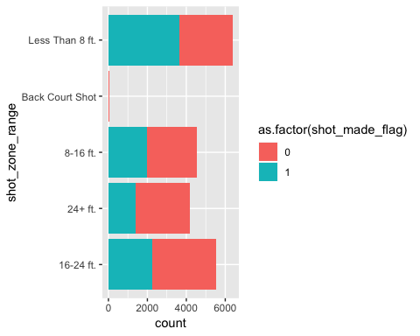

## Numerical variables that can be treated as factors

### game_event_id

## Continuous var

### game_event_id

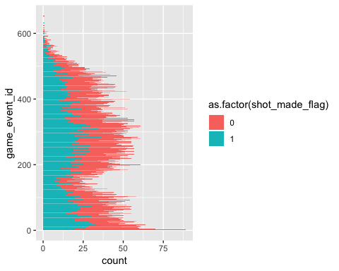

### shot_distance

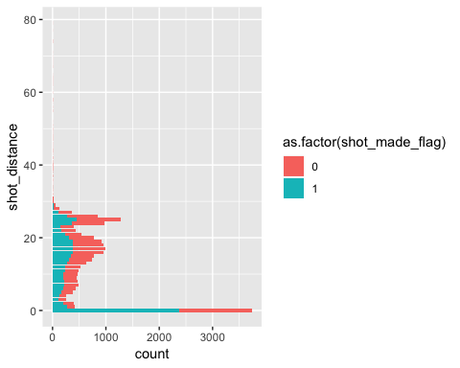

### lat

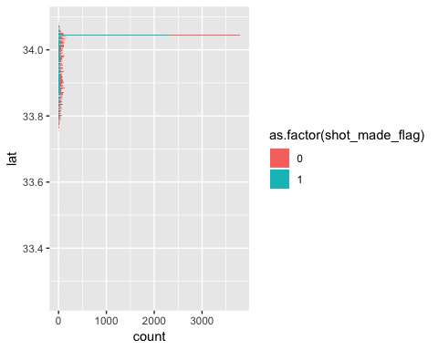

## `stat_bin()` using `bins = 30`. Pick better value with `binwidth`.

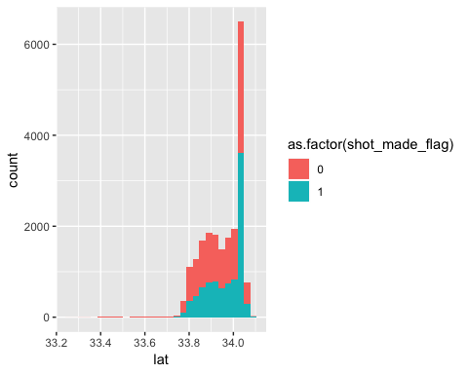

## <ggproto object: Class CoordFlip, CoordCartesian, Coord, gg>  
## aspect: function  
## backtransform_range: function  
## clip: on  
## default: FALSE  
## distance: function  
## expand: TRUE  
## is_free: function  
## is_linear: function  
## labels: function  
## limits: list  
## modify_scales: function  
## range: function  
## render_axis_h: function  
## render_axis_v: function  
## render_bg: function  
## render_fg: function  
## setup_data: function  
## setup_layout: function  
## setup_panel_params: function  
## setup_params: function  
## transform: function  
## super: <ggproto object: Class CoordFlip, CoordCartesian, Coord, gg>

### loc_x

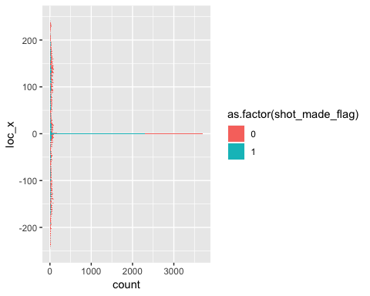

## `stat_bin()` using `bins = 30`. Pick better value with `binwidth`.

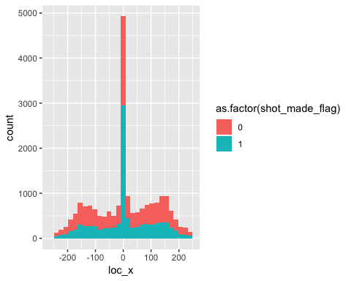

## <ggproto object: Class CoordFlip, CoordCartesian, Coord, gg>  
## aspect: function  
## backtransform_range: function  
## clip: on  
## default: FALSE  
## distance: function  
## expand: TRUE  
## is_free: function  
## is_linear: function  
## labels: function  
## limits: list  
## modify_scales: function  
## range: function  
## render_axis_h: function  
## render_axis_v: function  
## render_bg: function  
## render_fg: function  
## setup_data: function  
## setup_layout: function  
## setup_panel_params: function  
## setup_params: function  
## transform: function  
## super: <ggproto object: Class CoordFlip, CoordCartesian, Coord, gg>

### loc_y

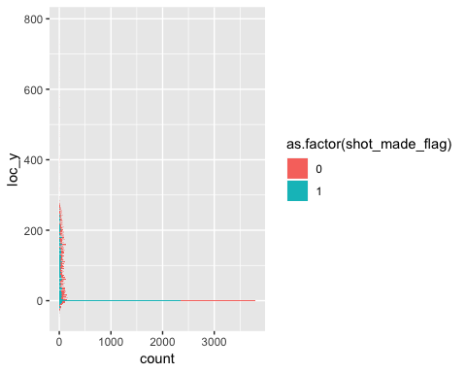

## `stat_bin()` using `bins = 30`. Pick better value with `binwidth`.

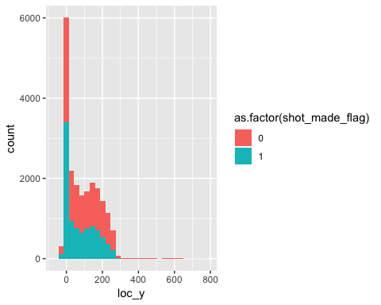

## <ggproto object: Class CoordFlip, CoordCartesian, Coord, gg>  
## aspect: function  
## backtransform_range: function  
## clip: on  
## default: FALSE  
## distance: function  
## expand: TRUE  
## is_free: function  
## is_linear: function  
## labels: function  
## limits: list  
## modify_scales: function  
## range: function  
## render_axis_h: function  
## render_axis_v: function  
## render_bg: function  
## render_fg: function  
## setup_data: function  
## setup_layout: function  
## setup_panel_params: function  
## setup_params: function  
## transform: function  
## super: <ggproto object: Class CoordFlip, CoordCartesian, Coord, gg>

### lon

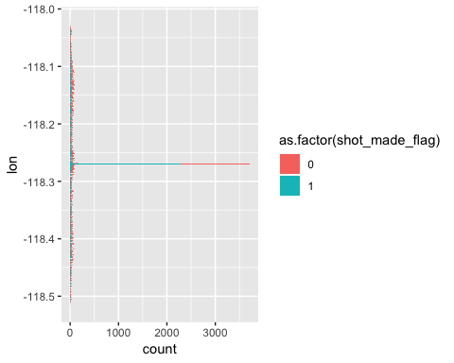

## `stat_bin()` using `bins = 30`. Pick better value with `binwidth`.

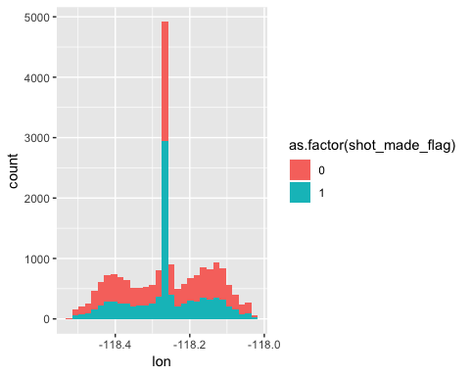

## <ggproto object: Class CoordFlip, CoordCartesian, Coord, gg>  
## aspect: function  
## backtransform_range: function  
## clip: on  
## default: FALSE  
## distance: function  
## expand: TRUE  
## is_free: function  
## is_linear: function  
## labels: function  
## limits: list  
## modify_scales: function  
## range: function  
## render_axis_h: function  
## render_axis_v: function  
## render_bg: function  
## render_fg: function  
## setup_data: function  
## setup_layout: function  
## setup_panel_params: function  
## setup_params: function  
## transform: function  
## super: <ggproto object: Class CoordFlip, CoordCartesian, Coord, gg>

### minutes_remaining

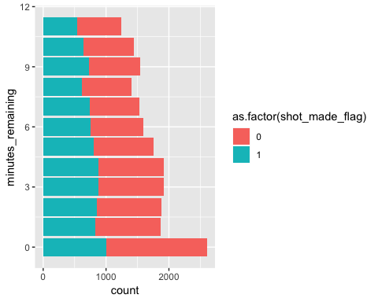

## `stat_bin()` using `bins = 30`. Pick better value with `binwidth`.

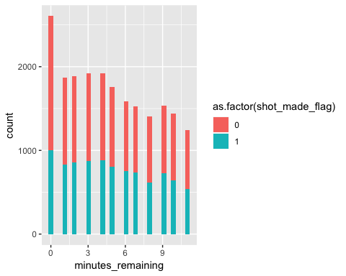

## <ggproto object: Class CoordFlip, CoordCartesian, Coord, gg>  
## aspect: function  
## backtransform_range: function  
## clip: on  
## default: FALSE  
## distance: function  
## expand: TRUE  
## is_free: function  
## is_linear: function  
## labels: function  
## limits: list  
## modify_scales: function  
## range: function  
## render_axis_h: function  
## render_axis_v: function  
## render_bg: function  
## render_fg: function  
## setup_data: function  
## setup_layout: function  
## setup_panel_params: function  
## setup_params: function  
## transform: function  
## super: <ggproto object: Class CoordFlip, CoordCartesian, Coord, gg>

### seconds_remaining

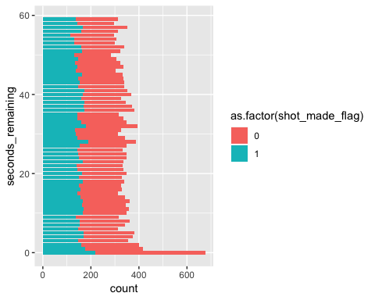

## `stat_bin()` using `bins = 30`. Pick better value with `binwidth`.

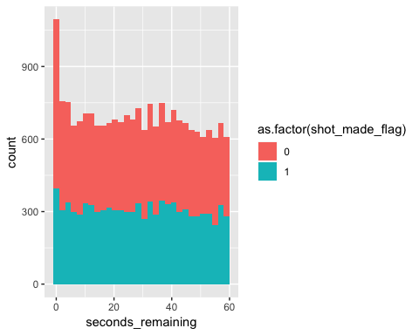 ### game_date

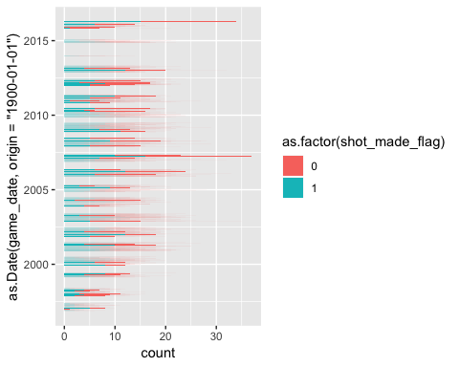

## `stat_bin()` using `bins = 30`. Pick better value with `binwidth`.

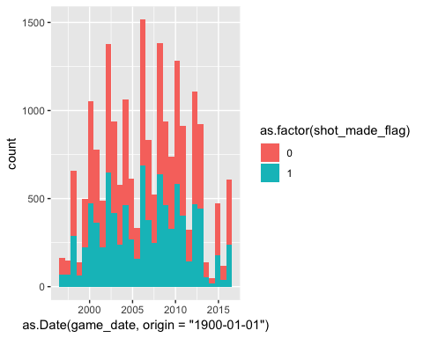

### attendance

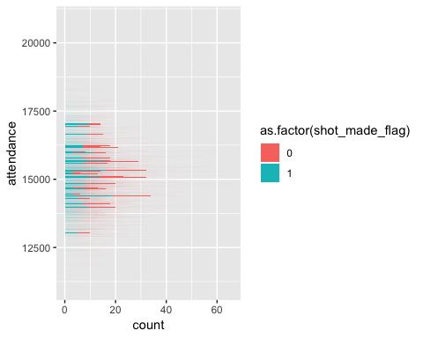

## `stat_bin()` using `bins = 30`. Pick better value with `binwidth`.

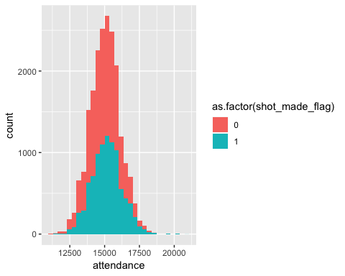

### arena_temp

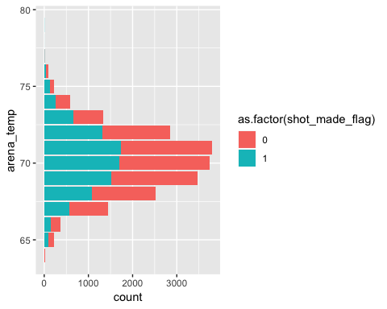

## `stat_bin()` using `bins = 30`. Pick better value with `binwidth`.

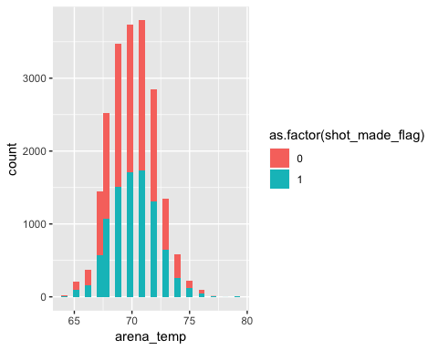

### avgnoisedb

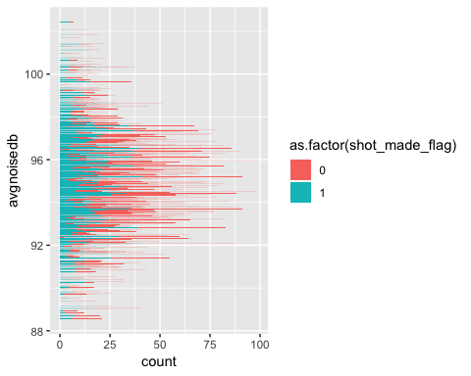

## `stat_bin()` using `bins = 30`. Pick better value with `binwidth`.

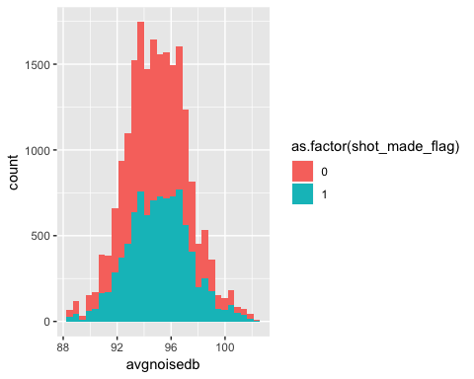

### Multicolineariy detection using VIF

## avgnoisedb arena_temp attendance game_date lon loc_y loc_x  
## avgnoisedb 1 0 1 0 0 0 0  
## arena_temp 0 1 0 0 0 0 0  
## attendance 1 0 1 0 0 0 0  
## game_date 0 0 0 1 0 0 0  
## lon 0 0 0 0 1 0 1  
## loc_y 0 0 0 0 0 1 0  
## shot_distance lat  
## avgnoisedb 0 0  
## arena_temp 0 0  
## attendance 0 0  
## game_date 0 0  
## lon 0 0  
## loc_y 1 -1

## Var1 Var2 value  
## 1 avgnoisedb avgnoisedb 1  
## 2 arena_temp avgnoisedb 0  
## 3 attendance avgnoisedb 1  
## 4 game_date avgnoisedb 0  
## 5 lon avgnoisedb 0  
## 6 loc_y avgnoisedb 0

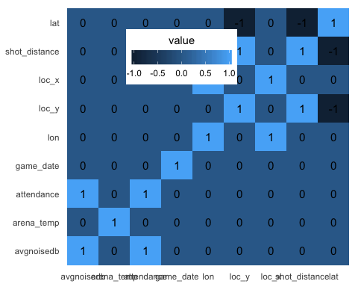

## arena_temp game_date   
## 81802.84 204061.55   
## attendance arena_temp:game_date   
## 498164.70 290160.27   
## arena_temp:attendance game_date:attendance   
## 609532.82 670177.98   
## arena_temp:game_date:attendance   
## 788182.21

## Model :  
## shot_made_flag ~ avgnoisedb + arena_temp + attendance + game_date +   
## seconds_remaining + minutes_remaining + lon + lat + game_event_id

## avgnoisedb arena_temp attendance game_date   
## 1.350766 1.005825 1.360433 1.014508   
## seconds_remaining minutes_remaining lon lat   
## 1.002014 1.080305 1.001722 1.016855   
## game_event_id   
## 1.081280

### Outlier detection using cook’s D value

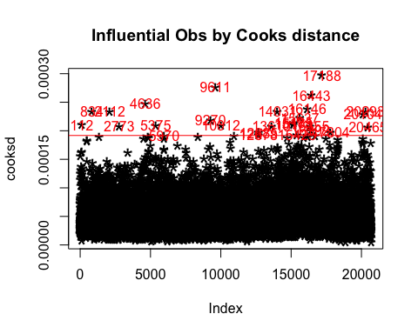

### Relation of shot made with distance and playoffs

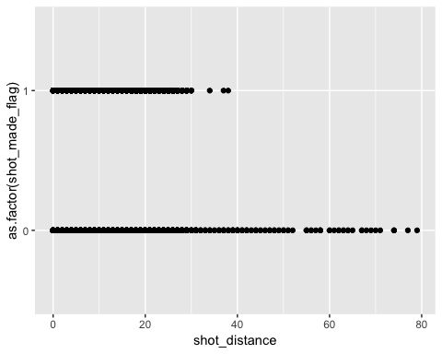

## `stat_bin()` using `bins = 30`. Pick better value with `binwidth`.

