Exploratory Data Analysis of New York City Yellow Taxi Trips (2023)
By: Pankaj Yadav

Date: Jun 7, 2026

Introduction
The objective of this analysis is to study yellow taxi trip data from 2023 and identify patterns and operations of the taxi. The insights will be used to improve the taxi operations, customer satisfaction and revenue. Helping all of the stakeholders like drivers, customers, and taxi operations management.

Data preparation and cleaning
The dataset was available for 2023 for each month in parquet format. Each month’s data has approx. 3 million entries. We followed the stratified sampling technique and took 5% of trip data per hour per day. We took sampling from per hour so that we keep the data unbiased.

The final data set has 1.8 million records
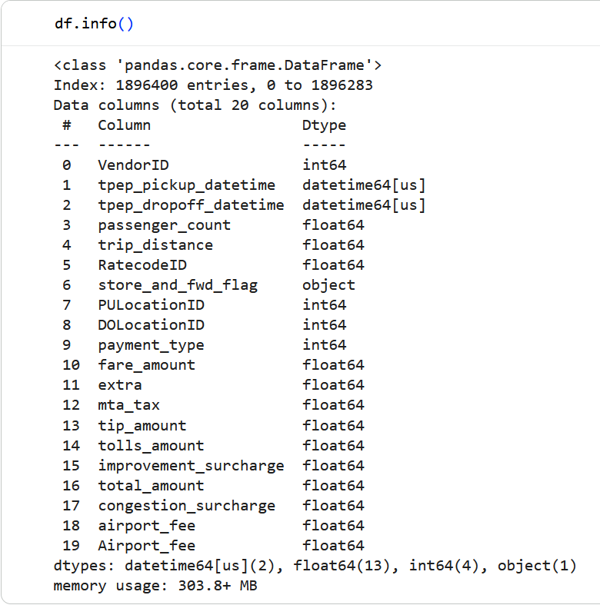

During data cleaning, several issues were identified:

- January contained a column named airport_fee and other months had Airport_fee.
- The two columns had to be merged to avoid column name duplications.
- 79 records had negative monetary values which represented 0.0005% of the sampled dataset.
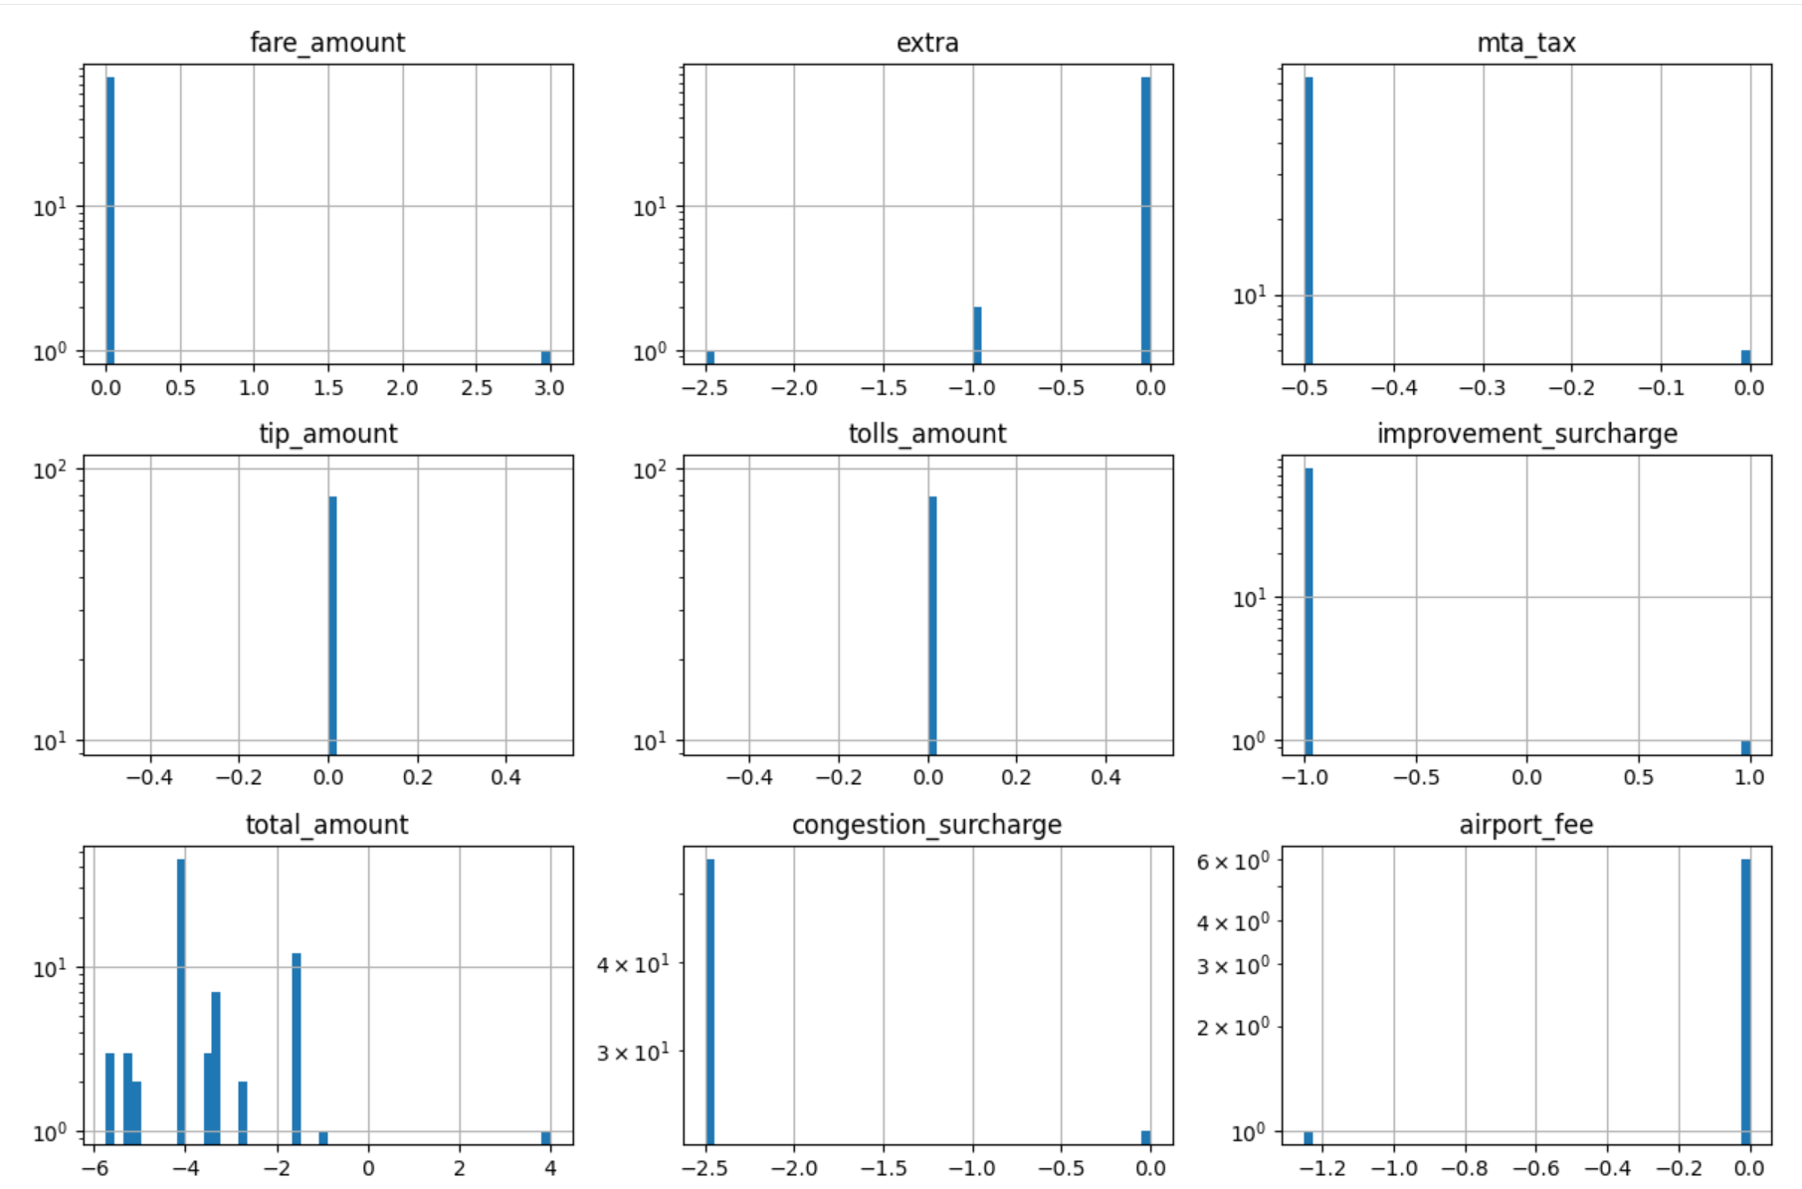
- Around 3.4% of records contained missing values in multiple columns
- Missing values were imputed using the mode because most affected variables were categorical or discrete
- There were approx 64k none values in the monetary columns, this nan was not random.
- Around 29k records had passenger count as 0, which was replaced using mode count

Demand Analysis

Daily Pickup Trends
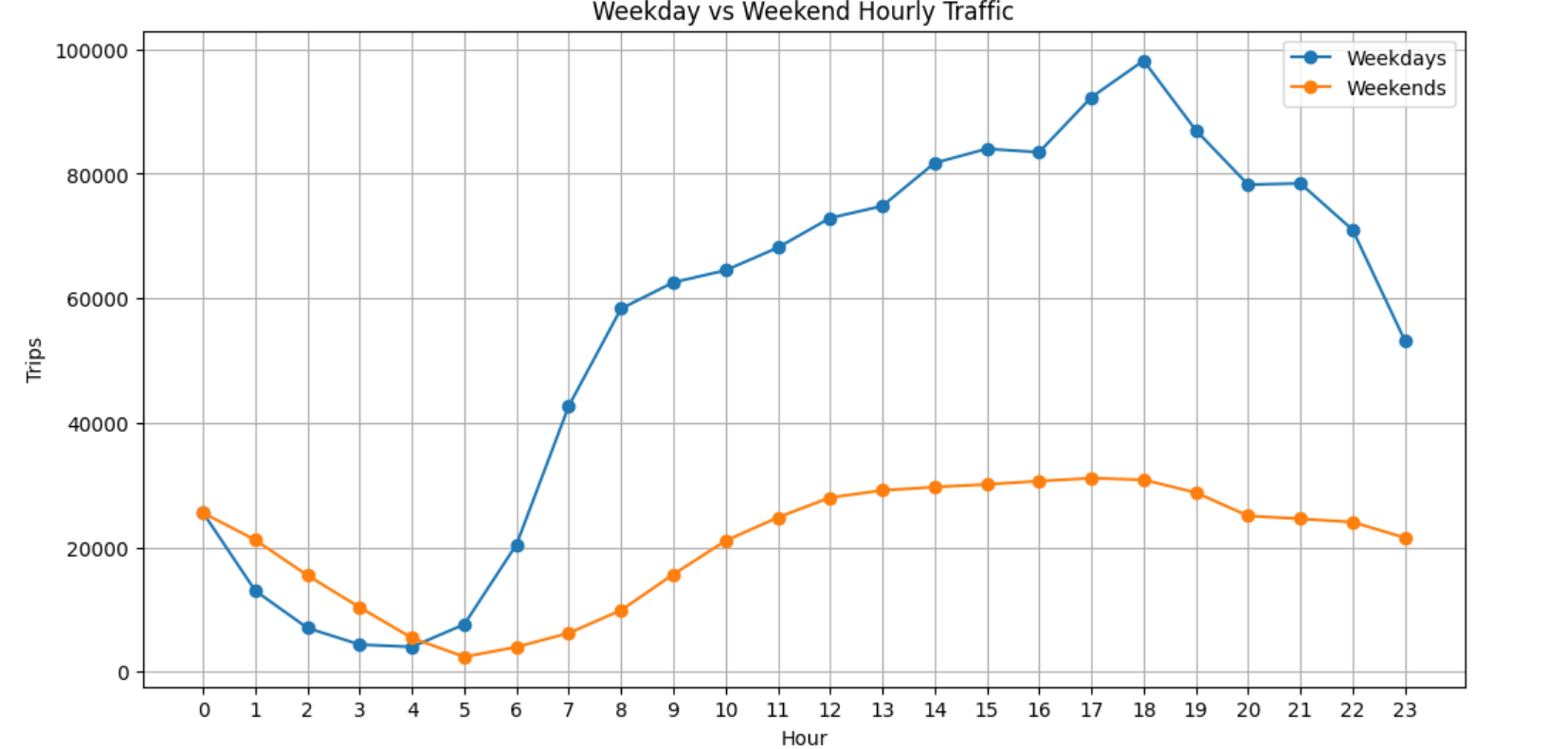

The taxi demand varies across different days of the week. Demand was generally higher on weekday then on the weekend

Monthly Pickup Trends
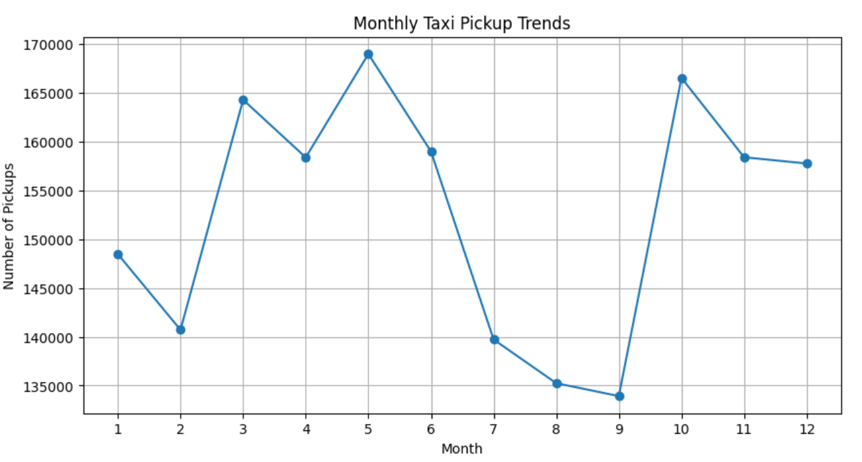

Taxi demand remained relatively stable throughout the year. However, demand increased during May and October and decreased during September.

This may be due tourism, seasonal travel pattern and local events occurring during specific months

Hourly Pickup Trend

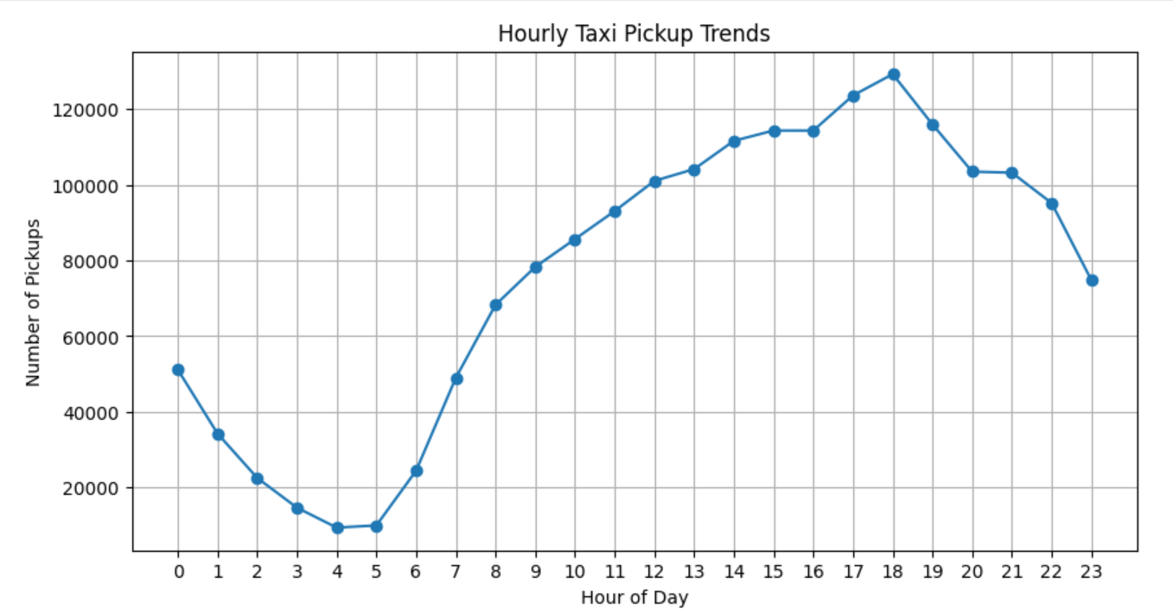
- Demand was lowest between 4 AM and 5 AM. Activity increased during morning commuting hours and continued to rise throughout the day.
- The highest demand occurred around 6 PM, corresponding to evening rush hour traffic.
- This suggest office commuting is the major taxi demand

Fare Analysis

Impact of distance on Fare

- A strong positive relationship was observed between trip distance and fare amount.
- As distance increased the fare value generally increased.
- The correlation coefficient of approx. 0.81 further confirms the strong relationship between trip distance and fare.
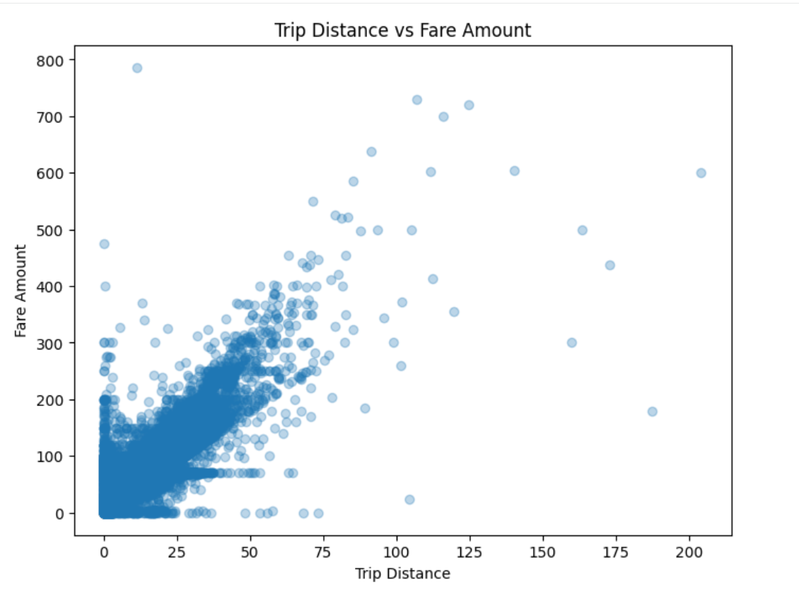

Passenger count and fare

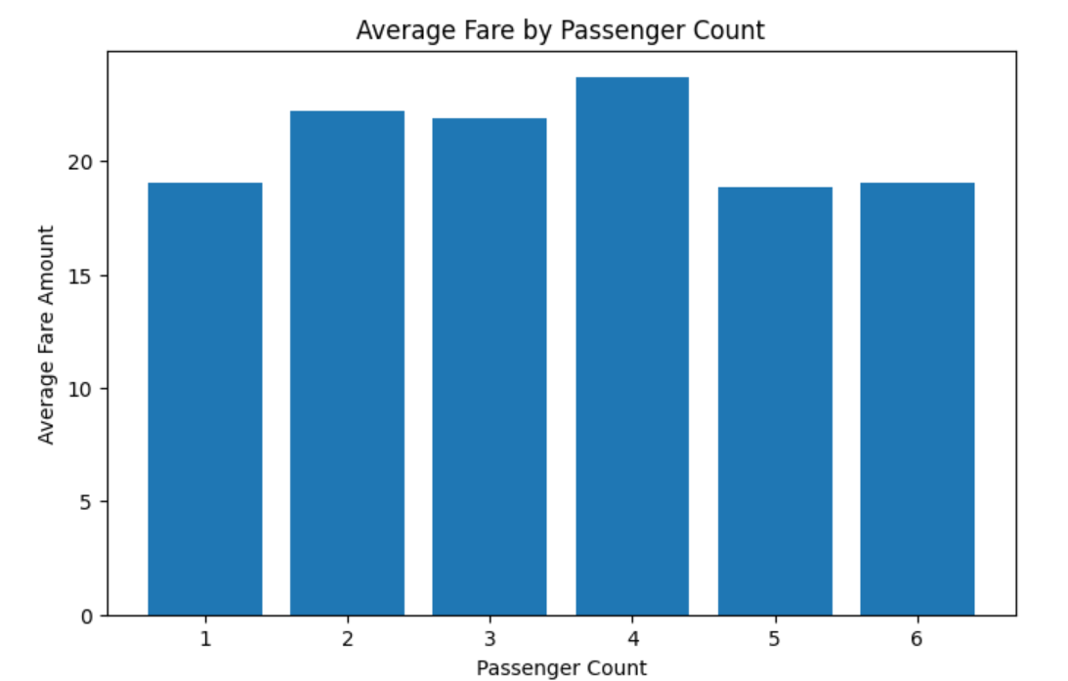
Passenger count showed very little influence on fare amount

Payment Behaviour
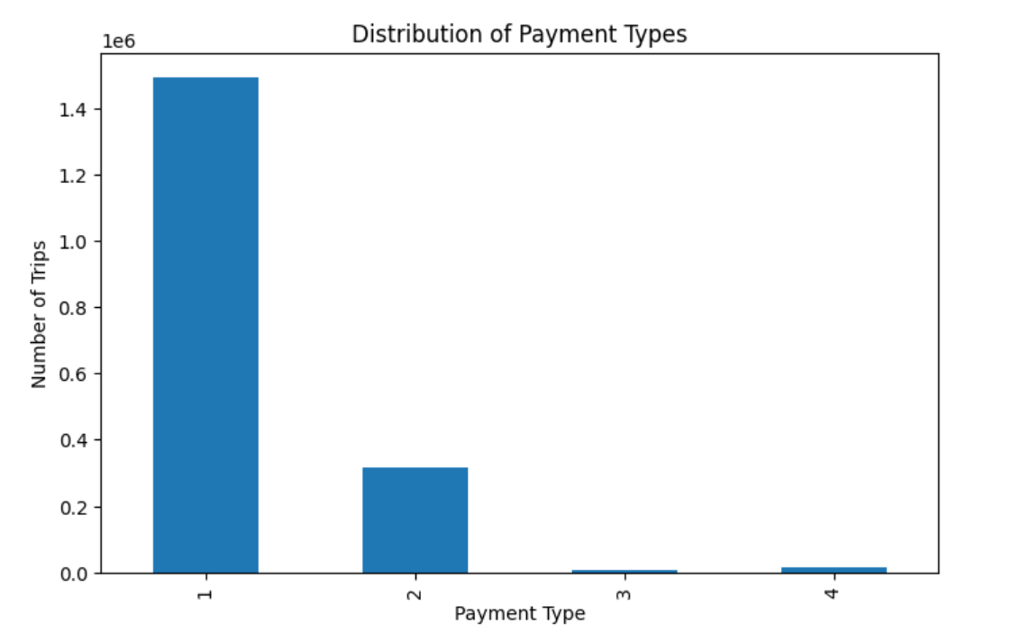
Credit card transaction accounted for the majority of the rides, representing more than 80% of all payments

Pickup and DropOff Analysis
Midtown center recorded the highest pickup volume, followed by airport zones
Dropoff activity was concentrated in residential and mixed-use neighborhoods 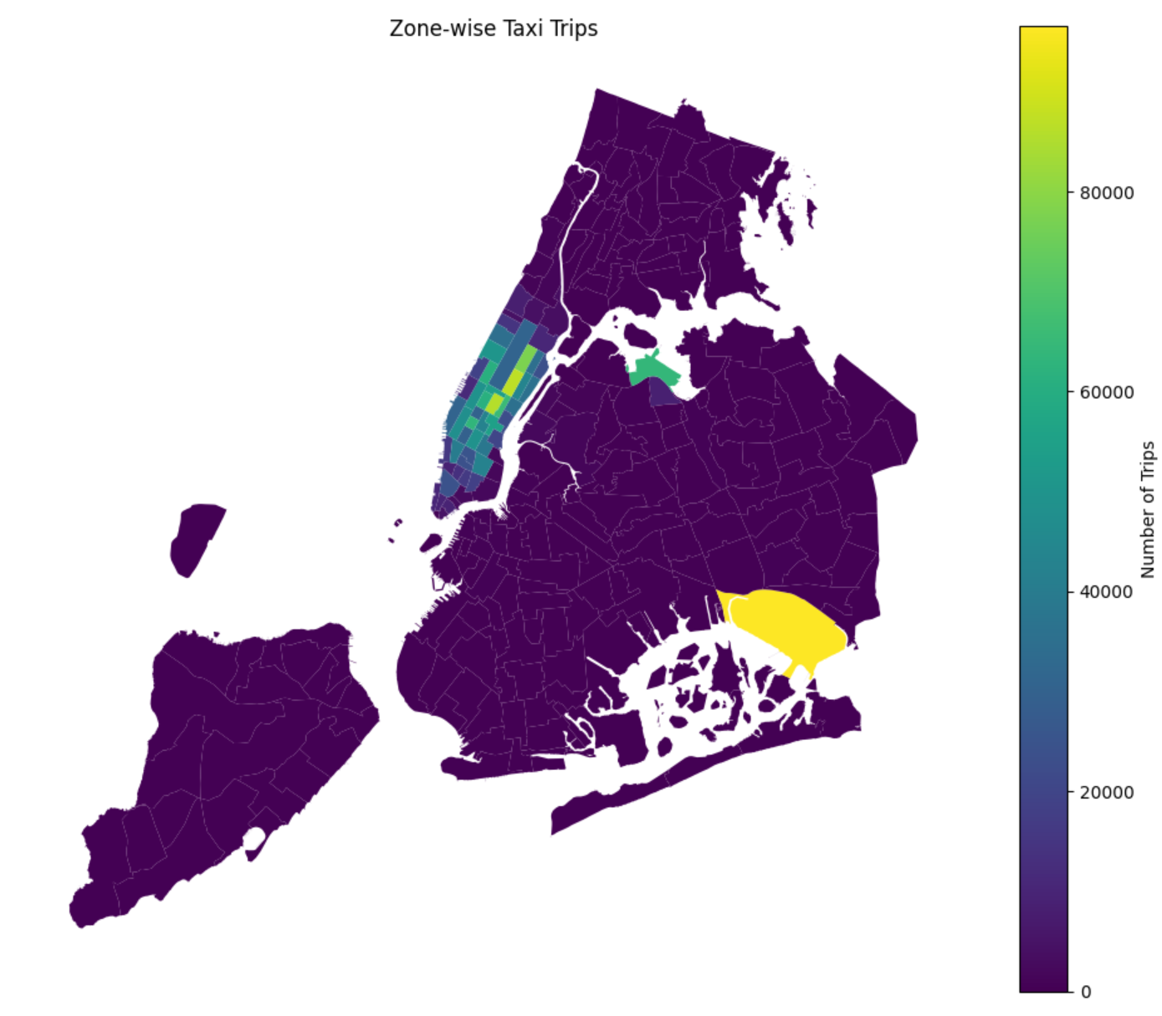

Revenue analysis
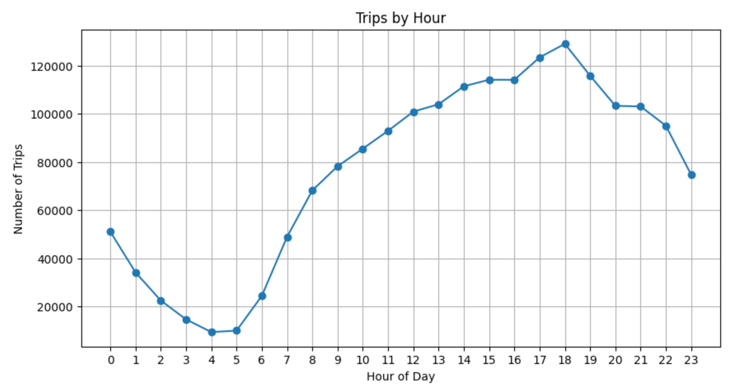

Approximately 88% of total revenue was generated during daytime operations, while only 12% originated from nighttime trips.

Vendor analysis
- Both vendors showed decreasing fare per mile as trip distance increased.
- The largest difference occurred for trips shorter than 2 miles, where vendor 2 charged more than vendor 1 per mile.

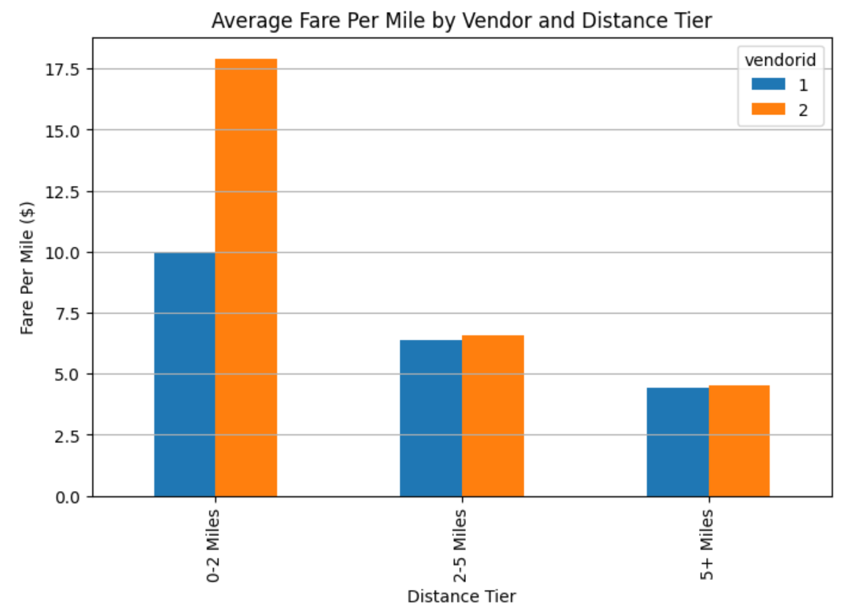

Conclusion

Demands and Patterns
- Taxi demand varies significantly throughout the day.
- Pickup activity is lowest during early morning hours (around 4-5 AM).
- Demand increases sharply after 6 AM and remains high throughout the afternoon and evening.
- The busiest hour is around 6 PM, indicating strong evening commuting. Office finish hours.

Revenue
- Daytime trips generate approx. 88% of total revenue and night trips contribute only about 12%.
- More number of trips lead to more amount of revenue.

Trip characteristics
- Fare amount and trip duration are strongly correlated.
- Tip amount shows a medium positive correlation with trip distance.

Passenger behaviours
- Most taxi rides are small groups, 1 or 2 passengers.
- Passenger count doesn't impact fare amount.

Geo analysis
- Airport zones are the most active pickup locations

Vendor analysis
- Vendor 2 consistently charge higher fare then vendor 1 for short trips

