California Traffic Collision Data Analysis using PySpark

By: Pankaj Yadav
Date: 13 July 2026

Introduction
The objective of this analysis was to study the California Traffic collision dataset and provide the insights. The EDA was done and the data cleanup of the data that had invalid or unstructured data.

Dataset Overview
There were 4 data files in SCV format, this data is provided by Statewide Integrated Traffic Records System (SWITRS)
- collisions
- parties
- victims
- case_ids

Data Cleaning (ETL)
Data was verified and analysed the missing and null values. There were invalid entries for age data for which the cleanup was done, there were invalid entries in distance column.

Many values were optional and therefore we left those null values untouched. Like side of highway, location_type, etc.

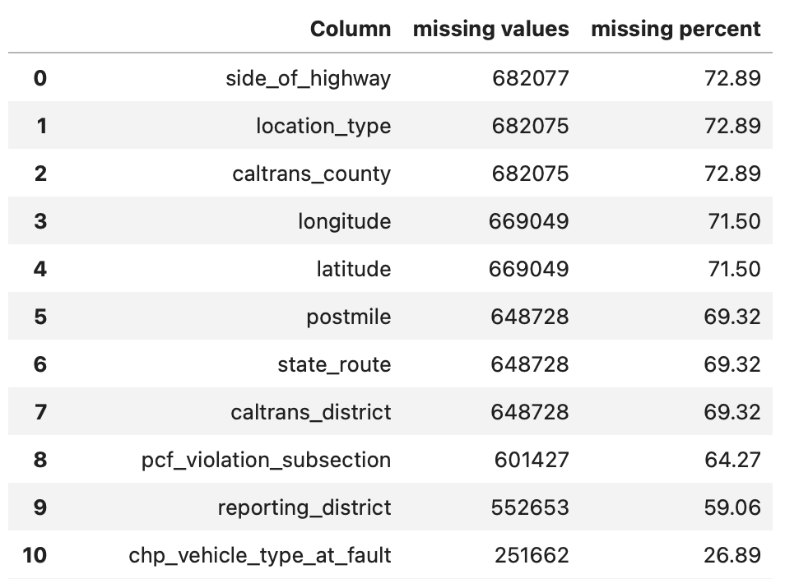
Since, these values accounted for upto 70% , we didn’t drop the values and neither we imputed as it would lead to inconsistent data.

EDA
Once we got the cleaned data, we started with the EDA of the data.

Collision Severity Distribution
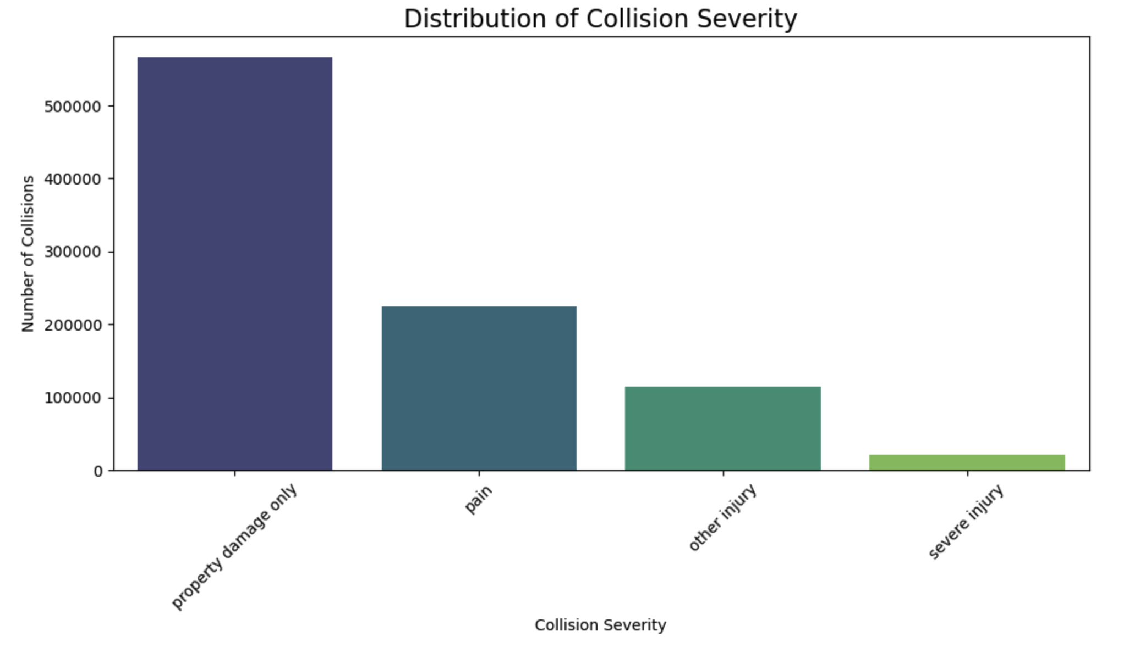
From the graph we can conclude the majority of the damage is of the “Property”, followed by “pain” and other “injury”. Severe injuries are relatively rare.

Weather conditions
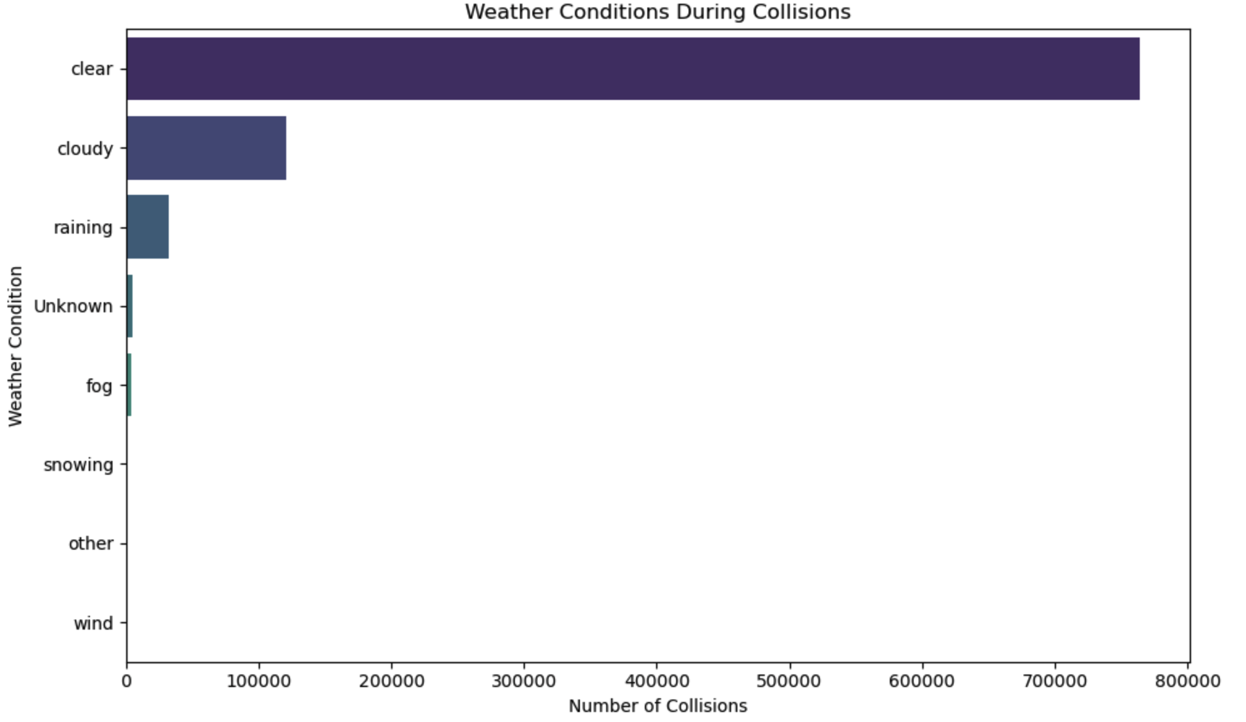
Clear weather had the majority of the incidents, followed by cloudy, raining and so on.

Victim age distribution

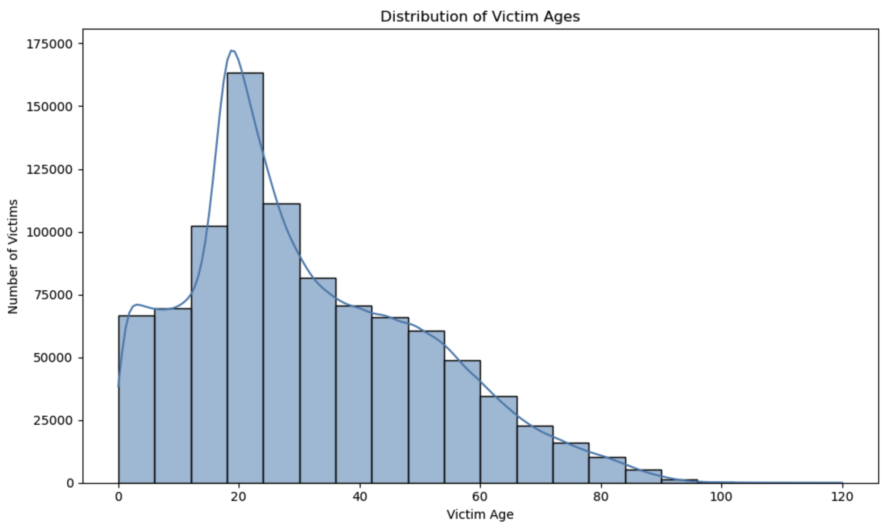
Age group 15 – 25 had maximum number of victims, the data had outliers and invalid data that we sanatized.

Collision severity with other factors
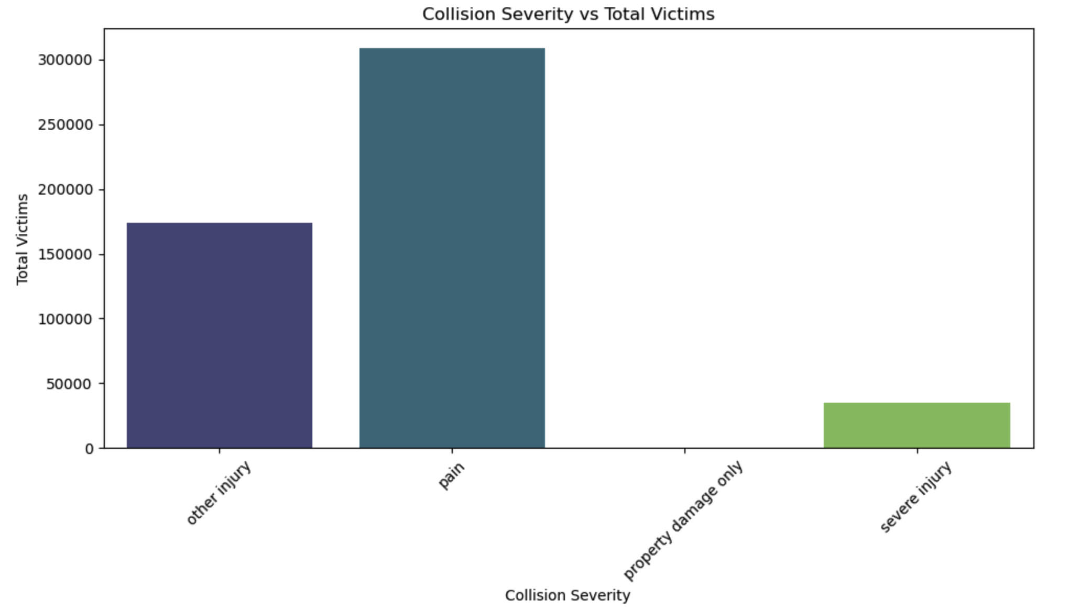
The most number of victims had a pain and other injury with few instances of severe injury.

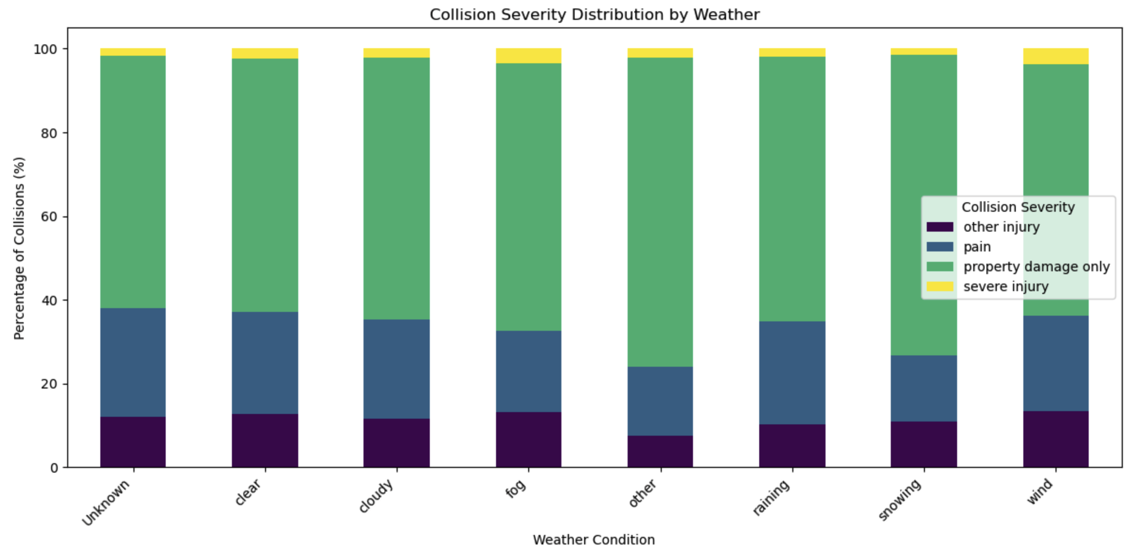
Although most collisions occur during clear weather, the proportional distribution of collision severity is fairly similar across weather conditions.

Lighting and severity

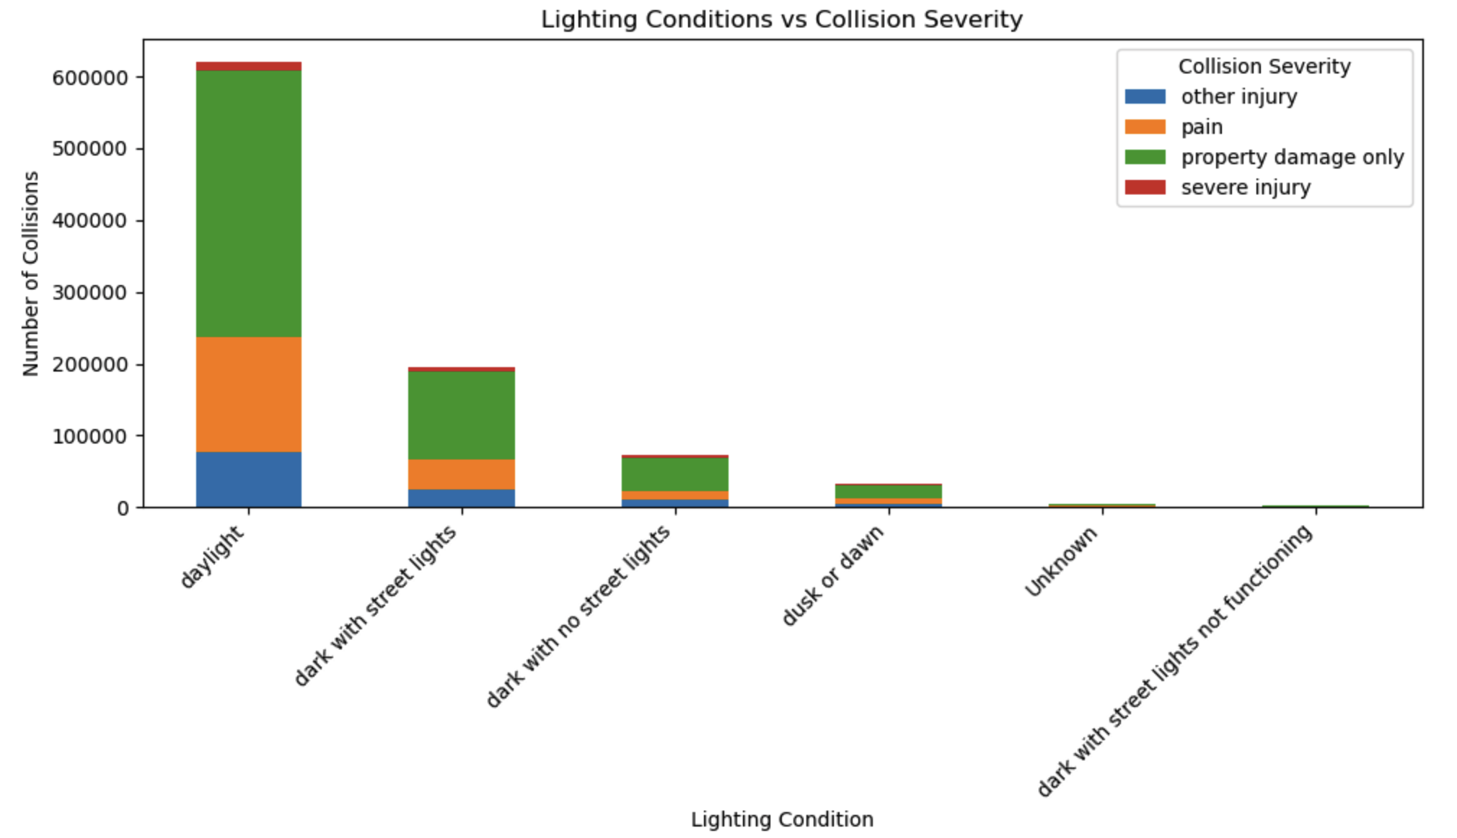
- Daylight contributes the highest number of reported collisions
- Which depicts the greater traffic volume during day time possess higher risks

Collision with weekday analysis
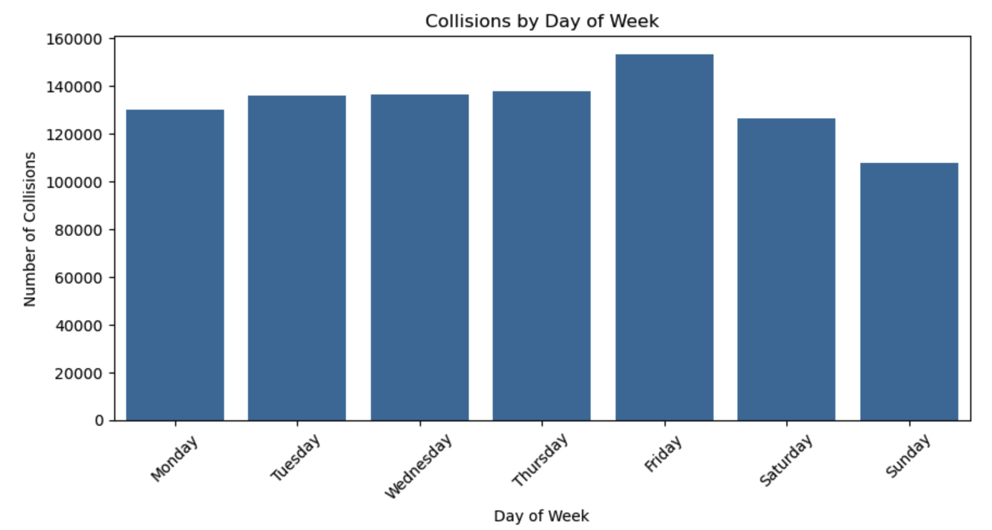
Friday has slightly higher number of incidents, with rest of the days having equal distribution.

County analysis
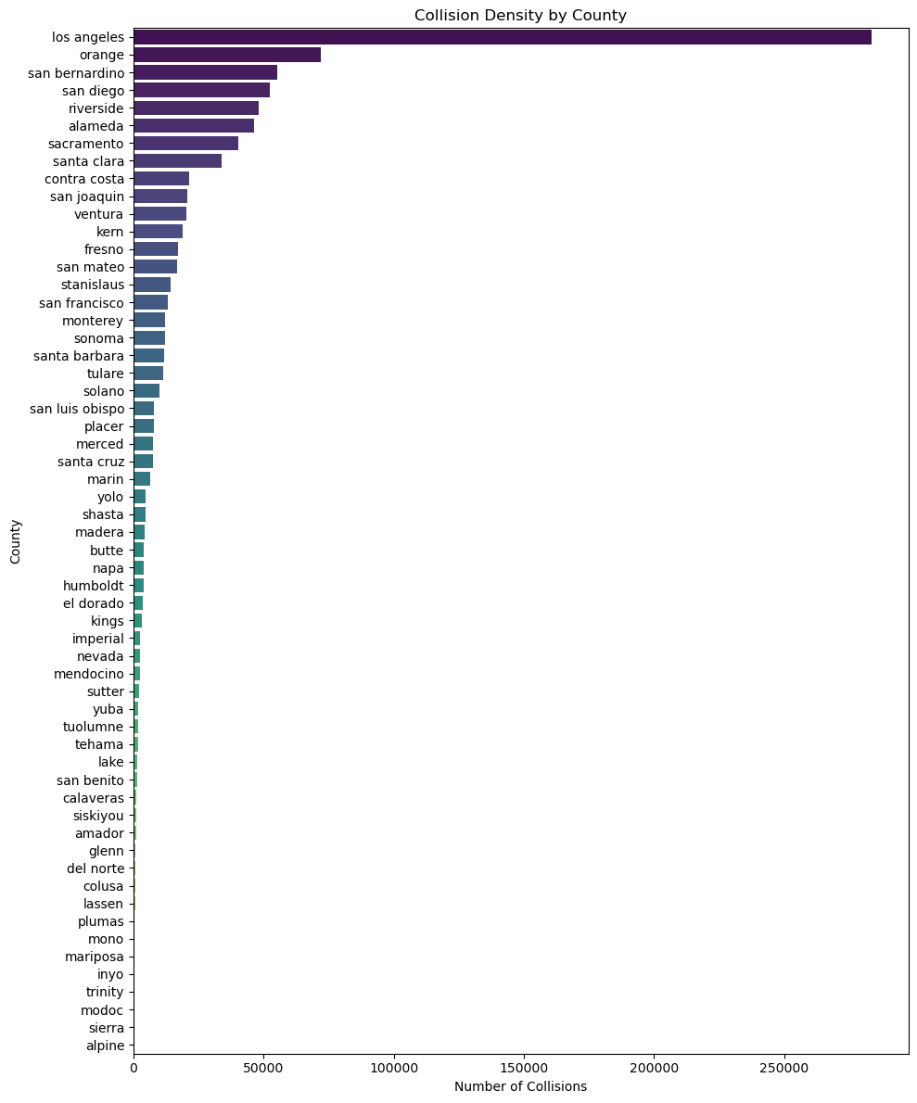
Los angeles has significantly higher number of collision incidents then any other place.
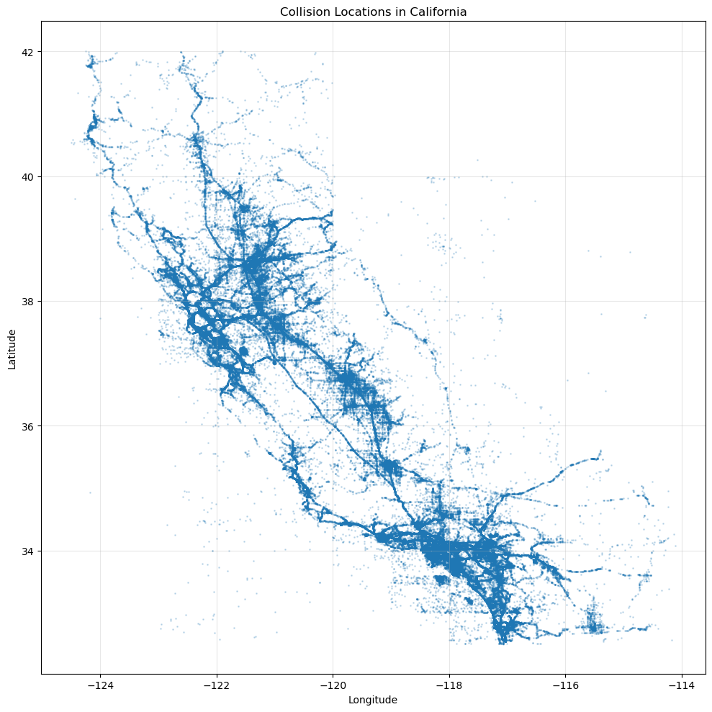

Yearly collision distribution

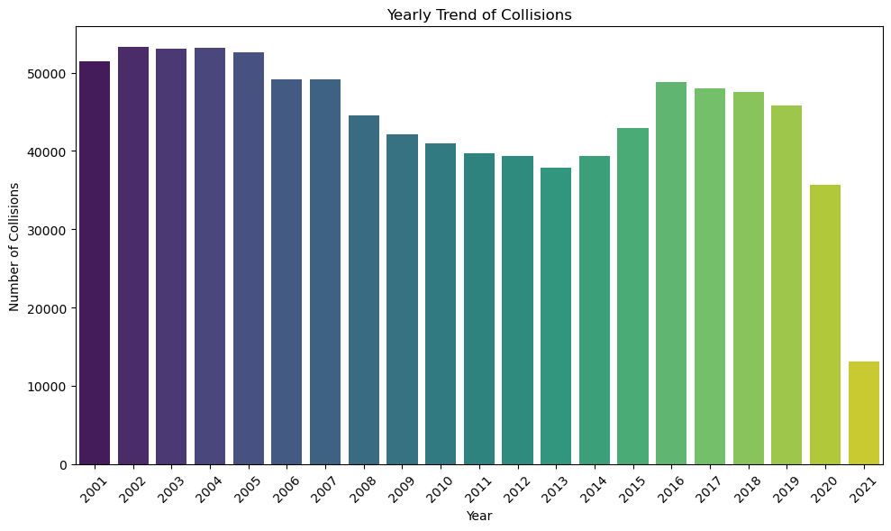
It is an increasing/decreasing trend. We couldn’t get the hourly trend due to data being invalid.

Conclusion
The analysis revealed several useful insights.
- Los Angeles County recorded the highest number of collisions, followed by Orange, San Bernardino, San Diego, and Riverside counties.
- October had the highest number of reported collisions, while July recorded the lowest among all months.
- Clear weather accounted for the majority of collisions, followed by cloudy and rainy conditions.
- Normal road surface conditions and daylight were associated with the highest number of reported collisions, mainly because these are the conditions under which most vehicles are on the road.
- The victim age distribution became much more realistic after removing invalid age values, with most victims belonging to the young and middle-aged population.
- Most collisions resulted in property damage only, while severe injury collisions represented only a small proportion of the total cases.

