Predicting Vehicle Prices Using Regression Models

By: Pankaj Yadav
Date: 22 August 2026

Table of Contents
1 Introduction 3
1.1 Problem Statement 3
2 Dataset Overview 3
2.1 Dataset and Feature Description 3
2.2 Target Variable 3
2.3 Dataset structure 3
3 Exploratory Data Analysis 5
3.1 Data Types and Summary Statistics 5
3.2 Missing Value Analysis 5
3.3 Categorical Variable Encoding 5
3.4 Feature Scaling and Selection 5
3.5 Train-Test Split 6
4 Model Development 6
4.1 Baseline Model 6
4.2 Model 1 – Ridge Regression 6
4.3 Model 2 – Lasso Regression 6
4.4 Hyperparameter Tuning 6
5 Model Evaluation 7
5.1 Evaluation Metrics 7
5.2 Model Performance Comparison 7
5.3 Residual / Error Analysis 7
5.4 Final Model Selection 9
6 Conclusion 9

Introduction
This is a project to develop a robust regression model to predict the used car prices for a reseller based on various listed features, specifications and car condition.

Problem Statement
There are several business objective of this assignment:
- ​Price prediction of the used car.
- Market analysis for trends and preferences.
- Feature importance of a vehicle influencing car parices.

Dataset Overview
Dataset is provided by the german online car reseller company “AutoScout”.

Dataset and Feature Description
- The dataset is a CSV file containing 15915 records and 23 columns.
- The document contain information on attributes such as engine, vehicle specifications, number of owners, vehicle condition etc.

Target Variable
The target variable is the price of the used vehicle for this assignment.

Dataset structure
- Numerical variables: price, km, gears, previous owners, hp_kw, ispection_new, displacement_cc, weight_kg, cons_comb.
The numerical value has both discrete and continuous fields
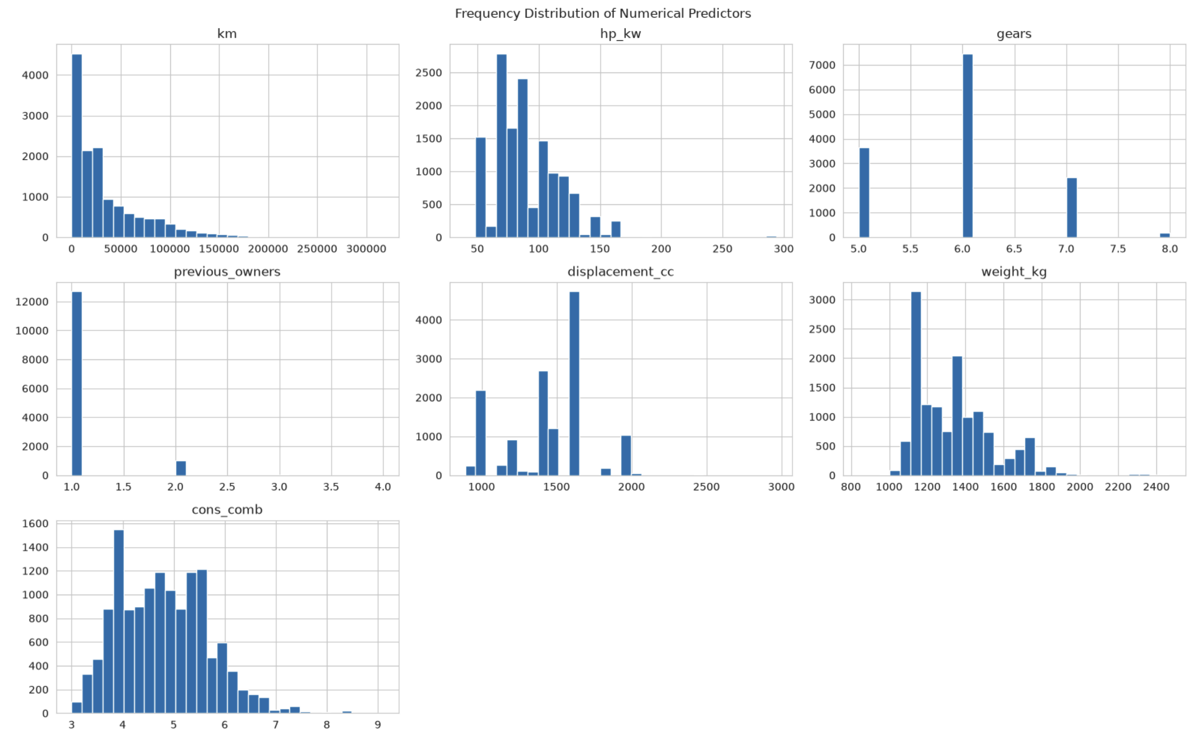Figure 1: Discrete variables
- Categorical variables: make_model, body_type, vat, Type, Fuel, Paint_Type, Upholstery_type, Gearing_Type, Drive_chain, Comfort_Convenience, Entertainment_Media, Extras, Safety_Security.
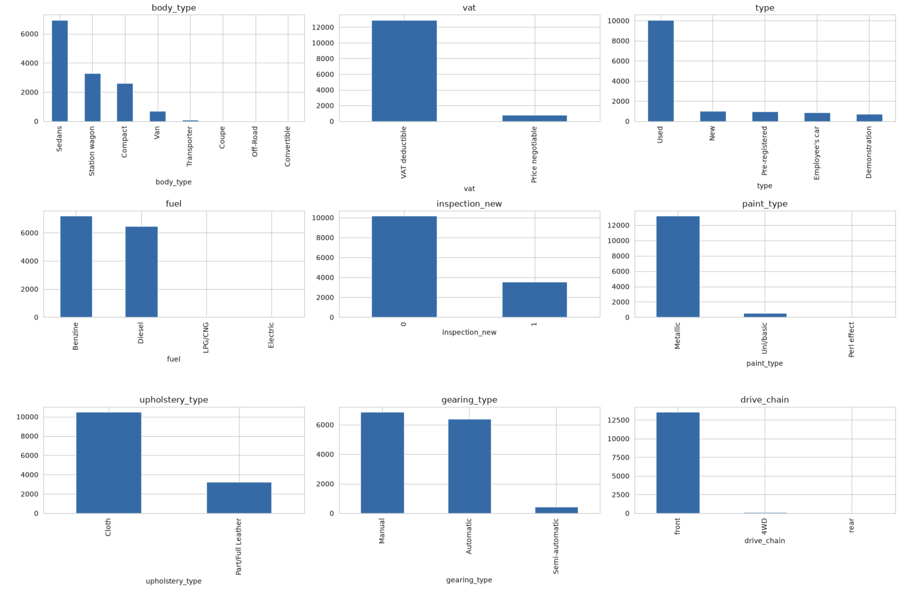Figure 2: Categorical variables

Exploratory Data Analysis

Data Types and Summary Statistics
- Data description shows km, age and previous owners as 0. We need to look at this data closely.
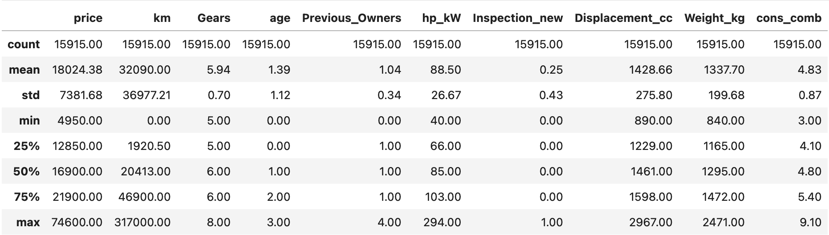Figure 3: Data description
- Few columns has mixed casing, I’ll sanitize the column names to be all small case.

Missing Value Analysis
No column found with missing values.

Categorical Variable Encoding
There are two types of categorical columns:
- Multi-label specs columns: comfort_convenience, entertainment_media, extras, safety_security.
These are CSV text lists so standard one-hot encoding doesn’t apply directly. Each text string is treated an an individual column.
- Standard categorical columns: body_type, vat, type, fuel, paint_type, upholstery_type, gearing_type, drive_chain, brand is one-hot encoded.

Feature Scaling and Selection
Standardscaler was applied to all numerical features before modelling.
- Item appearing in less than 5% or greater than 95% is dropped before flag encoding.
- VIF based removal: after encoding, multicollinearity was checked. Features with VIF > 10 were dropped iteratively.

Train-Test Split
Split ratio is 80% training and 20% test, random state used is 42

Model Development

Baseline Model
Linear regression is used as a baseline model.

Model 1 – Ridge Regression
L2-regularized linear regression, best alpha at coarse boundary

Model 2 – Lasso Regression
L1-regularized, same two stage search.

Hyperparameter Tuning
Tuned Ridge and Lasso alpha via two-stage coarse-to-fine grid search on test MAE.
Ridge coarse grid [0.001–1000] selected alpha=0.001 (boundary). Fine search extended to [1e-6, 5] confirmed MAE stays flat (~0.0918) with no interior minimum - optimal alpha ≈ 0.
Lasso coarse grid [0.0001–10] also hit the boundary (0.0001). Fine search [1e-6, 0.005] converged to a true interior optimum at alpha ≈ 0.000174 (test MAE ≈ 0.0917), eliminating 7 of 98 features.

Model Evaluation
Three models compared on identical train/test split (80/20, random_state=42), same target (log_price), same scaled feature set: baseline OLS, Ridge, Lasso. Comparison based on R², MAE, RMSE on both train and test to check for overfitting alongside raw accuracy.

Evaluation Metrics
- R²: proportion of variance in log_price explained by the model. Chosen as the primary fit metric since it's scale-independent and standard for regression comparison.
- MAE: average absolute prediction error, in log-price units. Chosen because it's robust to outliers (relevant given the extreme residuals identified in 5.4) and interpretable.
- RMSE: penalizes large errors more heavily than MAE. Reported alongside MAE to check whether a few large errors are disproportionately affecting the model — useful given the outlier residuals observed.
- All three reported for both train and test sets — the train/test gap is the actual diagnostic for overfitting, not the absolute value alone.

Model Performance Comparison
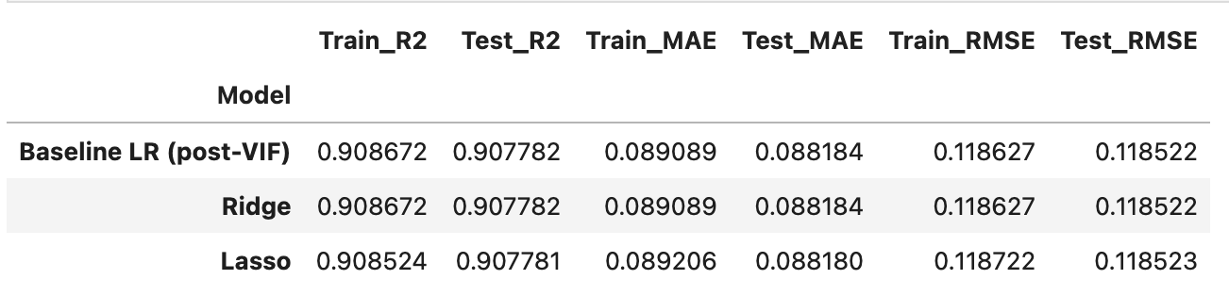Figure 4: Model performance comparison

Residual / Error Analysis
Baseline OLS residuals (from 3.4-equivalent diagnostic plots) show:
- Nonlinearity: residuals trend downward across fitted values rather than scattering randomly around zero — model underpredicts low-price cars, overpredicts high-price cars.
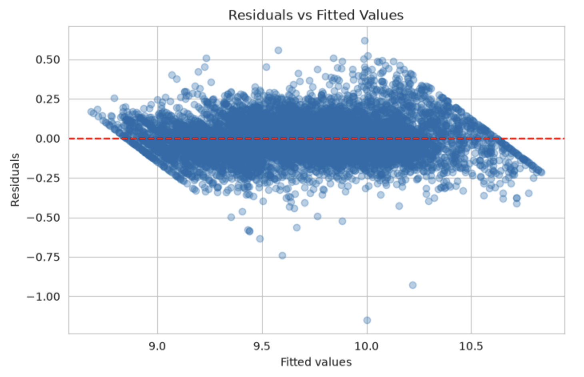Figure 5: Residula Vs Fitted Values
- Non-normality: Shapiro-Wilk p≈0.00000, rejects normality. Q-Q plot shows heavy tails, particularly a handful of large negative residuals (-0.6 to -1.1 in log-space) - a small number of cars the model badly overpredicts.
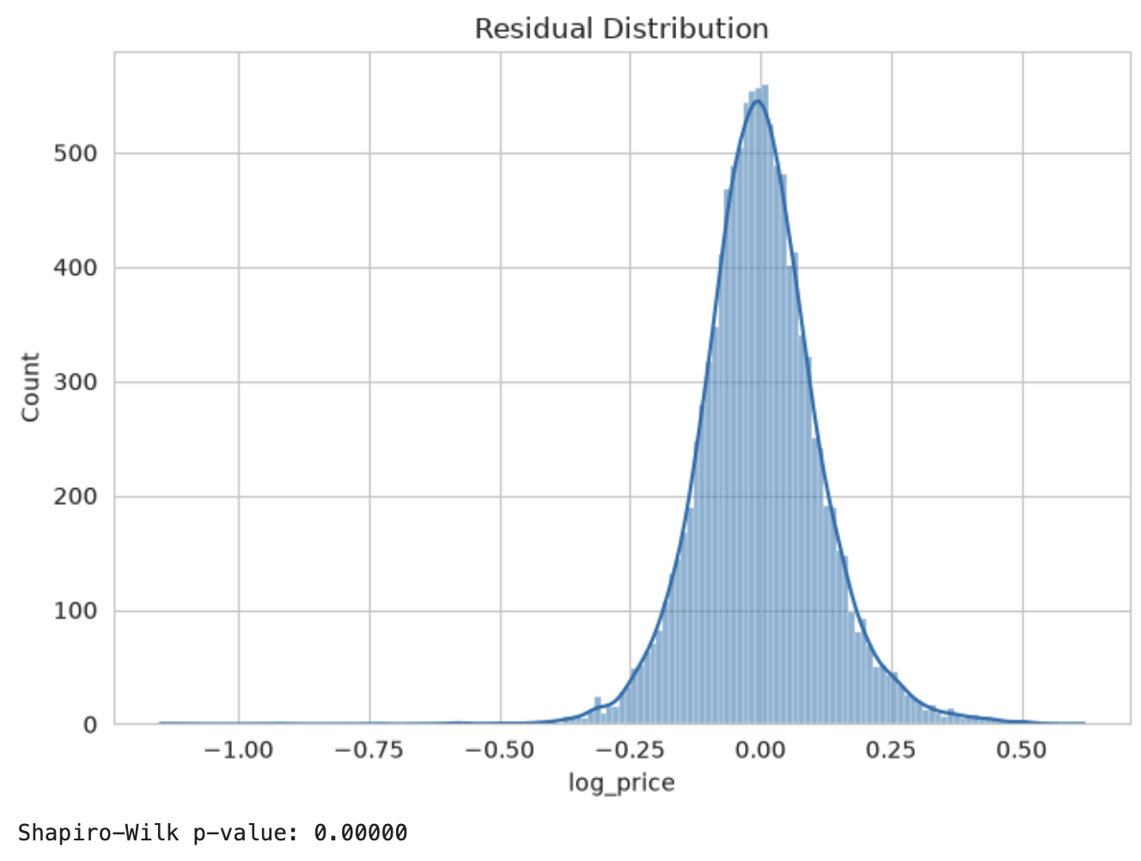

- Mild heteroscedasticity: tighter residual spread at fitted-value extremes, wider in the middle range.

Final Model Selection
Model comparison shows that there is a little difference in the performance and therefore we are selecting Baseline LR (post VIF) as the best choice

Conclusion
The analysis demonstrates that the car price can be predicted effectively using a linear regression-based approach. After data preprocessing, exploratory data analysis, feature engineering, scaling, and VIF-based feature selection, the models achieved a test R² of approximately 0.908, indicating that around 91% of the variation in log-transformed car prices is explained by the selected features.
Regularization using Ridge and Lasso did not provide a meaningful improvement over the post-VIF Linear Regression model. Ridge produced virtually identical results, while Lasso achieved only a negligible improvement in MAE but slightly lower R² and slightly higher RMSE. The final comparison was:
The close similarity between training and testing performance indicates no significant overfitting. This suggests that the available data is sufficient for building a stable predictive model and that a linear model is sufficient for this dataset. Since regularization did not materially improve predictive performance, Linear Regression after VIF-based feature selection is selected as the final model.
The overall conclusion is that the preprocessing and feature-selection steps were effective, and the resulting linear model provides strong predictive performance while remaining relatively simple and interpretable.

