Project Synopsis

Code Name : TIMETRAIN

Type : Rails Application

Abstract
Create a web application to view the whole activity of a user in different social networks.

What is TIMETRAIN?
It helps to view the users' activity in their connected accounts at a single page. It allows the user to connect to different social network accounts with a single login. The user can also publish to all the connected accounts through this application. TIMETRAIN supports the following social networking websites :
- Google Plus
- Facebook
- Twitter

How TIMETRAIN works?
TIMETRAIN is powered by RoR. Developer apps are created in each platforms and integrated to TIMETRAIN. When a user sign up in TIMETRAIN, he/she is asked to connect their social networking accounts. Then TIMETRAIN fetches their activities and shows it in a chronological order on a timeline powered by javascript and RoR.
Project Estimate
# | Task | Subtask | Estimated time (days)
1 | Wireframing |  | 1
2 | UI Designing and development | UI Designing ( PSD ) | 0.5
 |  | HTML/CSS | 1
 |  | Javascript Slider | 1
3 | Creating Models | User model | 3
 |  | Facebook model | 1
 |  | Twitter model | 1
 |  | Gplus model | 1
4 | API and Integration | Facebook App | 1
 |  | Twitter App | 1
 |  | Google App | 1
 |  | Integration to timetrain | 4
5 | Routing and Linking Front end | Routing | 1
 |  | Embedding to HTML | 2
6 | Testing and Publishing |  | 0.5
Total Man-Days required |  |  | 20

Team Size : 2
Total no. of days required : 20 / 2 = 10 days.

Project Start Date : 23rd June, 2014
Project Completion Date : 4th July, 2014
Site structure and Navigation

1. Login page
Login page is a simple form to submit values for username and password.
This will be the landing page unless a remembered login is active.
At the bottom a link is provided for new users to signup.

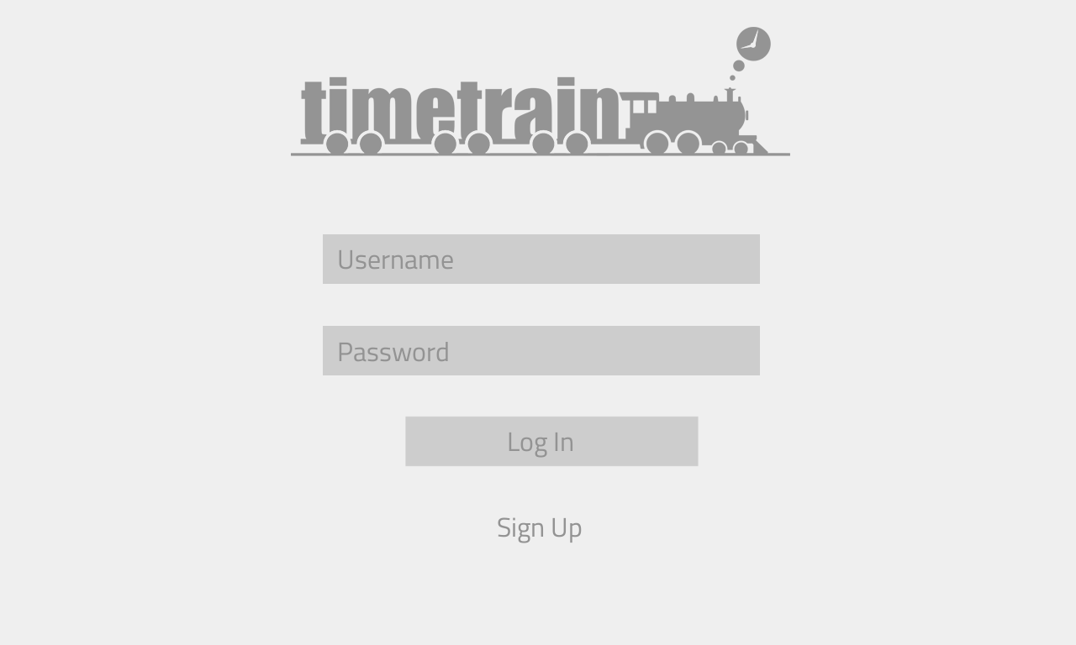

2. Signup Pages
Part 1
Part 1 of signup page recieves username and password,
Upon entering, user clicks Next button.
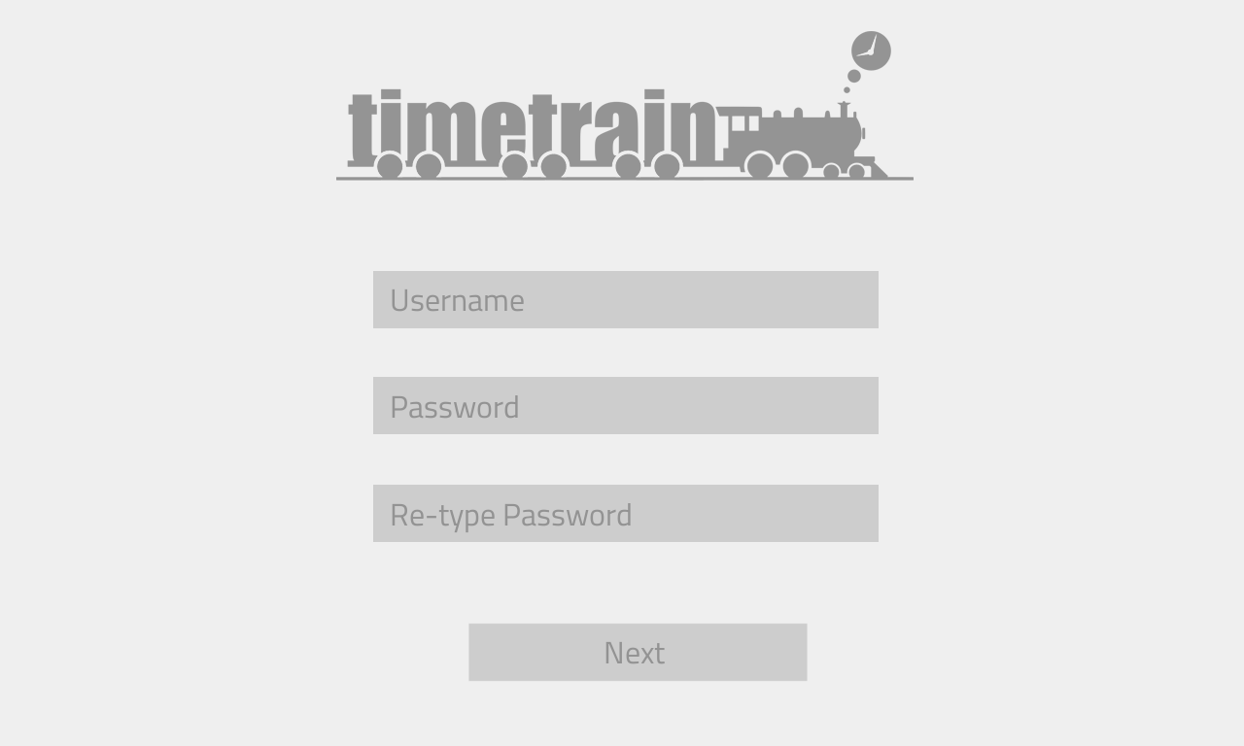
User Model
fields | description
user_id (PK)  user_name  user_password  profile_name  ... | Unique id. (Public Key)  unique alias for user_id  min 8 character  First name + Last name  ...

Part 2
Part 2 of signup page connects the user's social networking accounts to TIMETRAIN.
Upon successfull connection, a tick mark will be shown on the right ride.
To Continue or Skip the step, minimum of one connection is required.

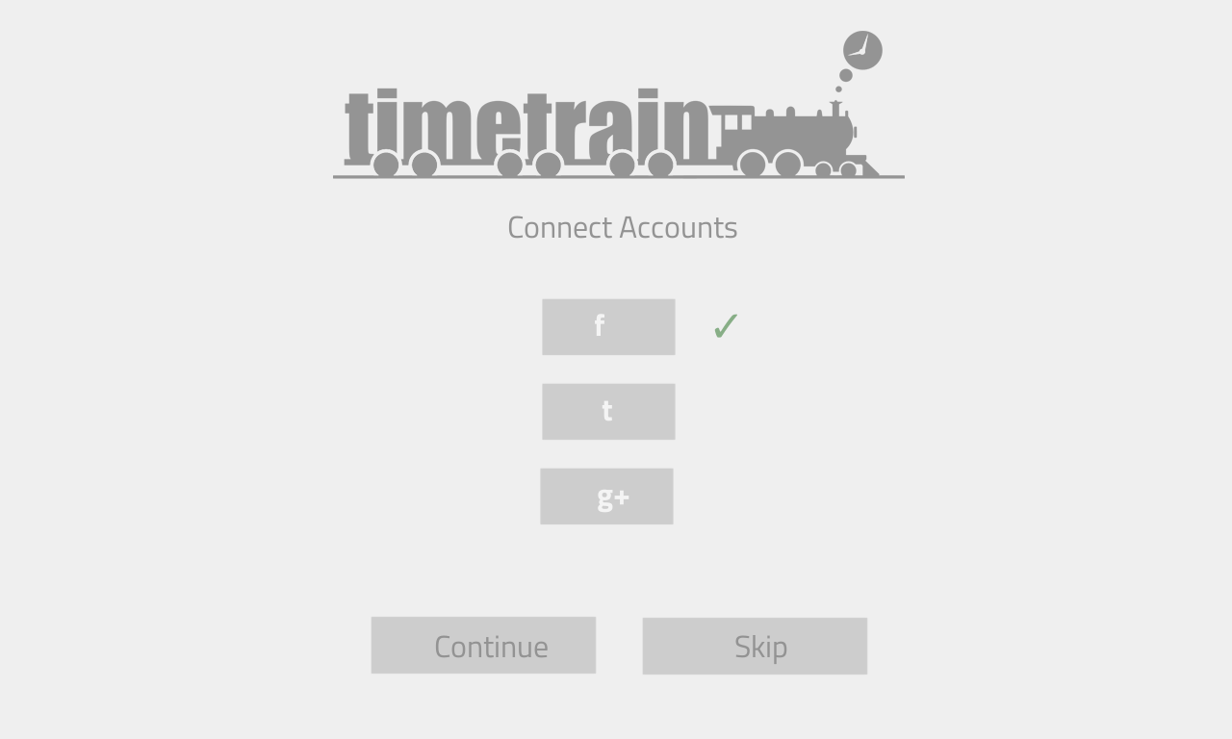
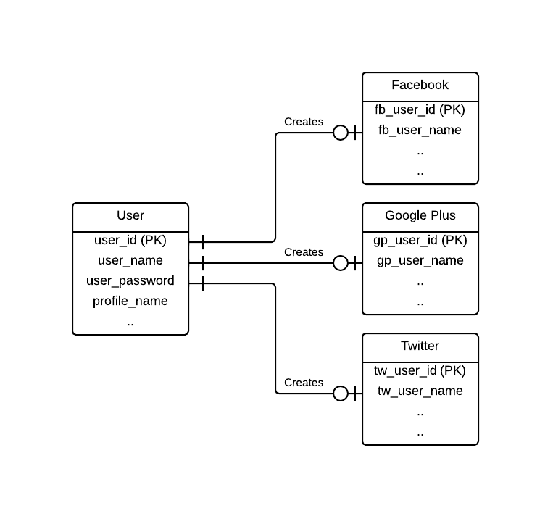

3. Home
This is the home page view after a successfull login/signup.
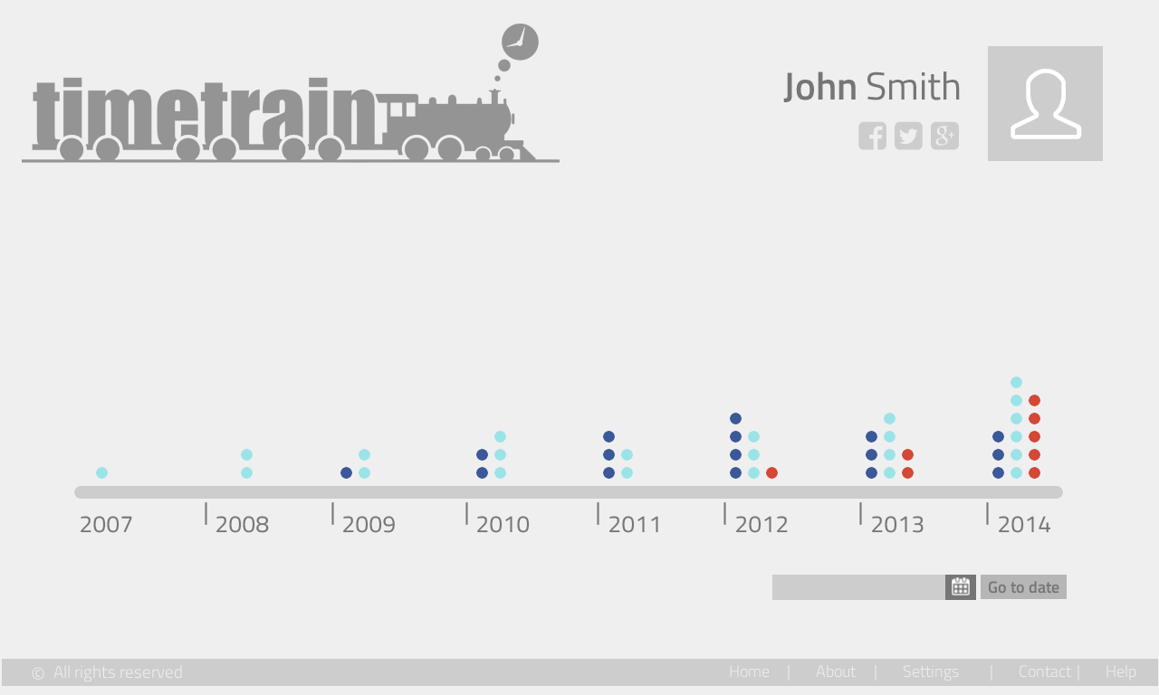
Legends
View Activities on a Specific date  Activity Dots  ● Google+ Posts  ● Tweets  ● Facebook Posts | Footer (Navigation)  Home : Link to Home Page  About : View app and developer details  Setting : hange user settings  Contact : Developer contact details  Help : User help

Timeline and actions
On clicking a part of the timeline, this zoomed timeline will be shown.Activity Dots are placed chronologically on the timeline. Clicking on an activity dot shows a miniature view of the corresponding activity.
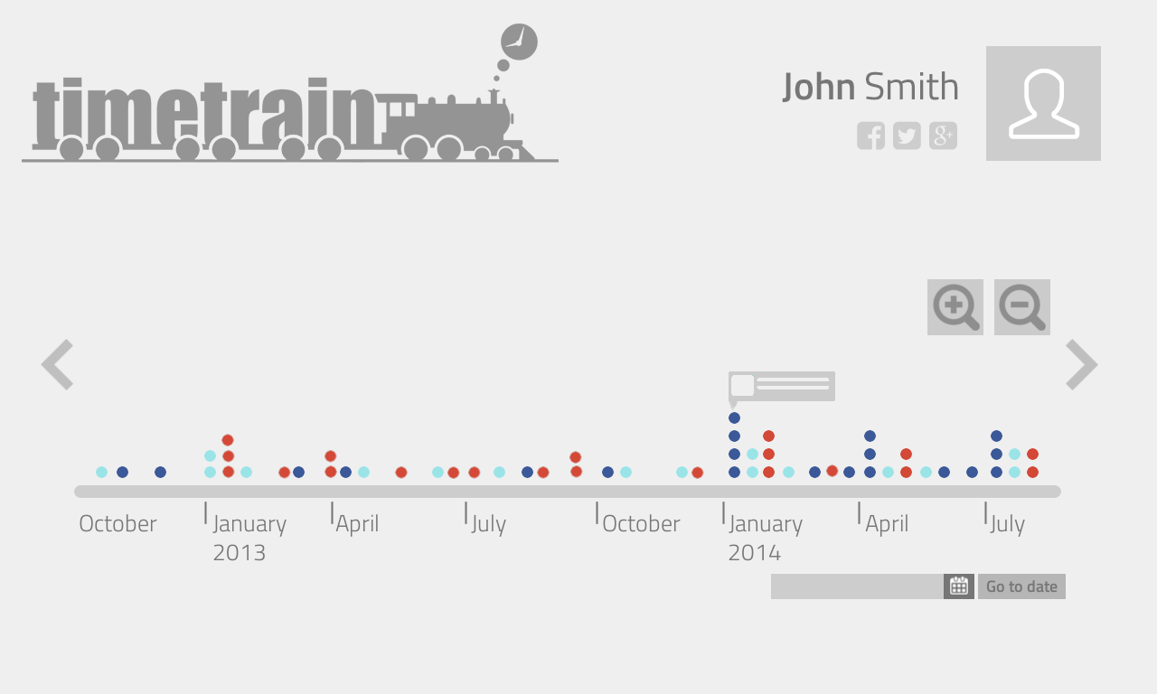
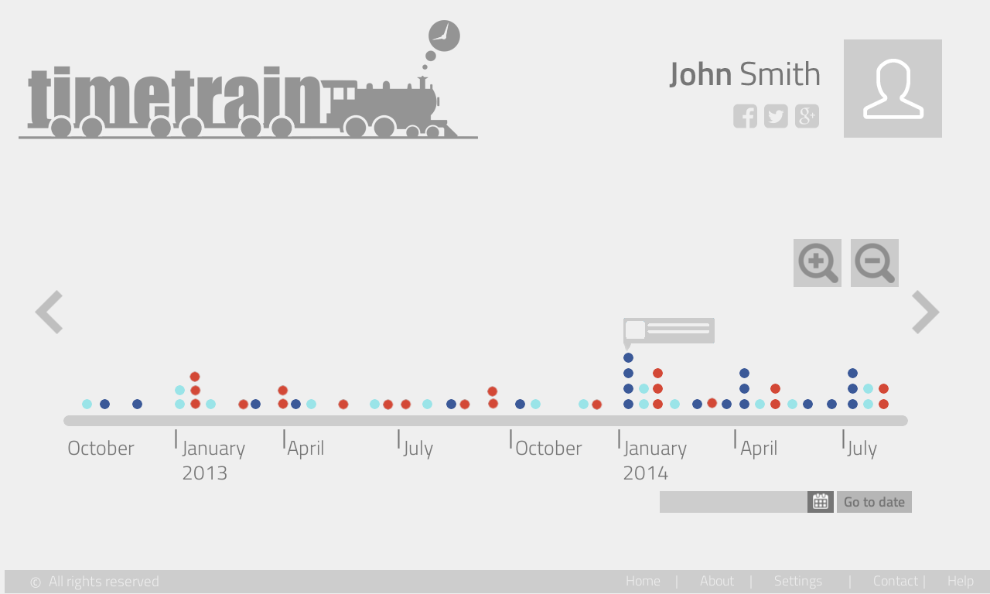
Legends
  Zoom In Timeline    Zoom Out Timeline |   Older Posts    Newer Posts

