Site structure and Navigation

1. Login page
Login page is a simple form to submit values for username and password.
This will be the landing page unless a remembered login is active.
At the bottom a link is provided for new users to signup.

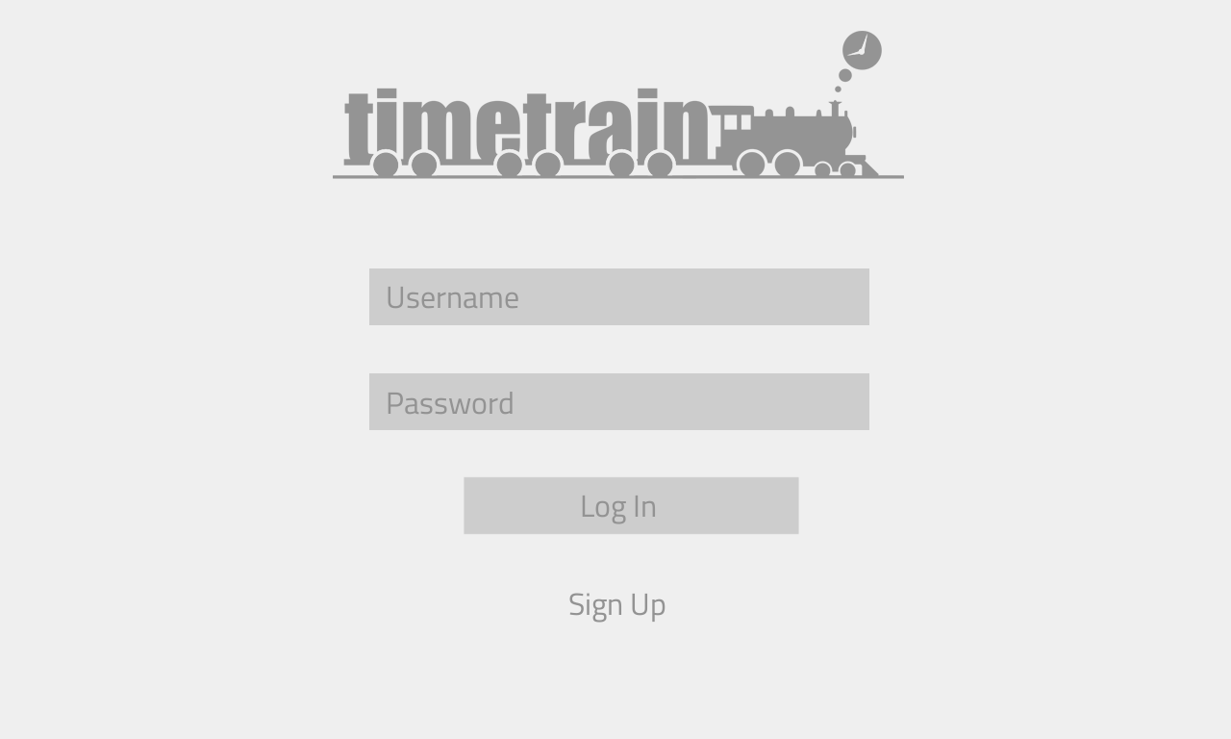

2. Signup Pages
Part 1
Part 1 of signup page recieves username and password,
Upon entering, user clicks Next button.
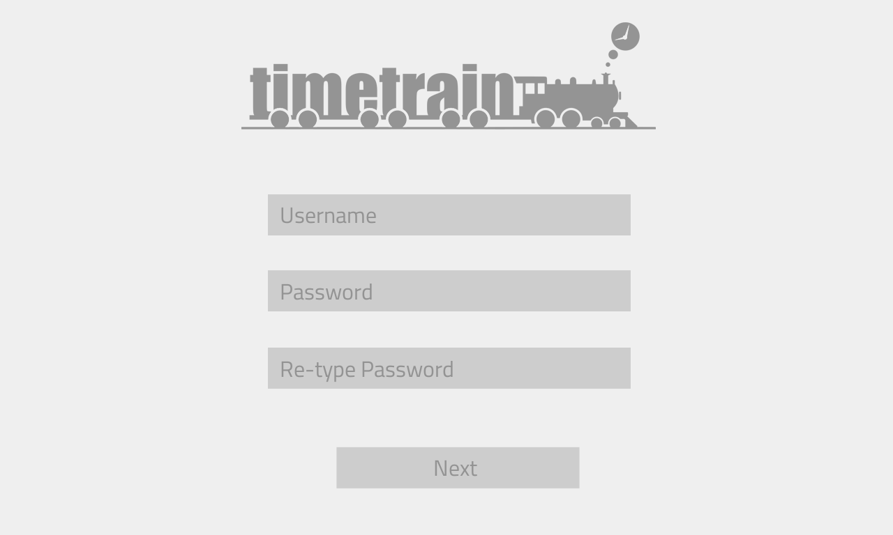
User Model
fields | description
user_id (PK)  user_name  user_password  profile_name  ... | Unique id. (Public Key)  unique alias for user_id  min 8 character  First name + Last name  ...

Part 2
Part 2 of signup page connects the user's social networking accounts to TIMETRAIN.
Upon successfull connection, a tick mark will be shown on the right ride.
To Continue or Skip the step, minimum of one connection is required.

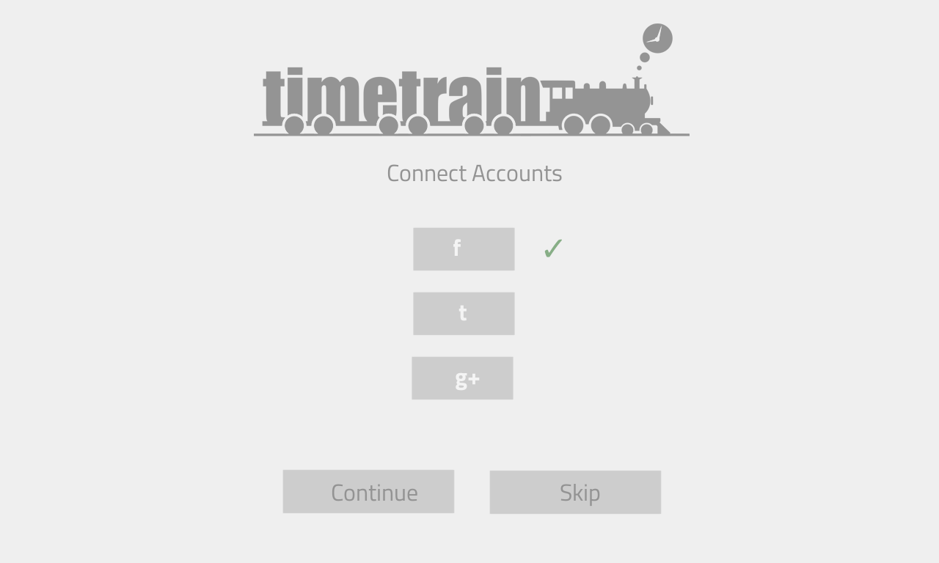
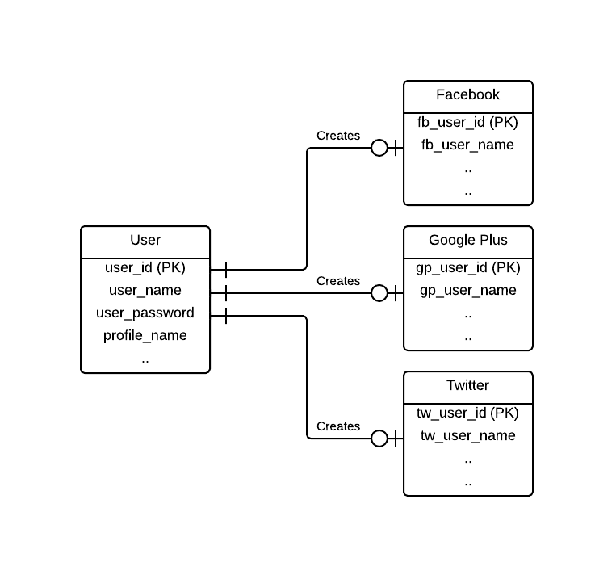

3. Home
This is the home page view after successfull login/signup.

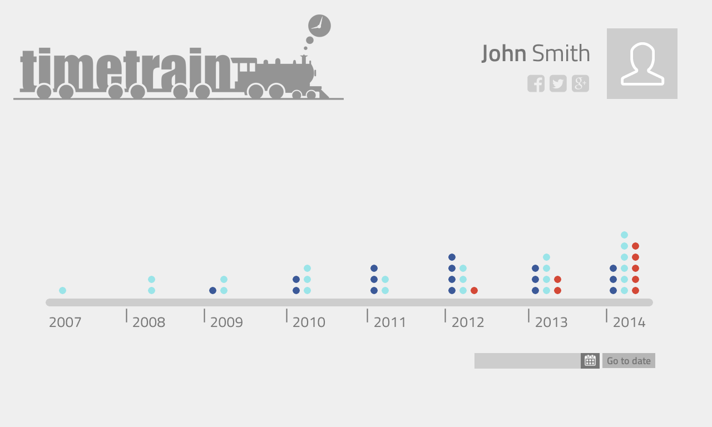
View Activities on a Specific date  Activity Dots  ● Google+ Posts  ● Tweets  ● Facebook Posts | Footer (Navigation)  Home : Link to Home Page  About : View app and developer details  Setting : hange user settings  Contact : Developer contact details  Help : User help

Timeline and actions
On clicking a part of the timeline, this zoomed timeline will be shown.Activity Dots are placed chronologically on the timeline. Clicking on an activity dot shows a miniature view of the corresponding activity.
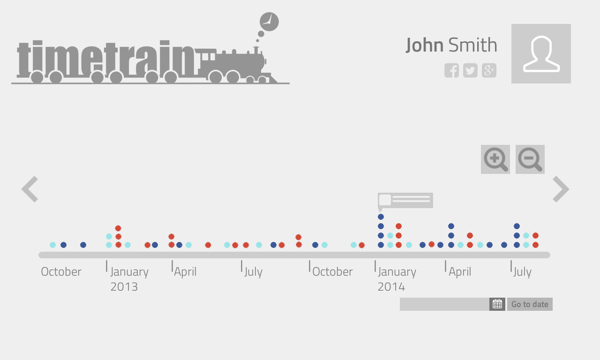
  Zoom In Timeline    Zoom Out Timeline |   Older Posts    Newer Posts

