ASSIGNMENT 02
======================================================================
- Importance:
  - Solutions will be marked by Automated Marking software.
  - The use of tools other than those allowed in the above section whether intentionally or unintentionally, is considered a violation of the exam rules, and the mark is 0
  - Do not: change the names of the folders, files, and struct (format) of .py files specified in the exam. If you change it, the marking software can not find the execute file (.py) or the program output to mark, thus the score will be 0
  - Do not: edit given statements in the main function. If you change, the marking software can not mark and the score will be 0.
- Notes 01:
  - You can create new functions if you think they are necessary.
  - Carefully read the instructions in each question to complete the practical exam.
- Notes 02:
  - The input and expected output below are only used to test your codes.
  - The input and expected output in the real testcases (for marking) are different.
Submission:
  - The folder should be named like this:
RollNumber_StudentName_ASMCode
Ex:
SE180351_TranVanAnh_ASM02
SE180351-TranVanAnh-ASM02
  - The submission folder should look like this:
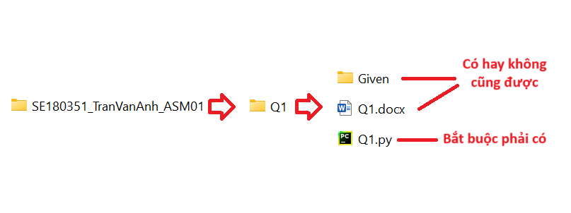
  - Then zip it to ZIP FILE (Do not use RAR).
  - Now you can submit to LMS.
=====================================================================================

The given files already contain statements to implement a program for managing a computer store. The structure of the main classes is as follows:
- Class Order: contains information about an Order object, including order_id, customer_name, and total_price.
- Class Node: includes an Order object and a next pointer for linking.
- Class TreeNode: includes an Order object and left, right pointer for tree structure.
- Class OrderQueue: is a queue structure (implemented as a linked list), where the Node contains complete Order data. This Queue is used to manage all the items in FIFO (First In – First Out) rule.
- Class OrderTree: is a Binary Search Tree structure, where the Node also contains complete Order data. This Tree’s role is to store, search and sort data (alphabetically) in ascending order (inOrder traversal) by order_id
- Class ComputerStore: is the main class of the program, containing an order_queue and an order_tree.
Students are required to carefully read the provided code segments to fully understand the relationships between the classes and the functions within each class. The specific task of the test is to execute the following requirements:
- f1(): To complete the requirement f1, students need to fulfill these two specific tasks: implement the function enqueue() in the OrderQueue structure and the function insert() in the OrderTree structure.
Insert() method should follow these rules:
    - if order_id is less than root → to the left
    - else → to the right
The expected output used to test your code are as follows:
OUTPUT:
Order Queue:
Computer, A, 1500
Keyboard, B, 120
Mouse, C, 100
Monitor, D, 500
Tablet, E, 1000
Laptop, F, 2000
Phone, G, 1000
=========
Order Tree:
Computer, A, 1500
Keyboard, B, 120
Laptop, F, 2000
Monitor, D, 500
Mouse, C, 100
Phone, G, 1000
Tablet, E, 1000
=========
- f2(): To complete the requirement f2, students need to perform this specific task: implement the search() function with the given search_id of the OrderTree structure, then:
  - Print the returned result as a found Order, or
  - If the id is not found, then return None.
  - If there are two order with the same id with the found id, return the first one founded in inOrder traversal.
  - You also need to call them in the f2() function

The expected output used to test your code are as follows:
search_id = “Tablet” | search_id = com
OUTPUT:  Order Queue:  Computer, A, 1500  Keyboard, B, 120  Mouse, C, 100  Monitor, D, 500  Tablet, E, 1000  Laptop, F, 2000  Phone, G, 1000  =========  Order Tree:  Computer, A, 1500  Keyboard, B, 120  Laptop, F, 2000  Monitor, D, 500  Mouse, C, 100  Phone, G, 1000  Tablet, E, 1000  =========  Search Result:  Tablet, E, 1000 | OUTPUT:  Order Queue:  Computer, A, 1500  Keyboard, B, 120  Mouse, C, 100  Monitor, D, 500  Tablet, E, 1000  Laptop, F, 2000  Phone, G, 1000  =========  Order Tree:  Computer, A, 1500  Keyboard, B, 120  Laptop, F, 2000  Monitor, D, 500  Mouse, C, 100  Phone, G, 1000  Tablet, E, 1000  =========  Search Result:  Not found

- f3(): In this task, students need to perform the find_max() function in OrderTree. This function will printout the Order with the highest “alphabetical” order_id, which is the last order in the inOrder traversal. You also need to call them in the f3() function
The expected output used to test your code are as follows:

OUTPUT:
Order Queue:
Computer, A, 1500
Keyboard, B, 120
Mouse, C, 100
Monitor, D, 500
Tablet, E, 1000
Laptop, F, 2000
Phone, G, 1000
=========
Order Tree:
Computer, A, 1500
Keyboard, B, 120
Laptop, F, 2000
Monitor, D, 500
Mouse, C, 100
Phone, G, 1000
Tablet, E, 1000
=========
Highest Alphabetical ID order:
Tablet, E, 1000

- f4(): In this task, students need to perform the remove() function in both OrderQueue and OrderTree. This function will remove the Order in order_queue and order_tree with input order_id. You also need to call them in the f4() function.
- If orders have same order_id, the first one encountered with the same id as delete_id will be removed, which will be the same node in both structures.
The expected output used to test your code are as follows:

OUTPUT:
Before
Order Queue:
Computer, A, 1500
Keyboard, B, 120
Mouse, C, 100
Monitor, D, 500
Tablet, E, 1000
Laptop, F, 2000
Phone, G, 1000
USB, H, 15
Tablet, I, 700
Speaker, J, 60
=========
Order Tree:
Computer, A, 1500
Keyboard, B, 120
Laptop, F, 2000
Monitor, D, 500
Mouse, C, 100
Phone, G, 1000
Speaker, J, 60
Tablet, E, 1000
Tablet, I, 700
USB, H, 15
=========
After
Order Queue:
Computer, A, 1500
Keyboard, B, 120
Mouse, C, 100
Monitor, D, 500
Laptop, F, 2000
Phone, G, 1000
USB, H, 15
Tablet, I, 700
Speaker, J, 60
=========
Order Tree:
Computer, A, 1500
Keyboard, B, 120
Laptop, F, 2000
Monitor, D, 500
Mouse, C, 100
Phone, G, 1000
Speaker, J, 60
Tablet, I, 700
USB, H, 15
=========
**In this case, the first Order with order_id “Tablet” is removed from both order queue and order tree.

