**Material Planner Assistant Video Script**

1. Team Intro

At the University of South Carolina, researchers from the McNair Aerospace Center and the AI Institute have teamed up with Fraunhofer USA to overcome challenges in BMW’s current supply chain operations. The project team is currently hard at work developing an artificial intelligence-based software assistant to help material planners optimize their decision making in both the short and long term. Sponsored by the South Carolina Fraunhofer USA Alliance and BMW -- this collaboration leverages the digital transformation and artificial intelligence expertise at the University of South Carolina and Fraunhofer USA with the supply chain knowledge of BMW personnel.

*[Show team logos]*

1. Problem

The BMW assembly process integrates thousands of parts, sourced from a wide variety of suppliers located around the world. If these parts fail to arrive on time, costly delays and work stoppages will follow. BMW’s current material planning method requires constant monitoring and manual oversight of all necessary materials by highly experienced supply chain professionals. To address this tedious and expensive undertaking, BMW seeks a dynamic solution that will capture, analyze, and capitalize on ever-growing datasets to enable and empower several key outcomes. These include optimized and proactive material control, specialized human expertise enhancement and optimization, and reduced line stoppages from missing parts.

*[Video of: bmw parts Assembly line Transportation?]*

1. Solution

The University of South Carolina and Fraunhofer teams propose the development of an artificial intelligence-based material planner assistant (MPA). The MPA would assist current material planners in their everyday work to optimize decision-making while simultaneously gathering data about these decisions for future analysis. This optimization will lead to both cost and time savings while reducing individual material planners’ workloads.

*[Picture 1]*

The MPA is composed of three main elements: a dashboard, a part health status algorithm, and a recommendation engine. The MPA is connected to BMW’s Cloud Data Hub, allowing the extraction of part and supplier-related data fields. This information is used by the part health status algorithm and recommendation engine and outputs to relevant information to the dashboard for the end user.

*[Picture 2]*

The MPA’s dashboard will aid in reducing the time a material planner spends looking up information by integrating all needed data and analysis into one location. Information is presented in visual groupings to enhance readability – these include:

* 1. Part Lookup and Detailed Description
  2. Part Health Status
  3. Part Exception Manager and Viewer
  4. Material Planner Suggestion, Response, and Reasoning

*[close ups of individual widgets]*

At the start of their shift, a material planner will log in to their dashboard, searching for the relevant materials for that day’s tasks. Using the Part Lookup, the planner can quickly see the health status of the queried materials and identify which ones need immediate attention. The Health Status is a number value between 0 and 100 that is calculated by the Part Health Status algorithm, taking into account…… [WHAT SHOULD WE ADD HERE]. In addition, the dashboard will display the results of the MPA’s recommendation engine for the selected material based on…… [WHAT SHOULD WE ADD HERE]. The material planner operator will be able to then agree or disagree with the MPA recommendation and give their reasoning, which the MPA logs for future analysis and improvement to its decision process.

1. Future Work

Phase 1 of the project has resulted in the development of the MPA’s interaction framework and the proven functionality of the algorithm and recommendation engine. In Phase 2, the team will work enhance and refine these developed capabilities – leading to a more robust MPA, geared towards real-world deployment, use, and added value.

*[Credits – Team Logos again]*

Picture 1:

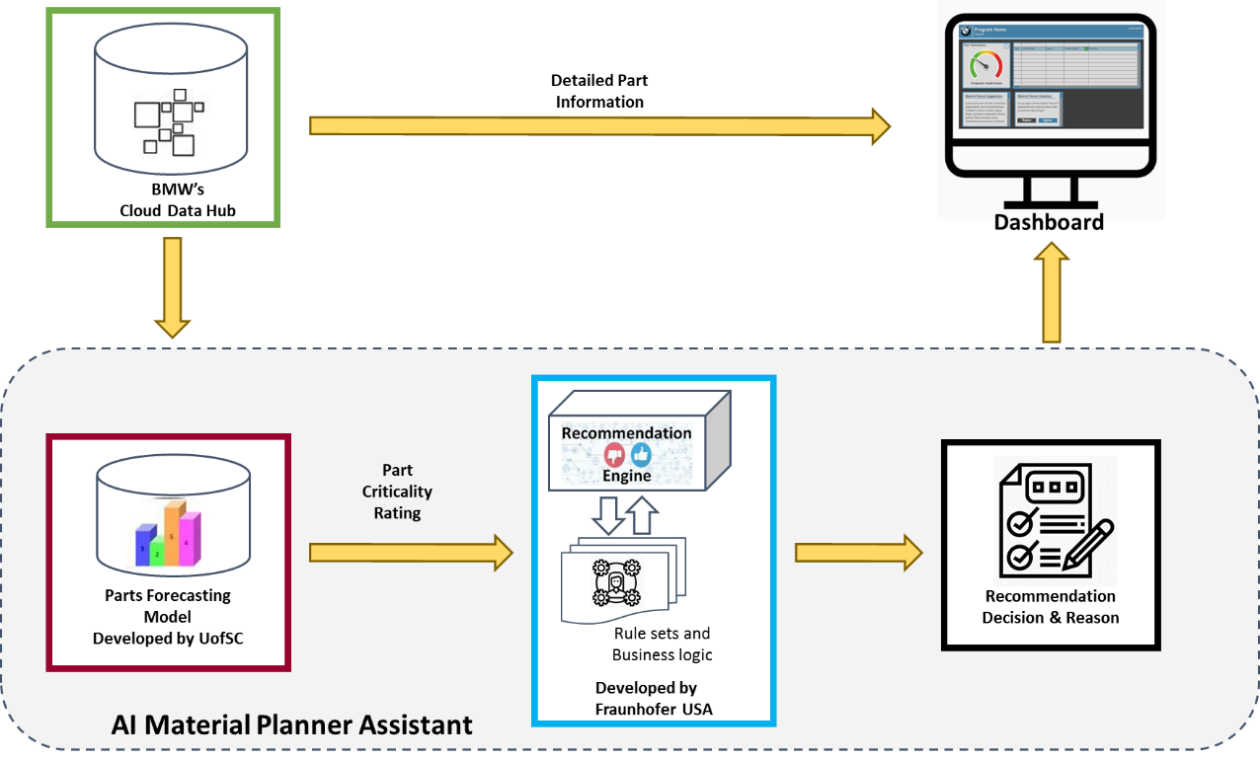

Picture 2:

