1. Checkout code from GIT

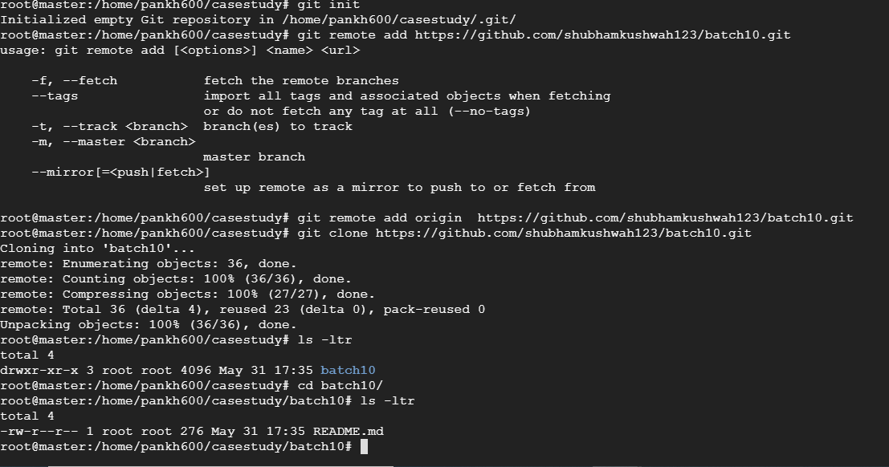

2) Implement build and test and package in Jenkins runtime:

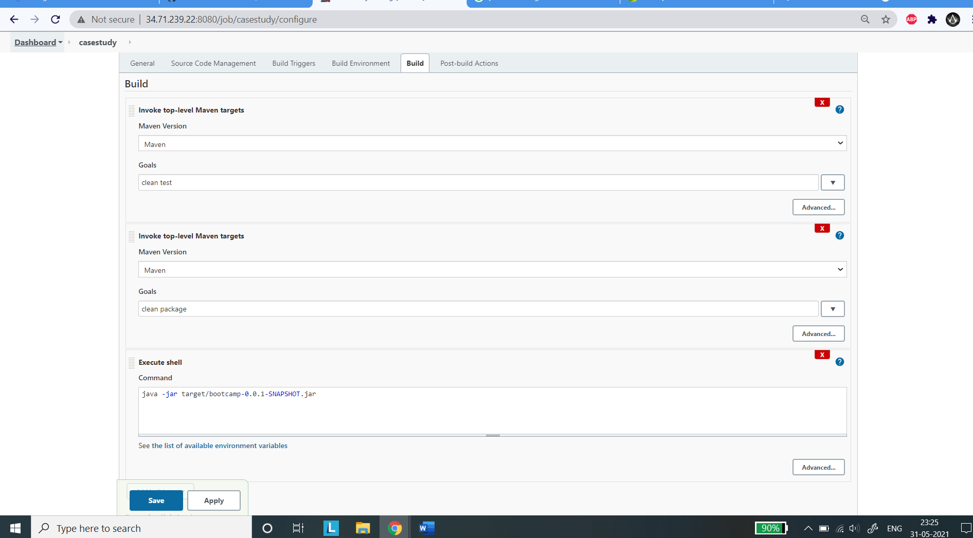

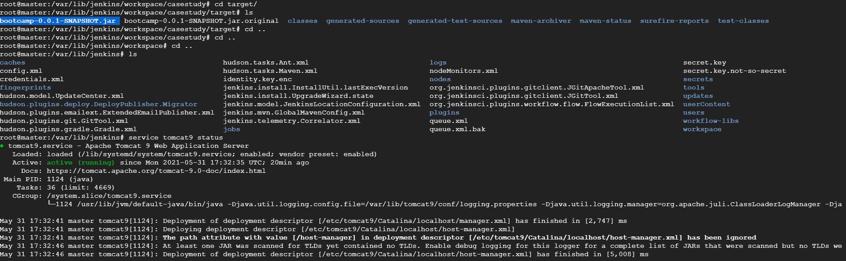

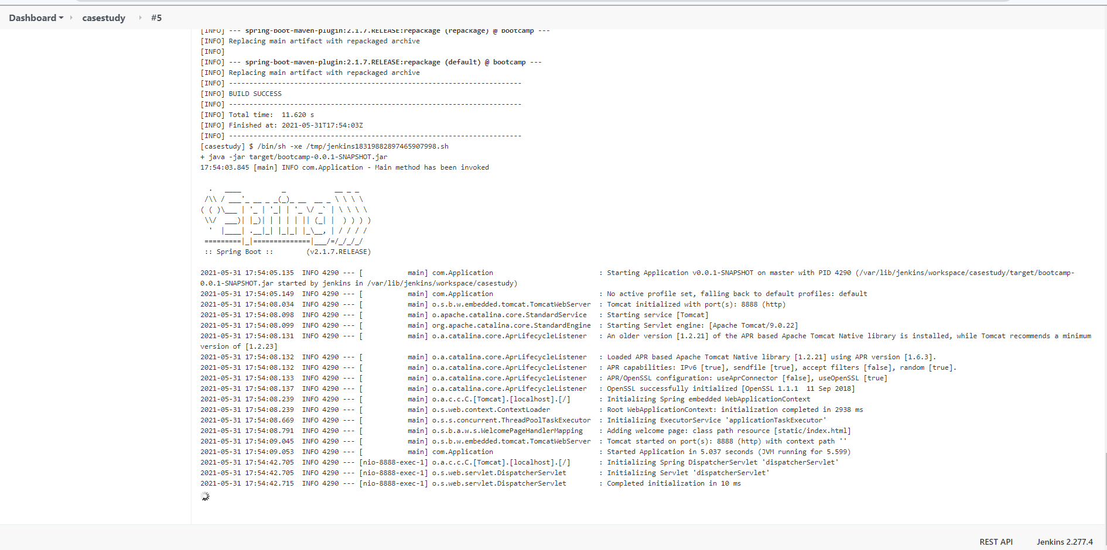

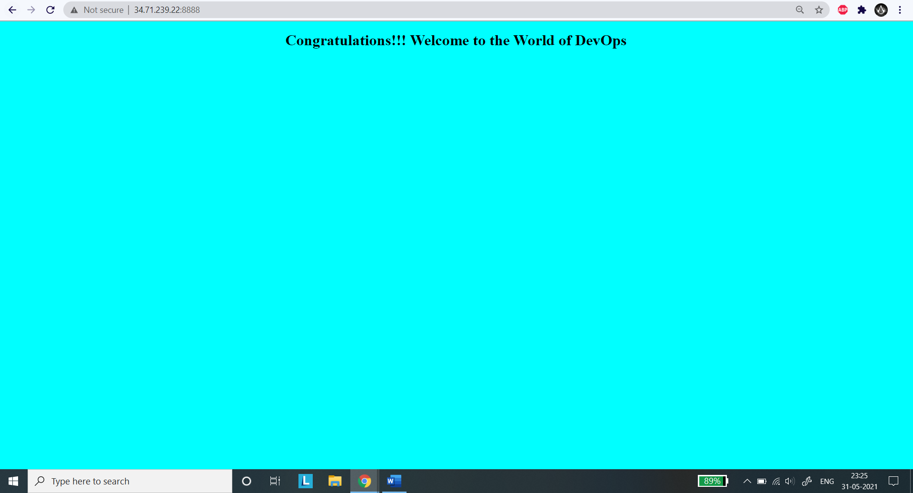

3) Implement sonarqube:

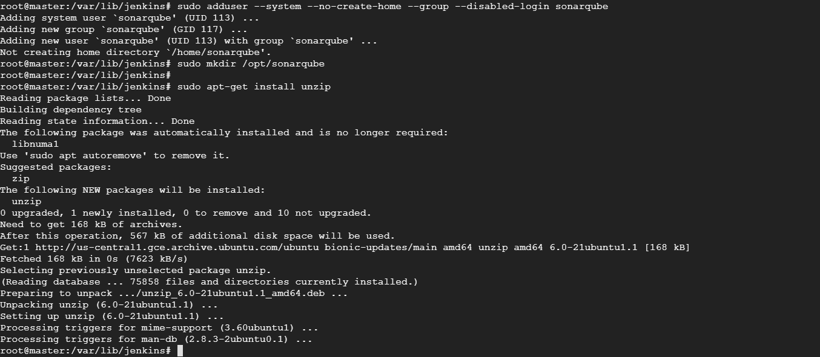

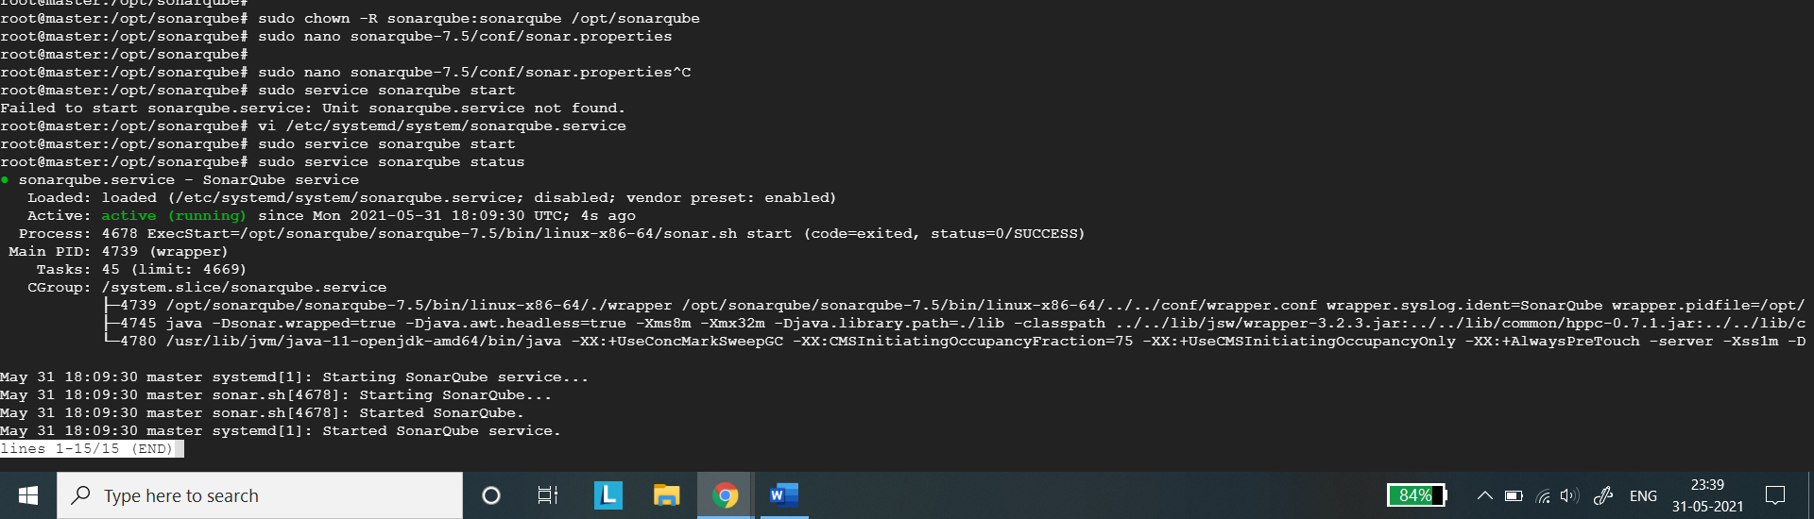

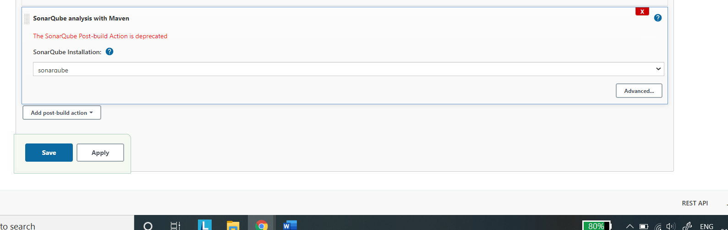

4) Appscan : Not required

5) Publish html reports:

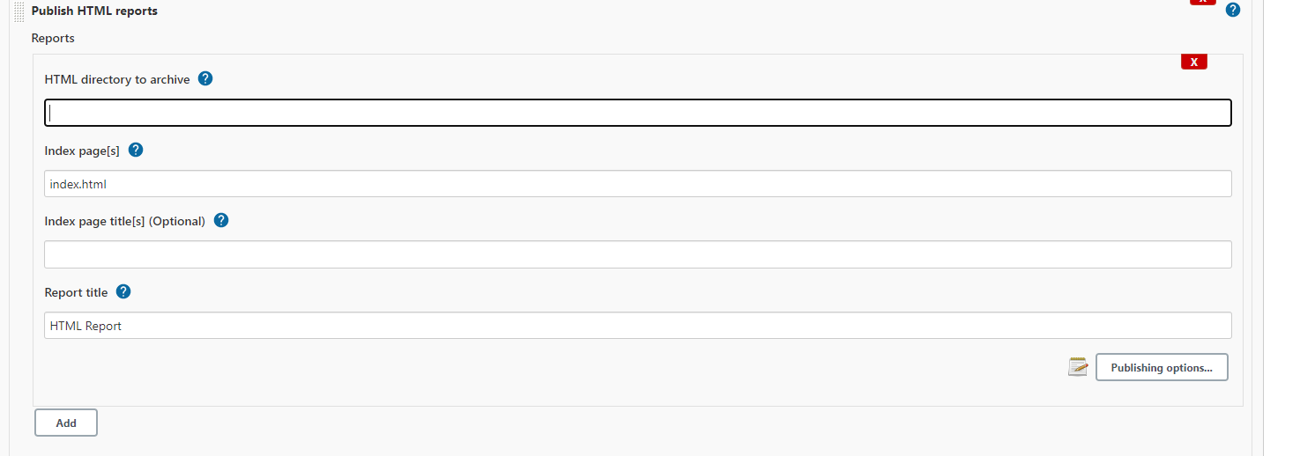

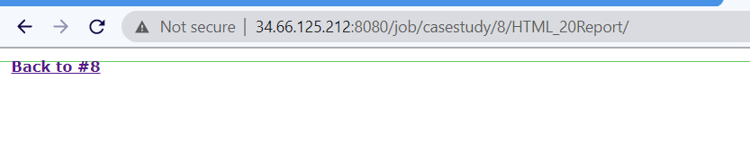

6)

Write dockerfile for application:

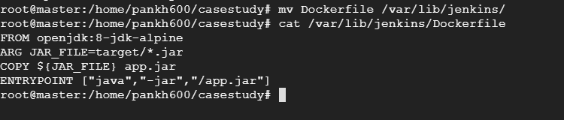

7) Authenticate to dockerhub registry

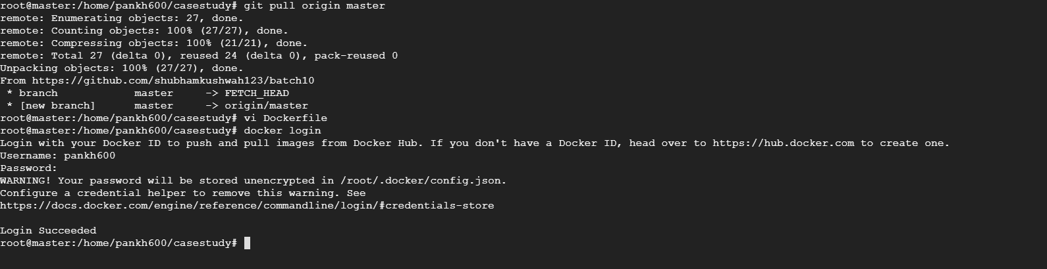



8)Push docker image using Jenkins runtime docker

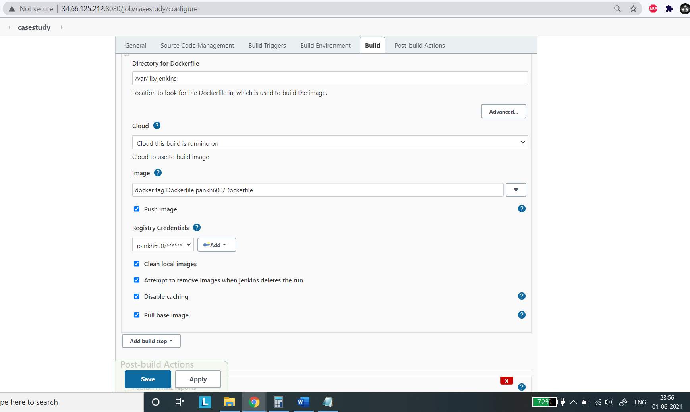

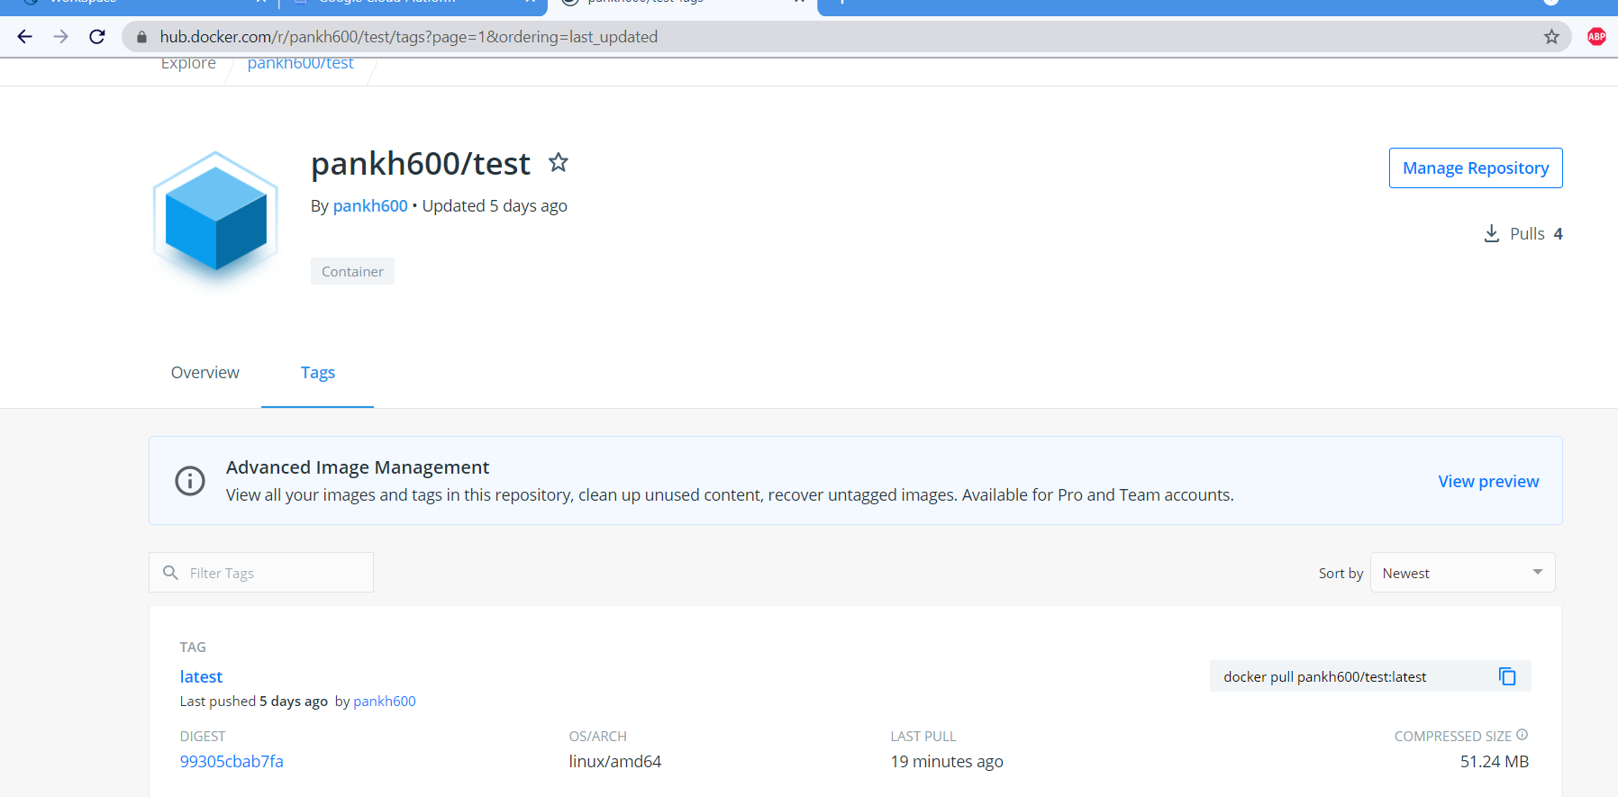

9) Email notification for each bad builds:

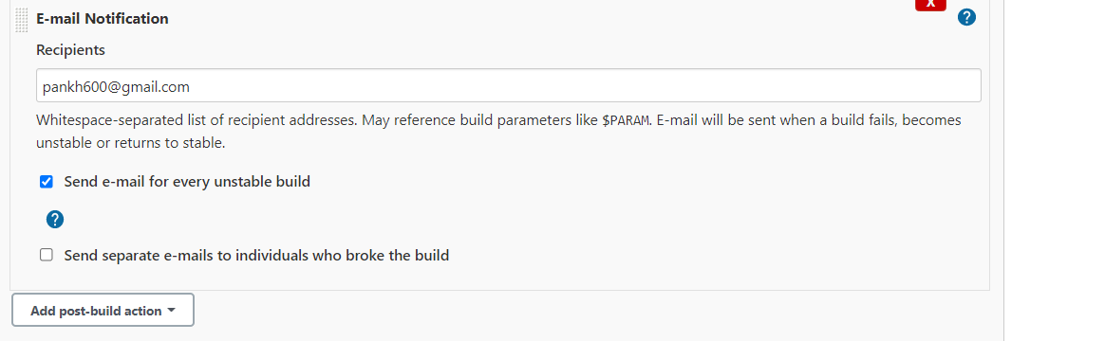

10) Ansible adding nodes to ansible controller:

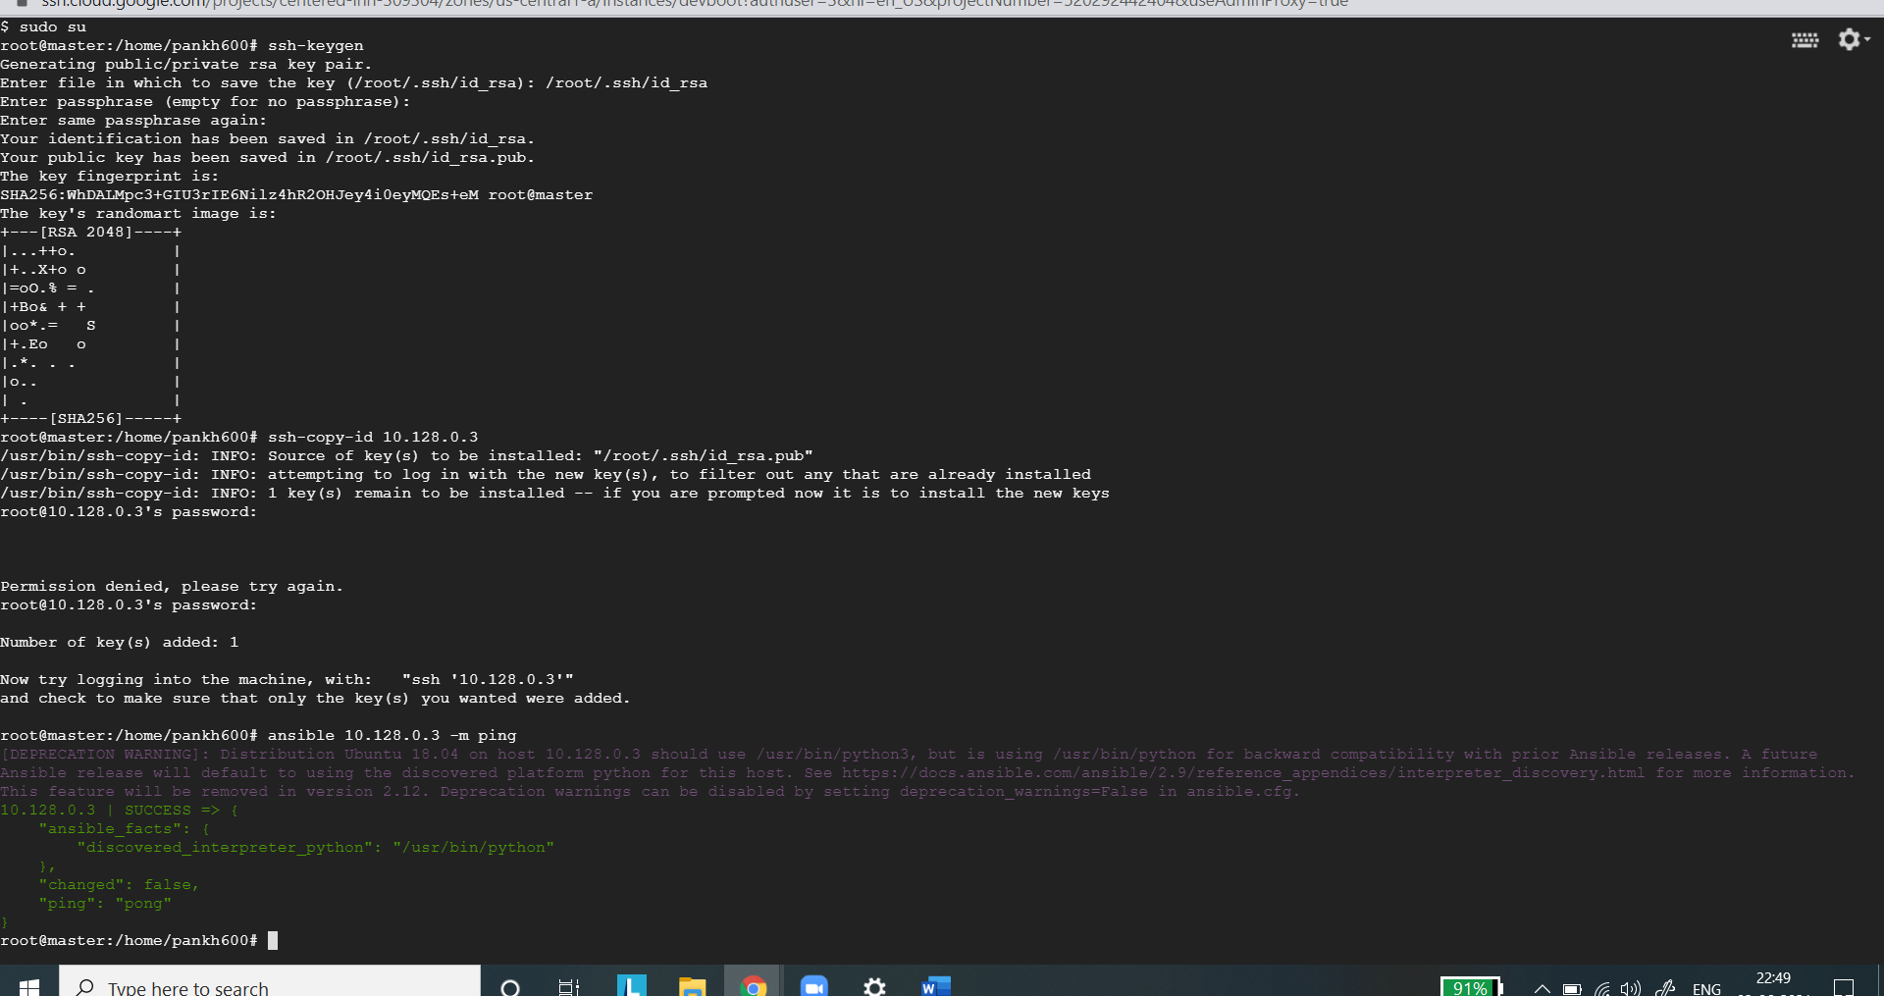

11) Simple playbook to install nginx and start as service in node:

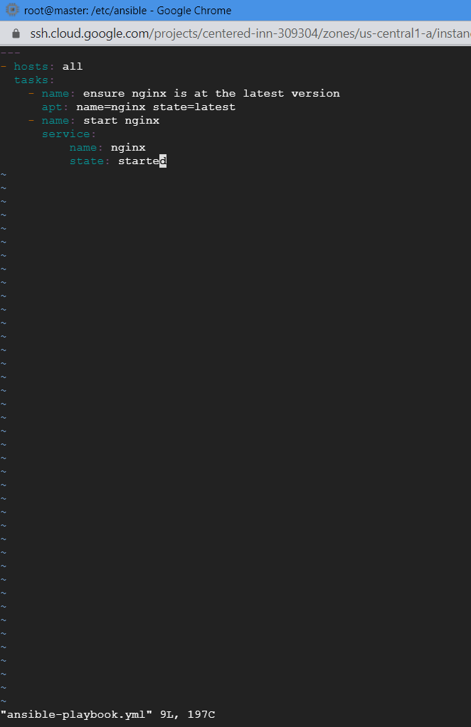

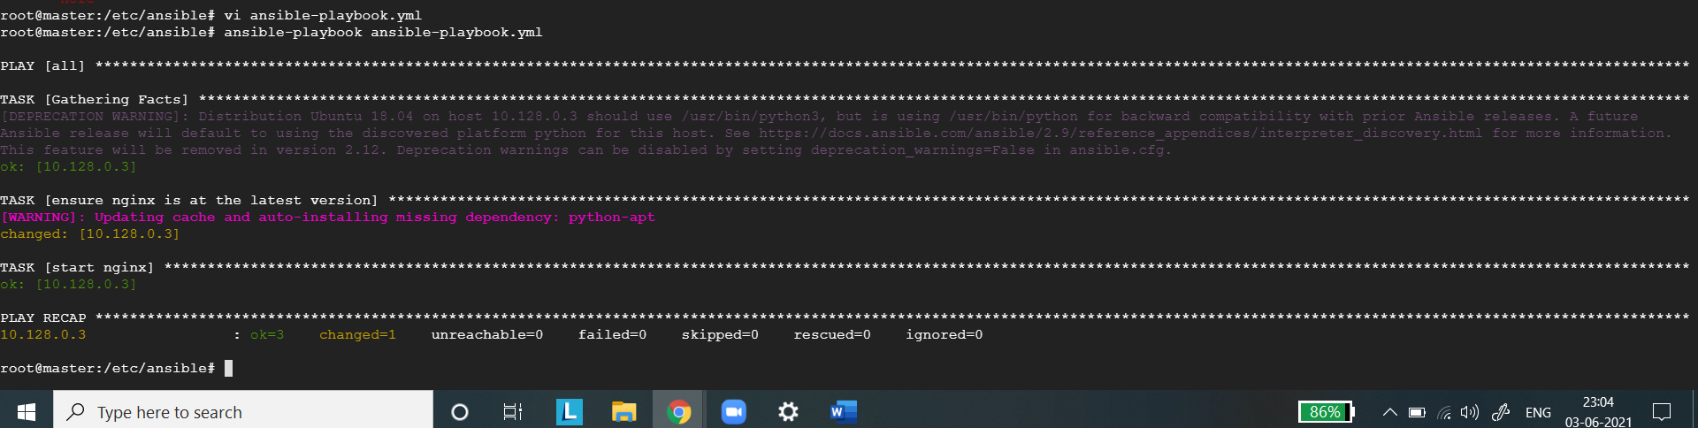

Checking nginx status at node:

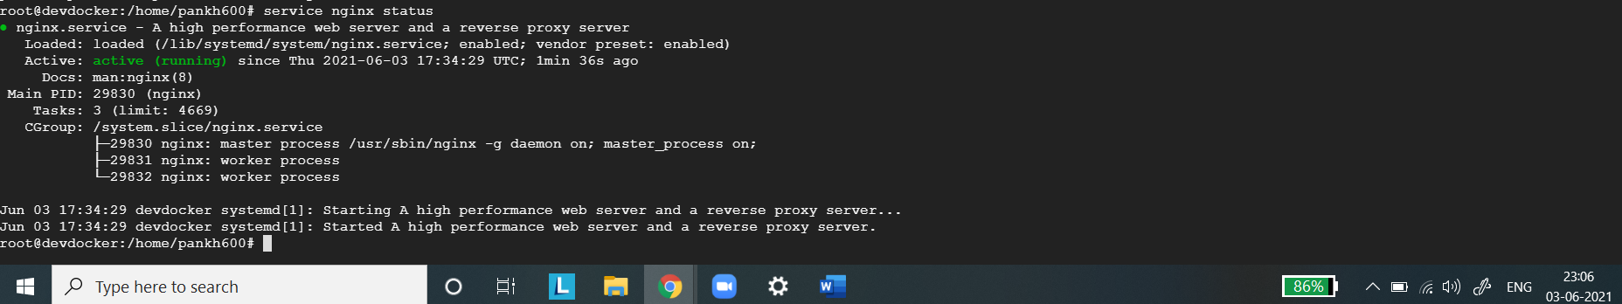

12) Installing and configuring Ansible plugin in Jenkins:

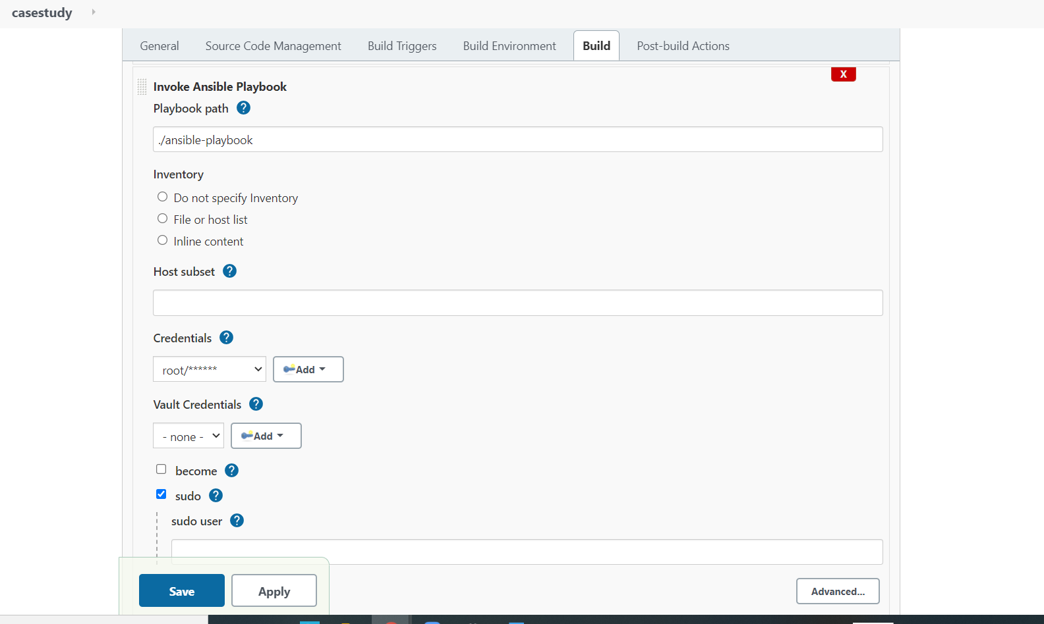

13) Updating webhook in github:

