Predicting Goals Scored per Football Match
Poisson and Negative Binomial Regression | Predictive Analytics Mini Project | B.Tech Computer Science

Abstract
This project predicts team-level goals in English Premier League matches using Generalized Linear Models. Five distinct seasons were verified: 2022-23, 2023-24, 2024-25, 2025-26 and the first 80 fixtures of 2026-27. The four completed seasons provide 1,520 training matches; 2026-27 provides 80 chronological test matches. Each fixture is converted into two team-perspective observations. Predictors include team, opponent, venue and past-only five-match form. Poisson and Negative Binomial models are compared with baselines. The observed mean is 2.945 total goals per match.

1. Introduction
Predictive analytics estimates future outcomes from historical data. Descriptive analytics summarizes past scoring and team performance; prescriptive analytics uses forecasts to inform actions such as training and tactical planning. Football goals are non-negative integer counts, often concentrated at low values. Ordinary linear regression may predict negative goals and does not encode a count distribution. Poisson and Negative Binomial GLMs are suitable statistical approaches.
Football analytics can support clubs, media and performance staff. Predictions are uncertain and should not be framed as guarantees or betting advice. Data quality, team-name changes, promoted clubs and missing context can introduce bias.

2. Dataset and preprocessing
The supplied files contain five distinct seasons, each verified by match dates and row counts. The 2022-23, 2023-24, 2024-25 and 2025-26 files each contain 380 matches; the ongoing 2026-27 file contains 80 matches from 21 August to 25 October 2026. Total dataset size is 1,600 matches (3,200 team-match rows). Required columns were checked, dates parsed day-first, goals converted to non-negative integers and duplicate fixture keys removed.
The response is goals scored by a team. Every fixture generates a home-team row and an away-team row. Categorical predictors represent team and opponent; a binary variable represents home advantage. Rolling scoring and conceding averages use only the previous five matches. Histories are updated after both perspectives of the current match are recorded, preventing target leakage.

3. Exploratory data analysis
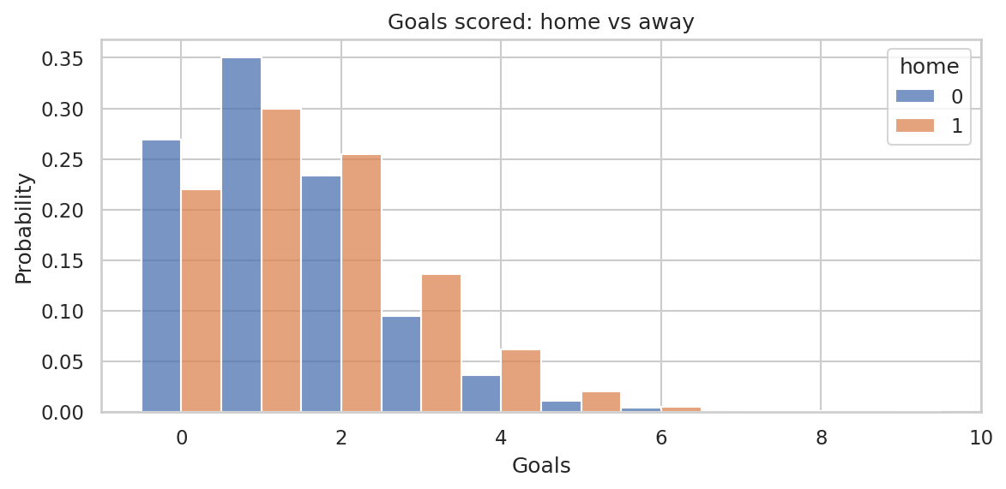
Figure 1. Distribution of home and away goals.
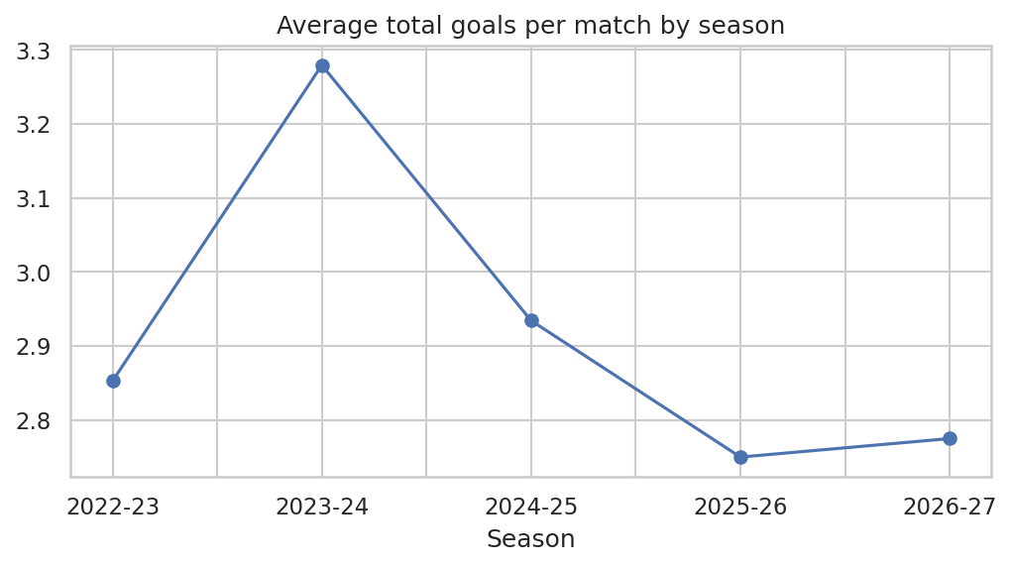
Figure 2. Average total goals per match across five seasons.

3. Exploratory data analysis (continued)
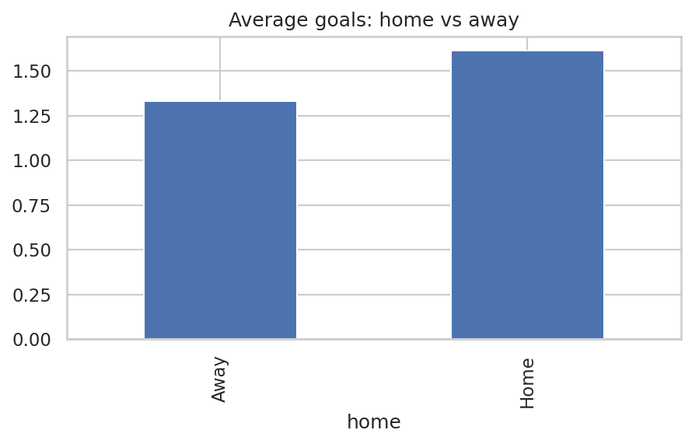
Figure 3. Venue scoring means. Home = 1.613; away = 1.332.
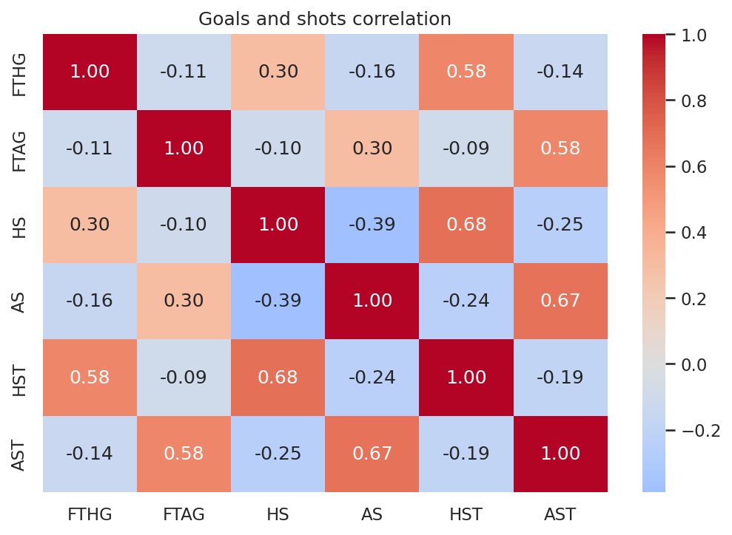
Figure 4. Correlation matrix for goals, shots and shots on target. Correlation is descriptive, not causal.

4. Methodology
The Poisson GLM uses log(E[goals|X]) = β0 + team effect + opponent effect + home effect + β1(past scoring form) + β2(past conceding form). The log link ensures a positive expected count. Maximum likelihood estimates the coefficients. Exponentiating a coefficient gives an incidence rate ratio (IRR).
The Poisson distribution assumes conditional mean and variance are equal. Overdispersion is checked using training variance/mean and Pearson chi-square per residual degree of freedom. Negative Binomial regression adds an NB2 dispersion parameter α, with variance μ + αμ². Alpha is estimated by the method of moments, stable when test-season clubs have no training observations.
Four completed seasons are used for training and the ongoing 2026-27 season is held out. The test includes clubs not present in earlier seasons; those clubs receive the reference-team effect rather than a fabricated learned team effect. TimeSeriesSplit is used for chronological regularization validation.
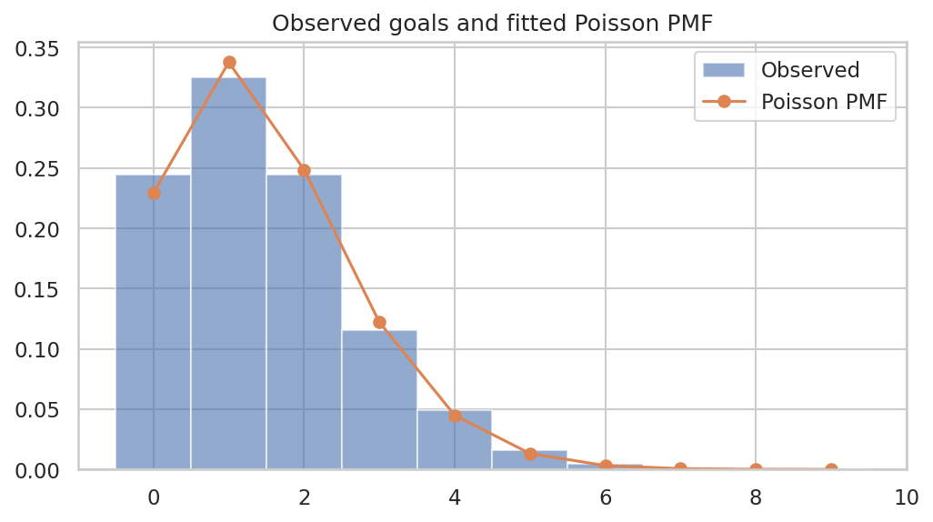
Figure 5. Observed goal counts and fitted Poisson probability mass function.

5. Results
Across all seasons, average total goals per match = 2.945; mean home goals = 1.613; mean away goals = 1.332. The Poisson home-advantage IRR is 1.212, corresponding to approximately 21.2% higher expected scoring at home, holding other predictors fixed.
Training dispersion diagnostics: variance/mean ratio = 1.079; Pearson chi-square/df = 0.935; approximate dispersion score-test p-value = 0.262. NB2 method-of-moments alpha is 0.0534. Poisson AIC = 9057.13; Negative Binomial AIC = 9085.80. Poisson has the lower AIC in this comparison.
Model | RMSE | MAE | Mean Poisson deviance
Poisson GLM | 1.2453 | 1.0016 | 1.3043
Negative Binomial GLM | 1.2452 | 1.0015 | 1.3043
Training-mean baseline | 1.2531 | 1.0340 | 1.3093
Linear regression | 1.2209 | 0.9865 | 1.2715
The 2026-27 test contains 80 fixtures (160 team-match rows). Poisson GLM RMSE = 1.2453 and MAE = 1.0016. Linear regression is a useful benchmark, but it does not enforce non-negative predictions or a count likelihood.
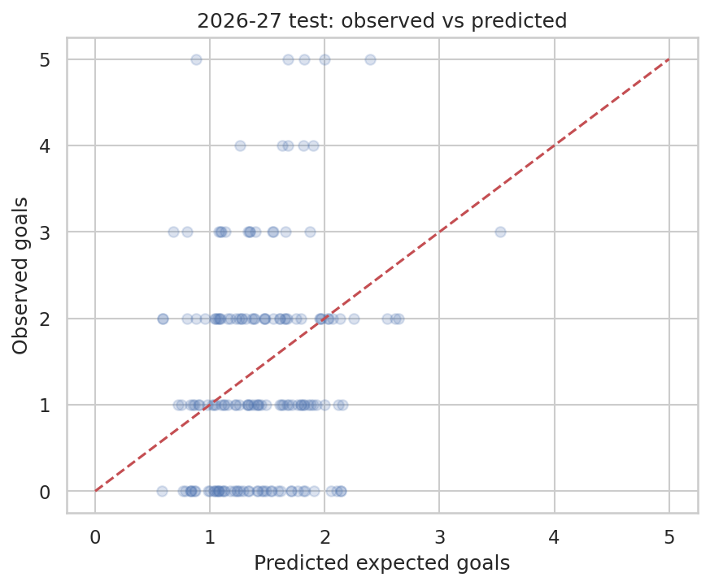
Figure 6. Predicted expected goals against observed test-set goals.

5. Results (continued)
Match outcome probabilities derived from independent Poisson score distributions achieve W/D/L accuracy 46.2% and log loss 1.076. Always-home-win baseline accuracy is 38.8%. This is a modest improvement over the baseline; exact match outcomes remain noisy.
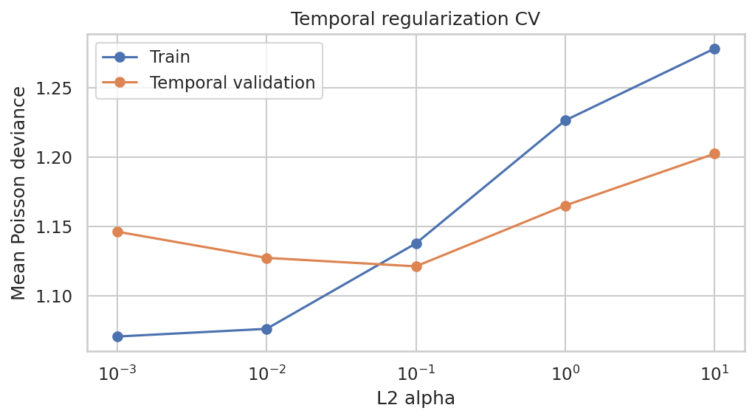
Figure 7. Training and temporal-validation deviance across L2 penalty strengths.

6. Ethical considerations
Football predictions may be repurposed for gambling. Communicate probabilities as uncertain estimates, avoid recommending stakes and do not describe predicted scores as certain. Data can encode historical imbalance or incomplete information. Post-match statistics such as shots should not be used as pre-match predictors.

7. Limitations and future work
The model omits injuries, starting line-ups, transfers, manager changes, referee effects, schedule congestion, tactical matchups and player-level quality. The 2026-27 test set is small and covers only the first 80 uploaded matches. Newly promoted teams have no team-specific training history and receive the reference effect. The independent-Poisson score matrix ignores dependence between team scores and truncates displayed scorelines at 0-6. Future work includes Dixon-Coles correction, Elo ratings, xG features, bivariate Poisson and zero-inflated models if justified.

8. Conclusion
The project demonstrates preprocessing, EDA, leakage-safe feature engineering, GLM coefficient estimation, Poisson and Negative Binomial comparison, chronological testing and regularization. Poisson offers a clear and interpretable baseline. The ongoing 2026-27 season provides a realistic future-season test, although conclusions should be revisited as more fixtures become available.

References
football-data.co.uk. English Premier League historical results. https://www.football-data.co.uk/englandm.php
McCullagh, P. & Nelder, J. A. (1989). Generalized Linear Models (2nd ed.). Chapman & Hall.
Statsmodels documentation. Generalized Linear Models. https://www.statsmodels.org/
Scikit-learn documentation. PoissonRegressor and TimeSeriesSplit. https://scikit-learn.org/

