DataPilot Spec: Agentic AI Edition

1. Project Name
Project Name: DataPilot
Tagline: An autonomous, multi-agent analytics system that turns business questions into validated insights.

2. Problem Statement
Modern organizations generate massive amounts of data, but accessing insights still requires technical expertise. Business users often depend on data engineers or analysts to write SQL, understand schemas, and validate results, creating bottlenecks and slowing decision-making. Existing BI tools offer dashboards but lack true autonomy and reasoning.
This problem matters now because organizations are pushing toward self-serve analytics while data complexity keeps growing. An autonomous agentic system that can reason over schemas, validate feasibility, control costs, and explain results directly aligns with the shift toward Agentic AI and real-world enterprise adoption.

3. Proposed Solution
DataPilot is a multi-agent autonomous data analyst that allows users to ask business questions in natural language. Behind the scenes, specialized agents collaborate to plan the analysis, explore available data, generate and validate queries, estimate cost, execute safely, and explain results with visualizations.
Key innovation
Instead of blindly translating text to SQL, DataPilot reasons about whether a question is answerable, adapts when results look incorrect or risky, and transparently shows its decision-making process.
Before: Users rely on analysts, run expensive queries, or get misleading results.
After: Users ask a question and receive validated, explainable insights with full visibility into how the answer was produced.

4. Key Features – Prioritized MVP Scope
MVP (Hackathon Scope):
- Multi-agent architecture with clear responsibilities
- Autonomous planning → execution → validation → adaptation loop
- Schema introspection and feasibility checks
- SQL generation with dry-run cost estimation
- Guardrails for safety, cost, and read-only access
- Agent trace UI showing real-time decision flow
- Insight explanation with charts and assumptions
Post-MVP / Stretch:
- Pluggable connectors for Snowflake, Postgres, NoSQL
- Advanced query optimization
- Saved analysis sessions and history

5. Key Journeys
- As a business user, I ask a question in plain English so I can get insights without writing SQL.
- As a user, I see whether my question is fully or partially answerable based on available data.
- As a user, I review the estimated cost before a query is executed.
- As a user, I see charts and a natural-language summary explaining the results.
- As a user, I can view the agent’s step-by-step reasoning and decisions.
User Flow (Textual Diagram):
User Input → Planning Agent → Data Discovery Agent → Query Execution Agent → Validation → Visualization & Explanation

6. High-Level Architecture & Technology Choices

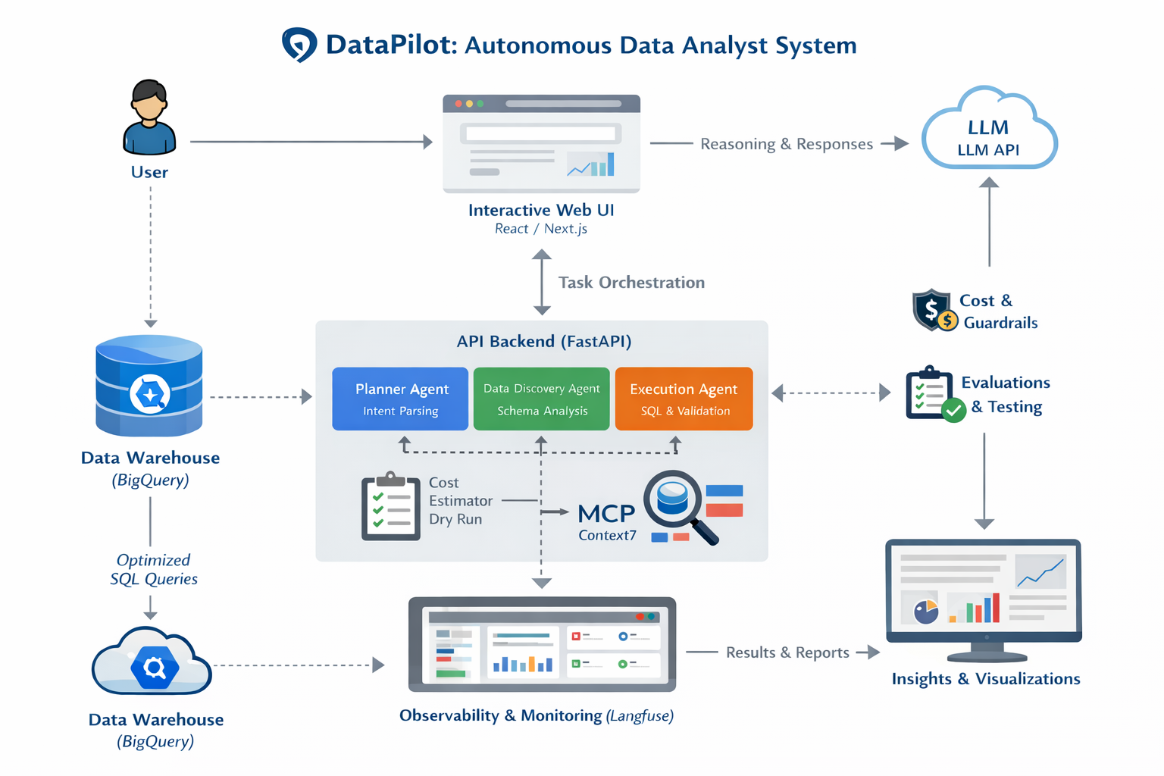

Overall Architecture:
Client (Web UI) → FastAPI Backend → Multi-Agent Orchestrator → Data Warehouse (BigQuery)
Frontend:
- Next.js (React) + Tailwind CSS
Backend / Logic:
- Python FastAPI
- LangGraph for agent state machine and orchestration
Agents:
- Planner Agent: Interprets user intent and creates an analysis plan
- Data Discovery Agent: Explores schemas, tables, and feasibility
- Execution & Validation Agent: Generates SQL, estimates cost, executes, validates results
Observability:
- Langfuse for traces, logs, and evaluations
External Integrations:
- LLM API (OpenAI / Gemini)
- BigQuery metadata and query APIs
- Context7 MCP for SQL dialect reference
Deployment:
- Frontend on Vercel
- Backend on Railway / Render
Rationale:
Chosen for fast development, strong agent support, and enterprise relevance.

7. Where DataPilot Can Be Used (Real-World Impact)
- Self-Serve Analytics for Business Teams
Product managers, ops teams, and leadership can ask questions without waiting on analysts, reducing insight turnaround from days to minutes.
- Analytics Engineering & Data Platform Teams
DataPilot acts as a “first-line analyst,” validating questions, preventing unsafe queries, and reducing ad-hoc load on data teams.
- Cost & Governance-Aware Querying
By estimating query cost and enforcing guardrails, DataPilot prevents runaway warehouse costs and enforces responsible data access.
- Data Discovery & Onboarding
New hires and non-technical users can explore datasets safely, understand schemas, and learn what questions are answerable.
- Enterprise AI Assistants
DataPilot can plug into internal AI platforms as an analytics capability, powering Slack bots, internal tools, or executive dashboards.

