SYSTEM DESIGN
●INTRODUCTION
System design is the process of defining the architecture, components, modules, interfaces, and data for a system to satisfy specifies requirements. System design could be as seen as the application of systems theory to product development. It is about the physical organisation of the system. It is demonstrated with the help of UML Diagram or block Diagrams etc. it is explained in a pictorial representation.
Figure 5.a: Pre-processing

.SYSTEM ARCHITECTURE
System Architecture
1.Image Acquiring
The Primary Phase is acquiring images. After the Images collection, the obtained images have to be prepared with a wide range of vision.
2. Pre Processing
The images which are collected are subjected to preprocessing. In Pre-processing stage basic steps are image resizing and applying Gaussian filters for a perfect input clear image for easy identification of an image. 1. Segmentation In this stage of implementation, Pre-processed images will be segmented digitally into various pixels. We do this segmentation for an image is to modify its representation to have more clarity to study and analyse the images.
3.Feature Extraction
In the feature extraction process, we can implement the effective texture operator which labels the pixels of an image. Here we extract the features and characteristics of Images for easy detection of brain tumor.
4.Classification
In Classification stage, Convolutional neural networks algorithm is used for classification of brain images. It is a non-parametric method which is used for both classification and regression.
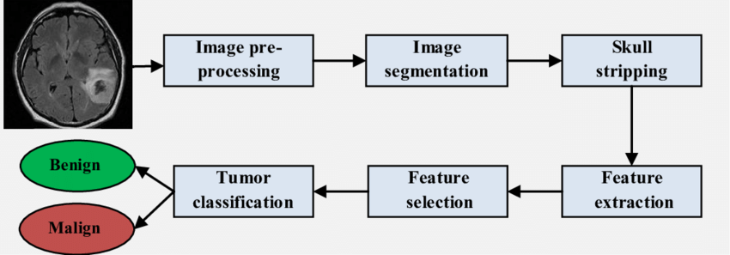
●UML Diagrams
The Unified Modelling Language (UML) is a general-purpose modelling language in the field of software engineering, which is designed to provide a standard way to visualize the design of a system. The Unified Modelling Language (UML) offers a way to visualize a system’s architectural blueprints in a diagram.
●Use case Diagram for Brain Tumor Detection Using Convolutional Neural Networks
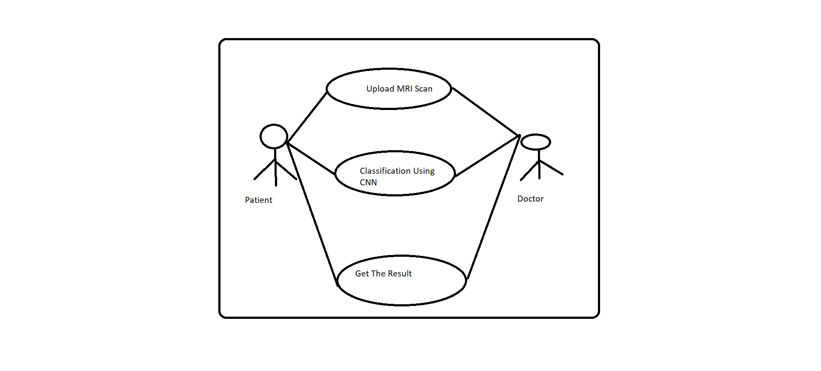
Use case Diagram for Brain Tumor Detection Using Convolutional Neural Networks
A use case Diagram at its simplest is a representation of a user’s interaction with the system that shows the relationship between the user and the different use cases in which the user is involved. A use case Diagram can identify the different types of users of a system and the different use cases and will often be accompanied by other types of Diagrams as well.

CONVOLUTION NEURAL NETWORK
Convolutional Neural network is a deep learning technique which is feed forward artificial neural networks that are applied to visual images. These are also called as CONV NETS. These are combined set of layers that can be worked on group functionalities.
Convolutional Neural Network

Pooling in Convolutional Neural Network

