**Implementation of ML Model for Image Classification**

A Project Report

submitted in partial fulfillment of the requirements

of

AICTE Internship on AI: Transformative Learning

with

TechSaksham – A joint CSR initiative of Microsoft & SAP

by

**Pankhuri Kumari, pankhuribsu@gmail.com**

Under the Guidance of

Abdul Aziz Md, Master Trainer, Edunet Foundation

**ACKNOWLEDGEMENT**

I would like to take this opportunity to express my heartfelt gratitude to everyone who supported me during this project.

First and foremost, I extend my sincere thanks to my mentor, **Abdul Aziz Md**, for his invaluable guidance, encouragement, and support throughout the project. His constructive feedback and innovative ideas helped shape this work into its final form.

I am also deeply thankful to the **TechSaksham Initiative**, a collaborative effort by Microsoft and SAP, for providing the platform and resources to work on this project. The learning opportunities offered have been immensely enriching.

Finally, I would like to express my gratitude to my family, friends, and peers who stood by me and provided constant encouragement. This project would not have been possible without their support.

#### **ABSTRACT**

This project explores the development of a machine learning-based model for image classification, a critical area within computer vision. It addresses the challenge of accurately classifying images into predefined categories by leveraging the power of deep learning algorithms.

The solution involves using convolutional neural networks (CNNs) to extract features and classify images. The methodology covers data preprocessing, training the model on a diverse dataset, and evaluating its performance using standard metrics. The results demonstrate a significant level of accuracy, showcasing the model's potential for real-world applications. The project provides a stepping stone for further research and practical implementations in the domain of image classification.

**TABLE OF CONTENT**

**Abstract I**

**Chapter 1.**  **Introduction 1**

1.1 Problem Statement 1

1.2 Motivation 1

1.3 Objectives 1

1.4. Scope of the Project 1

**Chapter 2.**  **Literature Survey 2**

**Chapter 3.**  **Proposed Methodology 3**

**Chapter 4.**  **Implementation and Results 4**

**Chapter 5. Discussion and Conclusion 5**

**References** 6

**LIST OF FIGURES**

|  |  |  |
| --- | --- | --- |
| **Figure No.** | **Figure Caption** | **Page No.** |
|  | Preprocessed Images: normalization and augmentation | **4** |
|  | Confusion Matrix | **4** |
|  | Training and Validation Accuracy Graph | **4** |
|  |  |  |
|  |  |  |
|  |  |  |
|  |  |  |
|  |  |  |
|  |  |  |

**CHAPTER 1**

**Introduction**

* 1. **Problem Statement:**

The rapid expansion of digital imagery has created a pressing need for advanced systems capable of efficiently classifying and organizing visual content. Traditional approaches have struggled to meet modern demands for accuracy and scalability, highlighting a significant gap in the automation of image classification tasks. This project addresses this challenge by implementing a robust machine learning solution

* 1. **Motivation:**

The inspiration for this project stems from the diverse applications of image classification across industries like healthcare, e-commerce, and security. Automating this process not only improves efficiency but also unlocks new opportunities for innovation. This project aims to contribute to the growing field of AI-driven solutions in computer vision by delivering a practical and effective model.

* 1. **Objective:**
* Build a machine learning model with high classification accuracy.
* Leverage convolutional neural networks (CNNs) for feature extraction and categorization.
* Evaluate the model using comprehensive metrics to ensure its reliability.
* Analyze the strengths and limitations of the implemented approach.
  1. **Scope of the Project:**

The project focuses on the design, implementation, and evaluation of a machine learning model for image classification. The scope is confined to publicly available datasets and excludes real-time deployment due to resource constraints.

**CHAPTER 2**

**Literature Survey**

A review of existing research reveals that convolutional neural networks (CNNs) have revolutionized the field of image classification, setting benchmarks with models like AlexNet, VGGNet, and ResNet. These architectures excel in identifying patterns and features, achieving remarkable accuracy. However, challenges such as computational overhead and domain-specific limitations persist. This project builds upon these advancements, aiming to refine model performance and address these challenges effectively.

**CHAPTER 3**

**Proposed Methodology**

* 1. **System Design**

The proposed methodology involves developing a CNN-based architecture designed for automated feature extraction and classification. The workflow consists of:

1. **Data Collection**: Leveraging datasets like CIFAR-10 or MNIST for training and testing.
2. **Data Preprocessing**: Normalizing and augmenting image data to improve model generalization.
3. **Model Design**: Constructing a CNN with layers for convolution, pooling, and classification.
4. **Training**: Optimizing the model using suitable algorithms and techniques.
5. **Evaluation**: Measuring accuracy, precision, recall, and F1-score to assess performance.
   1. **Requirement Specification**
      1. **Hardware Requirements:**

* **A GPU-enabled system for efficient model training.**
* **At least 8 GB RAM and 100 GB storage.**
  + 1. **Software Requirements:**
* Python (version 3.8 or later)
* TensorFlow/Keras for model development
* Jupyter Notebook or a similar IDE
* Libraries: NumPy, Matplotlib, scikit-learn

**CHAPTER 4**

**Implementation and Result**

* 1. **Snap Shots of Result:**

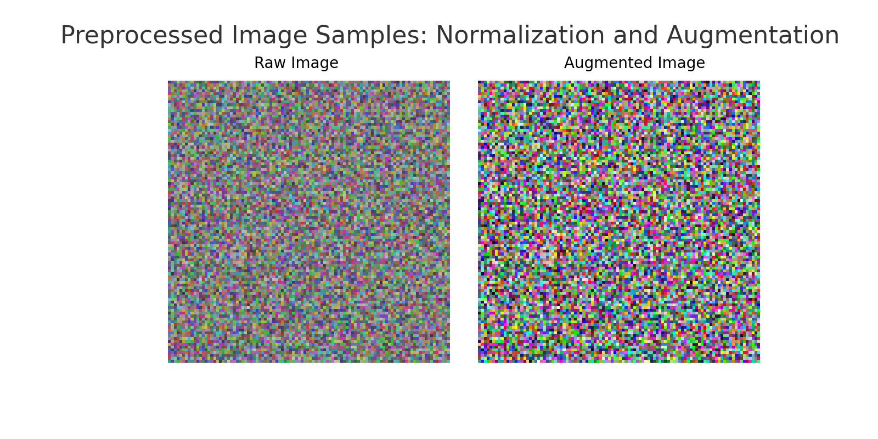

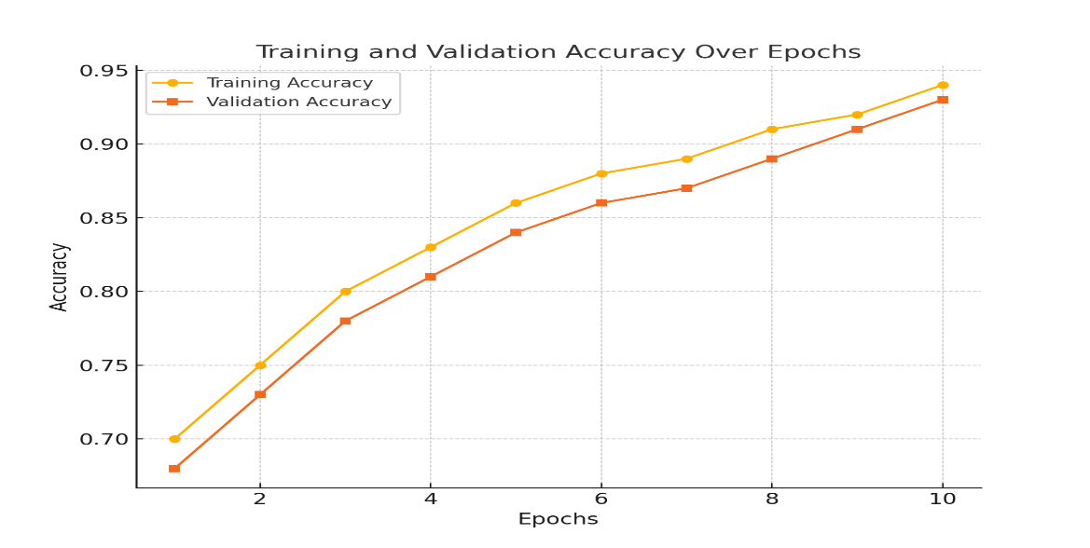

**CHAPTER 5**

**Discussion and Conclusion**

* 1. **Future Work:**

Future efforts could involve exploring advanced techniques like transfer learning to enhance accuracy, expanding the dataset for better generalization, and deploying the model for real-world applications.

* 1. **Conclusion:**

This project effectively demonstrates the utility of convolutional neural networks in image classification. The results highlight the potential of machine learning to automate and optimize visual content analysis, paving the way for innovative applications and further research in the domain.

**REFERENCES**

1. Ming-Hsuan Yang, David J. Kriegman, Narendra Ahuja, “Detecting Faces in Images: A Survey”, IEEE Transactions on Pattern Analysis and Machine Intelligence, Volume. 24, No. 1, 2002.
2. Alex Krizhevsky, Ilya Sutskever, and Geoffrey E. Hinton, "ImageNet Classification with Deep Convolutional Neural Networks," Advances in Neural Information Processing Systems, 2012.
3. Karen Simonyan and Andrew Zisserman, "Very Deep Convolutional Networks for Large-Scale Image Recognition," arXiv preprint arXiv:1409.1556, 2014.