Data Visualization
C=1 was the best choice for all the datasets. Other than that I used all the default parameters since there was no need to change them. C was chosen on the basis of trial and error.

DATA_1
Concetric circles. Data is not linearly seperable so we use polynomial kernel with degree 2 to make the data linearly separable and plot the decision boundary.The data consists of 2 classes.
No of samples of class A = No of samples of class B

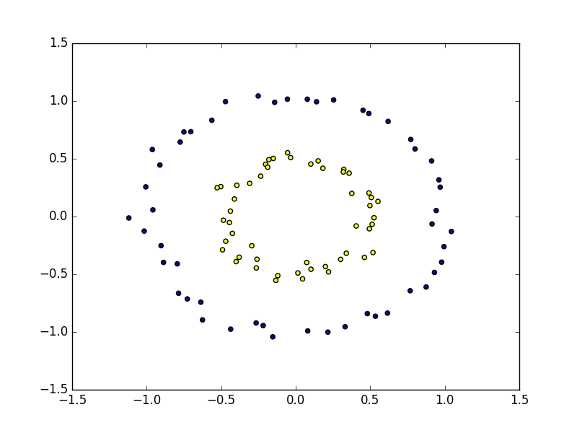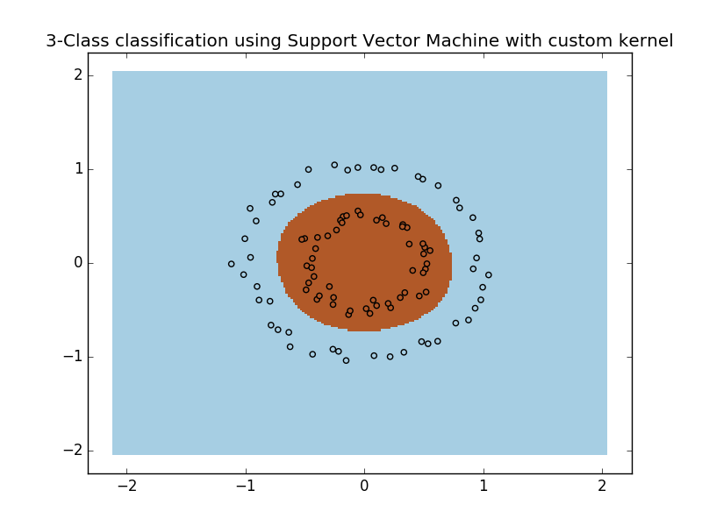

DATA_2
we have c=1 ,The data is not linearly separable and consists of 2 classes .We can use either the rbf kernel or polynomial kernel with degree 3/4 to make the data linearly seperable and plot the decision boundary.
No of samples of classA = no of samples of classB

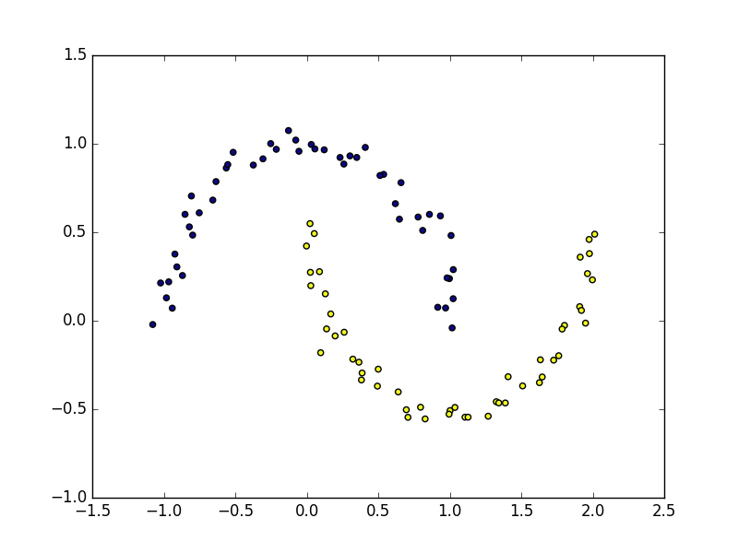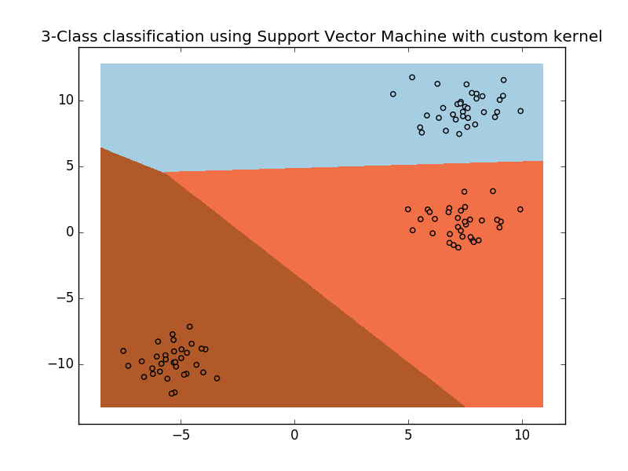

DATA_3
The data consists of 3 classes and is already linearly separable. We use a linear kernel to plot the decision boundary.

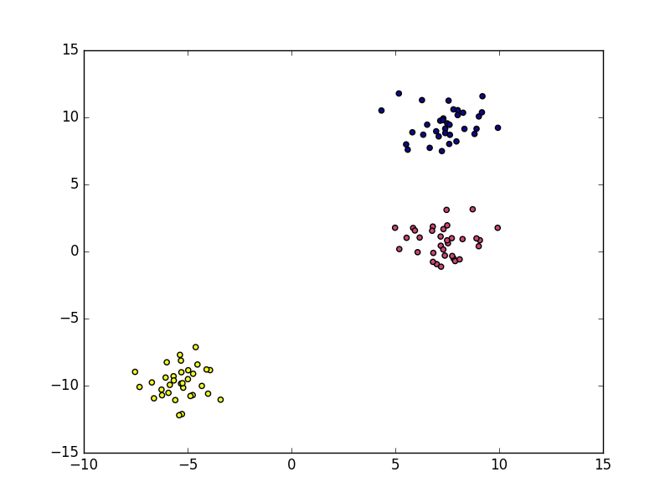

DATA_4
We have circles formed with same centre in this dataset. It consists of 2 different classes that are not linearly seperable and we can either use a polynomial kernel or a gaussian kernel to make the data linearly seperable and plot the decision boundary.

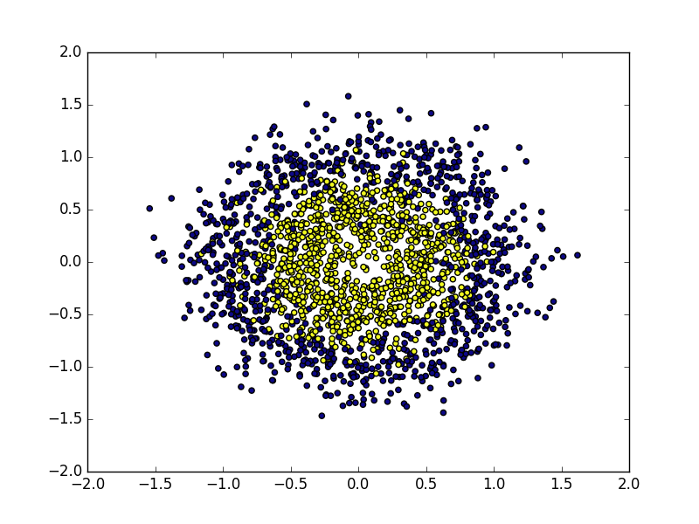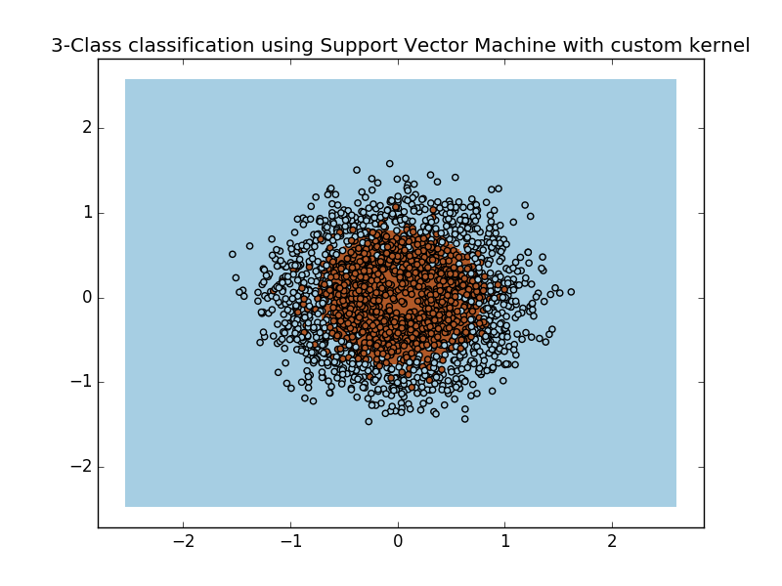

ACCURACY AND F1 SCORES ON EACH DATASET USING LINEAR KERNEL FOR SOFT MARGIN SUPPORT VECTOR MACHINE

 | Accuracy(OVR) | Accuracy(OVO) | F1-score(OVR) | F1-score(OVO)
Data_1 | 0.45 | 0.45 | [0.35294118 0.52173913] | [0.47058824 0.60869565]
Data_2 | 0.75 | 0.8 | [0.72727273 0.89655172] | [0.73684211 0.76190476]
Data_3 | 1.0 | 1.0 | [1. 1. 1.] | [1. 1. 1.]
Data_4 | 0.4925 | 0.485 | [0.48314607 0.58558559] | [0.47428571 0.59111111]

ACCURACY AND F1 SCORES ON EACH DATASET USING RBF KERNEL FOR SOFT MARGIN SUPPORT VECTOR MACHINE

 | Accuracy(OVR) | Accuracy(OVO) | F1-score(OVR) | F1-score(OVO)
Data_1 | 0.4 | 0.55 | [0.33333333 0.45454545] | [0.30769231 0.66666667]
Data_2 | 0.85 | 0.8 | [0.77777778 0.81818182] | [0.94117647 0.95652174]
Data_3 | 0.45 | 0.7 | [0. 0.77777778 1 . ] | [0.875 0.5 1. ]
Data_4 | 0.4825 | 0.5 | [0.50971922 0.3264095 ] | [0.65771812 0. ]

HINDI HANDWRITTEN CHARACTER DATASET
Validation set Accuracy with 21 K-folds = 0.9405940594059405
Training vs Test set Accuracy = 0.9546666666666667

CONFUSION MATRIX FOR DATA_1
[[2 4]
[8 6]]

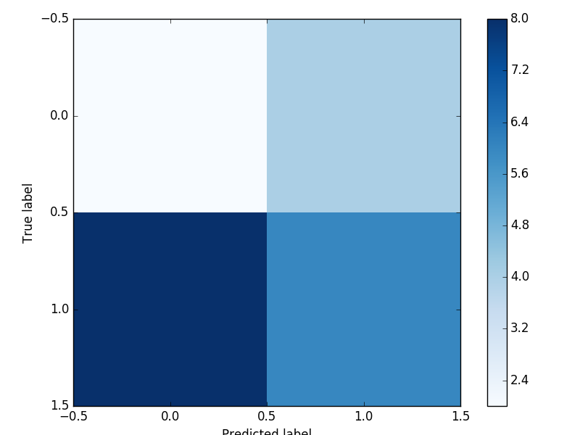

CONFUSION MATRIX FOR DATA_2
[[ 8 0]
[ 1 11]]

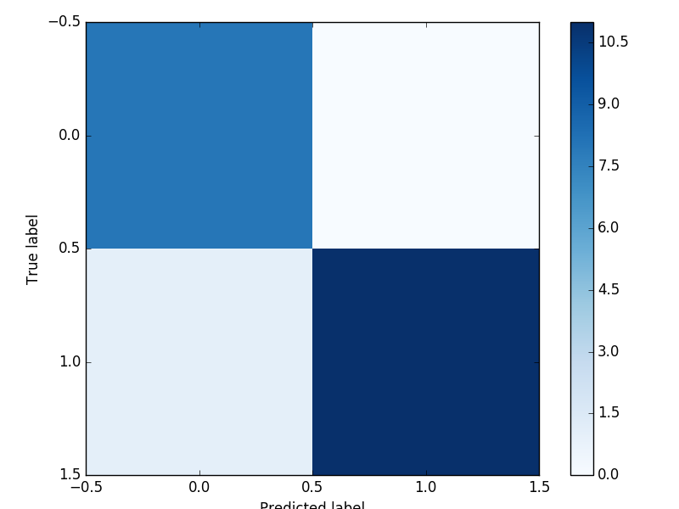

CONFUSION MATRIX FOR DATA_3
[[10 0 0]
[ 0 6 0]
[ 0 0 4]]
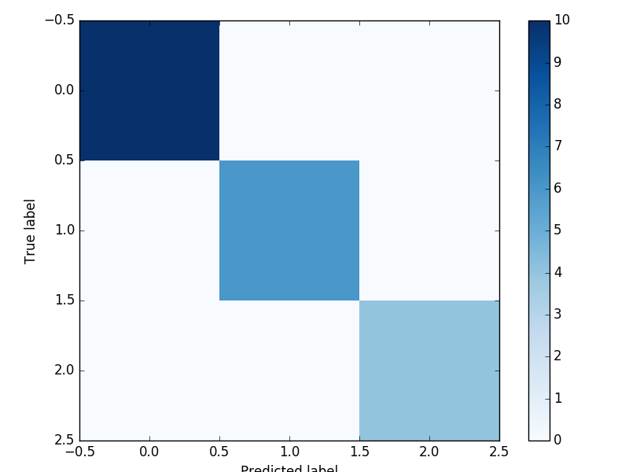

CONFUSION MATRIX FOR DATA_4
[[ 82 76]
[117 125]]
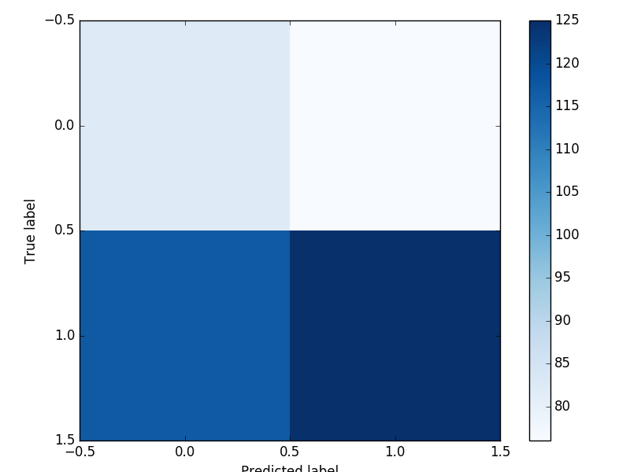

ROC CURVES

X : False +ve rate
Y : True +ve rate

1st plot : data_1
2nd plot : data_2
3rd plot : data_4
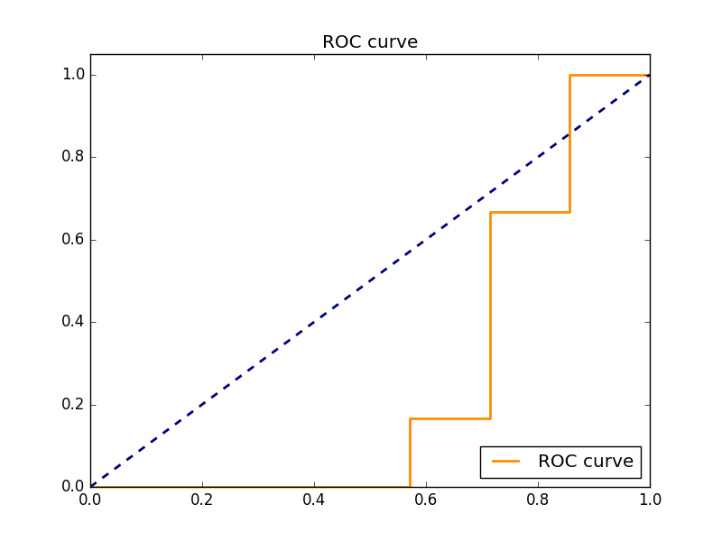

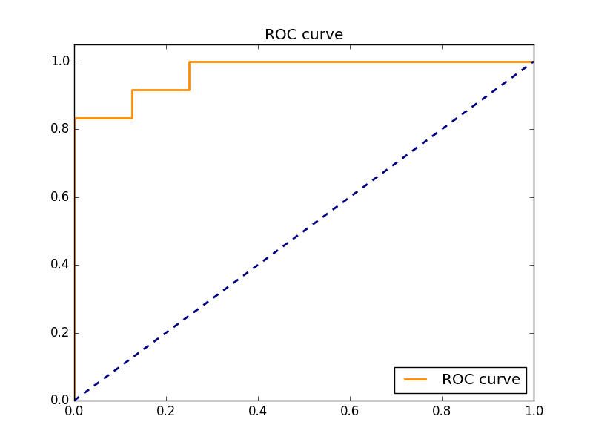

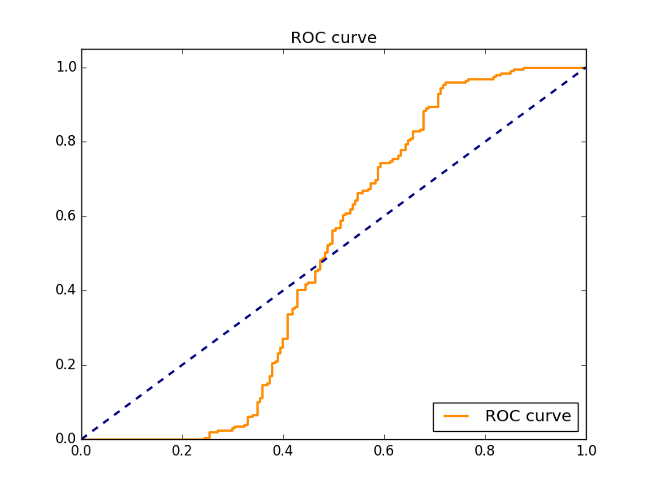
SVM WITH LINEAR KERNEL
data_1
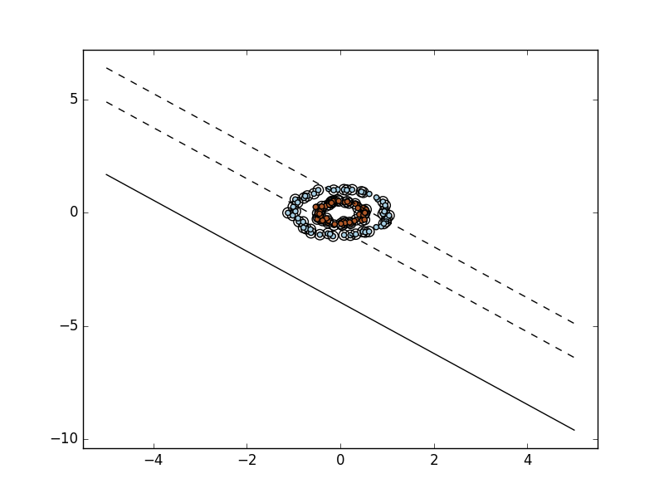

data_2

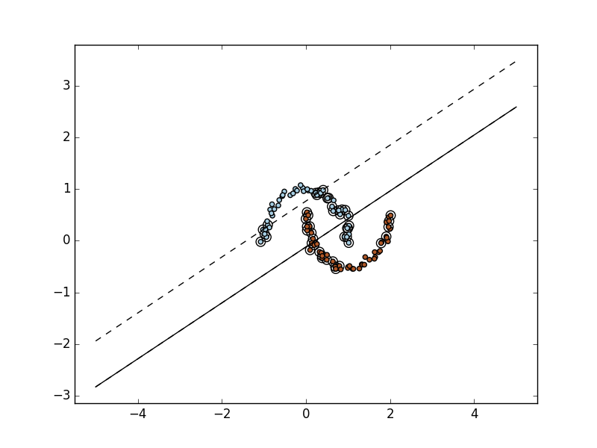

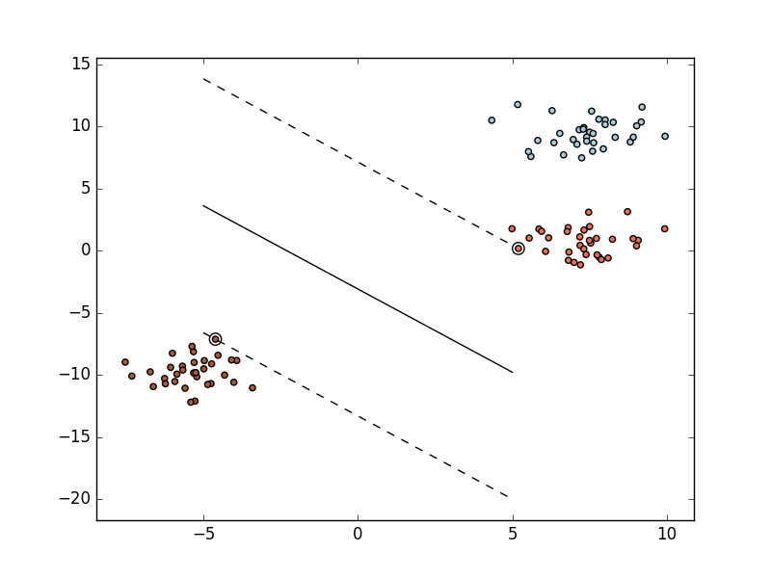
data_3

data_4
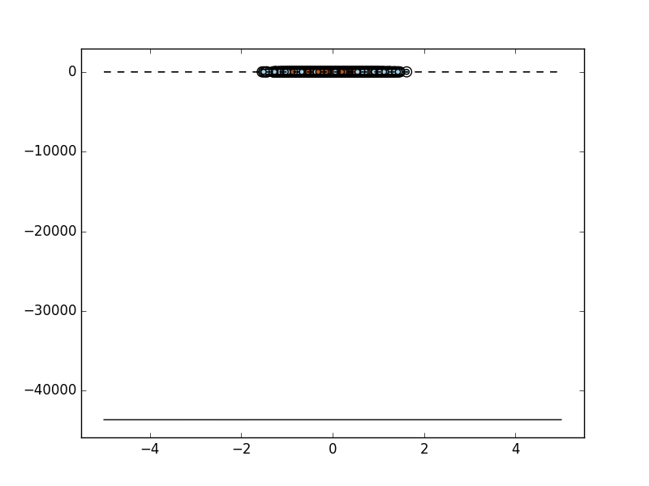

SVM WITH RBF KERNEL

