

COMPLETION CERTIFICATE

Date: 02 May, 2024

This is to certify that the project report titled “**Personally Identifiable Information Analysis**” is the bonafide work of **Mr. Piyush Kumar, PRN: 22030142020**, MSc-CA Batch 2022-2024 at Symbiosis Institute of Computer Studies and Research (SICSR) who carried out the project work under my supervision. He has completed the project during 0**5 Dec 2023** to **02 May 2024**.

Signature: - 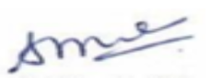

Name of Supervisor: - Shubhashri Waghmare

SICSR, Pune

2