Cita 450 Sprint 2

Status Report Liam Pankow & Will Norton

10/5 Meeting:

Worked on Login form interface and delivery information interface. Later in the week worked on code for the forms.

10/12 Meeting:

Worked on finishing the login form code and testing. Started work on main menu. Finished work on add delivery

10/19 Meeting:

Added Update Form and functionality. Later worked on finishing touches. Also merged the files of the two different branches of the project.

Sprint-2 Backlog

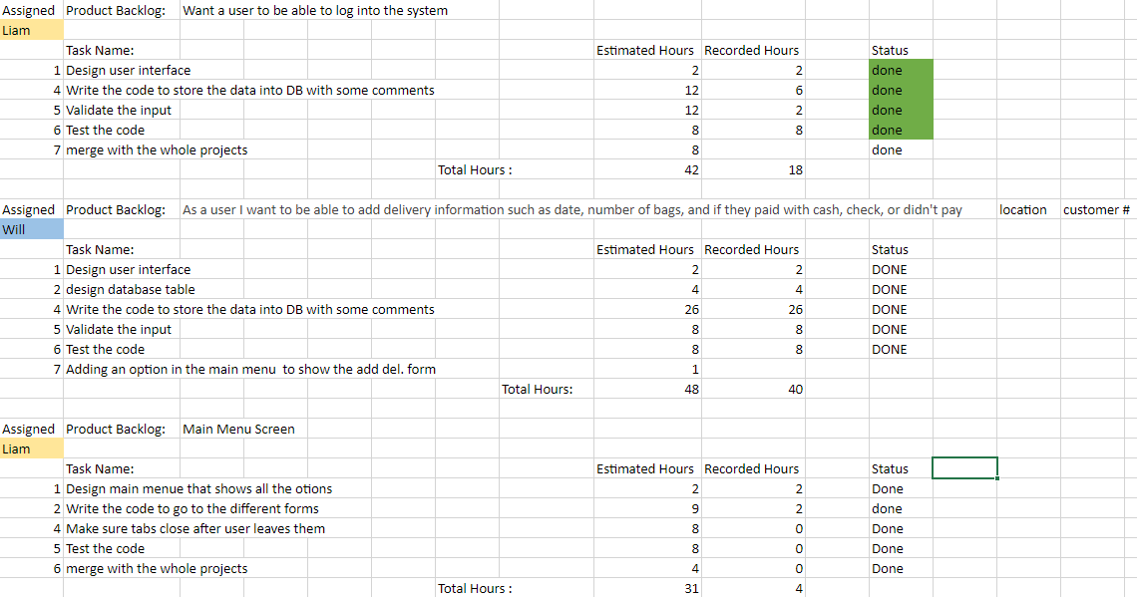

Sprint-2 Burndown Chart





