To use this template, make a copy by selecting FILE / MAKE A COPY to make your own Google Docs file, or FILE / DOWNLOAD to create a word doc if you’d prefer to work offline.

**Project “True sword & lots magic” 1.5-Page GDD**

*Skyrim meets diablo*

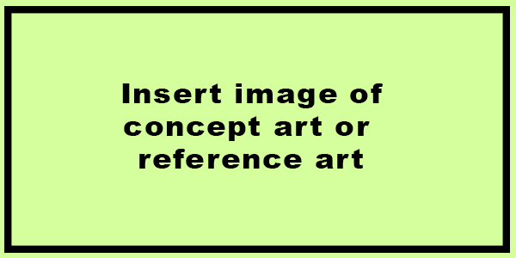

**Genre:** 3rd person action rpg  
**Target Audience:** 18+

**Controls:** mouse + keyboard

**Thematic Setting:** Medieval + fantasy

**Tech Stack:** unity

**Platform(s):** steam

**MVP Game Moment: 2 minutes of simple linear smash’em up**

**Game Summary:**

**Core Player Experience:**

**Central Story Theme:**

**Design Pillar:**

**Remarkability:**

**Anticipated Steam Early Access Launch date:**

**Feature Development Priorities:**

**Reference Games:**