CE706 - Information Retrieval SU 2022
Assigment 1
Student ID

Instructions for running your system
The project demonstrates the capabilities of elastic search engine as a Query tool for reliable search and analysis. The setup involves the following steps:
Assumptions:
- The setup instructions assume user operating system is Linux/Ubuntu.
- The User system is loaded with a Python3 Environment.
- GitHub access to repository

Setup:
- Downloading Elastic search and Kibana using curl commands:
curl -L - O https://artifacts.elastic.co/downloads/elasticsearch/elasticsearch-6.5.1.tar.gz
curl -L -O https://artifacts.elastic.co/downloads/kibana/kibana-6.5.1-linux-x86_64.tar.gz
- Install Jave Runtime Environment:
sudo apt install default-jre
- Run elastic search elasticsearch-6.5.1/bin/elasticsearch -d and Kibana elasticsearch-6.5.1/bin/elasticsearch -d.
- To Check, Kibana GUI should open successfully at http://localhost:5601/
- For Python Elastic Search API installation execute pip install elasticsearch
- Git clone repository :

Indexing
The Signal Media One Million New Article dataset was downloaded after filling a Google Request Form to download the data released by Signal Media on their NewsIR’16 webpage.[Link]. A file ‘sample-1M.jsonl’ is extracted containing the list of articles. Each article object contains following fields:
id: a unique identification number for the article
title: The article Summary
content: Content of the article
source: Publisher details
published: Date of Publication
media-type: The Type of Article : News or Blog
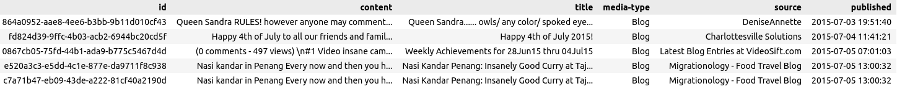
Figure 1: Sample Content of ‘sample-1M.jsonl’
The Articles are majorly of ‘News’ or ‘Blog’ type and published latest in the year of ‘2015’. The publishers of these articles include majorly Reuters and other local news sources. The file contains 1 million multi lingual articles mainly in English. The uncompressed dataset file exceeds 2.5 GB of file and cannot be uploaded to Elastic Search at once. Therefore, I have read the json file using Python and used Python Elastic Search API to post the documents using es.index() method.
Challenges:
- Huge size of dataset hampered the direct methods to upload the document using REST API via curl or Kibana
- The Signal dataset documents in the ‘jsonl’ file did not contain indexes. For Elastic search upload format expect the documents to be tagged with an index.
- The escape sequences and unicode characters disturb the format of an expected JSON file and thus elastic search Bulk API method threw Syntax errors.
To overcome the challenges, Python library to read JSON was used and Elastic Search API es.index() method was used to post documents iteratively.
Improvements:
An improved way to push data in Elastic search would be to involve FileBeat which parses and import data in near real time or Logstash which can push data into Elastic Search from many machines.

Indexing and Mapping:
The elastic search implicitly does the field mapping after understanding the nature of fields, however, I have created the mappings explicitly according to the type of fields as shown in figure. As the default mappings for all the fields were mapped to ‘text’, I have explicitly mapped the ‘published’ field to ‘Date’. The fields id, content and source are mapped to text, and title and content to text.

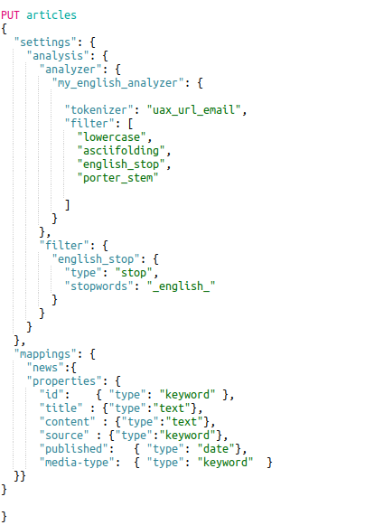

Figure 2 : Mapping
﻿Tokenization and Normalisation
Tokenization is breaking a stream of characters into individual tokens usually words. ElasticSearch offer a number of built in tokenizers like standard, Letter, whitespace etc. The builtin tokenizers can be used to create custom analyzers. Additinaly the tokenizer records the position of each term, start and end character offsets and token type to identify the term produced as Alphanum, Num etc. I have a custom analyzer to implement ‘Standard’ Tokenizer which was able to divide terms on word boundaries and remove punctuations. For reference, Figure 3. show a sample of Tokenization, where the terms are generated successfully with word boundaries. The special characters were ignored successfully and punctuations are removed.
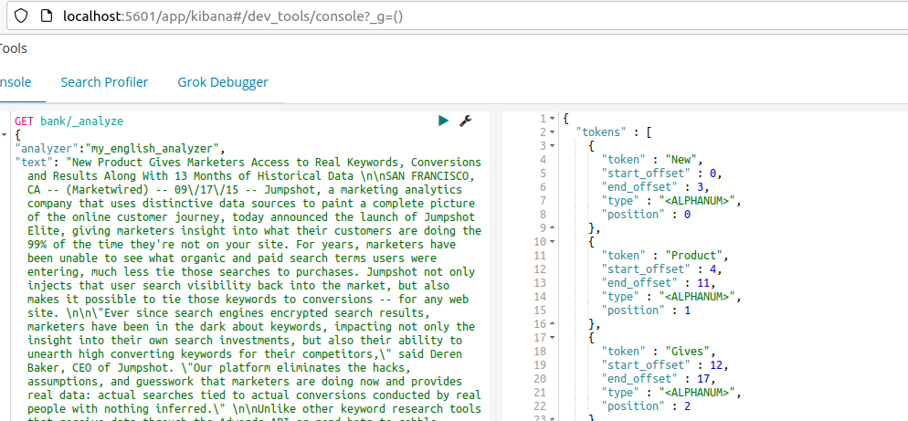
Figure 3. ‘Standard’ Tokenization

However, Standard Tokenizer is not smart enough to handle email, Url and Timestamps as shown in Figure 4 The terms of the email are separated incorrectly.
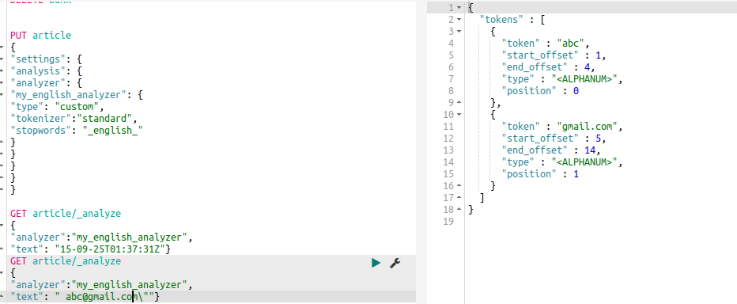
Figure 4: Tokenization Challenges

I have used uax_url_email tokenizer which is similar to standard tokenizer except that it can recognise URLs and email as single tokens.
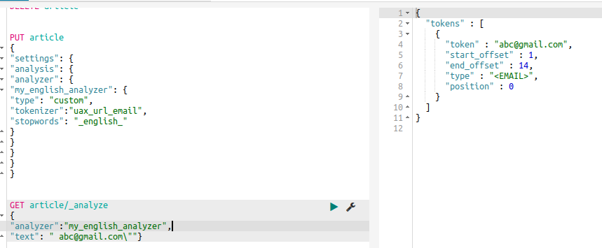
Figure 5: uax_url_email Tokenizer

I have applied case folding using token filters to convert the words into lowercase. The case folding helps in reducing the vocabulary size by reducing the difference in same words and different case.
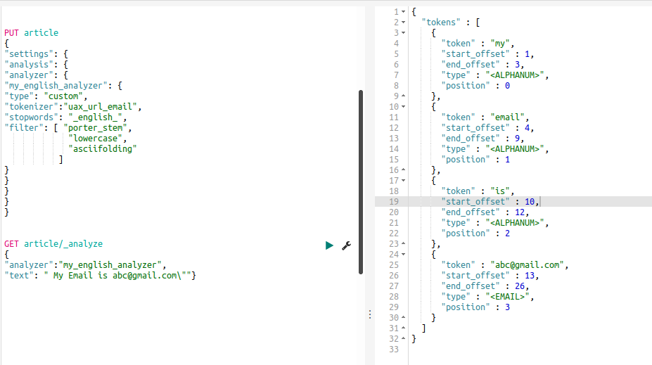
Figure 6 : Case Folding

For Normalization I have used ASCII Folding which converts the alphabetic, numeric, and symbolic characters into their ASCII equivalent.

Selecting Keywords
Elastic search provides removal of Stop words using a ‘Stop token filter’. I have added a stop word filter to my customized analyzer to remove stop words of English. The stop words do not add much information to the sentence and it is a good practice to remove the stop words to reduce the vocabulary size and improve search performance. Figure 7 shows the English stop word list which will be removed by the analyzer as shown in Figure 8.

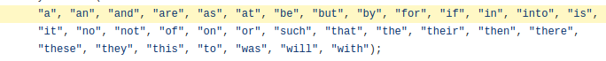

Figure 7: English Stop Word List

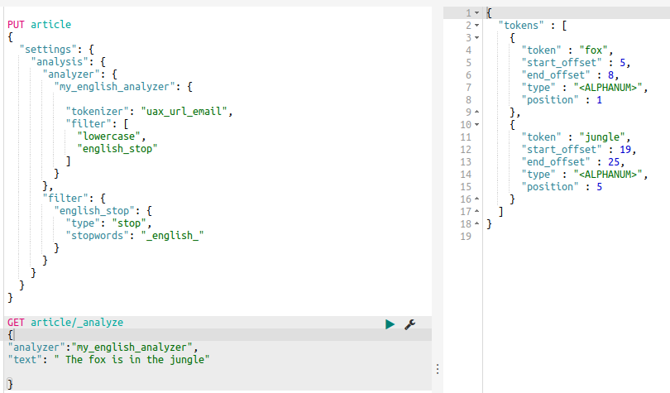
Figure 8: Stop Word Removal

The boolean model in Elastic Search is similar to a binary search and excludes the documents which do not qualify and does not care about relevancy. For improving relevancy of our search results we can combine TF/IDF and Boolean model to rank the documents. The Vector space model is used to compare multi term queries in a document by calculating a similarity score per field on vectors, Term Frequency i.e. How often a term appears in a document and Inverse Document Frequency i.e. How often a term appears in an index. I have used the ‘Scripted’ Similarity to apply the TF-IDF for selection and weighting step.

Stemming or Morphological Analysis
Stemming can be explained as reducing a word to its root form. This allows the search of variants of a root word. The scope of the search is not limited to a specific word and can be matched to its variants as well. For instance, root word for running and run can be stemmed to same root word: run. I have used algorithmic stemmers as they require less memory and setup to achieve good results. They are also fast in execution in comparison to dictionary stemmers. I have used porter_stemmer which is a recommended stemmer for English language. Since it requires lowercased words to work properly, I have first added the lowercase and then the stemmer in my custom analyzer.
PUT article
{ "settings": { "analysis": {
"analyzer": {
"my_english_analyzer": {
"tokenizer": "uax_url_email",
"filter": [ "lowercase", "english_stop", "porter_stem"]}},
"filter": {"english_stop": { "type": "stop", "stopwords": "_english_"}}}
}
}
I have added a screenshot of sample data from our dataset and highlighted a stemmed example.
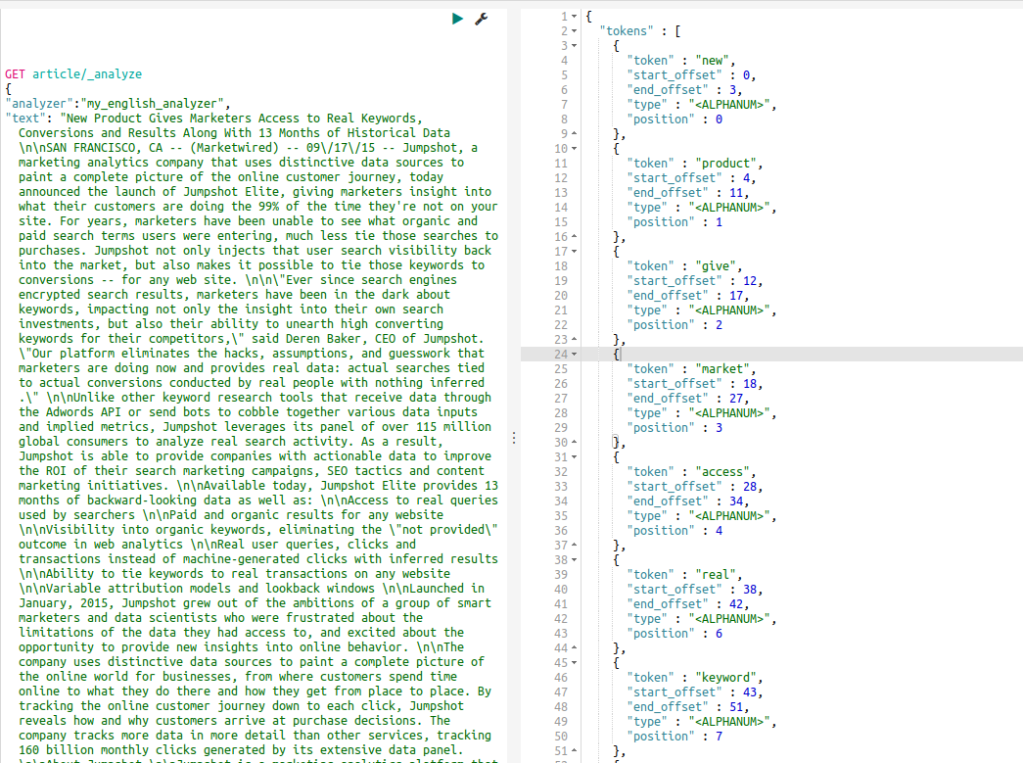
Figure 8: Porter Stemming

Searching
Query 1:

Query 2:

Query 3:

Challenge:
It was difficult to identify non English documents in the huge dataset. The Text preprocessing steps like tokenization, stop word removal are done majorly considering ‘English’ as main language.
Improvements:
Using NLTK library language detection model the language of the articles can be detected and text pre processing steps can be configured accordingly.

