**CHAROTAR UNIVERSITY OF SCIENCE &TECHNOLOGY CHANDUBHAI S. PATEL INSTITUTE OF TECHNOLOGY DEVANG PATEL INSTITUTE OF ADVANCE TECHNOLOGY AND RESEARCH U & P.U. Patel Department of Computer Engineering F.Y. B.Tech (CE/IT/EC/CSE)**

Subject Name: Object Oriented Programming with C++

Semester: II

Subject Code: CE142

Academic year: 2017-18

1. Write a C++ program that will output this passage by Deepak Chopra. Make sure your output looks exactly as shown here (including spacing, line breaks, punctuation, and the title and author). **Use cout and cin objects and endl manipulator**.

“You alone are the judge of your worth

and your goal is to discover infinite

worth in yourself, no matter what

anyone else thinks.” by Deepak Chopra

**To include a quotation mark in your output, try this: \"**

**Program:-**

//Output any message on screen

#include<iostream>

using namespace std;

int main()

{

cout<<"\t \"You alone are the judge of your worth"<<endl;

cout<<"\t and your goal is to discover infinite" <<endl;

cout<<"\t worth in yourself,no matter what"<<endl;

cout<<"\t anyone else thinks.\" by Deepak Chopra";

cout<<”PANKTI SHAH”<<endl<<”17EC078”<<endl;

return 0;

}

**Output:-**

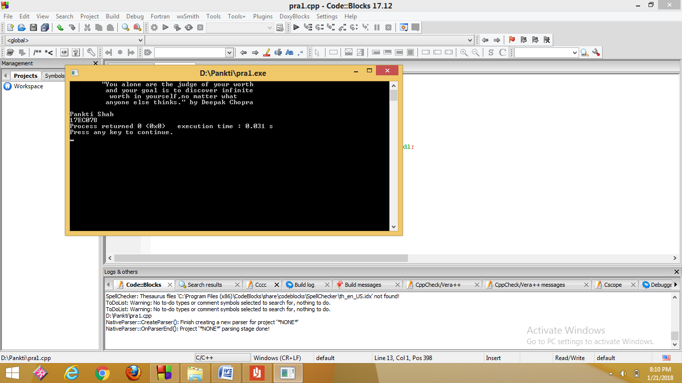

2. Write a program to create the following table. **Use endl and setw manipulator**.

1 2 3 4

2 4 6 8

3 6 9 12

4 8 12 16

**Program:-**

//Program to create table

#include<iostream>

#include<iomanip>

using namespace std;

int main()

{

int i;

for(i=1;i<=4;i++)

{

cout<<left;

cout<<setw(4)<<i*1<<setw(4)<<i*2<<setw(4)<<i*3<<setw(4)<<i*4<<endl;

}

cout<<"PANKTI SHAH"<<endl<<"17EC078"<<endl;

return 0;

}

**Output:-**

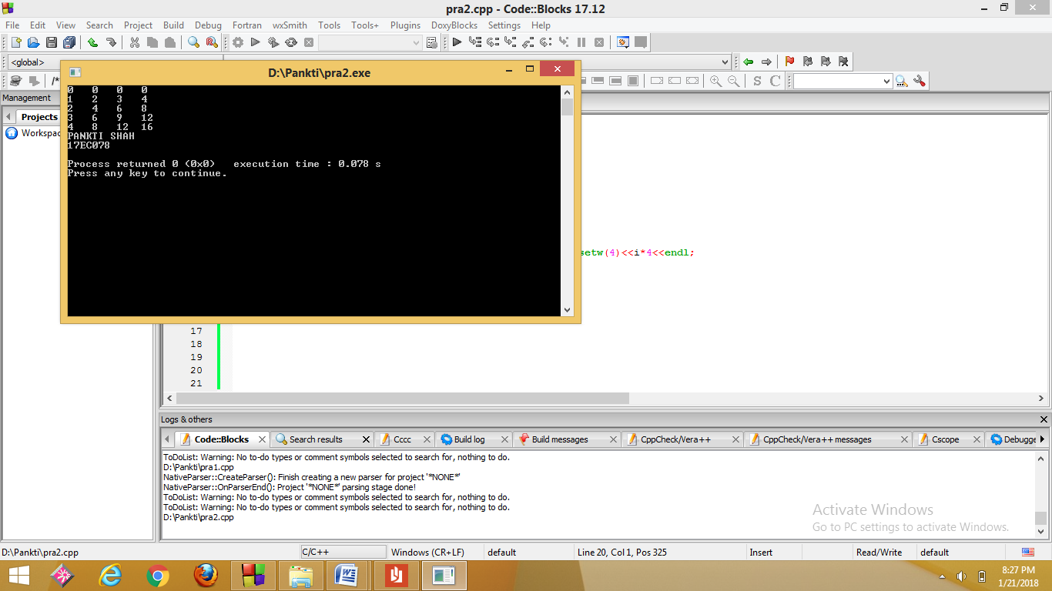

3. Write a C++ program to add two floating numbers using pointer. The result should contain only two digits after the decimal. **Use fixed, scientific and setprecision () manipulators for controlling the precision of floating point numbers.**

**Program:-**

//Program to find setprecision value or fixed value or scientific value

#include<iostream>

#include<iomanip>

using namespace std;

int main()

{

float a,b,*p,*q,ans;

cout<<"Enter the value of a:"<<endl;

cin>>a;

cout<<"Enter the value of b:"<<endl;

cin>>b;

p=&a;

q=&b;

ans=*p+*q;

cout<<setprecision(2)<<"Answer of setprecision is:"<<ans<<endl;

cout<<fixed<<"Answer of fixed is:"<<ans<<endl;

cout<<scientific<<"Answer of scientific is:"<<ans<<endl;

cout<<"PANKTI SHAH"<<endl<<"17EC078"<<endl;

return 0;

}

**Output:-**

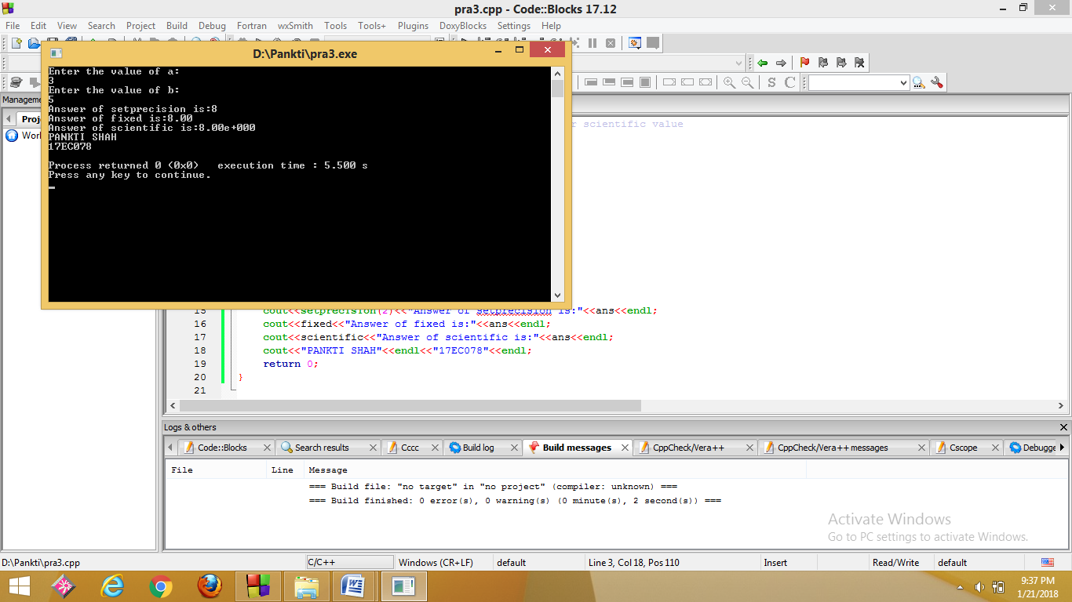

4. Find error in the following code and give reasons for each error: Can we declare an array of references? Can we assign NULL value to reference variable? Is **Reference variable** a pointer variable? Can we declare a reference variable without initializing it?

#include<iostream>

using namespace std;

int main()

{

int a =10, b=12;

int & r;

int & c = NULL;

int & d[2] = {a,b};

cout<<"r = "<< r;

return 0;

}

**Program:-**

//Error finding

#include<iostream>

using namespace std;

int main()

{

int a=10,b=12;

int &r=a;

//int &c=NULL;

//int &d[2]=(a,b);

cout<<"r ="<<r<<endl<<endl;

cout<<"PANKTI SHAH"<<endl<<"17EC078"<<endl;

return 0;

}

**Output:-**

Ans: We have errors in the given pogram in 7th,8th and 9th lines so to correct the errors we have made 7th line

int&r=a;

and we have made 8th and 9th lines as comments.

* No, we cannot declare array of references.
* No,we cannot assign null value to reference variable.
* No, reference variable is not a pointer variable.
* No, we cannot declare a variable without initializing it.

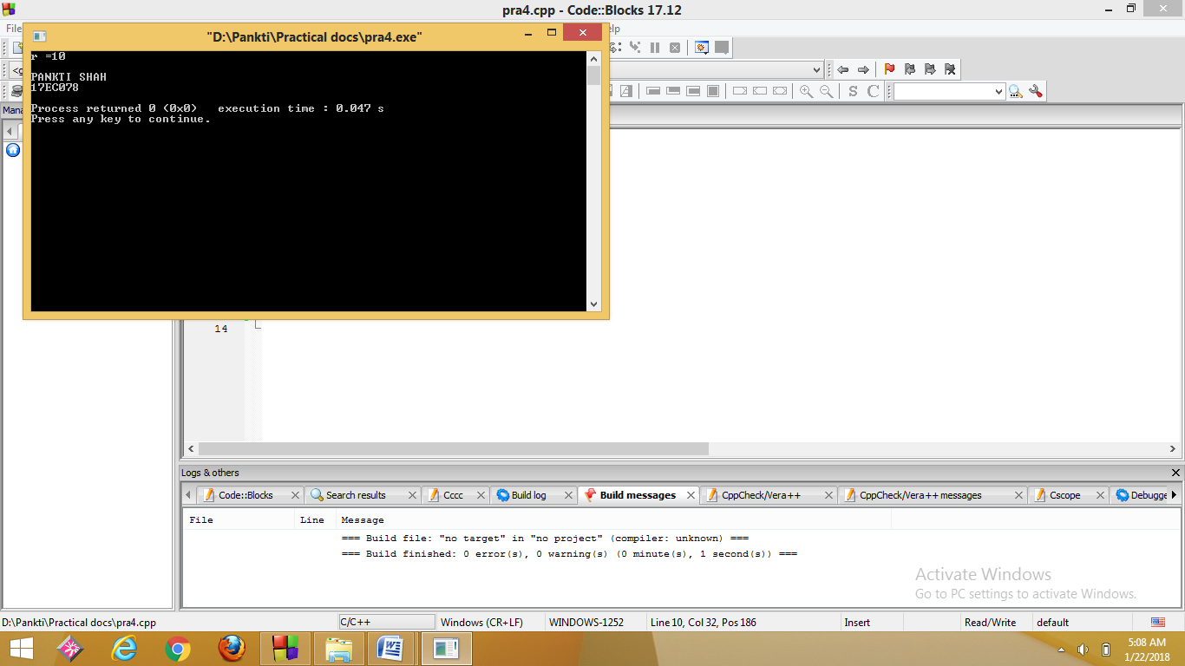

5. Find output of the following code: Explain how scope Resolution operator is used to access global version of a variable.

#include<iostream.h>

#include<conio.h>

int m=30;

int main()

{

int m=20;

{

int m=10;

cout<<”we are in inner block”<<endl;

cout<<”value of m=”<<m<<”\n”;

cout<<”value of ::m=”<<::m<<”\n”;

}

cout<<”we are in outer block”<<endl;

cout<<”value of m=”<<m<<”\n”;

cout<<”value of ::m=”<<::m<<”\n”;

getch();

return 0;

}

**Program:-**

//Find Output

#include<iostream>

using namespace std;

int m=30;

int main()

{

int m=20;

{

int m=10;

cout<<"We are in inner block"<<endl;

cout<<"Value of m="<<m<<endl;

cout<<"Value of ::m="<<::m<<endl;

}

cout<<"We are in outer block"<<endl;

cout<<"Value of m="<<m<<endl;

cout<<"Value of ::m="<<::m<<endl<<endl;

cout<<"PANKTI SHAH"<<endl<<"17EC078"<<endl;

return 0;

}

**Output:-**

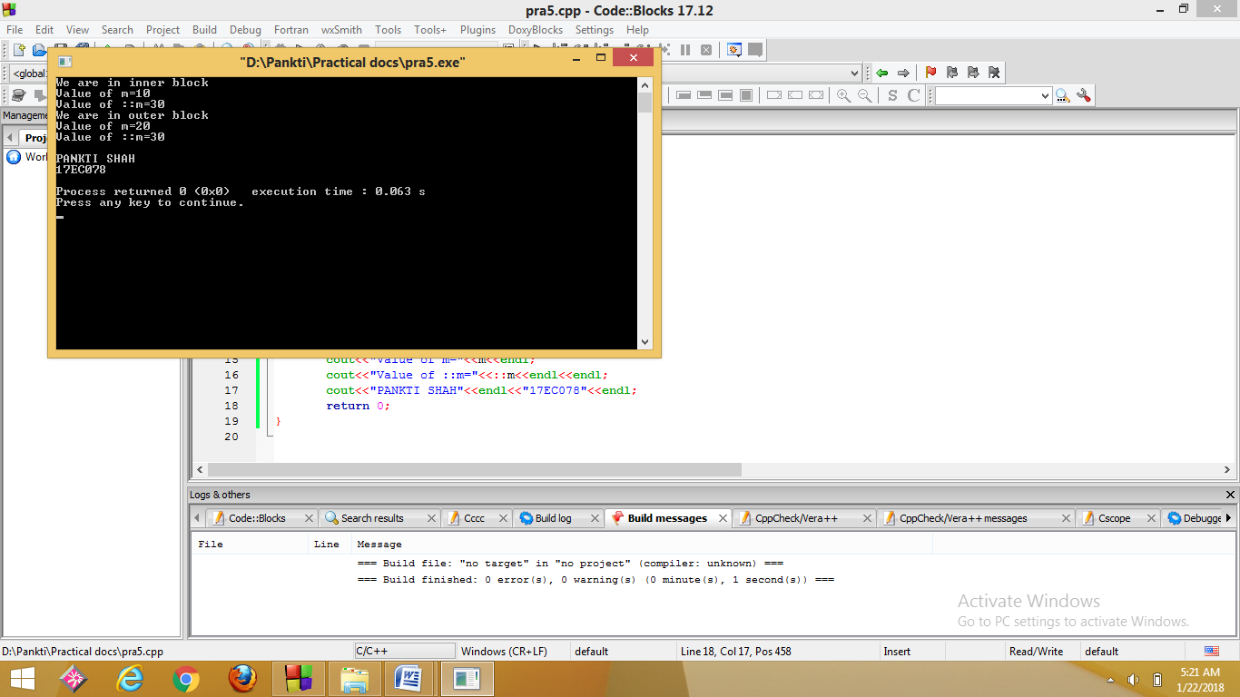

**6. Find Error in the following code of a program and give explanation why these errors exist.**

|  |
| --- |
| **1. //This is an example of constant pointer** |

**#include<iostream>**

**using namespace std;**

**int main()**

**{**

**int var1=35,var2=20;**

**int *constptr=&var1;**

**ptr=&var2;**

**cout<<"Var1="<<*ptr;**

**return 0;**

**}**

**Program:-**

//Error finding

#include<iostream>

using namespace std;

int main()

{

int var1=35,var2=20;

int *constptr=&var1;

//ptr=&var2;

cout<<"Var1="<<*ptr;

return 0;

}

**Output:-**

Here, in 8th line again pointer is assigned a different value so that is an error.

So, that line is made a comment .

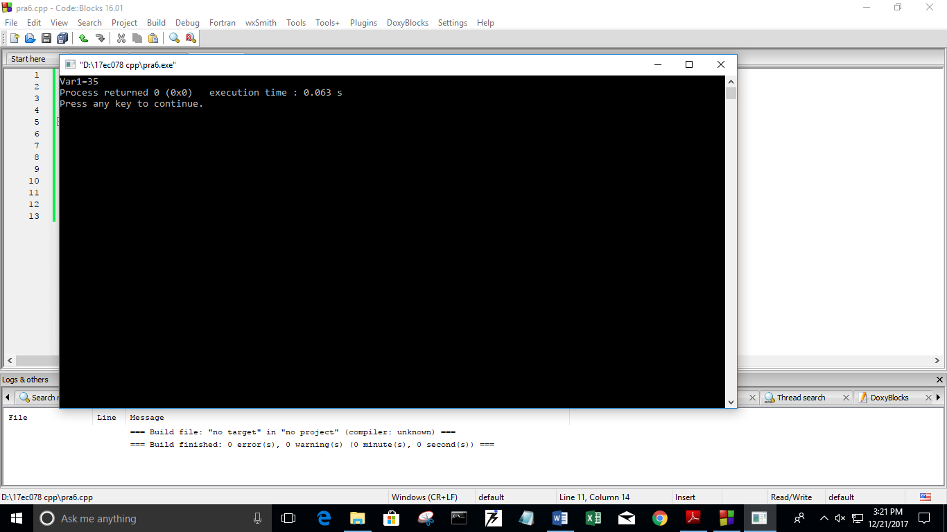

**2. //This is an example of pointer to constant.**

**#include<iostream>**

**using namespace std;**

**int main()**

**{**

**int var1=43;**

**constint* ptr=&var1;**

**\*ptr=1;**

**var1=34;**

**cout<<"Var1="<<*ptr;**

**return 0;**

**}**

**Program:-**

//Error finding

#include<iostream>

using namespace std;

int main()

{

int var1=43;

constint* ptr=&var1;

// *ptr=1;

var1=34;

cout<<"Var1="<<*ptr;

return 0;

}

**Output:-**

Here ,in given program there is error in the 8th line.

So,in order to remove error we made it a comment.

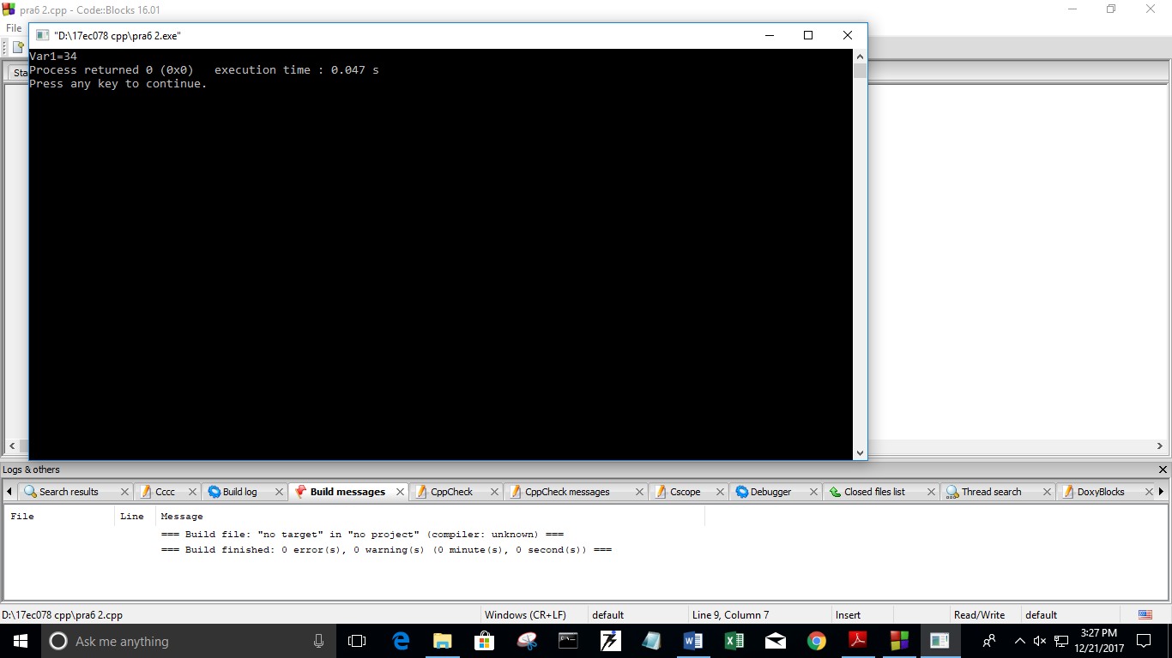

**3. //This is an example of constant pointer to a constant.**

**#include <iostream>**

**using namespace std;**

**int main()**

**{**

**int var1 = 0,var2 = 0;**

**constint* constptr = &var1;**

**\*ptr = 1;**

**ptr = &var2;**

**cout<<"Var1 = "<<*ptr;**

**return 0;**

**}**

**Program:-**

#include <iostream>

using namespace std;

int main()

{

int var1 = 0,var2 = 0;

constint* constptr = &var1;

//*ptr = 1;

//ptr = &var2;

cout<<"Var1 = "<<*ptr;

return 0;

}

**Output:-**

Here ,in given program there are errors in the 8th and 9thline.

So,in order to remove error we made it a comment.

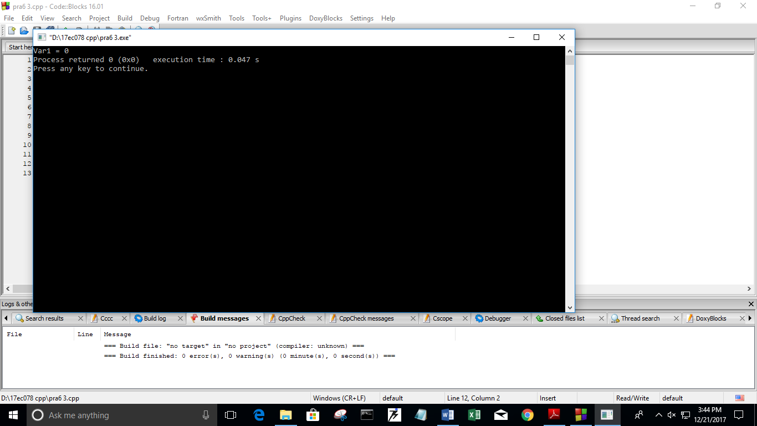

7. Write a program to enter a size of array. Create an array of size given by user using “new” Dynamic memory management operator (free store operator). Enter the data to store in array and display the data after adding 2 to each element in the array. Delete the array by using “delete” memory management operator.

**Program:-**

//Program to enter a size of array

#include<iostream>

using namespace std;

int main()

{

int sizeofarray,i,a[i];

cin>>sizeofarray;

cout<<"Enter size of array:"<<endl;

int *arrptr=new int{sizeofarray};

if(!arrptr)

{

cout<<"Memory is not allocated"<<endl;

}

for(i=0;i<10;i++)

{

a[i]=a[i+2];

}

delete[]arrptr;

cout<<"PANKTI SHAH"<<endl<<"17EC078"<<endl;

return 0;

}

**Output:-**

8. Find the output of following program. Explain the use of bool data type.

#include<iostream>

using namespace std;

int main()

{

bool a = 321, b;

cout << "Bool a Contains : " << a<<endl;

int c = true;

int d = false;

cout<<"c = "<<c <<endl<<"d = "<<d;

c = a + a;

cout << "\nInteger c contain : " << c;

b = c + a;

cout << "\nBool b contain : " <<b;

return 0;

}

**Program:-**

//Find output of the program

#include<iostream>

using namespace std;

int main()

{

bool a=321,b;

cout<<"Bool a contains:"<<a<<endl;

int c=true;

int d=false;

cout<<"c="<<c<<endl<<"d="<<d<<endl;

c=a+a;

cout<<"\nInteger c contain:-"<<c<<endl;

b=c+a;

cout<<"\nBool b contains:"<<b<<endl<<endl;

cout<<"PANKTI SHAH"<<endl<<"17EC078"<<endl;

return 0;

}

**Output:-**

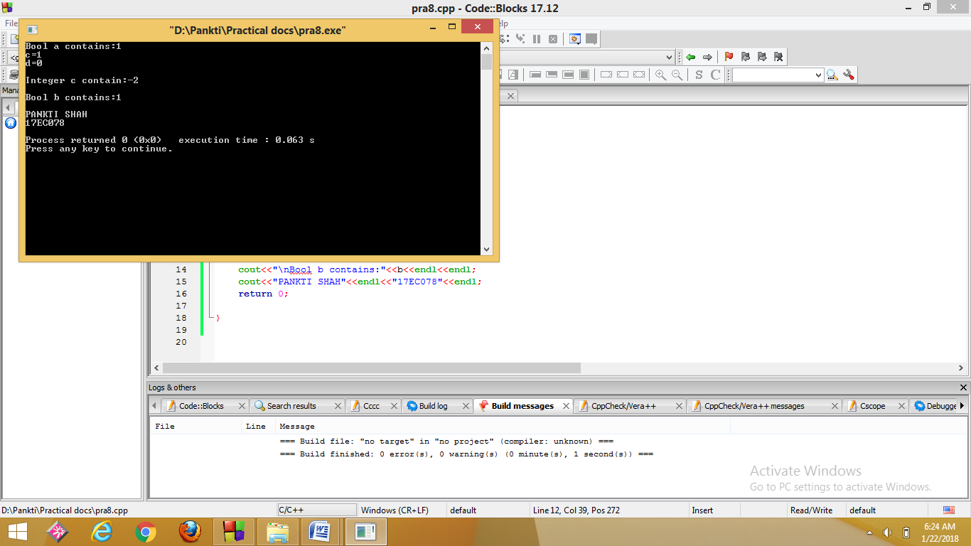

9. Define three functions named convert (). First function takes rupees as an input argument and converts into paisa, second function takes meter as an input argument and converts into centimeter and last function takes character as an input argument and converts entered small character into capital. Here, rupee is in integer and meter is in float.Use concept of Function Overloading. Function overloading is also known as Compile Time Polymorphism or static binding.

**Program:-**

//Program using the concept of function overloading

#include<iostream>

using namespace std;

void convert(double rupees)

{

double paisa;

paisa=rupees*100;

cout<<"Value of paisa after conversion from rupees:"<<paisa<<endl;

}

void convert(int meter)

{

int cm;

cm=meter*100;

cout<<"Value of cm after conversion from meter:"<<cm<<endl;

}

void convert(char c )

{

char a;

a=toupper(c);

cout<<"Value of a after conversion to upper :"<<a<<endl;

}

int main()

{

double rupees;

int meter;

char c;

cout<<"Enter value of rupees:"<<endl;

cin>>rupees;

convert(rupees);

cout<<"Enter value of meter:"<<endl;

cin>>meter;

convert(meter);

cout<<"Enter a character:"<<endl;

cin>>c;

convert(c);

cout<<"PANKTI SHAH"<<endl<<"17EC078"<<endl;

return 0;

}

**Output:-**

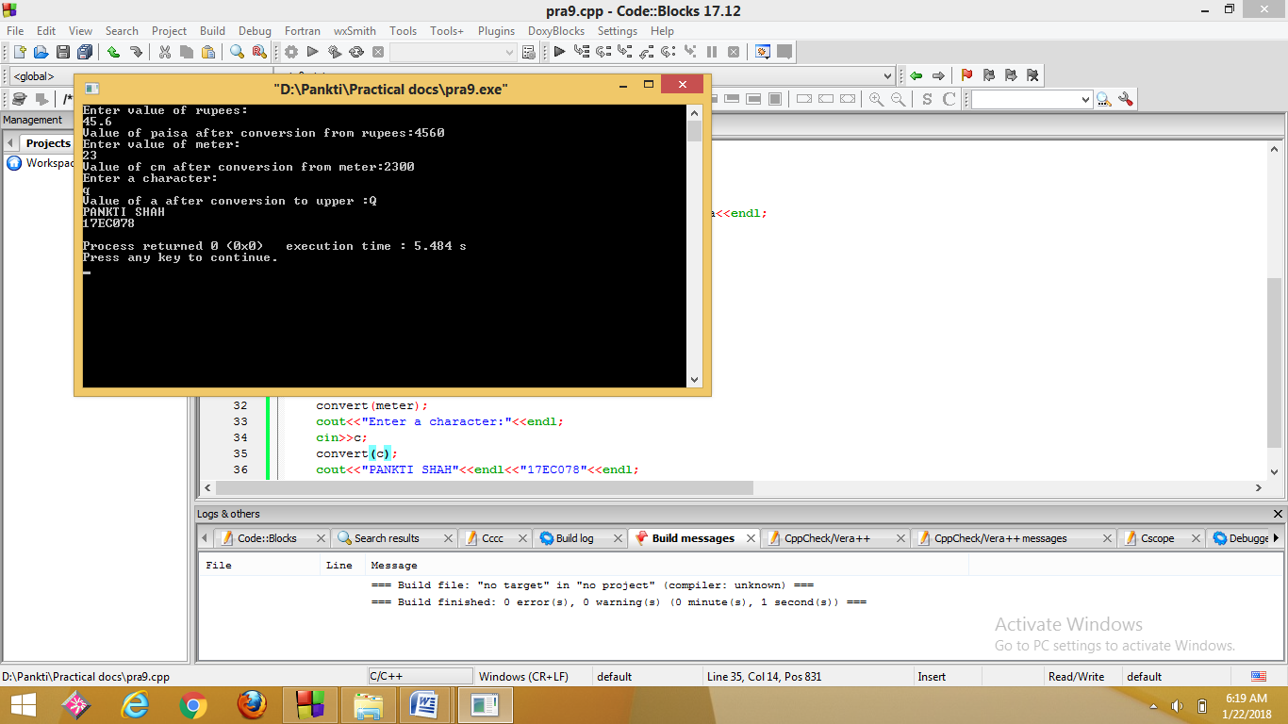

10.Define four function void swap () which accepts two arguments by reference and swap the values. First function swaps two characters, second function swaps two integers, third function swaps two floats values and fourth function swaps two double values. Use the concept of call by reference in all four functions and function overloading and inline function.

**Program:-**

//Program using the concept of call by reference in all four functions and function overloading

#include<iostream>

using namespace std;

inline void swap(char &a,char &b)

{

char c;

c=a;

a=b;

b=c;

cout<<a<<endl<<b<<endl;

}

inline void swap(int &t,int &u)

{

int r;

r=t;

t=u;

u=r;

cout<<t<<endl<<u<<endl;

}

inline void swap(float &x,float &y)

{

float z;

z=x;

x=y;

y=z;

cout<<x<<endl<<y<<endl;

}

inline void swap(double &n,double &m)

{

double o;

o=n;

n=m;

m=o;

cout<<n<<endl<<m<<endl;

}

int main()

{ char a,b;

cout<<"Enter a character:"<<endl;

cin>>a>>b;

swap(a,b);

int t,u;

cout<<"Enter a integer:"<<endl;

cin>>t>>u;

swap(t,u);

float x,y;

cout<<"Enter a float value:"<<endl;

cin>>x>>y;

swap(x,y);

double n,m;

cout<<"Enter a double value:"<<endl;

cin>>n>>m;

swap(n,m);

cout<<endl<<"PANKTI SHAH"<<endl<<"17EC078"<<endl;

return 0;

}

**Output:-**

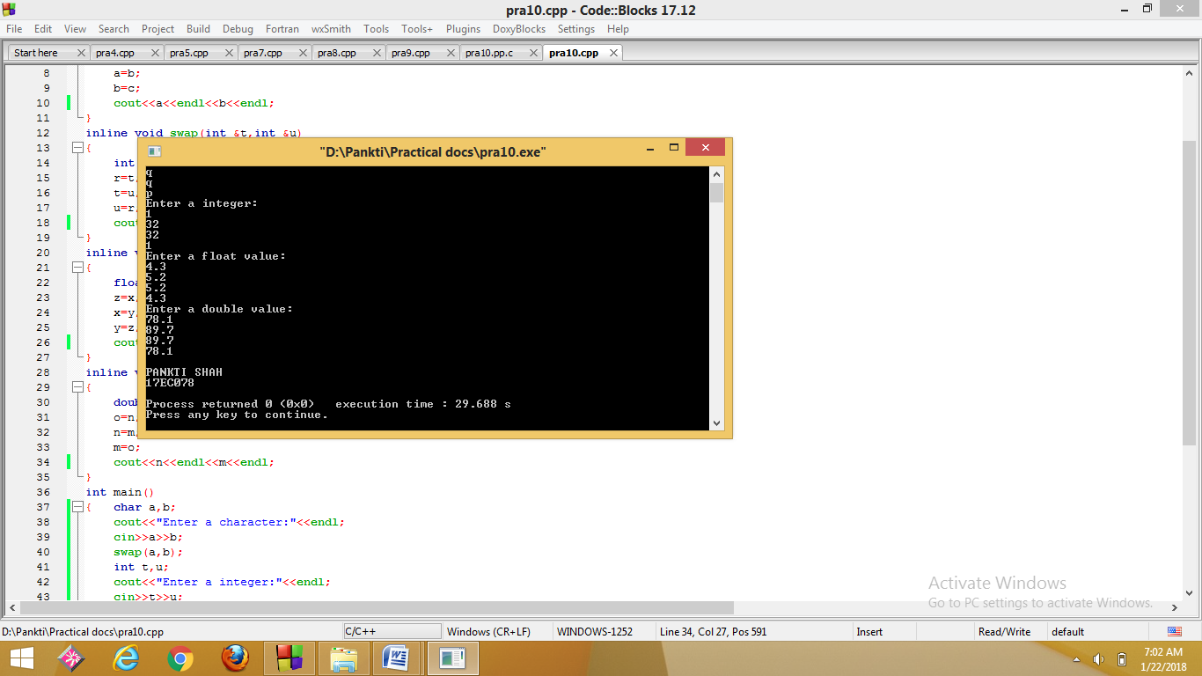

11.Declare an array of 5 double elements and assign some values to it. Create a function setvalue( ) which takes the index of the array as an input and Returns by Reference double value and change the value of the array element stored in that index.

For eg: double arr[] = {23.71, 45.6, 88.1, 19.1, 54.7}.

A function call such as setvalue (2) = 70.23 will result in the following array

double arr[] = {23.71, 45.6, 70.23, 19.1, 54.7} . (Hint: Declare array as a global variable).

**Program:-**

//Program by using reference function

#include<iostream>

using namespace std;

double array[]={23.714,45.6,88.1,19.31,54.7};

double &setvalue(int n)

{

return array[n];

}

int main()

{

int index;

double value;

cout<<"Enter index of array:"<<endl;

cin>>index;

cout<<"Enter value:"<<endl;

cin>>value;

cout<<"Value before change:"<<value<<endl;

for(int i=0;i<5;i++)

{

cout<<array[i]<<" ";

}

cout<<endl;

setvalue(index)=value;

cout<<"Value after change:"<<endl;

for(int i=0;i<5;i++)

{

cout<<array[i]<<" ";

}

cout<<endl<<endl<<"PANKTI SHAH"<<endl<<"17EC078"<<endl;

return 0;

}

**Output:-**

