**AIM:**

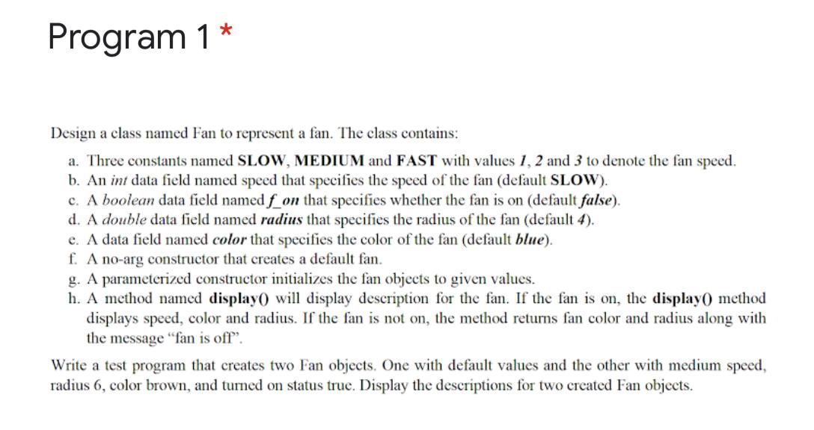

**CODE:**

**package** pracexam;

**public** **class** Fan {

**public** **static** **final** **int** ***SLOW***=1,***MEDIUM***=2,***FAST***=3;

**int** speed;

**boolean** f_on;

**double** radius;

String color;

Fan(){

speed=***SLOW***;

f_on= **false**;

radius=4;

color="Blue";

}

Fan(**int** x, **int** y, String c,**boolean** d)

{

**this**.speed =x;

**this**.radius=y;

**this**.color=c;

**this**.f_on=d;

}

**void** display()

{

**if**(f_on==**true**)

{

System.***out***.println("Speed of the Fan is :" + speed);

System.***out***.println("Color of the fan is :" + color);

System.***out***.println("Radius of the fan is:" + radius);

System.***out***.println("Fan is on.");

}

**else**

{

System.***out***.println("Color of the fan is :" + color);

System.***out***.println("Radius of the fan is:" + radius);

System.***out***.println("Fan is off");

}

}

**public** **static** **void** main(String args[])

{

Fan f1 = **new** Fan();

Fan f2 = **new** Fan(2, 6 ,"Brown", **true**);

f1.display();

f2.display();

}

}

**OUTPUT:**