**Practical No:** 01

**AIM:** Write a program to display two messages in separate lines.

**Input**

Alexendria Outwaithe

Pankti Shah

**Output**

Alexendria

Outwaithe

Pankti

Shah

1. **Solution**

**Solution.java**

**import** java.util.Scanner ;

**class** Namestring {

**public** **static** **void** main(String[] args) {

System.***out***.print("Alexendria"+ "\n" + "Outwaithe");

//With Scanner class

Scanner var= **new** Scanner(System.***in***);

System.***out***.println("\nEnter a string:");

String str1=var.nextLine();

System.***out***.print(str1);

//System.out.println("Enter a string:");

String str2=var.nextLine();

System.***out***.println(str2);

}

}

1. **Output**

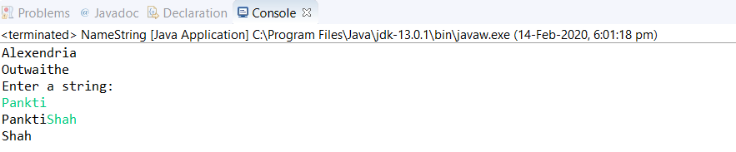

**Practical No:** 02

**AIM:** Write a program to display a string with an embedded quote.

For example:

Shastri said:” Sachin has played a game of his Life.”

**Input**

Simran said**:** “Life is beautiful”

**Output**

Simran said**:** “Life is beautiful”

* **Solution**

**Solution.java**

**class** Namestring {

**public** **static** **void** main(String[] args) {

System.***out***.print("Simran said: \"Life is beautiful\"");

}

}

* **Output**

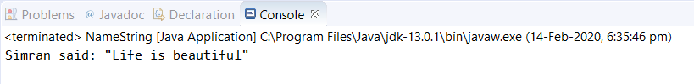

**Practical No:** 03

**AIM:** Write a program for calculating Fibonacci series.

**Input**

10

0

1

**Output**

Enter a total number of elements in a string:

10

0

1

0,1,1,2,3,5,8,13,21,34,

**1.0 Solution**

**Solution.java**

**import** java.util.Scanner;

**public** **class** Fibonacci {

**public** **static** **void** main(String args[])

{

Scanner s1 =**new** Scanner(System.***in***);

System.***out***.println("Enter a total number of elements in a string:");

**int** n=s1.nextInt();

System.***out***.println("Total number of a series is " + n);

**int** a=s1.nextInt();

**int** b=s1.nextInt();

**int** sum=0;

**for** (**int** i=0;i<n;i++)

{

System.***out***.print(a+ ",");

sum = a + b;

a= b;

b = sum;

}

}

}

**2.0 Output**

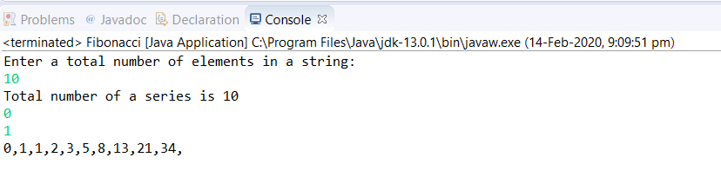

**Practical No:** 04

**AIM:** Write a program to add 2 nos.(without command line argument)

**Input**

2

4

**Output**

Enter value of a:

2

Enter value of b:

4

Addition of 2 & 4 is 6

**1.0 Solution**

**Solution.java**

**import** java.util.Scanner;

**public** **class** Javaadd {

**public** **static** **void** main(String args[]) {

Scanner s1= **new** Scanner(System.***in***);

**int** c;

System.***out***.println("Enter value of a:");

**int** a= s1.nextInt();

System.***out***.println("Enter value of b:");

**int** b= s1.nextInt();

c=a+b;

System.***out***.println("Addition of "+ a + " & " + b+ " is " +c);

}

}

1. **Output**

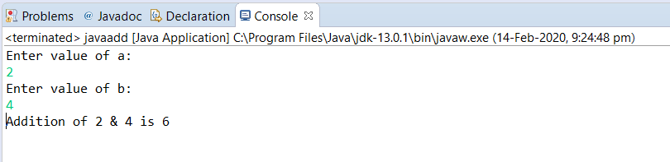

**Practical No:** 05

**AIM:** Write a program to print second element of command line argument.

**Input**

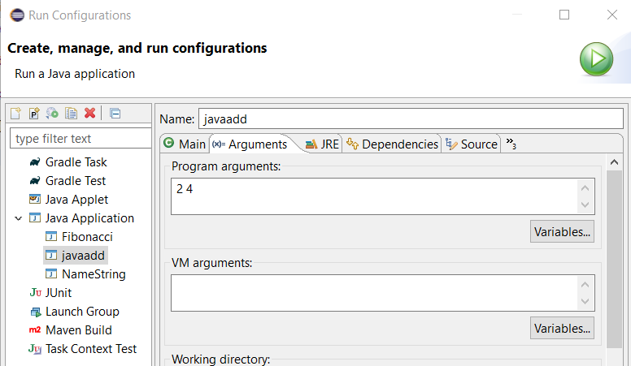

**Output**

Second element of command line argument is :4

1. **Solution**

**Solution.java**

**public** **class** Javaadd {

**public** **static** **void** main(String args[]) {

System.***out***.println("Second element of command line argument is:" + args[1]);

}

}

1. **Output**

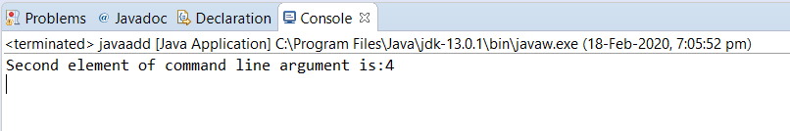

**Practical No:** 06

**AIM:** Write a program to find out that the given no number is odd or even (pass argument in command line argument).

**Input**

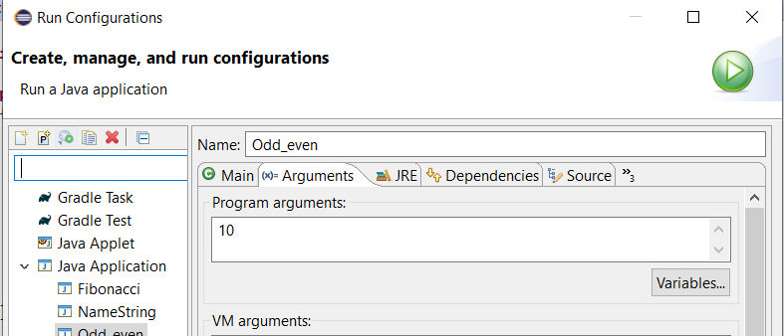**Output**

Entered integer 10 is even

1. **Solution**

**Solution.java**

**public** **class** Odd_even {

**public** **static** **void** main(String args[])

{

**int** x =Integer.*parseInt*(args[0]);

**if** (x%2==0)

{

System.***out***.println("Entered integer " + args[0] + " is even");

}

**else**

{

System.***out***.println("Entered integer " + args[0] + "is odd");

}

}

}

1. **Output**

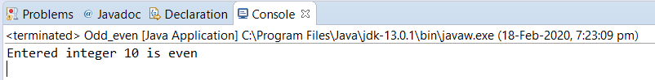

**Practical No:** 07

**AIM:** Write a program in java to find the factorial of a given number (While loop).

**Input**

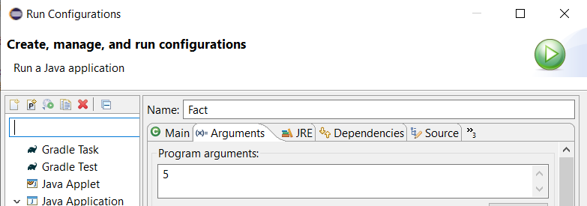

**Output**

Factorial of args[0] is:120

1. **Solution**

**Solution.java**

**public** **class** Fact {

**public** **static** **void** main(String args[])

{

**int** x=Integer.*parseInt*(args[0]);

**int** f=1;

**while**(x!=0)

{

f = f * x;

x--;

}

System.***out***.println("Factorial of args[0] is:" + f);

}

}

1. **Output**

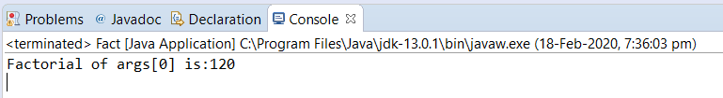

**Practical No:** 08

**AIM:** Write a program in java to find the largest among three numbers (if else statement).

**Input**

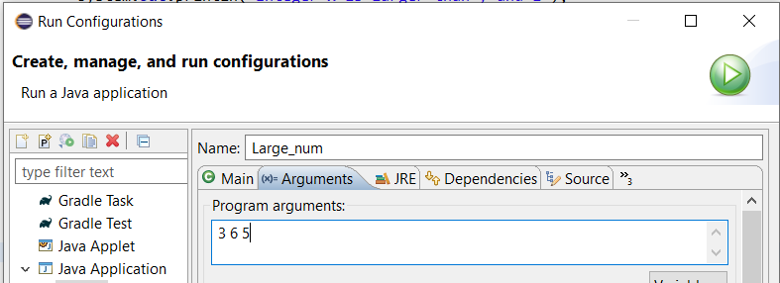

**Output**

Integer y is larger than x and z

**1.0 Solution**

**Solution.java**

**public** **class** Large_num {

**public** **static** **void** main(String args[])

{

**int** x=Integer.*parseInt*(args[0]);

**int** y=Integer.*parseInt*(args[1]);

**int** z=Integer.*parseInt*(args[2]);

**if**(x>y)

{

**if**(x>z) {

System.***out***.println("Integer x is larger than y and z");

}

}

**else** **if**(y>z)

{

System.***out***.println("Integer y is larger than x and z ");

}

**else**

{

System.***out***.println("Integer z is larger than x and y");

}

}

}

**2.0 Output**

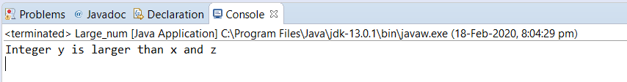

**Practical No:** 09

**AIM:** Write a program in java to swap two numbers without using auxiliary memory location (Using Bitwise XOR operation).

**Input**

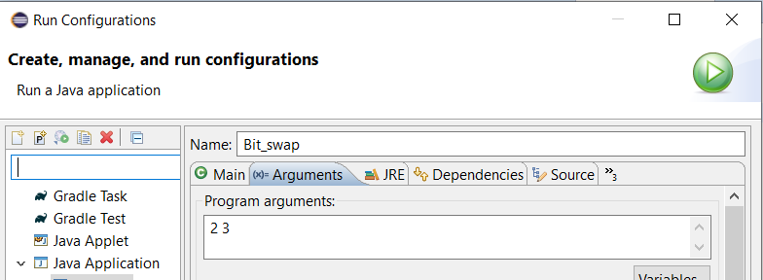

**Output**

BEFORE SWAPPING

Integer a is : 2

Integer b is : 3

BEFORE SWAPPING

Integer a is : 3

Integer b is : 2

**1.0 Solution**

**Solution.java**

**public** **class** Bit_swap {

**public** **static** **void** main(String args[])

{

**int** a=Integer.*parseInt*(args[0]);

**int** b=Integer.*parseInt*(args[1]);

System.***out***.println("BEFORE SWAPPING");

System.***out***.println("Integer a is : " + a);

System.***out***.println("Integer b is : " + b);

a=a^b;

b=b^a;

a=a^b;

System.***out***.println("BEFORE SWAPPING");

System.***out***.println("Integer a is : " + a);

System.***out***.println("Integer b is : " + b);

}

}

**2.0 Output**

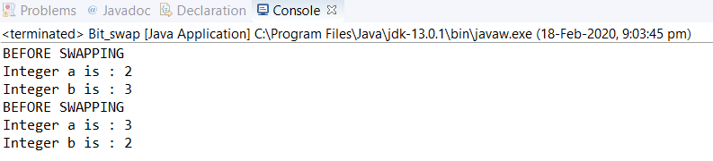

**Practical No:** 10

**AIM:** Generate the following output, using the control statements learnt in the class:

1111

111

11

1

**Input**

Enter value of n:

4

**Output**

Enter value of n:

4

Value of total iteration is: 4

1111

111

11

1

**1.0 Solution**

**Solution.java**

**import** java.util.Scanner;

**public** **class** Pattern {

**public** **static** **void** main(String args[])

{

System.***out***.println("Enter value of n:");

Scanner s1=**new** Scanner(System.***in***);

**int** n= s1.nextInt();

System.***out***.println("Value of total iteration is: " + n);

**for**(**int** i=n; i>=1; --i)

{

**for**(**int** j=1; j<=i ; ++j)

{

System.***out***.print("1");

}

System.***out***.print("\n");

}

}

}

**2.0 Output**

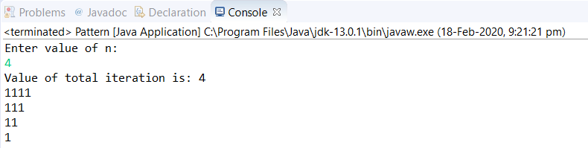

**Practical No:** 11

**AIM:** Try a program to display in which season the month of April lies. Use the ‘switch’ statement. Hint: We have four seasons: Summer, Winter, Autumn and Spring.

Months: 12,1,2 come in Winter.

Months: 3,4,5 come in Spring.

Months: 6,7,8 come in Summer.

Months: 9,10,11 come in Autumn

**Input**

Enter value of n:

4

**Output**

Enter value of n:

4

Value of total iteration is: 4

1111

111

11

1

**1.0 Solution**

**Solution.java**